**Evaluating Youth and System Outcomes in the Louisiana Coordinated System of Care (CSoC)**

**January 2, 2013 version**

Michael D. Pullmann, Ph.D., Eric J. Bruns, Ph.D.

University of Washington School of Medicine and National Wraparound Initiative

Jody Levison-Johnson, Keith Durham

Louisiana Department of Health and Hospitals-Office of Behavioral Health

**Background and Purpose**

The State of Louisiana is currently launching an ambitious and highly innovative system of care and wraparound initiative. The ***Coordinated System of Care (CSoC)*** will serve young people with behavioral health challenges who are in or at-risk of out of home placement and their families. Goals for the CSoC include reduction in the number of youth in residential/detention settings and reduced cost of providing services by leveraging funding sources and improving outcomes for these children and their caregivers.

The CSoC is currently being implemented in five regions of the state. An additional five regions are not implementing CSoC services. Youths with significant behavioral health challenges who are clinically eligible for CSoC (i.e. score positively on the Child and Adolescent Needs and Strengths (CANS) screen) who reside in regions of the state that are not in the initial phase of implementation are offered admittance into the Resiliency Care Management (RCM) program provided by Magellan of Louisiana (the managed care organization). RCM is a more intensive care management approach used by Magellan to offer enhanced supports to youth with complex needs. These youth are identified in the same manner as youth in CSoC regions—via a standardized cutoff using the Child and Adolescent Needs and Strengths Assessment (CANS).

The CSoC regions will have a more comprehensive service array and will provide high-fidelity wraparound care coordination using facilitators with small caseloads and extensive professional development support. It is our interest to evaluate how these enhancements affect youth and system outcomes as well as costs. The implementation of CSoC in only some regions of the state, while others continue services as usual, provides an excellent opportunity to conduct a controlled study.

**Research Questions**

The evaluation study is focused on evaluating the impact of the Louisiana CSoC on two broad domains:

1. Impact on individual (youth and family) outcomes
2. Impact on system (e.g., residential and cost) outcomes

Within these domains, there are three research questions:

**Individual outcomes:**

1. Do youths enrolled in the CSoC experience improved outcomes over time in areas such as child functioning, youth/family needs and strengths, residential placement and stability, and school achievement and attendance?
2. Do youths enrolled in the CSoC experience better individual outcomes over time, compared to similar youths who are not in CSoC services (i.e., who are in non-CSoC regions)?

**System Outcomes:**

1. Compared to non-CSoC regions, do CSoC regions demonstrate better system outcomes such as lower overall rates of use of restrictive residential placements, crisis intervention, and emergency room use; lower overall costs of service; and lower rates of school suspension, juvenile justice commitment, juvenile justice recidivism, and reports of child abuse and neglect?

**Overview of Method[1]**

The current evaluation will conduct two linked but independent studies to address the three research questions listed above.

**Study 1 (Individual outcomes): Retrospective data analysis using administrative data and retrospective multilevel propensity score matching.**

Study 1 uses existing administrative data. This study will ensure a strong match between CSoC youth and comparison youth and ensure ample statistical power because of a large sample size. In addition, because administrative data will be de-identified to us and collected as part of the usual functioning of the LA child serving systems, we will not need to secure consent for individual youth.

Our CSoC “sample” will be the entire population of youth served by CSoC services ***during an agreed-upon time period***. The comparison sample will be a matched group of similar youth from non-CSoC regions. To identify this matched comparison sample for the CSoC youth, we will first select all youth in non-CSoC regions who meet the cutoff score on the CANS for CSoC services. From this sample, we will build a multilevel propensity score model [2] to identify a sample of individuals matched on individual characteristics as well as regional characteristics. Individual level variables to be used to build the model will include:

* CANS screening and/or full assessment
* Age, sex, race/ethnicity,
* GAF score,
* Medicaid status,
* Presenting problem, disability, and diagnostic category,
* Referring agency,
* Residential status,
* Admission driver,
* Substance use disorder (SUDS) services use,
* Pregnancy/marital status,
* Whether the child has a PCP, and
* Regional characteristics (e.g., county rurality, poverty rate, and employment rate)

Using this model, we can retrospectively match those who are in the CSoC to similar youth who are in non-CSoC regions. After the youth are identified, we will obtain administrative records for these youth from the data systems of child welfare, juvenile justice, public education, and mental health. ***Because our evaluation team will not have permission to see the names of youth, we will require assistance from our Louisiana partners to retrieve and de-identify these data (See examples of administrative data elements in Appendix B).*** Analysis of between-group differences will use longitudinal Multilevel Generalized Models.

**Study 2 (System Outcomes): Using regional-level data to compare system differences.**

In this study we will examine the broader systemic impact of the CSoC, by region. We will examine whether there are differences in system outcomes such as less use of restrictive residential placements, crisis intervention, emergency room use, and community re-entry for youth who have been placed out of home (see Research question 3 above). We will do this through examining overall rates of occurrence for all served youth in the region. ***If data is available on these factors prior to the implementation of CSoC, then we will analyze whether these change over time at different rates in implementing and non-implementing regions.*** If only more recent data is available for these variables, we will conduct cross-sectional analyses. Statistical power permitting, we will control for important regional-level covariates that may be related to these variables, such as rurality, poverty rate, and employment rates. We should note that because the number of regions is relatively small, our statistical power to incorporate important covariates and detect differences will be relatively weak.

**Hypothesized effects.**

A summary of hypothesized effects is presented in the figures below. ***Figure 1*** corresponds to Research Question 1 and Study 1. Figure 1 represents change we would expect for individual youths enrolled in the CSoC, compared to statistically matched non-CSoC youths (using propensity score matching) from non-CSoC regions. As shown, we would hypothesize that CSoC youths demonstrate better outcomes compared to statistically matched non-CSoC youths.

***Figure 2*** corresponds to Research Question 3 and Study 2. ***Although the timeline of rollout of the CSoC approach to additional regions is not known at this time,*** Figure 2 represents hypothesized change in system outcomes for three cohorts of regions that initiated CSoC implementation at different times in the statewide rollout. As shown, we would hypothesize that CSoC regions would demonstrate positive outcomes (e.g., reductions in costs or out of home placement rates) region-wide that occur after implementation of the CSoC. Demonstration of these system outcomes at initiation of the CSoC services in three regions would increase our confidence that the change was due to the CSoC initiative.

***Figure 1. Hypothesized individual and system effects of the CSoC***

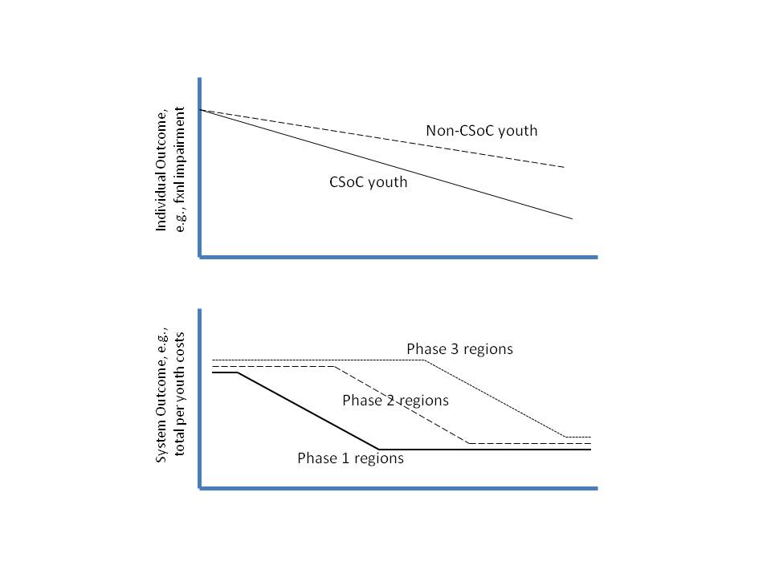

**Appendix A: List of CSoC and non-CSoC Parishes**

|  |  |  |  |  |
| --- | --- | --- | --- | --- |
| COUNTY (parish) | DHH REGION | Act 1225 Region | CSoC Initial Implementation | |
| Jefferson | 1 | 1 | Yes | Note: Jefferson Parish was originally treated as a separate region for CSoC |
| Orleans | 1 | 1 | Yes |  |
| Plaquemines | 1 | 1 | Yes |  |
| Saint Bernard | 1 | 1 | Yes |  |
| Ascension | 2 | 2 | Yes |  |
| East Baton Rouge | 2 | 2 | Yes |  |
| East Feliciana | 2 | 2 | Yes |  |
| Iberville | 2 | 2 | Yes |  |
| Pointe Coupee | 2 | 2 | Yes |  |
| West Baton Rouge | 2 | 2 | Yes |  |
| West Feliciana | 2 | 2 | Yes |  |
| Assumption | 3 | 4 | No |  |
| Lafourche | 3 | 4 | No |  |
| Saint Charles | 3 | 4 | No |  |
| Saint James | 3 | 4 | No |  |
| St John The Baptist | 3 | 4 | No |  |
| Saint Mary | 3 | 4 | No |  |
| Terrebonne | 3 | 4 | No |  |
| Acadia | 4 | 5 | No |  |
| Evangeline | 4 | 5 | No |  |
| Iberia | 4 | 5 | No |  |
| Lafayette | 4 | 5 | No |  |
| Saint Landry | 4 | 5 | No |  |
| Saint Martin | 4 | 5 | No |  |
| Vermilion | 4 | 5 | No |  |
| Allen | 5 | 6 | No |  |
| Beauregard | 5 | 6 | No |  |
| Calcasieu | 5 | 6 | No |  |
| Cameron | 5 | 6 | No |  |
| Jefferson Davis | 5 | 6 | No |  |
| Avoyelles | 6 | 7 | Yes |  |
| Catahoula | 6 | 7 | Yes |  |
| Concordia | 6 | 7 | Yes |  |
| Grant | 6 | 7 | Yes |  |
| La Salle | 6 | 7 | Yes |  |
| Rapides | 6 | 7 | Yes |  |
| Vernon | 6 | 7 | Yes |  |
| Winn | 6 | 7 | Yes |  |
| Bienville | 7 | 8 | Yes |  |
| Bossier | 7 | 8 | Yes |  |
| Caddo | 7 | 8 | Yes |  |
| Claiborne | 7 | 8 | Yes |  |
| De Soto | 7 | 8 | Yes |  |
| Natchitoches | 7 | 8 | Yes |  |
| Red River | 7 | 8 | Yes |  |
| Sabine | 7 | 8 | Yes |  |
| Webster | 7 | 8 | Yes |  |
| East Carroll | 8 | 9 | Yes |  |
| Franklin | 8 | 9 | Yes |  |
| Jackson | 8 | 9 | Yes |  |
| Lincoln | 8 | 9 | Yes |  |
| Madison | 8 | 9 | Yes |  |
| Morehouse | 8 | 9 | Yes |  |
| Ouachita | 8 | 9 | Yes |  |
| Richland | 8 | 9 | Yes |  |
| Tensas | 8 | 9 | Yes |  |
| Union | 8 | 9 | Yes |  |
| West Carroll | 8 | 9 | Yes |  |
| Caldwell | 8 | 9 | Yes |  |
| Livingston | 9 | 3 | No |  |
| Saint Helena | 9 | 3 | No |  |
| Saint Tammany | 9 | 3 | No |  |
| Tangipahoa | 9 | 3 | No |  |
| Washington | 9 | 3 | No |  |

**Appendix B: Proposed Outcomes to be Examined using Administrative Data from Partner Agencies**

|  |  |  |
| --- | --- | --- |
| **Goal or Outcomes (examples)** | | **Data Source** |
| CSoC | Reduction in number of youths in residential settings   * Admissions to residential settings * Restrictiveness of living settings for youths | Medicaid, OJJ, and DCFS admin data |
| Improved functional outcomes for youth and caregivers   * CANS total and subscale scores | CANS data for CSoC enrolled youths |
| Reduction in costs of services   * Emergency Department Admissions * Community Resource Utilization –MH services * Admission (and re-admission) rates to inpatient facilities | Medicaid and other costs admin data |
| DOE | Reduction in school suspensions and expulsions   * Number of disciplinary actions (suspensions, expulsions) | DOE administrative data |
| Increased school achievement   * Attendance * Grades (GPA) * Standardized Test Scores   + Growth or number meeting cutoffs | DOE state assessment data |
| OJJ | Increased community-based services for youth on probation   * Number of available services * Number of services used by youths on probation | OJJ and Medicaid admin data |
| Shorter length of stay in residential group homes | OJJ administrative data |
| Fewer youths in secure care | OJJ administrative data |
| Decreased recidivism   * All referrals * Filed petitions * Adjudicated delinquent | OJJ administrative data |
| DCFS | Reduced placement disruptions/multiple placements   * Number of placements | Medicaid, OJJ, and DCFS admin data |
| Reduced inpatient and RTC services   * Rate of inpatient and RTC admissions * Days of inpatient and RTC services | Medicaid and DCFS admin data |
| Length of stay in out-of-home care | DCFS administrative data |
| Reduced incidence of crisis episodes | Medicaid and DCFS admin data |
| Improved interpersonal and social skills   * CANS scores | CANS data for CSoC enrolled youths |
| Improved parental ability to manage behaviors   * CANS scores | CANS data for CSoC enrolled youths |

1. Sections in ***bold italics*** reference methodological issues that will be affected by decisions made by state officials and providers in Louisiana. These decisions must be made before a final research protocol can be developed.
2. Propensity score approaches help ensure that the comparison group is an equivalent comparison and that factors that contribute to selection bias are minimized. It involves building a statistical model that “predicts” whether someone would be in the CSoC (if in non-CSoC regions) based on various characteristics. We will build a model that incorporates available data in the MIS at intake.