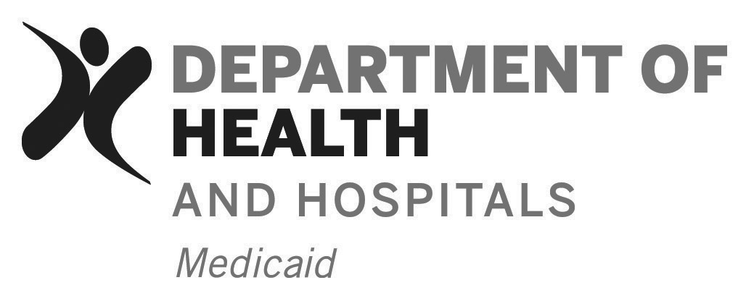
Bayou Health
FOR DHH USE ONLY
STAGE OF REVIEW | DATE
Form Received at DHH

Investigation Begins

Sanctions Applied

Response Sent to Complainant

Investigation Closed

Marketing Complaint Tracking #
Marketing Complaint Form

COMPLAINANT CONTACT INFORMATION
Complainant Name/ Title/Organization:
Address:

Phone: | E-mail: |  | Fax:
COMPLAINT DETAILS
Parties to the Alleged Violation: (violator, witnesses and others)

Date/Time/Frequency of Alleged Violation:

Location of Alleged Violation: (facility name including location - address, unit, room, floor)

Narrative/specifics of alleged violation: (Please attach any documentation to support this allegation and attach additional pages if more space is needed for the narrative)

Why is this alleged violation a violation of the Marketing Policy and Procedures? Please include citations to specific policies and procedures?
What harm has resulted due to this alleged violation? (such as misrepresentation, unfair advantage gained)
What is the complainant’s expectation/desire for resolution/remedy, if any?

DHH FINDINGS
DHH Investigator Signature:  (at completion of investigation) |  | Date:

