**1115 SUD Health IT Plan – DY6 (Q3) Update**

The state provides the following updates to activities and metrics appearing in the approved HIT Plan. Updates are included in Attachments A1 and A2 included with the report’s submission. Data and updates to process measures following submission of this report will be communicated to CMS during future monthly phone calls and quarterly reports.

1. Pg 2 - The state should provide CMS with an analysis of the current status of its health IT infrastructure/”ecosystem” to assess its readiness to support PDMP interoperability. Once completed, the analysis will serve as the basis for the health IT functionalities to be addressed over the course of the demonstration – or the assurance described above.

Currently, LDH is no longer pursuing PDMP Interoperability through the SUPPORT Act Funding. This initiative has been placed on hold.

1. Pg 3 – Process measure: Status of contracting as reported by Board of Pharmacy.

The Board of Pharmacy reported that they awarded a new five-year contract in January 2019 to Appriss Health.

1. Pg 5 – Process measure: Regular updates at quarterly Board of Pharmacy meetings. Attach minutes.

The Prescription Monitoring Program Advisory Council met on 4/12/23 and the draft meeting minutes may be accessed here:

https://wwwcfprd.doa.louisiana.gov/boardsandcommissions/MeetingMinutes/336_2023-0412_Minutes_DRAFT.pdf

1. Pg 5 – Process measure: Continue ad hoc meetings with CMS and ONC for IAPD guidance to enhance PMP connectivity in either HIE or EHR.

HIE Integration activities have been placed on hold until further notice.

1. Pg 6 – Process measure: During procurement of data warehousing module under modernization, set capability for data match.

The Decision Support System module (previously known as Data Warehouse) started procurement activities in 2021, with a planned

contract execution by July 2023, if State funding is approved and a vendor is selected timely. This procurement is delayed but the state is still working towards executing a contract in early 2024.

The state intends to execute a contract for its Claims & Encounter module in early 2023 with a transition to follow.  Louisiana will be

among the first states to file a participating addendum for a Medicaid Enterprise System offering. Participating in NASPO for the

procurement will give Louisiana access to a highly configurable, web-based, and automated solution for the Claim and Encounters module in a shorter time period and for less of a financial investment than a "from scratch" solution. The contract was executed in early 2023 but the award was protested and the decision on the protest of the award is currently pending.

1. Pg. 6 – Process measure: During procurement of pharmacy module, create reporting relationship and data feed into warehousing module.

No update at this time.

1. Pg 8 – Process measure: Re-procure managed care contracts on timeline.

LDH executed new MCO contracts with the following MCO plans on 1/1/23:  AmeriHealth Caritas Louisiana; Healthy Blue; Humana;

Louisiana Healthcare Connections; United Healthcare Community Plan Louisiana.

1. Pg 9 – Process measure: If legislation does not proceed, we will pursue alternative data tracking internal to Medicaid.

The state will explore internal data resources needed for tracking as it continues to work towards implementing the Medicaid Data

Warehouse and Pharmacy modules.

LDH executed a contract with Magellan Medicaid Administration, LLC on 2/1/23 to serve as the Single PBM for the Medicaid managed

care program.

1. Pg 9/10 – Medicaid data measures
   1. Opioid prescription utilization trend (recipients, drug name, amount, payments)
   2. Opioid prescription utilization trend in naïve patients (recipients, drug name, amount, payments)

See attachment LA SUDHIT-DY6 (Q3) Report Part A2. This file contains updated data through September 2023.

1. Pg. 10 – PMP data measures
   1. User statistics by provider type

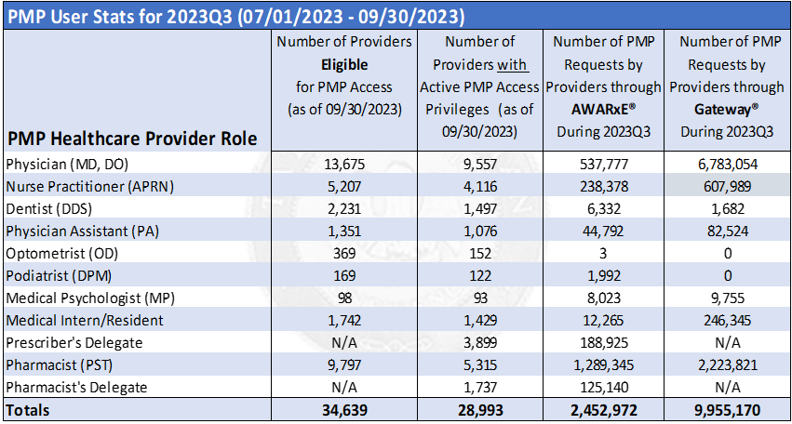

1. Eligible transactions reported to PMP

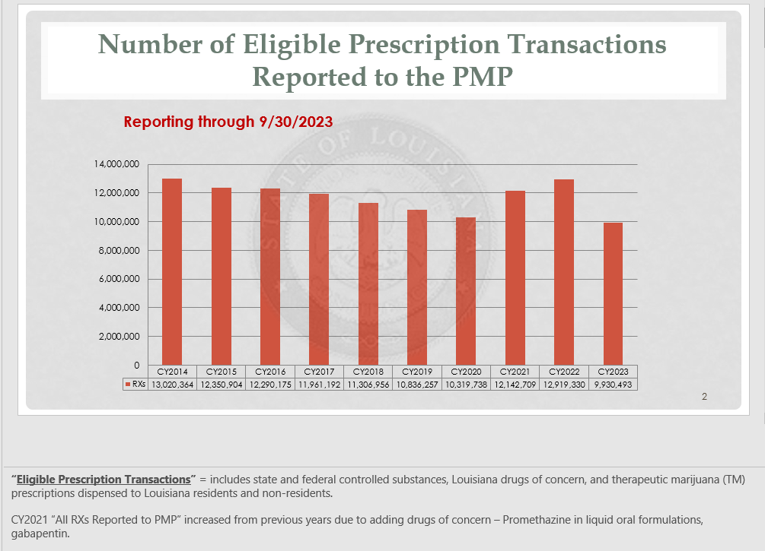

1. Prescriber and Pharmacists

No update at this time.

1. Pg. 10 – Process measure: Timeline and progress on RFP re-procurement

LDH executed new MCO contracts with the following MCO plans on 1/1/23:  AmeriHealth Caritas Louisiana; Healthy Blue; Humana;

Louisiana Healthcare Connections; United Healthcare Community Plan Louisiana.

12. Pg 10 – Process measure: Decide which HIE technology will be utilized as an ADT feed.

Currently, ADT feeds are being handled by the Louisiana Emergency Department Information Exchange (LaEDIE) run by the Louisiana Health Care Quality Forum (LHCQF). There are several organizations within the state that are developing their own ADT feed system. This section will be updated when we receive more information. Currently, there are no changes to this information and HIE planned activities have been placed on hold.

1. Pg 10 – Process measure: Establish quarterly standing report for MCOs

No updates at this time.

1. Pg 10 – Data measure – How many ADT feeds are fed at different locations across the state by MCO and providers

There are 92 hospitals actively providing feeds to LaEDIE. The system provides a daily export to the five Healthy Louisiana MCOs based on their patient lists. The MCOs use this data to provide case management to their recipients.

1. Pg 11 - Data measure: Opioid naïve utilization trend monthly report (compare to cancer/palliative care Rx baseline)

Report included in the attached LA SUDHIT-DY6 (Q3) Report Part A2- Excel spreadsheet (Monthly Tracking Impact of 7-day Opioid Quantity Limit and Utilization.xslx).