Guidelines for Support Planning

Applicable to the New Opportunities Waiver

Office for Citizens with Developmental Disabilities
Louisiana Department of Health and Hospitals

Issued: September 25, 2012
Version 7
Effective September 25, 2012

Original Issue date: January 24, 2009
Table of Contents
Section Subject Click to go to section
Introduction: Acronyms, Terms, and Definitions
1 OCDD’S Support Planning Process Overview
1.1 Planning Values
1.2 Planning Assumptions
1.3 Support Planning and the Louisiana Resource Allocation System
1.4 Use of the Guidelines
2 New Opportunities Waiver Offer Activities
2.1 Letters to Participants on the Request for Services Registry or those Receiving an Emergency Option or Transition from Supports and Services Center
2.2 Completion of the 90-L Request for Medical Eligibility Determination
2.3 Follow-Up of NOW Offer Letter Mailings
2.4 Selection of a Support Coordination Agency
2.5 Linkage to Support Coordination
2.6 Scheduling the Supports Intensity Scale (SIS) and the Louisiana Plus (LA PLUS)
2.7 Establishing the Person’s Acuity Level
2.8 Attachments
2.8.1 New Opportunities Waiver Offer - Request for Information
2.8.2 Waiver Acceptance/Inactive/Declination Status Form
2.8.3 Request for Medical Eligibility Determination BHSF Form 90-L
2.8.4 Support Coordination Choice and Release of Information Form
2.8.5 BHSF Form 90-L: Physicians Letter and Instructions
2.8.6 Request for Removal from Inactive Status
2.8.7 Key: Supports Intensity Scale (SIS) Rating Guide

3 Completing Discovery Activities for the Support Plan
3.1 Beginning Discovery Using the SIS/LA PLUS for Planning
  - Completing Discovery (Using the Personal Outcomes Interview/Mapping/ Discovery Meeting)
  - Developing a Personal Vision and Goals
  - Establishing the Support Team
  - Meeting Preparation
  - Attachments
    - Personal Outcomes Worksheets - Support Plan Format
4 Developing the Participant’s Support Plan
4.1 Facilitating the Planning Meeting
4.2 Developing Plan Strategies and Actions
4.3 Using Natural and Community Supports
4.4 Attachments
4.4.1 Support Plan Format
5 Planning for the Use of Recommended IFS Hours
5.1 Working within the Recommended Hours
5.2 Using the Conversion Table to Establish a Typical Weekly Schedule
5.3 Planning for Known and Predictable Deviations from the Typical Schedule
5.4 Planning for Unpredictable Deviations from the Typical Schedule: Flexible Hours
5.5 Using the IFS Flex Conversion Table with Flexible Hours Management
5.6 Planning Examples
5.7 When Additional IFS Hours are Needed
5.8 Justifying the Need for Additional IFS Hours
5.9 Requests for Additional IFS Hours: Expectations of Support Coordinators and/or Support Teams
5.10 Attachments
5.10.1 Recommended of IFS and Day Program Hours by Level - Lives with Family
5.10.2 Recommended of IFS and Day Program Hours by Level - Lives Independently
5.10.3 Conversion Table
5.10.4 Weekly Schedule and Budget Pages with Instructions
5.10.5 IFS Flex Conversion Table
6 Using Shared Supports
6.1 Benefits of Sharing Supports
6.2 General Requirements for Sharing Supports
6.3 Requirements when Sharing Supports in Casual/Everyday Situations (Non-Roommate)
6.4 Requirements for Sharing Supports Among Roommates
6.5 NOW Protocol for Support Coordination and Sharing IFS Supports
6.6 Roles and Responsibilities of the IFS Provider with Service Delivery of Shared Supports
6.7 Roles and Responsibilities of the Participant when Sharing Supports
6.8 When Not to Share Supports
6.9 Using Intermittent Supports
6.10 Attachments
6.10.1 Shared Supports Brochure
6.10.2 HIPAA 404P
6.10.3 Documentation for Authorization of Shared Staff and Release of Information for New Opportunities Waiver (NOW)
7 Support Plan Approval Process
7.1 Supervisory Review
7.2 OCDD Regional Waiver Office Review
7.3 OCDD Guidelines for Planning Regional Office Review Committee
7.4 OCDD Guidelines for Planning State Office Review Committee
7.5 Attachments
7.5.1 Individual Supports Review (ISR)
7.5.2 Individual Support Plan Approval Guidelines form
8 Implementing the Participant’s Support Plan
8.1 Support Plan Approval: Activities for Implementation
8.2 Providing Training to Family and Staff
8.3 Identifying and Securing Needed Resources
8.4 Documentation of Implementation and Collecting Data/Information
8.5 Family Members as Staff
8.6 Attachments
8.6.1 Support Plan Revision Request Form
8.6.2 Provider Guidelines
8.6.3 Instruction Sheets
8.6.4 Skills Training Data Sheet
8.6.5 Seizure Report
8.6.6 Weight Log
8.6.7 Meal/Fluid Log
8.6.8 Bowel Log
8.6.9 Medication Side Effects Assessment
8.6.10 Psychiatric Symptoms Assessment
8.6.11 Menstrual Chart
8.6.12 Sleep Log
8.6.13 Challenging Behavior Chart
8.6.14 Behavioral Incident Report (ABC)
8.6.15 Graphic Schedule
9 Review and Modification of the Participant’s Support Plan
9.1 Purpose of Monthly Calls in the Plan Review Process
9.2 Preparing for the Quarterly Review
9.3 Completing the Quarterly Review
9.4 Using the Quarterly Quality Review to Document Progress
9.5 Using the Quarterly Review for Annual Planning
9.6 Urgent Meetings to Address Crisis Issues
9.7 Attachments
9.7.1 Quarterly Quality Review
10 Appealing Denials of Services
10.1 Disenrollment, Decertification, and Discharge Procedures
10.2 Denial of IFS Hours
10.3 Attachments
10.3.1 BHSF Form 142 Notice of Medical Certification
11 Training and Certification Processes
11.1 Training for the SIS/LA PLUS Assessors
11.2 Certification in the use of the SIS/LA PLUS
11.3 Certification Step 1: Classroom Training for the “Guidelines for Support Planning”
11.4 Certification Step 2: Support Plan Completion Consistent with the
“Guidelines for Support Planning”
11.5 Designation and Requirements of Master Trainers
11.6 Attachments
12 OCDD Quality Monitoring Process
12.1 Relevant Policies and Requirements
12.2 Support Planning Quality Monitoring Process
12.3 Establishing and Monitoring Performance Indicators
12.4 Responsibilities for Assuring the Quality of Support Plans and Delivery of Services
12.5 Attachments
13 Frequently Asked Questions
13.1 Assessments
13.2 Planning
13.3 Shared Supports
13.4 Resource Allocation
13.5 General Questions
APPENDICES
14 APPENDIX: Development of Louisiana’s Resource Allocation System
14.1 Selection and Testing of the Needs Assessment
14.2 Linking the Needs Assessment to Resource Use
14.3 Validation of the Model
14.4 Framework for Louisiana’s Allocation of IFS Hours
14.5 Programmatic Assumptions for Each of Seven Levels
14.6 IFS Hours Allocated to Each Level
14.7 Resource Allocation for Participants Under 16 Years of Age
14.8 Attachments
14.8.1 Recommended IFS and Day Program Hours by Level - Lives with Family
14.8.2 Recommended IFS and Day Program Hours by Level - Lives Independently
14.8.3 Conversion Table
15 APPENDIX: Emergency Protocol for Tracking Location Before, During, and After Hurricanes
16 APPENDIX: NOW Resource Allocation Phase-In Plan Beginning July 1, 2009

Acronyms, Terms, and Definitions

CPOC | Comprehensive Plan of Care is the support plan format currently used in the NOW. The CPOC format is included as an attachment in Section 4.
Day Hab  Day Habilitation  Day Program | Day Habilitation services provide participants, age 18 years or older, with assistance in developing social and adaptive skills necessary to enable them to participate as independently as possible in the community. It allows for peer interaction, meaningful and age-appropriate activities, community and social integration, which provide enrichment and promote wellness. It includes the assistance and/or training in the performance of tasks related to acquiring, maintaining, or improving skills including but not limited to: personal grooming; housekeeping; laundry; cooking; shopping; and money management.  Day Habilitation services are provided in a community-based setting focused on enabling the participant to attain or maintain his or her maximum functional level. Day Habilitation services shall be coordinated with any physical, occupational, or speech therapies or employment listed in the participant’s approved Plan of Care.  In addition, Day Habilitation services may serve to reinforce skills or lessons taught in school, therapy, or other settings.
ERT | Employment Related Training services consists of paid employment for participants, 18 years of age old or older, for whom competitive employment at or above the minimum wage is unlikely and who because of their disabilities need intensive ongoing support to perform in a work setting.  Employment Related Training services also include training designed to improve and/or maintain the participant’s capacity to perform productive work and function adaptively in the work environment.  Description of Services  Employment Related Training Services include, but are not limited to:  A participant receives assistance and prompting in the development of employment-related skills. This may include assistance with personal hygiene, dressing, grooming, eating, toileting, ambulation or transfers, and behavioral support needs and any medical task, which can be delegated.  - A participant is employed at a commensurate wage at a provider facility for a set or variable number of hours.  - A participant observes an employee of an area business to obtain information to make an informed choice regarding vocational interest.  - A participant is taught to use work related equipment.  - A participant is taught to observe work-related personal safety skills.  - A participant is assisted in planning appropriate meals for lunch while at work.  - A participant learns basic personal finance skills.  - A participant and his/her family, as appropriate, receive information and counseling on benefits planning and assistance in the process.
GPSORC | Guidelines for Planning State Office Review Committee  OCDD developed the Guidelines for Planning State Office Review Committee and process to perform oversight functions required for implementation of the “Guidelines for Support Planning.” Details of the committee function and makeup are covered in Section 7.3.
HIPAA | The Health Insurance Portability and Accountability Act of 1996 includes privacy rules that protect the privacy of individually identifiable health information. The Privacy Rule provides federal protections for personal health information held by covered entities, such as Medicaid, and gives people an array of rights with respect to their private information. At the same time, the Privacy Rule is balanced so that it permits the disclosure of personal health information needed for patient care and other important purposes. Following HIPAA is important in the team process and also must be taken into account when planning for shared supports.
ICF/DD | Intermediate Care Facility for Persons with Developmental Disabilities  In 1971, an amendment to the Social Security Act allowed the financing of special facilities with federal dollars. These facilities were called Intermediate Care Facilities for the Mentally Retarded or ICFs/MR. As of 2007 Louisiana defined ICFs/MR as Intermediate Care Facilities for People with Developmental Disabilities or ICFs/DD. The purpose of the ICF/DD is that of diagnosis, treatment, or rehabilitation of people with developmental disabilities. The ICF/DD provides a protected residential setting, ongoing evaluation, planning, 24-hour supervision, coordination, and integration of health or rehabilitative services that are individualized according to each participant’s needs. ICF/DD services are provided in a broad range of residential services such as community homes (up to 7 people), group homes (8-15 people), small (16-32 people) or large (33+) institutions, including state-operated supports and services centers (previously developmental centers) and privately-operated agencies.
IFS | Individual and Family Support services are defined as direct support and assistance, which may take place in the participant's residence or community, to achieve and/or maintain the outcomes of increased independence, productivity, enhanced family functioning; provide relief of the caregiver; and promote inclusion in the community. IFS services may not supplant primary care available to the participant through natural and community supports.  Description of Services  - Assistance and prompting with personal hygiene, dressing, bathing, grooming, eating, toileting, ambulation or transfers, other personal care and behavioral support needs, and any medical task which can be delegated.  - Assistance and/or training in the performance of tasks related to maintaining a safe, healthy, and stable home, such as: housekeeping; bed making; dusting; vacuuming; laundry; cooking; evacuating the home in emergency situations; shopping; and money management (including bill paying). The IFS rate does not include the cost of the supplies needed or the cost of the meals themselves.  - Personal support and assistance in participating in community, health, and leisure activities. This may include accompanying the participant to these activities.  - Support and assistance in developing relationships with neighbors and others in the community and in strengthening existing informal, social networks, and natural supports.  - Enabling and promoting individualized community supports targeted toward inclusion into meaningful integrated experiences (e.g., volunteer work, community awareness activities).
ISR | The Individual Supports Review Protocol defines requirements and review criteria for assessments needed for CPOC planning and each section of the CPOC. The Protocol is used by the support coordinator supervisor, OCDD Regional Waiver Office, and state office for review of individual CPOCs to assure compliance with OCDD “Guidelines for Support Planning” prior to plan approval and implementation. The ISR utilization is discussed in Section 7.
LA PLUS | Louisiana Plus includes complimentary assessment items in a number of areas: material supports (e.g., powered wheelchair, walker, vehicle modification, etc.), vision related supports, hearing related supports, supports for communicating needs, positive behavior supports, physician supports, professional supports (e.g., registered nurse, psychologists, occupational therapists, physical therapists, speech therapists, etc.), stress and risk factors, protective supervision, summoning help, and sharing supports.  The information on the SIS/LA PLUS is used both in determining the Resource Allocation Level System and in developing support plans for each participant based upon his/her unique support needs.
NOW | New Opportunities Waiver is a Home and Community-Based Services Waiver program. Waiver programs are based on federal criteria which allow services to be provided in a home or community-based setting for the participant who would otherwise require institutional care. Due to the demand for these services, there is a Developmental Disability (DD) Request for Services Registry (RFSR) that lists participants who meet the Louisiana definition of developmental disability and their request date. This waiver is offered on a first-come, first-served basis. Persons interested in being added to the RFSR for this waiver should contact their local Regional Office/ Human Services District/Authority. The application process does not begin until an opening (slot) is available. At that time, medical and financial determinations are completed simultaneously to validate that the participant has a developmental disability and meets the financial and medical/psychological requirements for institutional care in an ICF/DD. Through freedom of choice, requestors choose their support coordinator and direct service provider(s).  NOW is only appropriate for those participants whose health and welfare can be assured through the Comprehensive Plan of Care and for whom home and community-based waiver services represent a least restrictive treatment alternative. NOW is intended to provide specific, activity-focused services rather than continuous custodial care.  The following are the services provided under the NOW: Individualized and Family Support (IFS) Service-Day-Night; Center-Based Respite; Community Integration and Development; Environmental Accessibilities Adaptations; Specialized Medical Equipment and Supplies as an Extended State Plan Service; Supported Living; Substitute Family Care; Day Habilitation and Transportation for Day Habilitation; Supported Employment and Transportation for Supported Employment; Employment Related Training; Professional Services; Personal Emergency Response System; Skilled Nursing Services; and One-Time Transitional Services.

SE/Mobile Crew | Supported Employment is work in an integrated work setting or employment in an integrated work setting in which participants, age 18 and older, are working toward competitive work that is consistent with their strengths, resources, priorities, and interests and for whom competitive employment has not traditionally occurred.  Supported Employment includes activities needed to sustain paid work by participants receiving waiver services, including supervision and training.  Supported Employment services also includes assistance and prompting with personal hygiene, dressing, grooming, eating, toileting, ambulation or transfers, other personal care and behavioral support needs and any medical task which can be delegated.  Types of Supported Employment Services  1. Individual Placement or One-To-One Model:  A One-To-One Model of Supported Employment is a placement strategy in which an employment specialist (job coach) places a participant into competitive employment, provides training and support, and then gradually reduces time and assistance at the work site once a certain percentage of the job is mastered by the participant. Once the participant has mastered the job task, he or she may be transitioned to the Follow Along status of Supported Employment, if needed.  2. Follow Along:  Follow Along services are supports to maintain the participant in his/her job and are provided by an entity other than the Louisiana Rehabilitation Services (LRS). Follow along services are designed for persons only requiring minimum oversight at the job site and are limited to 24 days per Plan of Care year. Ongoing support services can be provided from more than one source.  3. Mobile Work Crew/Enclave:  An employment situation in which a group of two or more workers, but fewer than eight workers, with disabilities are working at a particular work setting under the supervision of a permanent employment specialist (job coach/supervisor). The workers with disabilities may be disbursed throughout the company and among workers without disabilities, or congregated as a group in one part of the business.
SFC | Substitute Family Care provides for day programming, transportation, independent living training, community integration, homemaker, chore, attendant care and companion services, medication oversight (to the extent permitted under State law) provided to participants residing in a Medicaid enrolled Substitute Family Care home.  Substitute Family Care is a stand-alone family living arrangement for participants, age 18 years of age or older, in which SFC parents assume the direct responsibility for the participant’s physical, social, and emotional well being and growth, including family ties.
SIS | Supports Intensity Scale assesses six life activities based on 49 items: (Home Living, Community Living, Lifelong Learning, Employment, Health and Safety, Social Activities); Advocacy; Medical Support; Behavior Support.  The information on the SIS/LA PLUS is used both in determining the Resource Allocation Level System and in developing support plans for each participant based upon his/her unique support needs.
SL | Supported Living (SL)services assist participants, age 18 years of age or older, to acquire, improve, or maintain social and adaptive skills necessary to enable participants to reside in the community and to participate as independently as possible.  SL services include assistance and/or training in the performance of tasks such as personal grooming, housekeeping, and money management (including bill paying). These services will also assist the participant in obtaining financial aid, housing, advocacy and self-advocacy training as appropriate, emergency support, trained staff, and assisting the participant in accessing other programs for which he/she qualifies.  Services must be coordinated with any other services listed in the CPOC and may serve to reinforce skills or lessons taught in school, therapy, or other settings.
SRI | Statistical Resources, Inc. is a data management contractor. SRI maintains the Request for Service Registry and mails out the NOW offer packet. The NOW offer packet form (Waiver Acceptance/Denial/Inactive Status Form) is returned to SRI. SRI is also contacted by the GPSORC regarding approvals of IFS hours. SRI manages prior and post authorization for the NOW services.
SSC | Supports and Services Center is a public (state-operated) Intermediate Care Facility for people with developmental disabilities (ICF/DD).
90-L | Request for Medical Eligibility Determination - BHSF Form 90-L is a form completed by a physician and is used to establish ICF/DD level of care. Proper completion of the 90-L verifies that the participant requires one or more waiver services at least monthly in order to avoid institutionalization for his/her mental retardation or developmental disability. The form is required for entrance into the waiver. For more information see Section 2.2.

1

OCDD’S Support Planning Process Overview

1.1 Planning Values
1.2 Planning Assumptions
1.3 Support Planning and the Louisiana Resource Allocation System
1.4 Use of the Guidelines
OCDD’S SUPPORT PLANNING PROCESS OVERVIEW
The Office for Citizens with Developmental Disabilities (OCDD) has developed the “Guidelines for Support Planning” as a framework for all activities related to planning for individualized supports and services within the New Opportunities Waiver (NOW). The “Guidelines for Support Planning” involve four main components:
- Discovery involves gathering information about the participant’s interests, goals, and support needs.
  - A Support Needs Assessment is conducted using the Supports Intensity Scale (SIS) and Louisiana Plus (LA PLUS).
  - A Personal Outcomes Interview/Discovery Meeting is completed with each participant and/or guardian.
  - Other needed information/assessments are completed as indicated for each participant.
- Planning involves using the information from Discovery to develop a support plan.
  - A support team is established to work with the participant to develop strategies to assist in achieving the participant’s goals and address his/her support needs.
  - The plan strategies identify all supports needed to assist the participant in achieving his/her goals and meeting other identified support needs.
- Implementation involves completion of the noted strategies and provision of needed supports according to the participant’s plan.
  - Training is provided for the participant’s family and support staff.
  - Resources needed are identified and secured.
- Review involves assessing if implementation occurred as planned and if positive changes occurred as a result of the plan.
  - The team assesses the effectiveness of strategies following implementation.
  - Changes are made as needed.
1.1 PLANNING VALUES
A. OCDD’s person-centered support planning process is founded on five values:
- Each person defines his/her own outcomes.
  - The process of assisting a participant to identify his/her own outcomes is developmental.
- The planning process begins with the discovery of who the person is.
  - The focus is on the participant receiving supports, his/her desires/goals/support needs, and strategies to move toward achieving goals and meeting support needs.
- The planning process builds on the important, meaningful life experiences of the person rather than with the limitation of services actually available.
  - Depending upon each participant’s past experiences and opportunities, there will be a difference in ability to identify things that are important to the participant, possible goals, or changes the person would like to have in his/her life.
- There is a partnership with the person and all the important people in his/her life.
  - The support team led by the support coordinator assists the participant in this process including planning and developing opportunities for greater experiences when appropriate.
  - Throughout the planning process, the support team listens, responds, and provides assistance to the participant.
- Individualized supports and services are provided to assist a person to achieve his/her vision and goals.
- Each participant’s plan is unique and focused on the things that are most important to him/her and the barriers that must be addressed.
- Each participant’s plan will identify and provide opportunities to learn new skills and increase independence in ways that move the person toward his or her life vision and goals.
B. Planning is a process and is not an event that occurs once a year. This process occurs continuously throughout each day, week, month, and year with subsequent needed changes in support plans occurring as interests and needs change.
C. The annual planning meeting and quarterly reviews represent only the minimum required planning activities.
D. Meetings, plan changes or other needed support activities occur as needed based upon each participant’s unique situation(s).

  - PLANNING ASSUMPTIONS
A. The “Guidelines for Support Planning” are consistent with the values discussed in the previous section and assume the following:
- People will have full lives with an array of activities and interests consistent with each person’s interests, goals, and life vision.
- People will have meaningful work, school or other appropriate daytime activities, including retirement activities if a person is of retirement age.
- People will use a variety of supports (natural, community, educational, paid, etc.) with all supports being coordinated to bring each person the best support and assistance possible.
- When people live independently and need significantly more supports than those recommended for their level, they will share supports unless contraindicated.
- Plans will foster independence for each person.
- People living with family and people living independently will have different needs, and the needs of each will be addressed.

  - SUPPORT PLANNING AND THE LOUISIANA RESOURCE ALLOCATION SYSTEM
A. The Louisiana Resource Allocation System, which is included as a part of the OCDD “Guidelines for Support Planning,” is completed as part of a person-centered planning process.
B. As a part of the planning process, the support team assists the participant in determining needed supports and services including recommended Individual and Family Supports (IFS) under the NOW to achieve the person’s life vision and goals. The support team completes this process using the framework in the “Guidelines for Support Planning.”
C. IFS may also be referred to as attendant care services (ACS).
D. These guidelines provide for the allocation of IFS supports based on the assessment of participant needs. OCDD has selected the Support Intensity Scale (SIS), complemented by the Louisiana Plus (LA PLUS), for assessing persons’ support needs. For participants younger than age 16, by agreement with AAIDD, a modified SIS assessment which removes SIS items not relevant for youths (e.g., employment items), complemented by the LA PLUS, is used.
E. IFS support hours are offered to participants based on the Louisiana Resource Allocation System. This system provides for the allocation of IFS hours to participants based on one of seven levels of need. (The levels are described in more detail in Section 14.) The system distinguishes participants living with family and those living independently.
F. Other services under the NOW are accessed in the planning process based on the participant’s identified needs within the current NOW service guidelines.

  - USE OF THE GUIDELINES
- The “Guidelines for Support Planning” publication describes the operations and application of the procedures involved in making a waiver offer, discovery, planning, plan approvals, implementation of plans, review of plans, and training requirements for persons involved in the process. In addition, the publication provides information on the Resource Allocation Level System in the New Opportunities Waiver Individual and Family Support (IFS) service.
- Appropriate elements of the “Guidelines for Support Planning” are intended to be used by support coordinators, participants and families, and service providers.
- The “Guidelines for Support Planning” does not replace the Louisiana Medicaid New Opportunities Waiver Service Manual. The Medicaid manual covers details of the waiver as a Medicaid service and contains important information for service providers regarding service delivery, licensing, and billing.
- The Office for Citizens with Developmental Disabilities will maintain the “Guidelines for Support Planning” as an online publication. An electronic version of the publication will be posted and available on the official OCDD web site: http://www.dhh.louisiana.gov/offices/?ID=77.
    - The posted electronic version will be updated monthly, or more frequently as necessary.
    - The posted electronic version will be considered the most current version of the document.
    - Providers, support coordinators, OCDD staff, and other responsible parties must visit the online posting to acquire recent updates.
    - The OCDD will maintain and post a “Guidelines for Support Planning” Document Revisions Summary to assist users to locate corrections, additions, and deletions.
    - The publication is designed to facilitate frequent updates. If a section is revised, then the entire section should be removed and replaced with the most recent information. For example, if Section 1.4 is updated, then the user should remove the old Section 1.4 and replace the page with the updated Section 1.4. Updated pages will include an initial version issue date in parenthesis followed by a revision effective date (EF) noted in the bottom right footer.

    - Emergency updates are effective immediately, unless otherwise specified. Emergency updates notification will be made using the OCDD communications system of memorandum email and fax. The change will be posted online as a part of the manual and reflected in the Document Revision Summary.

2

New Opportunities Waiver Offer Activities

2.1 Letters to Participants on the Request for Services Registry or those Receiving an Emergency Option or Transition from Supports and Services Center
2.2 Completion of the 90-L Request for Medical Eligibility Determination
2.3 Follow-Up of NOW Offer Letter Mailings
2.4 Selection of a Support Coordination Agency
2.5 Linkage to Support Coordination
2.6 Scheduling the Supports Intensity Scale (SIS) and the Louisiana Plus (LA PLUS)
2.7 Establishing the Person’s Acuity Level
2.8 Attachments
2.8.1 New Opportunities Waiver Offer - Request for Information
2.8.2 Waiver Acceptance/Inactive/Declination Status Form
2.8.3 Request for Medical Eligibility Determination - BHSF Form 90-L
2.8.4 Support Coordination Choice and Release of Information Form
2.8.5 BHSF Form 90-L Physicians Letter and Instructions
2.8.6 Request for Removal from Inactive Status
NEW OPPORTUNITIES WAIVER OFFER ACTIVITIES
Before the support planning process begins for the New Opportunities Waiver (NOW), certain activities must be completed.
Participants on the Request for Services Registry or those receiving an emergency waiver option are contacted by OCDD by letter and must follow the letter’s instructions.
The support team at an OCDD Supports and Services Center (SSC) assists in notification and completion of activities for participants transitioning from an SSC.
This Section describes the NOW offer activities that must be completed before support planning is completed and NOW services are initiated. Section 2.3 describes OCDD Central Office and OCDD Regional Office/ Human Services District/Authority follow-up of NOW offer letter mailings.
2.1 LETTERS TO PARTICIPANTS ON THE REQUEST FOR SERVICES REGISTRY OR THOSE RECEIVING AN EMERGENCY WAIVER OPTION OR TRANSITION FROM SUPPORTS AND SERVICES CENTER
A. Participants on the Request for Services Registry who are offered an opening in the NOW and participants who qualify for the emergency waiver option will receive a NOW offer letter and a series of attachments from OCDD describing the steps that need to be completed to begin the process for receiving NOW services. The attachments to this Section appear in 2.8 and include a sample of the letter (Attachment 2.8.1) along with the three attachments:
- Waiver Acceptance/Inactive/Declination Status Form (Attachment 2.8.2)
- Request for Medical Eligibility Determination Form - BHSF Form 90-L (Attachment 2.8.3)
- Support Coordination Choice and Release of Information Form (Attachment 2.8.4 - Example is provided for Region 1.)
B. All three forms are required to begin the NOW waiver process and are described in this Section.
C. The Waiver Acceptance/Inactive/Declination Status Form (Attachment 2.8.2) is used to determine if the participant wants to use NOW services at this time, at a later time or not at all. The form provides three choices:
- I want to use NOW services as soon as I can qualify to get them.
- I want to use NOW services later on. I have the supports I need right now.
- I do not want to use NOW services.
D. Participants/families are instructed to return the Waiver Acceptance/Inactive/ Declination Status Form immediately to:
OCDD
c/o Statistical Resources Inc.
11505 Perkins Road, Suite H
Baton Rouge, Louisiana 70810

E. For participants transitioning from a Supports and Services Center (SSC), the Waiver Acceptance/Inactive/Declination Status Form is completed with assistance from the SSC support team and forwarded to OCDD at the address noted above.
F. Participants and families are also instructed to initiate completion of the BHSF Form 90-L (Attachment 2.8.3) and the Support Coordination Choice and Release of Information Form (Attachment 2.8.4) consistent with the process described that follows in Sections 2.2 and 2.4.
2.2 COMPLETION OF THE BHSF FORM 90-L REQUEST FOR MEDICAL ELIGIBILITY DETERMINATION
A. In order to receive NOW services, participants must meet the definition of developmental disability and require the level of care available in an Intermediate Care Facility for Persons with Developmental Disabilities (formerly Intermediate Care Facility for the Mentally Retarded) which requires active treatment of mental retardation or developmental disability. Entrance to the waiver is contingent on the participant requiring one or more waiver services at least monthly in order to avoid institutionalization for mental retardation or developmental disability. Louisiana defines developmental disability in LRS 28:451.2 as:
“Developmental Disability” means either:
(a) A severe chronic disability of a person that:
(i) Is attributable to an intellectual or physical impairment or combination of intellectual and physical impairments.
(ii) Is manifested before the person reaches age twenty-two.
(iii) Is likely to continue indefinitely.
(iv) Results in substantial functional limitations in three or more of the following areas of major life activity:
  - Self-care.
  - Receptive and expressive language.
  - Learning.
  - Mobility.
  - Self-direction.
  - Capacity for independent living.
  - Economic Self-sufficiency.
- Is not attributable solely to mental illness.
- Reflects the person’s need for a combination and sequence of special, interdisciplinary, or generic care, treatment, or other services which are of lifelong or extended duration and are individually planned and coordinated.
- A substantial developmental delay or specific congenital or acquired condition in a person from birth through age nine which, without services and support, has a high probability of resulting in those criteria in Subparagraph (a) of this Paragraph later in life that may be considered to be a developmental disability.
B. Medical Eligibility Determination is completed by a physician on the BHSF Form 90-L - Request for Medical Eligibility Determination (Attachment 2.8.3) to establish that the participant meets the ICF/DD level of care requirement for waiver supports and services.
1. For those on the Request for Services Registry receiving a NOW offer letter or those receiving an emergency waiver option, participants/families are instructed to complete Section I of the 90-L and have their physician complete Sections II and III of the form.
2. A letter to the physician which includes a fact sheet and 90-L completion instructions is also provided. (See Attachment 2.8.5.)
3. For participants transitioning from a Supports and Services Center (SSC), the 90-L is completed by their physician at the SSC.

2.3 FOLLOW-UP OF NOW OFFER LETTER MAILINGS
- Statistical Resources, Inc. (SRI) provides notification to OCDD regarding NOW offer mailings. OCDD attempts to contact by phone each participant/guardian who has been mailed a NOW offer letter.
  - The phone contact is focused on several issues:
a. Assuring that the participant/guardian receives the mailed information,
- Providing clarification regarding the next steps be taken by participant to complete the 90-L,
- Updating all contact information, and
- Facilitating completion and return of the offer forms to SRI.
- Multiple attempts with documentation are made to contact the participant/guardian by phone. These attempts are made after hours and on weekends as necessary.
- If a participant is not reached by using the contact information on the DD Request for Services Registry, the OCDD will make attempts to locate a more current address using available state databases (e.g. MEDS, LAMI, LDET, BENDEX, ITS).
    - If new contact information is found, the OCDD resumes phone contact as described in A.1.
4. If all attempts at phone contact have failed, the participant/guardian’s information is then forwarded to the OCDD Regional Office/Human Services District/Authority of the last known location for further investigation and follow-up.
- If the participant does not respond, SRI sends a second and final NOW offer letter mailing.
C. OCDD Regional Offices/ Human Services Districts/Authorities are responsible for making follow-up contact with:
1. Persons who are un-locatable following the efforts described in item A,
2. Persons supported in ICFs/DD who have not responded to the NOW offer letter mailing, and
3. Persons supported in nursing facilities who have not responded to the NOW offer letter mailing.
D. OCDD Regional Office/ Human Services District/Authority follow-up contacts require in-person discussion with the participant or legally authorized representative/guardian. OCDD Regional Offices/ Human Services Districts/Authorities may work in collaboration with applicable local ombudsmen programs to complete these contacts.
1. The purpose of the follow-up contact is:
- Assuring that the participant/guardian receives the mailed information,
- Providing clarification regarding the next steps be taken by participant to complete the 90-L,
- Updating all contact information, and
- Facilitating completion and return of the offer forms to SRI.
E. If concerns arise about freedom of choice or rights violations, OCDD Regional Offices/ Human Services Districts/Authorities should refer the concern to the appropriate ombudsman for assistance.
F. OCDD Regional Offices/ Human Services Districts/Authorities are responsible for completing required follow-up forms for documentation and tracking purposes and for submitting these forms to the appropriate OCDD Central Office representative.
G. If after all efforts to reach the participant there is still no response to the second offer letter mailing, SRI will close the participant’s request on the Request for Services Registry due to his/her failure to respond.
H. The participant/guardian may elect to be placed on inactive status, which preserves his/her Request for Services Registry date.
      - Participants are removed from inactive status at the request of the participant/guardian. The regional waiver office must be contacted to complete the inactive status documentation (Attachment 2.8.6).

2.4 SELECTION OF A SUPPORT COORDINATION AGENCY
A. The next step in securing New Opportunities Waiver services is completion of the Support Coordination Choice and Release of Information Form (Attachment 2.8.4). Completion of this form accomplishes three requirements for receipt of waiver services:
- Documents that the participant was offered both institutional and waiver services (This is a federal Medicaid requirement.),
- Allows the participant to select among support coordination agencies available in the region and documents their freedom of choice, and
- Documents the participant’s agreement to release information relevant to the application.
B. The Support Coordination Choice and Release of Information Form is completed by the participant/family. It should be returned to the address below:
OCDD
c/o Statistical Resources Inc.
11505 Perkins Road, Suite H
Baton Rouge, Louisiana 70810
2.5 LINKAGE TO SUPPORT COORDINATION
A. Once the activities described in Section 2.1 are completed and the three forms identified in Section 2.1 are returned to OCDD c/o SRI, the participant is linked to his/her chosen support coordination agency.
      - Following linkage:
1. The support coordination agency administration assigns a support coordinator.
2. A referral is sent by SRI to the parish Medicaid office to complete the financial determination.
C. The assigned support coordinator will contact the participant by phone within three (3) days of receipt of linkage notification. Within ten (10) calendar days following linkage, the support coordinator meets with the participant face-to-face.
1. At this time the support coordinator determines any “need for immediate case management intervention” and takes appropriate steps to address any identified needs.
2. Required OCDD forms are completed, and the participant/guardian is provided with information about rights and responsibilities, specific policies and procedures, and helpful toll-free numbers.
D. Upon linkage and completion of financial determination, the planning process is initiated as described in the next Section. (See Attachment 4.4.1 for Timelines for Initial Support Planning.)
2.6 SCHEDULING THE SUPPORTS INTENSITY SCALE (SIS) AND THE LA PLUS
A. For participants on the Request for Services Registry receiving a NOW offer letter or those receiving an emergency waiver offer, the support coordination agency receives notification of completion of freedom of choice documentation [made by means of the Support Coordination Choice and Release of Information Form (Attachment 2.8.4)]. Once the support coordination agency is notified, the support coordination agency contacts the participant/guardian to schedule the SIS/LA PLUS.
- The SIS/LA PLUS assessment is expected to be completed, submitted for review to the SIS Project Office, and accepted by the SIS Project Office within thirty (30) days of linkage to a support coordination agency.
  - This SIS/ LA PLUS are part of the Discovery process discussed in Sections 3.1 and 3.2.
  - The SIS/LA PLUS must be completed before the Planning Meeting. (Section 3.5, Section 4 introduction and 4.1)
  - OCDD recommends that the support coordination agency schedule the SIS/LA PLUS assessment to occur within two weeks of the linkage date, allowing an additional two weeks for revisions. (Process is discussed in Section 2.7.)
- For participants transitioning from a Supports and Services Center, the support coordination agency contacts the agency Transition Services Officer to schedule completion of the assessment.
- It is important that SIS/LA PLUS forms are completed and submitted promptly according to schedule so that planning and services are not delayed.

- At the time the SIS/LA PLUS is completed, the Support Coordinator must explain to the person (or legal guardian) that he/she may want a copy of his/her completed assessment and must provide the person with the key in Attachment 2.8.7(Supports Intensity Scale (SIS) Rating Guide) to assist the person in providing answers to the questions.

- The Support Coordinator must ask each person (legal guardian) if they want a copy of the completed assessment.

- If the person (legal guardian) wants a copy, the Support Coordinator must obtain documentation on the SIS/LA PLUS consent form.

- The requested copy will be brought to the person (legal guardian) at the planning meeting and results of the assessment will be explained to the person (legal guardian) by the Support Coordinator.

- If any inconsistencies or omissions are discovered during this discussion, the typical procedure for requesting changes to the assessment (3.2.O) shall be followed.
2.7 ESTABLISHING THE PERSON’S ACUITY LEVEL
A. The process for submission, review, and acuity level determination is completed as follows:
- The assigned support coordinator submits the completed assessment to the OCDD Regional Office Specialist (ROS) in their region within three business days of completion of the assessment.
- The ROS uploads the assessment to the SIS/LA PLUS database and a preliminary acuity level is assigned within 2 business days of submission.
- The assigned support coordinator receives notification of the preliminary acuity level once determined by the ROS.
- Discovery and planning activities occur consistent with Sections 3 and 4 of these Guidelines. During these activities, any needed modifications to the SIS/LA PLUS are determined and submitted with the plan for approval. Confirmation of the acuity level occurs during the review and approval process as outlined in Section 7 of these Guidelines.
B. One of seven acuity levels in the Louisiana Resource Allocation System is assigned based on the needs of the participant as reflected on the SIS/LA PLUS and pre-established criteria. Development and validation of the Resource Allocation System is described in the Appendix, Section 14.

2.8 ATTACHMENTS
Attachment 2.8.1 New Opportunities Waiver Offer- Request for Information
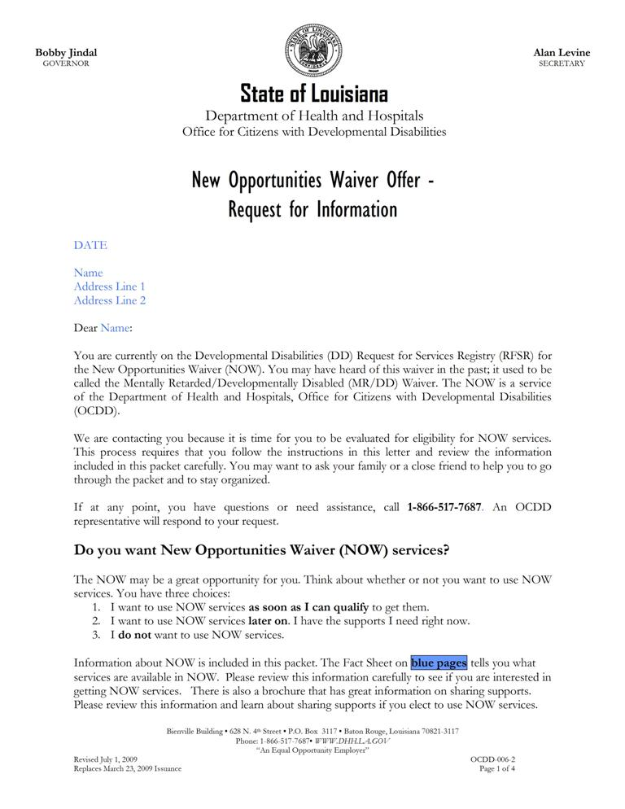
Attachment 2.8.1 New Opportunities Waiver Offer- Request for Information

Attachment 2.8.1 New Opportunities Waiver Offer- Request for Information
Attachment 2.8.1 New Opportunities Waiver Offer- Request for Information
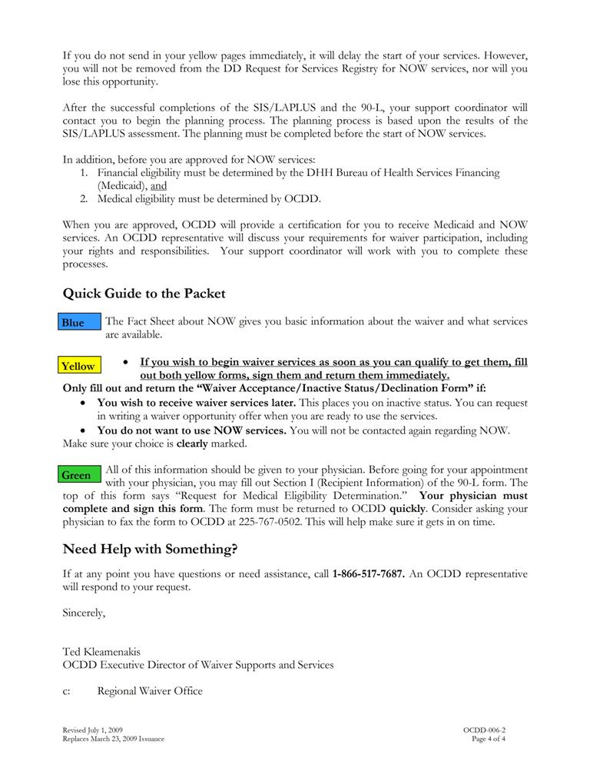
Attachment 2.8.2 Waiver Acceptance/Denial/Inactive Status Form

Attachment 2.8.3 Request for Medical Eligibility Determination - BHSF Form 90-L
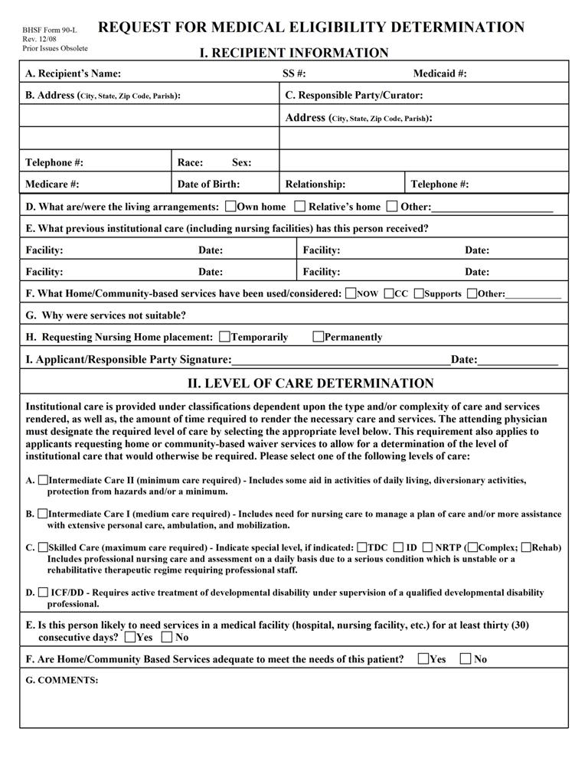
Attachment 2.8.3 Request for Medical Eligibility Determination - BHSF Form 90-L
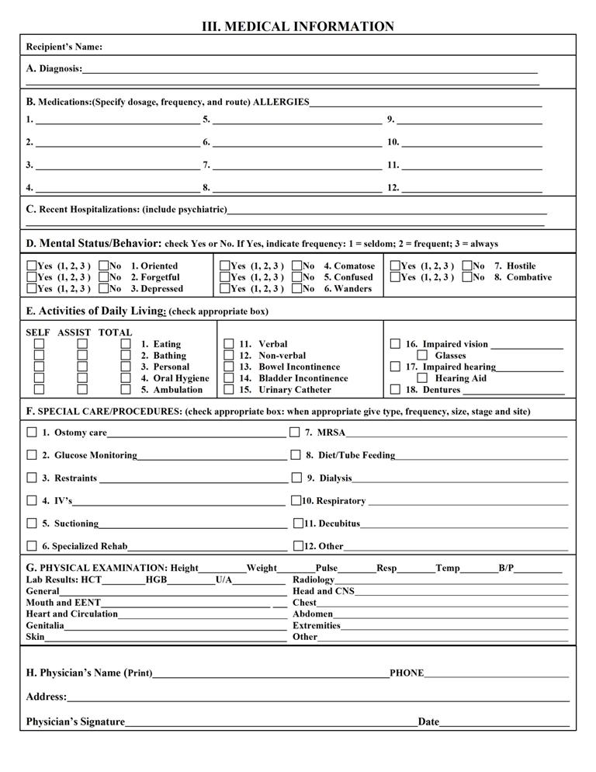
Attachment 2.8.4 Support Coordination Choice and Release of Information Form (Example from OCDD Region 1)
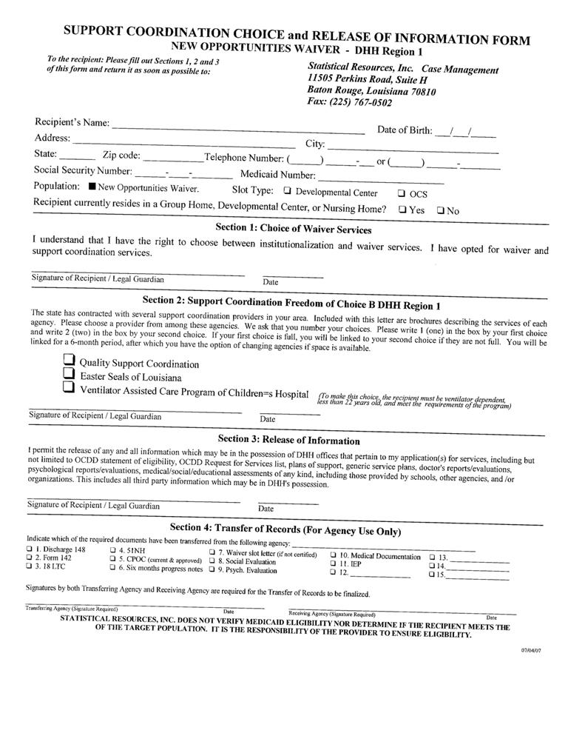
Attachment 2.8.5 Request for Medical Eligibility Determination - BHSF Form 90-L: Physician Letter and Instructions
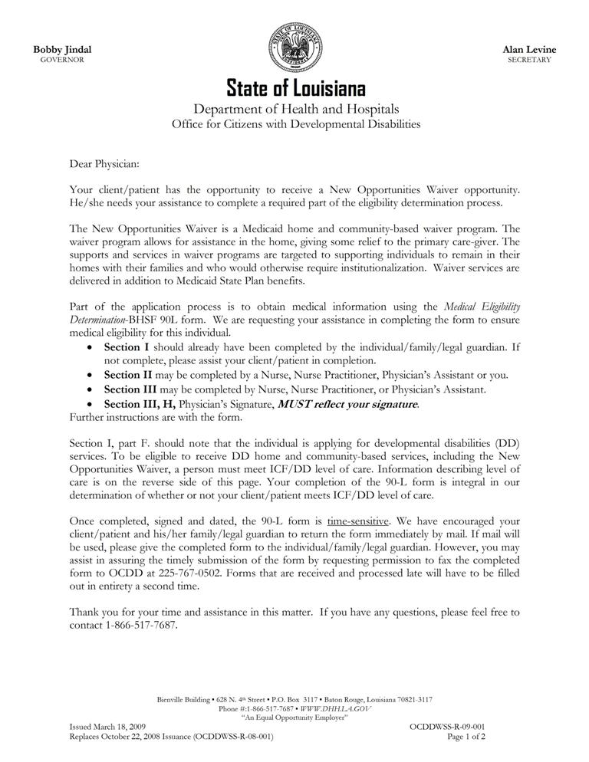
Attachment 2.8.5 Request for Medical Eligibility Determination BHSF Form 90-L: Physician Letter and Instructions
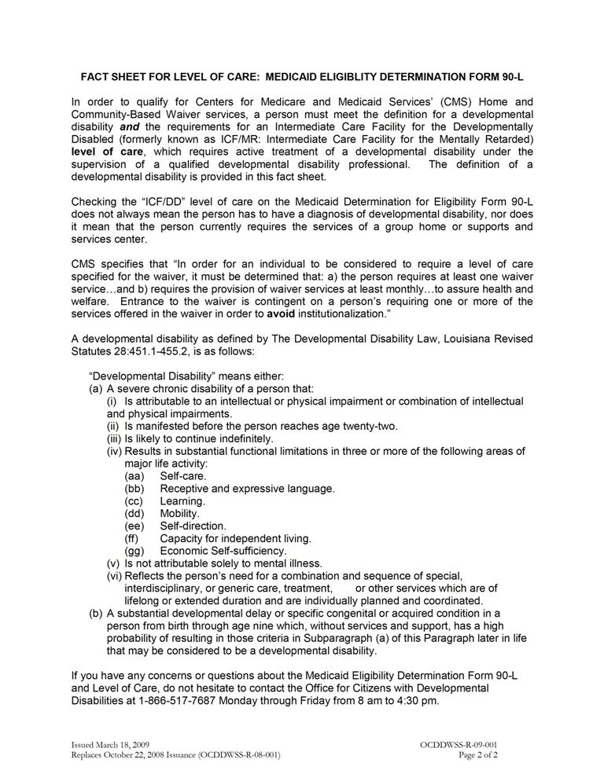
Attachment 2.8.6 Process for Request for Removal from Inactive Status
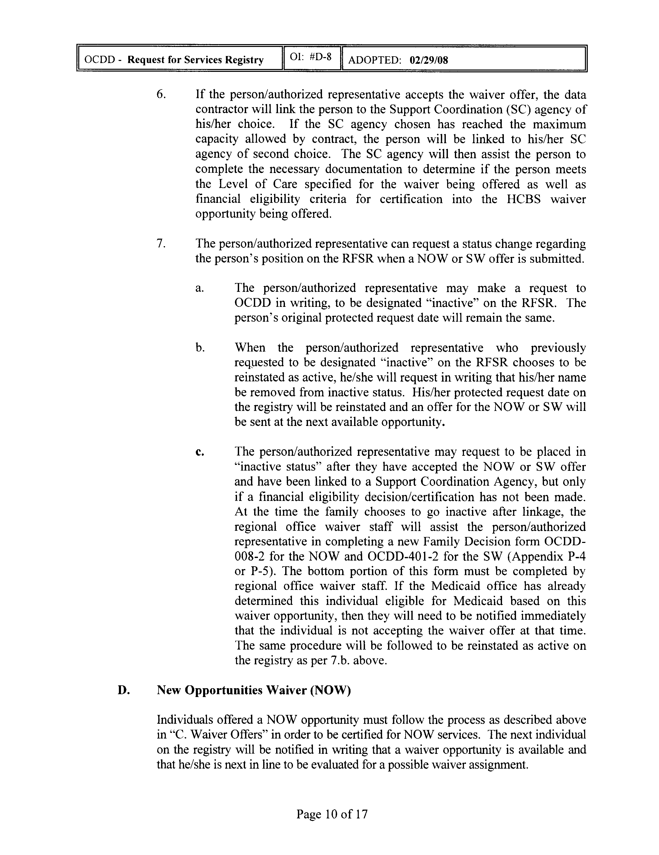
Office for Citizens with Developmental Disabilities OI #D-8, Request for Services Registry. Adopted 2/29/08. Section II.C.7., page 10:

Attachment 2.8.7 Key: Supports Intensity Scale (SIS) Rating Guide

Supports Intensity Scale (SIS) Rating Guide

Important to/for:
For each item one of the ratings below will be chosen
T= important to the person (activities that are particular preferred activities or interests of the person; things that the person really wants in his or her life)
F= important for the person (activities or support areas that must be addressed for the person's health and safety in a way that is more necessary than would be typical for most people)
N= neither important to or for the person

Type of Support:
For each item you will be asked to rate what kind of support is needed for the activity
0= no support needed (person is able to do this independently)
1= monitoring is needed from another person for this activity (person can do the activity but someone must be present)
2= verbal prompts or gestures are needed to guide the person
3= partial physical assistance is needed
4= full physical assistance is needed

Frequency:
For each item you will be asked to rate how often support is needed (if no support is needed this rating will be 0)
0= support for the activity is not needed or it happens less than once a month
1= support for the activity happens at least once a month but less than once a week
2= support for the activity happens at least once a week but less than once a day
3= support for the activity happens at least once a day but less than once an hour
4= support for the activity happens once an hour or more

Daily Support Time:
For each items you will be asked to rate how much time support is needed on a typical, day the person needs support for the activity (if no support is needed this rating will be 0)
0= no support time is needed
1= less than 30 minutes
2= 30 minutes to less than 2 hours
3= 2 hours to less than 4 hours
4= 4 hours or more

Important things to know about the assessment:
- The rating keys above help you respond to the questions. They will not take the place of the decisions the person completing the assessment must make about the final rating.
- The assessor has training on the definitions of each item. Many items cover several smaller tasks and the assessment training and manual give rules for how the total rating is made.
- There may be different ratings from you and from different people who support or know you. The assessor's job is to ask questions and look at what they see as well. All of this information helps them to decide what rating is correct. The assessor should be able to tell you why an item has a rating if it does not seem correct to you.
- If the assessor cannot tell the correct rating after they get all the information, then the rating should be the higher rating ( for example, if it is hard to tell if partial or full physical support is needed, then full physical support should be rated).

3

Completing Discovery Activities for

the Support Plan

3.1 Beginning Discovery Using the SIS/LA PLUS for Planning
3.2 Completing Discovery (Using the Personal Outcomes Interview/Mapping/Discovery Meeting)
3.3 Developing a Personal Vision and Goals
3.4 Establishing the Support Team
3.5 Meeting Preparation
3.6 Attachments
3.6.1 Personal Outcomes Worksheets - Support Plan Format

COMPLETING DISCOVERY ACTIVITIES FOR THE SUPPORT PLAN

Prior to planning for supports and service needs, information is gathered about the participant.
The support coordinator is responsible for completing Discovery activities prior to the planning meeting. The purpose of Discovery is to identify those things that matter most to the participant and to identify his/her support needs.
Discovery activities include:
- A review of all records relevant to the participant’s interest and needs for support (i.e., school, previous assessments, and medical records),
- Completion and/or review of the SIS LAPLUS to determine interest and support needs in a variety of life areas,
- Completion of needed interviews, observations, and professional assessments (i.e., OT, PT, Speech), and
- Completion with the participant/guardian of a Personal Outcomes Assessment and Discovery Meeting ( Attachment 3.6.1 ) using a variety of person-focused planning methods to determine the participants’ life vision, goals, preference, interests, and challenges.
Discovery Activities are completed prior to the planning meeting.
Planning activities beyond Discovery require the assistance of a support team led by the support coordinator.
As Discovery activities progress, the support coordinator also works with the participant/guardian to establish his/her support team.
Attachment 4.4.1 contains details of timelines for initial support planning, including timelines for activities in the Discovery phase.
3.1 BEGINNING DISCOVERY USING THE SIS/LA PLUS FOR PLANNING
A. The SIS/LA PLUS assessments inform both the planning process and the recommended IFS hours.
B. The SIS/LA PLUS is completed no more than 90 days prior to the initial plan. Prior to the annual planning, it is completed at least every 2 years or in the event that the person experiences significant life changes. See item F below if assessment is older than 90 days.
C. Support coordinators use the SIS/LA PLUS assessment data from the most recent assessment for input into the planning process and into the support plan in at least five ways.
- Demographic information – The demographic information on the SIS/LA PLUS provides input to the demographics page of the support plan including:
- Primary and secondary diagnoses,
- Mobility,
- Need for 24-hour service,
- Living situation, and
- Matching the participant’s assessed needs, or appropriate referrals as a component of the plan.
- Important Things to Know about the Individual – The SIS/LA PLUS provides information in the following areas:
- Where and with whom the person lives,
- Current and needed home modifications,
- Importance of work to the participant,
- Favorite activities, and
- Important “to” activities reflected on the SIS/LA PLUS for home life, community life, social life, education and work.
- Medical and Mental Health Concerns – Information in the support plan regarding the participant’s medical status and conditions reflects the SIS/LA PLUS assessment of needs in the following areas:
- Mobility, nutrition and communication,
- Diagnoses,
- Practitioner/doctor visits,
- Psychiatric/behavior concerns,
- Behavior support plan (Check yes if the score is 5 or greater on Part E, Positive Behavior Supports of the LA PLUS. A behavior support plan is required if the Part E Positive Behavior Supports on the LA PLUS score is 5 or greater. A behavior plan is required if the participant is a member of level 4 or level 6, unless determined otherwise by the GPSORC), and
- Possible risk factors for the participant.
- Medications and Treatments – Medications and treatments are consistent with the SIS/LA PLUS assessment of health unless documentation of needed changes since the SIS/LA PLUS appear in the support plan including:
- Dose,
- Frequency, and
- Method of administration.
- Support Type and Frequency - Identified services and supports in the support plan are consistent with the SIS/LA PLUS.
- The IFS hours used in the support plan are within those recommended by the Louisiana Resource Allocation System unless additional IFS hours above those suggested for the assigned level are requested and approved. (See Section 5.7-5.9 and Section 7.3.)
D. Once the SIS/LA PLUS is completed/reviewed and information is included within the support plan, the support coordinator also reviews any other information or assessments available and places that information into the plan format as well.
- If additional assessments are deemed necessary based upon the SIS/LA PLUS assessment or other information, attempts are made to acquire these assessments. If they cannot be completed prior to the planning meeting, part of the plan includes timeframes for completion. Depending on the results of these assessments, additional meetings and/or services may be needed.
- If the SIS/LA PLUS assessment completed for the initial plan is greater than 90 days old or annual planning is occurring between SIS/LA PLUS assessment intervals at the time of planning, the support coordinator must make a determination as to whether the assessment information is still current, or if the participant’s support needs have changed. This determination is required before moving forward with planning using the SIS/ LA PLUS. If significant changes in support needs have occurred, a new SIS/LA PLUS assessment must be completed.
      - To determine whether the assessment information is current for initial planning with assessments greater than 90 days old:
- Contact by phone the individual and family/guardian/staff who were the original respondents. Discuss key support items in the assessment. For example, ask if the participant still requires full physical support with home living activities, if the person still needs support for certain medical and/or behavioral conditions/concerns, if the person requires nighttime supports.
- If original respondents are unable to participate or cannot provide updated information, then the support coordinator must contact person(s) who know the participant well (e.g., having known and observed the participant in various settings for at least 3 months).
  - Based upon the conversation, the support coordinator must determine if support needs remain consistent with the SIS/LA PLUS assessment or if support needs have changed.
  - For annual planning between SIS/LA PLUS intervals, discussions about support need changes should occur during Discovery and planning activities.
  - If support needs have not changed and remain consistent with the SIS/LA PLUS assessment:
- The support coordinator may proceed with planning using the existing SIS/ LA PLUS assessment.
- Section II. General Health Profile, Part A. Health Status section of the support plan must include the following documentation:
    - When the contact took place
    - Who was contacted
    - The statement: “While the assessments are over 90 days, recent follow-up contact has found no significant support needs changes since the original contact and assessment.”
  - If support needs have changed since the SIS/ LA PLUS assessment, the support coordinator (or a certified assessor) must re-administer the assessments per protocol.
  - Following completion of the reassessment, the support coordinator will notify the ROS via email.
        - Subject Line: Updated SIS/ LA PLUS due to Prior Assessment Expiration
        - Message Attachment: completed updated assessment
        - Message Content: Explanation that reassessment occurred due to original assessment being older than 90 days or in between assessment intervals and follow-up contact determining that support needs have changed, requiring reassessment.
  - The ROS will complete procedures discussed in Section 2.7.
  - After completion of these activities, the support coordinator may then use the SIS/ LA PLUS as described in this section (3.1) as a current assessment for planning.

3.2 COMPLETING DISCOVERY (USING THE PERSONAL OUTCOMES INTERVIEW/MAPPING /DISCOVERY MEETING)
A. Discovering information about who the participant is and what is most important to him or her is central to person-centered planning and is a critical component of OCDD’s planning process.
B. There are numerous methods for completing Discovery including use of a Personal Outcomes Interview (See Attachment 3.6.1.), Mapping, or a Discovery Meeting. The support coordinator may use any method based on the preferences of the participant and skills and training of the support coordinator.
C. The Discovery process provides information that assists the participant in determining what is most important to him or her in each life area, establishing his or her life vision, and setting personal goals.
D. Over time, the Discovery process provides reference points as goals are achieved and replaced by new personal goals.
E. Discovery occurs 90 days prior to the initial plan and before the annual review. Discovery must be completed at least two weeks prior to the planning meeting. This will allow the support coordinator to process the Discovery information, input the information into the support plan format, and distribute the information one week prior to the planning meeting (as described in Section 9.5.E.). (Note: Initial assessment for any new participant must begin within seven (7) calendar days of linkage.)
- OCDD recommends that the Personal Outcomes Interview be completed at the ten (10) day face-to-face meeting post linkage for new waiver participants.
2. For participants in plan renewal, the Personal Outcomes information should be updated as needed during each quarterly review. The Personal Outcomes Worksheets must be completed and verified as accurate within 90 days prior to the expiration of the participant’s support plan.
F. A focused support plan depends on understanding the following about each participant:
  - Priorities,
  - Perspectives, and
  - Preferences.

G. There should be recognition that everything a participant may want is not practical or achievable. The support team helps the participant in sorting through personal goals to focus on the highest priority outcomes.
H. It is the support coordinator’s role to ensure that alternative strategies for achieving personal outcomes are reviewed and understood during the planning process.
I. Discovery is a fluid process. The support coordinator interacts with the participant and gathers information from the participant and those who know him/her best. Ideally, the support coordinator interacts and observes the participant across situations:
- At home,
- At work (with the approval of the employer),
- With family and friends, and
- With all support staff.
J. Information gathered from those who know the participant focuses on the participant’s perspective (not their own opinions) and clarifies information obtained directly from the participant. Research shows that family members, providers and friends do not always share the same perspective as participants on the care and supports they receive.
K. When the participant has difficulty communicating, the Personal Outcomes Interview is more challenging and requires that the support coordinator spend additional time with the person recognizing that everyone communicates in some manner.
1. The support coordinator uses observations of the participant in multiple situations and from multiple secondary sources, as well as asks for specific events that provide examples relevant to the participant’s personal priorities.
L. For participants already receiving services, the provider(s) is involved as appropriate for each participant’s situation. Issues to consider in determining the need/benefit of including others in these Discovery activities include:
- The participant’s preference for who assists in providing information,
- The participant’s ability to communicate his/her interests and desires independently, and
- The amount of support the participant needs and receives from others.
M. For annual planning purposes, the support coordinator uses the third quarterly review to complete Discovery activities in preparation for the annual planning meeting.
N. For an annual plan of care, the participant and his/her authorized representative are responsible for obtaining a completed 90-L from his/her primary care physician within 90 days before the annual plan of care start date.
1. The support coordinator reminds the participant and family of this requirement and assists the participant and family to obtain the completed 90-L as needed.
2. When there is a Supervised Living provider, this provider is responsible for assisting participants to obtain a completed 90-L on an annual basis.
- If during Discovery, the support coordinator or support coordinator supervisor discovers a significant oversight or error in SIS/LA PLUS ratings for a current assessment, the support coordinator should send a written request with the plan submission indicating a request to alter the relevant ratings. If the assessment is greater than 90 days old for an initial plan or from a previous year, then the procedures in Section 3.1 should be followed.
- The written request should include specific and compelling justification for the request to alter assessment ratings based on the additional information the support coordinator obtained during Discovery.
- The request should reference exactly which items/ratings the support coordinator is requesting be altered.
- The request should reference the source of the additional information suggesting the rating(s) should be altered.
- Examples of when alterations might be requested include:
  - Failure to note in SIS section 3A a medical support issue, and there is clear evidence that this support need exists and should have resulted in different ratings.

- Example 1: During SIS assessment, it was not reported that the person has diabetes. The medical diagnosis was discovered in reviewing medical records, and it was noted that in addition to being on medication, the person is on a special diabetic diet and that support is required for such.
- Example 2: During SIS assessment, the assessor was not made aware that the person has occasional asthma attacks. It is later reported during Discovery that the person requires inhaler treatments from time to time, and staff must closely observe for asthma symptoms during the winter months, particularly when he goes outdoors into the cold or when he exercises in the cold. The parent recalls an incident last year when failure to do this led to an attack.
  - Failure to note in SIS section 3B a behavioral support issue, and there is clear evidence that this support need exists and should have resulted in different ratings.
- Example 1: During SIS assessment, it was not reported that the person has mental health treatment support needs. During Discovery, the support coordinator discovers that the person has had two previous psychiatric hospitalizations and currently receives ongoing preventative environmental or therapeutic supports to minimize recurrence of psychiatric symptoms.
- Example 2: During SIS assessment, it was not reported that a person has, in the past, engaged in episodes of stealing from various stores. It is later reported by the family that, while there have been no episodes of stealing in the past year, it is because they never take their son to stores; thus, he has not had the opportunity to steal.
- After the written request has been submitted, Regional Waiver Office staff completing the review will:
  - Request the Support Coordinator submit a revised assessment
  - Request additional justification for the alteration of ratings, or
  - Instruct the Support Coordinator that the new information does not warrant revising the assessment.
- If the Regional Waiver Office requests the assessment be revised, revision should be submitted to the ROS within 3 working days of the request.
3.3 DEVELOPING A PERSONAL VISION AND GOALS
A. The plan is derived from a statement of the participant’s personal vision and goals.
B. Vision is defined as “How does the person see his/her life in the next 3-5 years?” Not all participants are able to state their vision, and the support coordinator infers the vision from the information gathered. The vision sets the tone for the entire process and considers the following:
- Where the person will be living,
- What the person will be doing (work as well as fun stuff or community life), and
- Who will be in the person’s life.
C. The goals are what the person wants to do within the next year to help him/her reach his/her vision. The goals are identified with the person and/or others that know him or her best. These are identified at the same time that the vision is determined. Examples of personal goals include:
- Getting a specific job,
- Taking a vacation, and
- Joining a club.
(Note: Obtaining or maintaining supports under NOW are not appropriate personal goals.)
D. The process of developing a vision and goals takes into account the complex nature and multiple needs and roles of ALL persons. ALL participants have multidimensional lives with themes that are important to them in multiple life areas.
E. For some participants, it is more difficult to determine a vision and goals because the participant may be limited in how he/she is able to communicate them. In these instances, the support coordinator relies on people who know the person best to assist in determining what the person enjoys and does not enjoy. People who know the person best may assist in determining a possible vision and goals. Some examples are noted below.

- A participant may appear to really enjoy being around people and interacting with others. Based upon this information, the team may determine that he/she would like to meet new people and make more friends.
- A participant may respond positively to various types of sporting activities. Based upon this information, the team might determine that the participant would like to join/access a local sports gym or group.
- A participant continues to leave his/her job site. Based upon this information, the team might determine that he/she would like to find another job. They may then use information about things he/she likes to determine possible job interests.

3.4 ESTABLISHING THE SUPPORT TEAM
A. The support coordinator facilitates the development of the participant’s support plan with the participant and his/her support team.
B. The objective of the planning process is finding and acquiring supports that have real potential to put positive outcomes in the person’s life based upon his/her vision and goals.
C. The primary team member is the participant.
D. The support coordinator reviews the support team membership with the participant during the Discovery process and assists the person in identifying his/her support team and who should be in attendance at the planning meeting.
E. The support coordinator assures that the person understands the role of the support team to ensure that they choose those people needed.
F. Required team members include a direct service provider representative able to make decisions about provider services along with a direct support staff member, if possible, and the participant’s legal guardian, if applicable.
      - If the participant receives day program services, a representative from his/her vocational/day program provider is included.
G. The support coordinator assists the participant/guardian in locating a provider if the participant does not yet have one (i.e., initial planning process or change in provider is needed).
H. Team members may also include family or friends, professionals providing supports, facility treatment team representatives (if person is moving from a facility), and any other person who knows the participant best.
I. Each member of the support team has specific roles and responsibilities to assist the participant in achieving his/her vision and goals.
1. The role of the participant (and family) includes:
- Participate in interviews, etc. during the Discovery process to provide information regarding his/her (the participant’s) wants and needs,
- Advocate for himself/herself in the planning process,
- Attend the planning meeting(s) and participate in the plan development,

- Be accountable for cooperation with agreed upon plan and agreed upon responsibilities within the plan,
- Acknowledge his or her rights and responsibilities in the planning and receipt of service,
- Verify any interdiction or guardianship with documentation if applicable,
- Attend meetings to review the plan including providing ongoing updates to vision and goals, and
- Comment on satisfaction with services.
2. The role of the support coordinator in the planning process includes:
- Assess support needs,
- Coordinate the planning process,
- Facilitate the planning meeting and plan development including a draft of the plan in the required format,
- Assure development of the full array of support needed to assist the participant,
- Monitor delivery of services,
- Complete monthly contacts and quarterly reviews,
- Revise the plan as needed, and
- Provide information to other team members as needed throughout the process.
3. The role of the provider participant(s) includes:
- Participate in interviews, etc. during the Discovery process to provide information regarding the participant’s wants and needs,
- Attend the planning meeting(s) and participate in the plan development,
- Assure staff are trained to adequately implement the plan,
- Implement the plan,
- Complete documentation as per agreement in the plan (i.e., action steps and sustained supports, critical incident reporting, major life changes),
- (For supervisory staff) Review plan and implementation at least quarterly and complete documentation as required for the support setting (Supervisory staff review includes monitoring of plan implementation and direct support staff documentation.),
- Serve as note takers during the meeting if requested,
- Submit a provider service plan and emergency/evacuation plan, and
- Complete standardized documentation and interviews of direct support staff prior to annual planning.
4. The role of other team members depends on the member, but can include:
  - Participate in interviews, etc. during the Discovery process to provide information regarding the participant’s wants and needs as needed for a particular program,
  - Attend the planning meeting(s) and participate in the plan development as available or as specified in the next section of this document,
  - Communicate with participant and support coordinator as needed throughout plan implementation,
  - Deliver and document services as specified in the plan, and
  - Attend review meetings.
3.5 MEETING PREPARATION
A. All team members are invited to the planning meeting. At a minimum, the participant/guardian, support coordinator, direct service provider representative and vocational/day program provider representative (if the participant receives these services) must be present.
B. If another support team member other than a required team member is unavailable to attend the meeting and has crucial information for the planning process, the plan coordinator completes the following activities:
- Contacts that person prior to the meeting - The support coordinator assures that the recommendations from that member are clear and can be conveyed during the meeting. Discussions with the direct support staff when the participant receives such supports are required.
- Offers participation by phone - The support coordinator invites participation during the meeting by phone or inquires about availability by phone should questions arise during the planning meeting.
- Provides further follow-up after the meeting - The support coordinator contacts the other members as needed after the meeting to assure agreement with the resulting plan or to answer any unexpected questions from the meeting.
C. The support coordinator supports the person to accomplish the following:
- Choose in consultation with core team members the date, time and place for the planning meeting;
- Make arrangements for a location of the person’s choice (Note: This is usually the person’s home. Restaurants are not usually the best place to have a meeting due to the privacy issue and needing space on the walls for flip chart paper.); and
- Decide how the person will present his/her vision, which could be done in a number of ways including, but not limited to the following:
- Slide show,
- Video,
- Posters,
- Photo albums,
- Verbal presentations,
- Written information, and
- Graphics.
D. The support coordinator completes the following prior to the planning meeting:
- Assists the participant in contacting in writing and/or by phone his/her family members and provider staff to schedule the planning meeting (The support coordinator provides written notice to plan participants 30 days prior to the meeting. The support coordinator makes phone contact reminding members of the meeting two weeks prior to the meeting and documents contacts in a progress note); and
- Develops the agenda to address the person’s support needs, natural and formal, which ensures that the meeting results in a single comprehensive support plan.
- The support coordinator shares information with support team members one week prior to the meeting by email or fax by circulating to the support team a rough draft of the support plan document that includes key information from Discovery, the Personal Outcomes Assessment, and results of the SIS/ LA PLUS. The SIS in its entirety is not sent to team members. It is important that support team members have all of the information that has been gathered, along with the vision and outcomes which have been identified by the person, available to them in the plan format for review before the meeting. This allows time for the team to prepare for the meeting, including bringing any concerns and proposed strategies to address these concerns to the planning meeting for optimal team discussion.
  - The support plan rough draft does not need to be written to the quality and volume of content required in the final planning document; it is a draft. However, the support coordinator must include information in all plan sections that can be filled in with Discovery information.
a. This includes information pertaining to criteria for shared supports.
        - Support coordinators are not to complete the Personal Outcomes Table (Section 5 of the CPOC) other than the person’s Vision.
  - In order to include shared supports information for roommates, the support coordinator and IFS provider must have held the roommate risk/benefit discussion prior to sending out the draft document (see Section 6.4).

  - The support coordinator is responsible for assuring that the person understands that this information will be shared.
3.6 ATTACHMENTS

Attachment 3.6.1 Personal Outcomes Worksheets - Support Plan Format
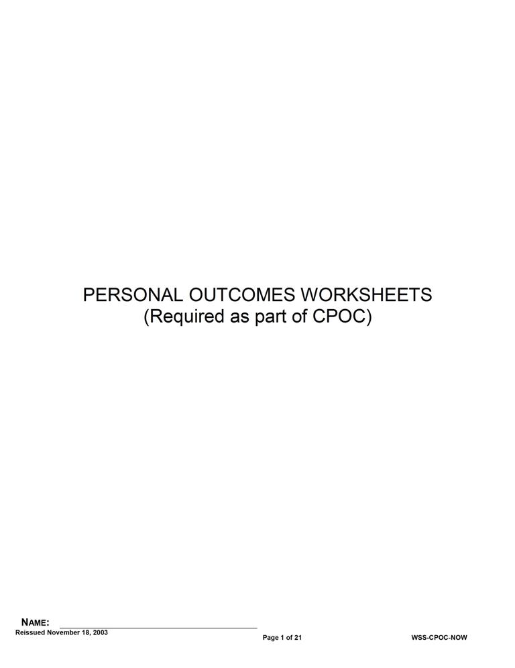
Attachment 3.6.1 Personal Outcomes Worksheets - Support Plan Format
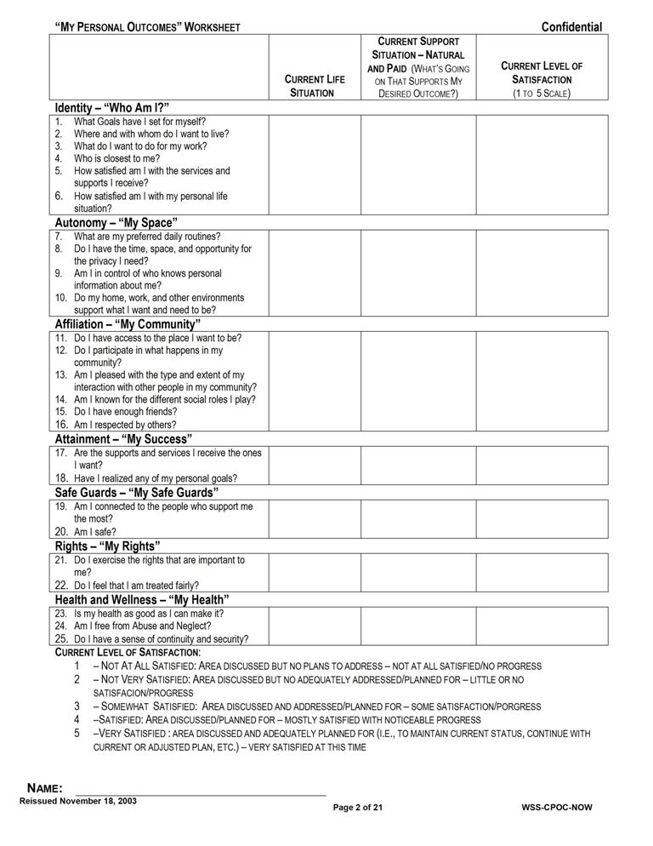

Attachment 3.6.1 Personal Outcomes Worksheets - Support Plan Format
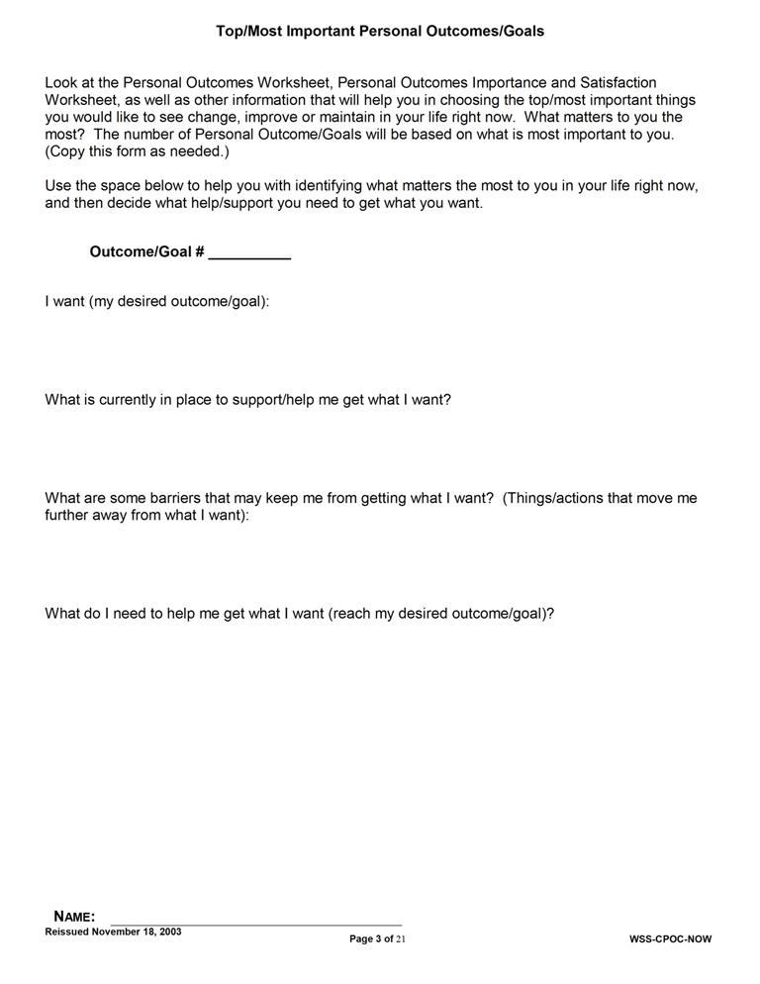
Attachment 3.6.1 Personal Outcomes Worksheets - Support Plan Format
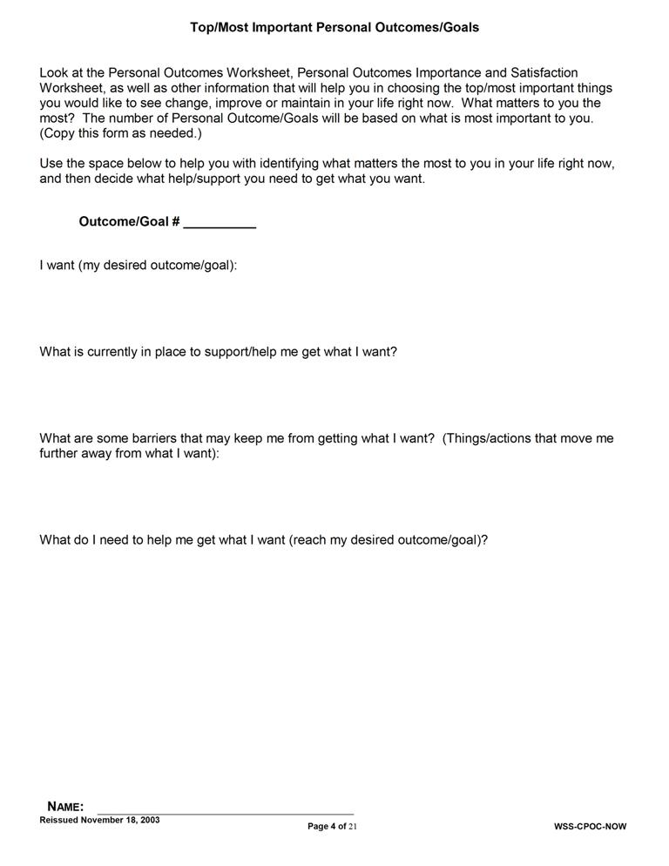
Attachment 3.6.1 Personal Outcomes Worksheets - Support Plan Format
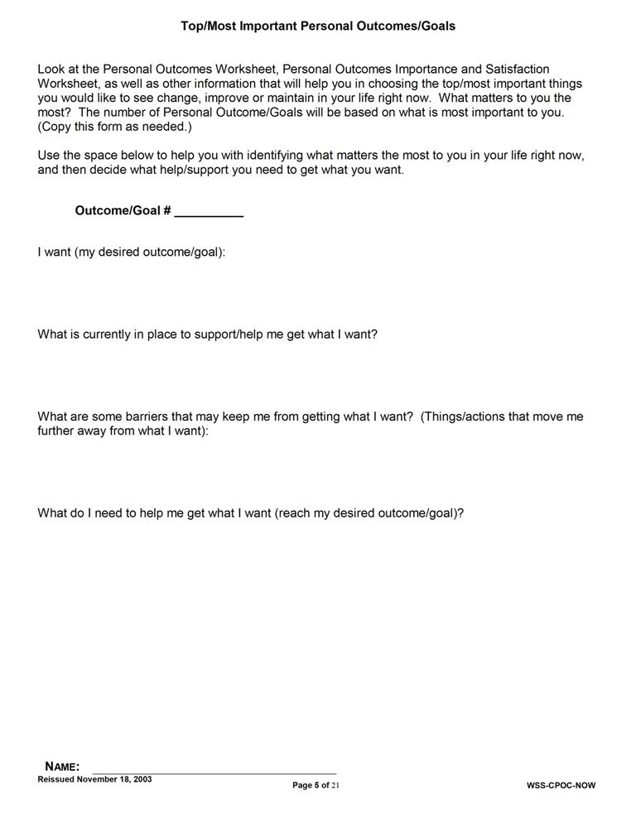
Attachment 3.6.1 Personal Outcomes Worksheets - Support Plan Format
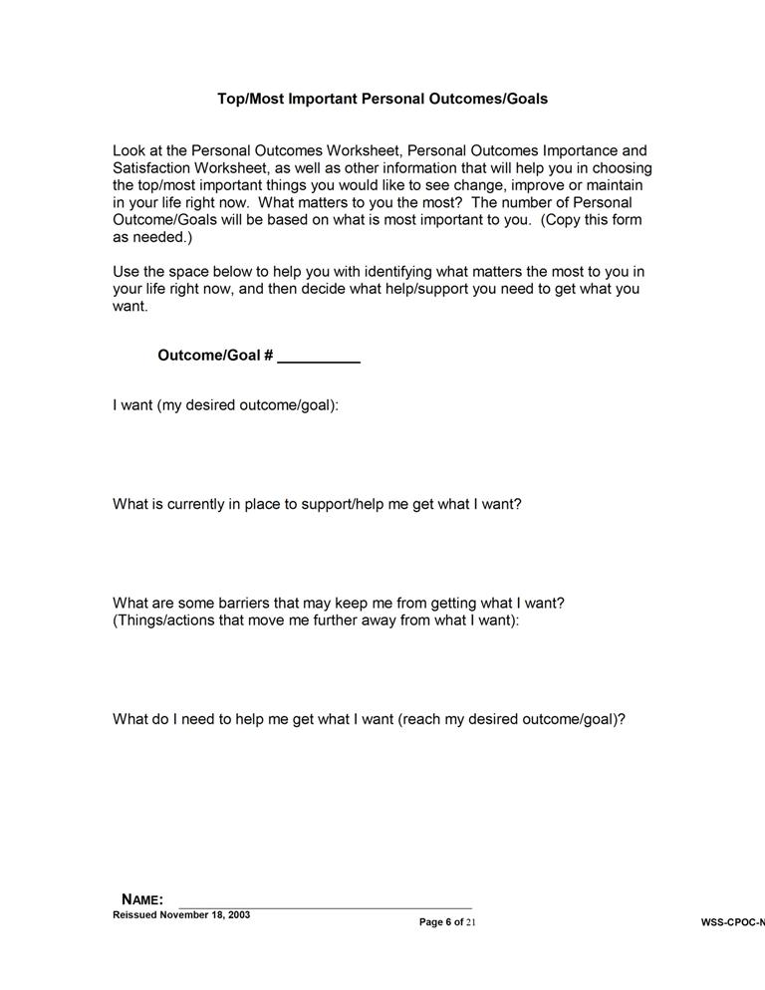

4

Developing the Participant’s Support Plan

4.1 Facilitating the Planning Meeting
4.2 Developing Plan Strategies and Actions
4.3 Using Natural and Community Supports
4.4 Attachments
4.4.1 Timelines for Initial Support Planning
4.4.2 Support Plan Format
DEVELOPING THE PARTICIPANT’S SUPPORT PLAN
After completion/review of the SIS/LA PLUS, review of any other relevant information/assessments, completion of Discovery, and definition of the vision and goals, the support coordinator schedules a planning meeting with the participant and his/her support team.
The planning meeting begins with a review of personal outcomes and goals and important information gathered from assessments.
Once there is consensus and familiarity with the participant’s desired outcomes, the support coordinator facilitates discussion to develop actions and strategies to address identified goals and support needs.
Attachment 4.4.1 contains details of timelines for initial support planning, including timeframes related to developing the participant’s support plan.
4.1 FACILITATING THE PLANNING MEETING
A. The support coordinator begins the planning meeting by assisting the participant in presenting his/her vision and goals. As noted in the previous section, the vision may be presented in any manner the participant desires. The support team then has an opportunity to ask questions and request clarification regarding the person’s vision and goals prior to beginning planning to meet the person’s vision and goals.
B. The support coordinator is responsible for facilitating discussion that encourages active participation of all support team members throughout the planning meeting.
- Some team members may be quiet and may need to be “invited” throughout the meeting to comment or contribute important information.
- Other team members may get “ahead” of the process or get stuck on a topic. When this occurs the support coordinator is responsible for bringing the team back into focus about the current topic of discussion and assist in moving forward with planning.
C. Facilitating discussion may also involve other activities that assist the team in completing the plan, including:
- Redirecting discussion based upon new information,
- Restating or summarizing information to assist the team in moving forward,
- Providing input from professionals who are unable to attend the meeting,
- Highlighting conflicting information and assisting the team in determining a course of action to address the conflict, and
- Assisting the participant in advocacy efforts regarding his/her interests and needs.
D. The support coordinator assures that the meeting ends with a full plan which includes actions and strategies related to each outcome or support need, designation of responsibility, frequency, target date for completion/review, and method for measuring progress.
4.2 DEVELOPING PLAN STRATEGIES AND ACTIONS
- For each personal outcome/goal, the support team:

- Identifies strengths that can be used to achieve personal goals:
- Strengths, skills and abilities of the participant (i.e., specific job skills that assist the participant in meeting his/her goals),
- Social and community connections of the participant and other support team members (i.e., a support team member knows the owner of a local scrapbooking store and a participant wishes to take up this hobby; family/friends who can assist with transportation), and
- Environmental positives (i.e., lives on a bus route which helps with transportation issues);
- Identifies challenges or barriers:
  - Health issues requiring treatment (i.e., diabetes, seizures),
  - Mental health and behavioral issues requiring intervention/support (i.e., depression, aggression),
  - Risk factors (i.e., person receives medication placing him or her at risk for a medical condition; person lives in a neighborhood with safety concerns),
  - Environmental barriers (i.e., person has no reliable means of transportation and lives in a rural area; mismatch between direct support provider’s available transportation and preferred frequency of person), and
  - Other participant-specific challenges.
- Develops strategies to achieve goals and overcome barriers;

- Identifies known needed treatments/medications (i.e., medication for seizures);

- Identifies assistance/support from others needed (i.e., need to assist the person in lying down and moving furniture/etc. out of the way during a seizure);

- Identifies skills the participant could learn to assist him or her (i.e., the participant may be able to learn improved eating habits to address diabetes);

- Identifies the available family/friends and other support options previously identified that can assist for each strategy;

- Where a goal/strategy or a participant’s preference involves needed transportation outside of his/her home, the support team must address the following:

- The direct support provider must meet all transportation needs for health and safety needs during the times that the provider is responsible for having staff present, or when there is no family available to provide assistance or the participant lives independently.

- The direct support provider must meet reasonable transportation needs for basic activities (i.e., provider must ensure person is able to get to the store to shop but does not have to transport the recipient to three different grocery stores each week because the recipient prefers to buy different items at different stores).

- The direct support provider must meet reasonable transportation needs to ensure the participant has opportunities to participate in a variety of social and community activities. The provider does NOT have to provide transportation to every requested event/activity regardless of frequency and location.

- When there is a mismatch between the direct support provider’s available transportation and participant’s preference, the support coordinator should facilitate team discussion of other options that might increase the ability to meet the participant’s preference, including family/friends, church groups or other organizations, shared opportunities, community/public transportation options, etc.

- The direct support provider is responsible for assisting with locating alternate transportation options where appropriate, and in conjunction with the support coordinator.

- The direct support provider may be responsible for teaching persons to access public transportation or other alternatives to increase independence and decreasing reliance on staff and/or provider transportation.

- Identifies opportunities for increased independence to achieve personal goals, including the following examples:
- Increasing independence in key daily living areas for a goal of living independently or increased privacy; and
- Learning to bank online for someone who wants to budget and acquire some preferred living situation or item.
- Personal goals, goals related to removal of identified barriers, and goals related to increasing independence (where appropriate) are entered in planning profile.

- The planning profile (Attachment 4.4.2) then allows for recording the support strategies to achieve each goal including:
- Specific actions listed in sequence,
- Who is responsible to assist/support/complete each action,
- Where the action will take place,
- What equipment/assistive devices are needed for the action to occur,
- Frequency of support,
- How each support will be measured/assessed for completion, and
- Date for completion or review of each action/support.
- The planning meeting is not concluded until all items are completed for all identified goals.
4.3 USING NATURAL AND COMMUNITY SUPPORTS
A. The use of natural and community supports is a key component of the “Guidelines for Support Planning.” Natural and community supports are represented in the support plan.
B. Natural and community supports allow the participant to accomplish the following:
- Build relationships,
- Play different social roles,
- Stabilize his/her care since there is less turnover in natural and community supports, and
- Reduce isolation and enhance integration.
C. The support coordinator, prior to utilization of paid supports, explores supports and activities available through the following:
- Family and friends,
- Neighbors, church members, support organizations, and volunteers,
- Informal and public transportation, and
- Community classes and organizations.
- The support coordinator will utilize strategies to appropriately involve a participant’s roommate who is not receiving services and is a competent major (not a dependant child) as a natural support.
    - If a participant chooses to live with a person not using OCDD services who meets the definition of a relative as defined in Section 8.5, then the participant meets criteria for the Lives with Family allocation.
    - If a participant chooses to live with a person not using OCDD services who is unrelated, then the participant meets criteria for the Lives Independently allocation.
    - With the participant’s permission, the roommate might become part of the support team and be included in the provision of appropriate unpaid natural supports hours and in evacuation and emergency plans. The support team should plan for any necessary training, as described in Section 8.2.

- The “Guidelines for Support Planning” assumes that natural supports are utilized in conjunction with paid supports.
4.4 ATTACHMENTS

Attachment 4.4.1 Timelines for Initial Support Planning
- Following linkage, the support coordinator has 3 business days to contact the participant or his/her authorized representative by phone to introduce himself/herself, explain support coordination services and the planning process, and to schedule the SIS/LA PLUS assessment and face-to-face meeting with the participant and his/her family.

- Within 10 calendar days following linkage, the support coordinator meets face-to-face with the participant and his/her authorized representative to begin discovery activities, complete the SIS/LA PLUS and other assessments, and discuss the plan for selecting providers through the Freedom of Choice (FOC) process. Within one business day of the participant’s selection of an Individual and Family Support (IFS) and day program provider, the support coordinator contacts the provider(s) by phone to inform the agency of the initial planning meeting.

- Within 30 calendar days following linkage, the support coordinator submits the approvable SIS/LA PLUS to the ROS.

- Within 10 calendar days following the receipt of the SIS/LA PLUS preliminary level, the support coordinator holds the planning meeting with the participant and his/her support team, including the participant’s family, friends, IFS provider, and day program provider.

- Within 7 calendar days following the planning meeting, the support coordinator must develop the support plan, and the provider concurrently must develop the participant’s individualized service plan, back-up plan, and emergency evacuation plan based on the consensus reached at the planning meeting.

- The support plan is then sent to the participant and the provider for review and agreement. If the person is moving from a facility (e.g., ICF/DD, nursing home, hospital), the persons representing the facility treatment team on the support team must also review and provide agreement with the support plan.

- The provider has 5 calendar days to review the support plan and return the signed support plan, participant’s service plan, back-up plan, and emergency evacuation plan to the support coordinator.

Attachment 4.4.1 Timelines for Initial Support Planning

- The support coordinator then submits the signed support plan to the support coordinator supervisor. The support coordinator supervisor has 7 calendar days to review, require any necessary revisions, and submit the approvable support plan, provider’s service plan, emergency evacuation plan, and back-up plan to the OCDD Regional Waiver Office for approval. Submission to the OCDD Regional Waiver Office for approval should occur within 60 days following linkage.

- The OCDD Regional Waiver Office is responsible for reviewing the SIS/LA PLUS and support plan, completing the pre-certification home visit, and approving the support plan within 10 business days following receipt of the approvable plan.

- Once the assessment and support plan are approved, level acuity confirmation occurs and the support coordinator forwards the approved support plan to the provider and the participant within 2 calendar days or by the next business day.

- The support coordinator then contacts the participant to assure the adequateness and appropriateness of service within 10 business days following the approval of the initial support plan.
Attachment 4.4.1 Support Plan Format
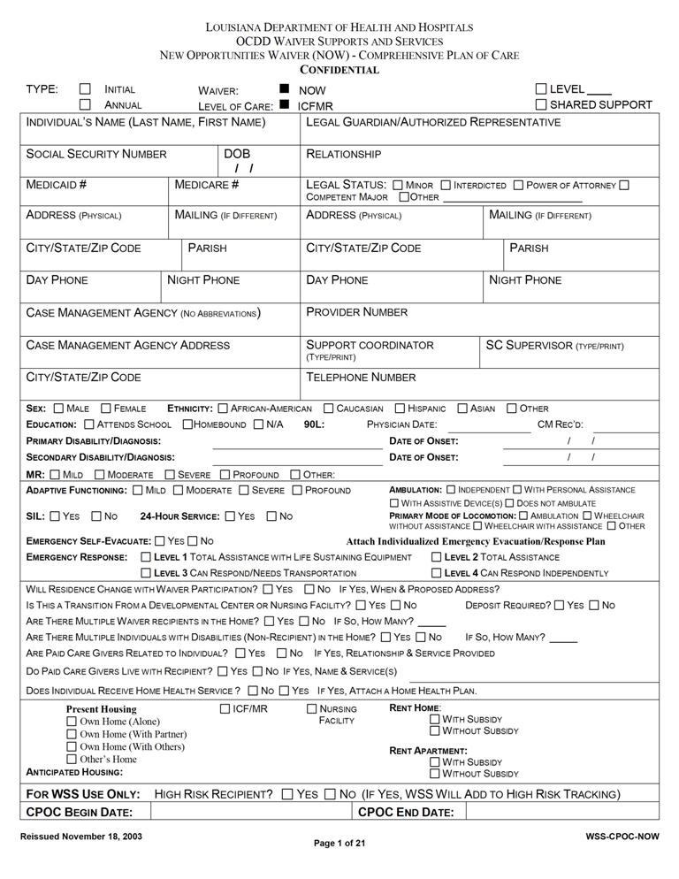
Attachment 4.4.2 Support Plan Format
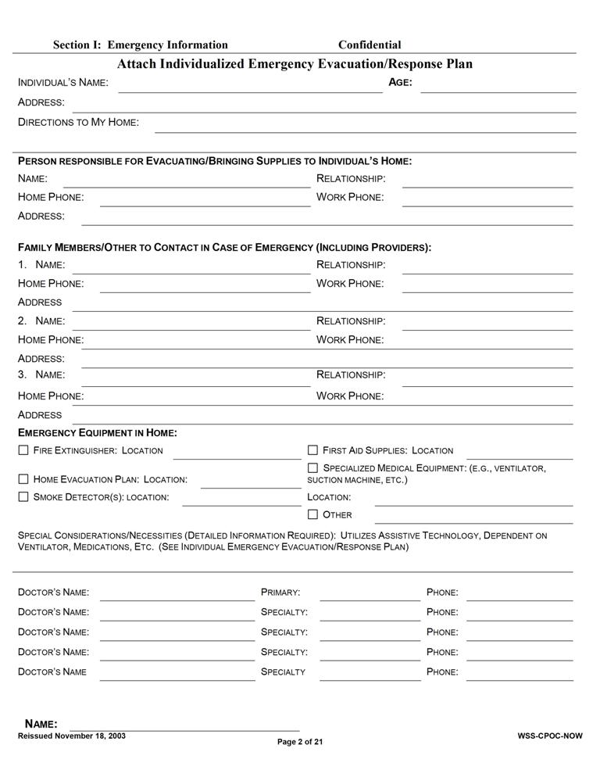

Attachment 4.4.2 Support Plan Format
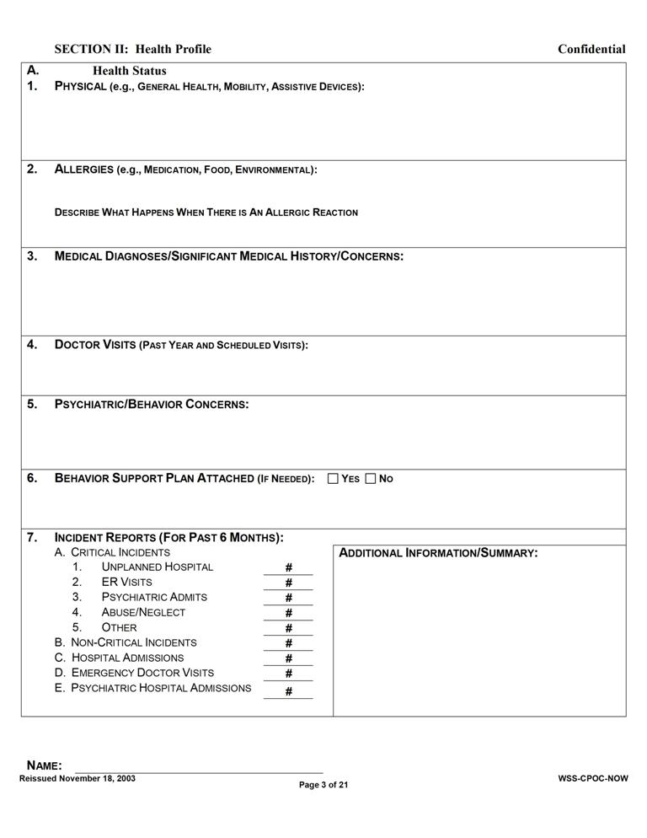

Attachment 4.4.2 Support Plan Format
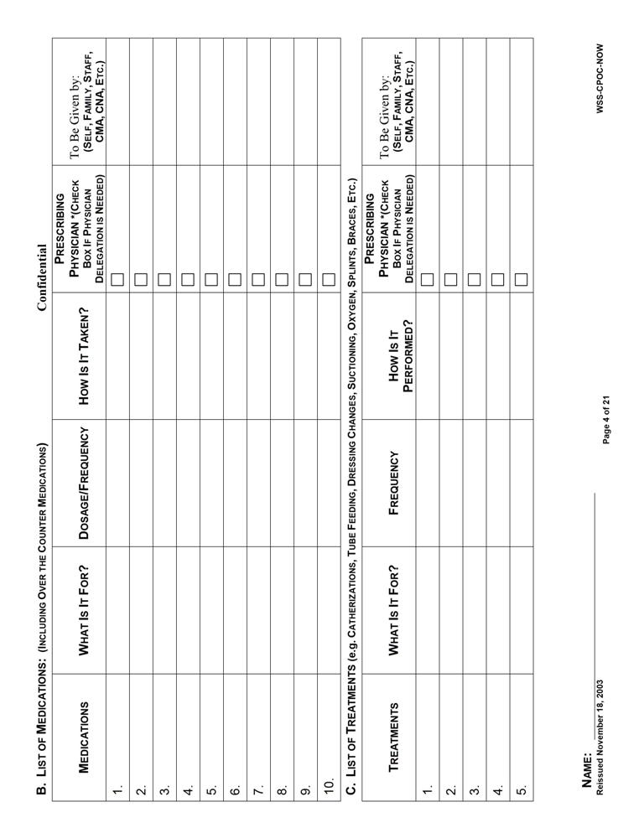
Attachment 4.4.2 Support Plan Format
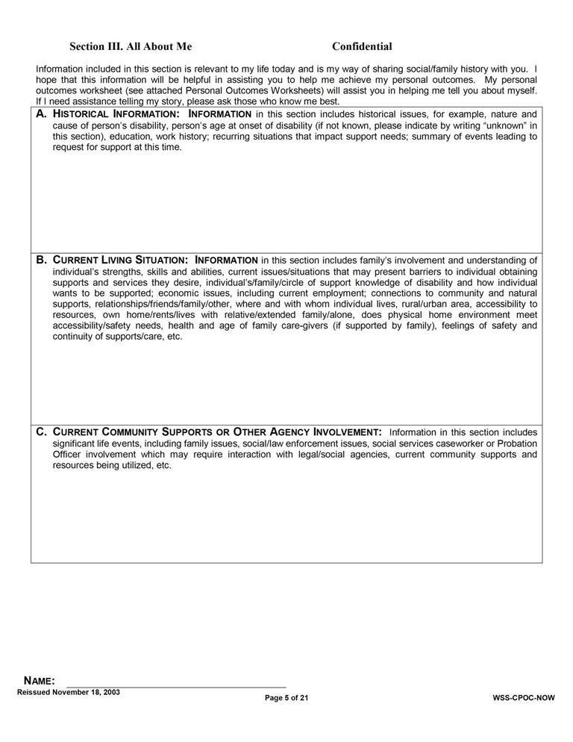
Attachment 4.4.2 Support Plan Format
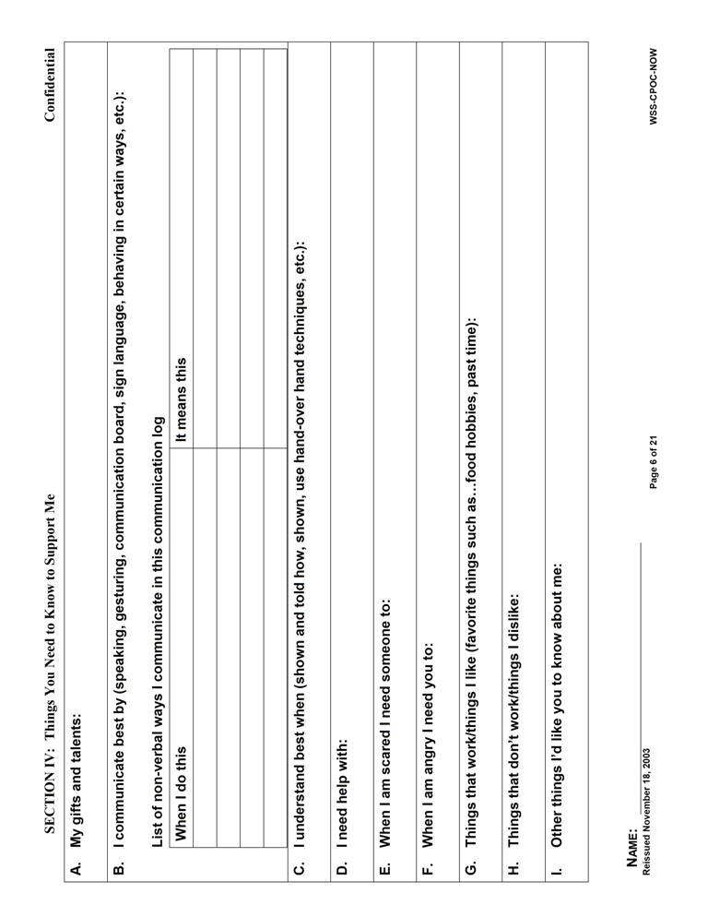
Attachment 4.4.2 Support Plan Format
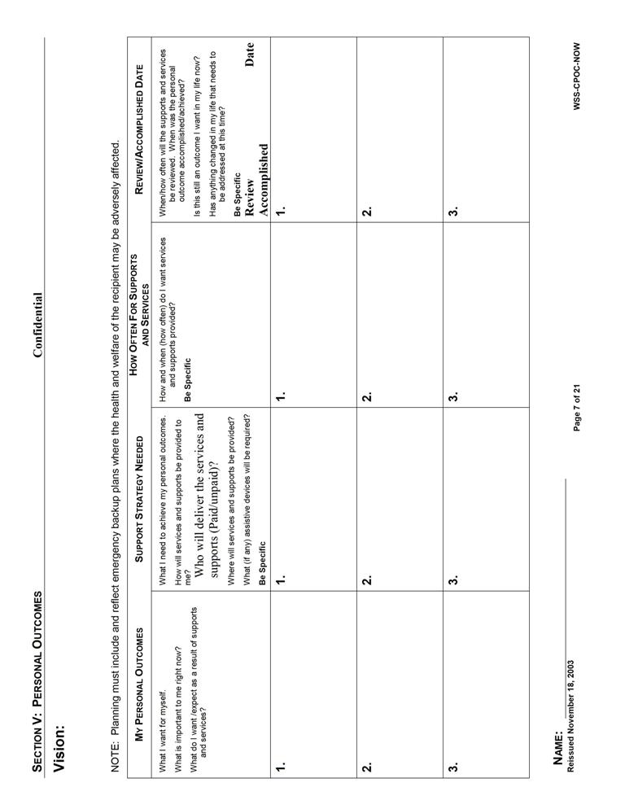

Attachment 4.4.2 Support Plan Format
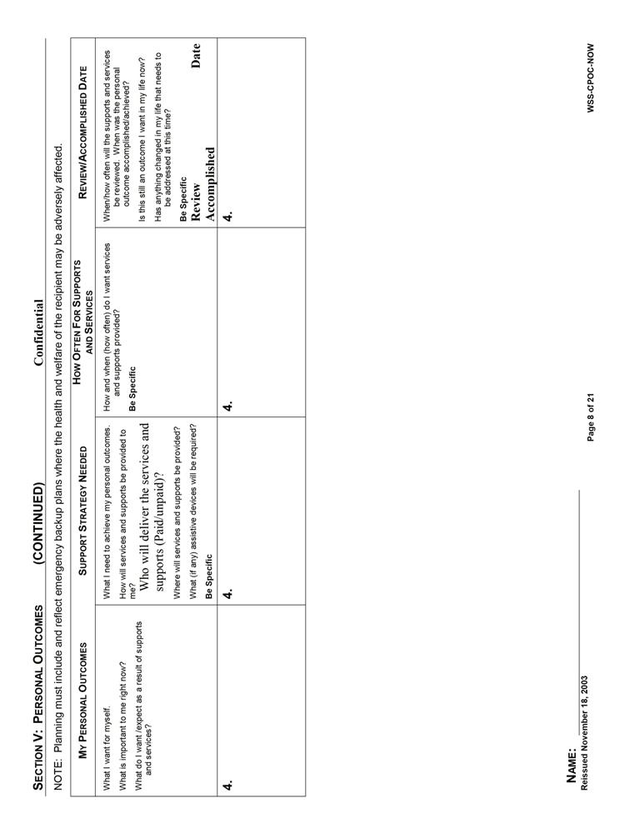

Attachment 4.4.2 Support Plan Format
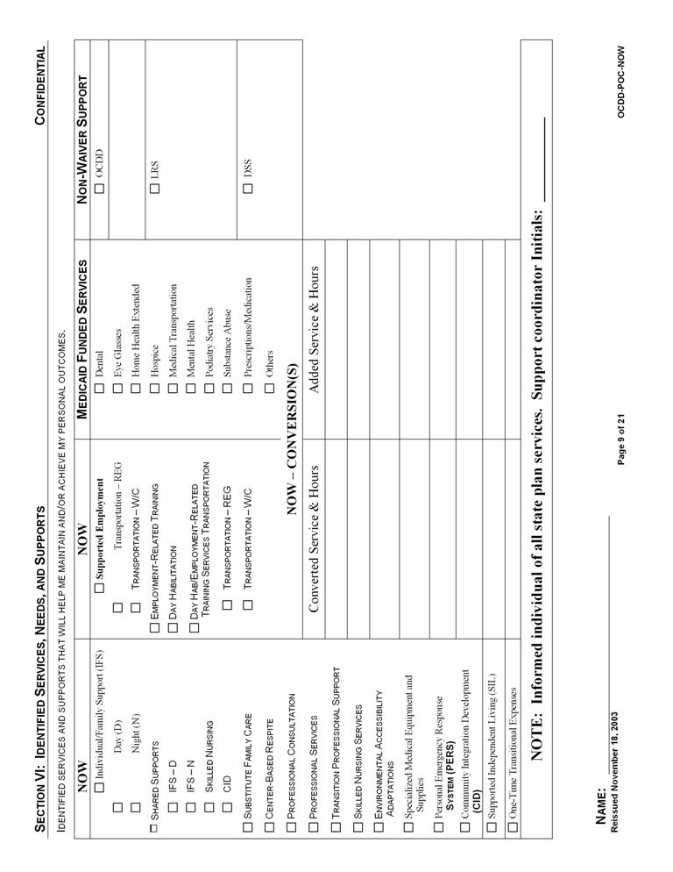

Attachment 4.4.2 Support Plan Format
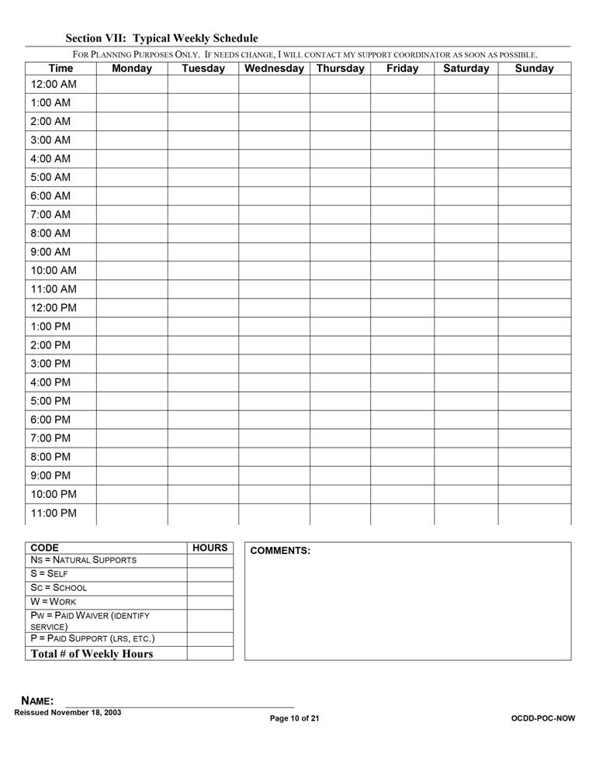
Attachment 4.4.2 Support Plan Format
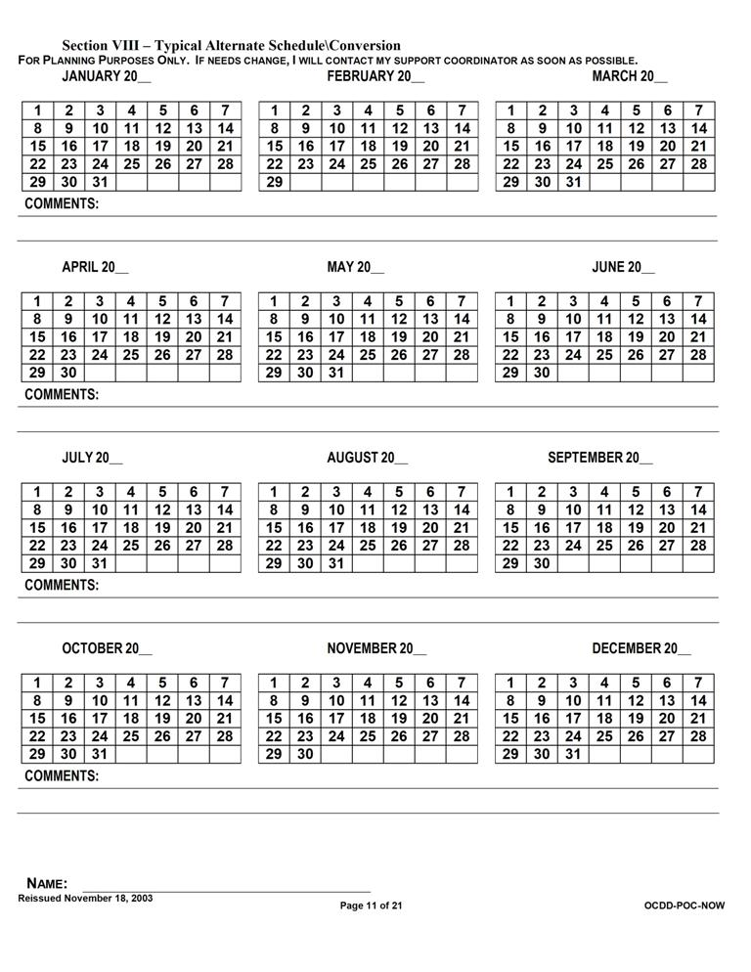
Attachment 4.4.2 Support Plan Format
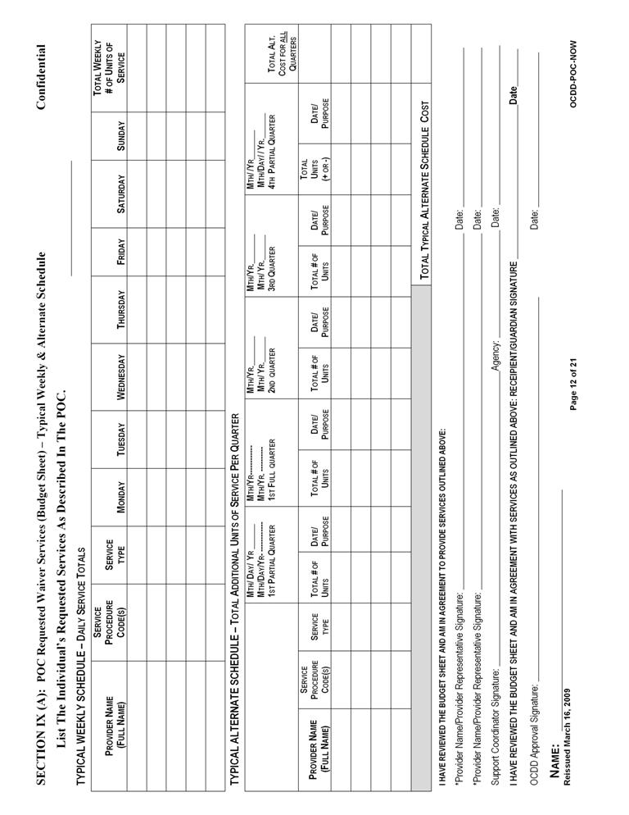
Attachment 4.4.2 Support Plan Format
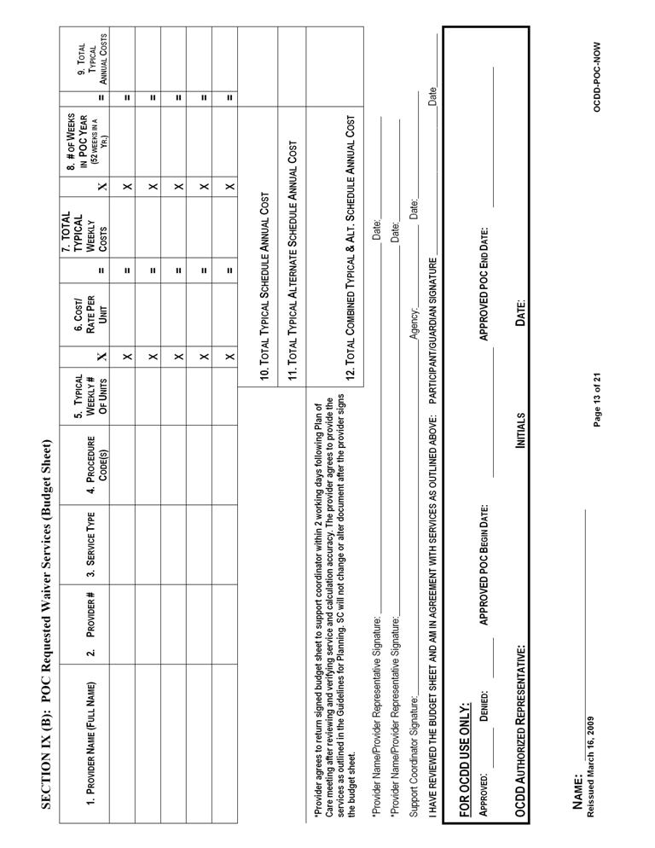
Attachment 4.4.2 Support Plan Format
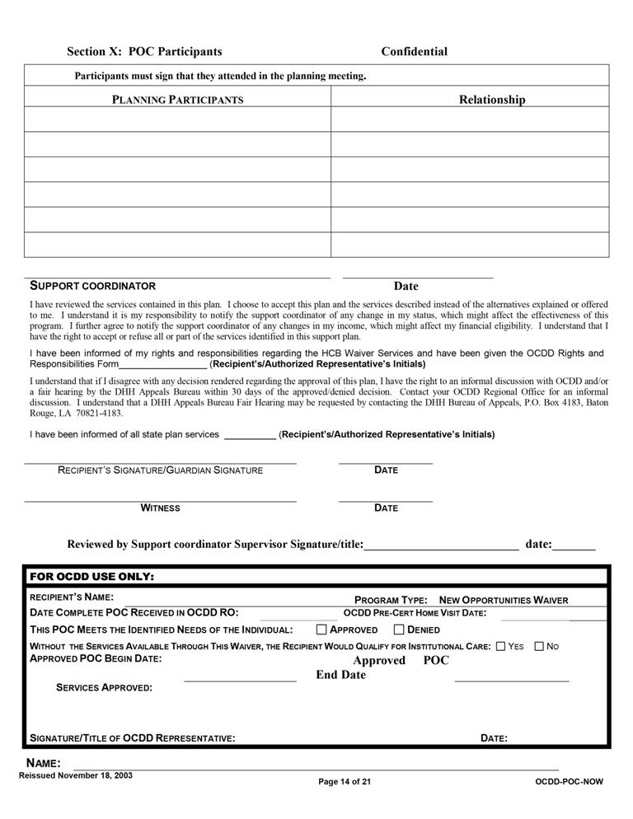

5

Planning for the Use of Recommended IFS Hours

5.1 Working within the Recommended Hours
5.2 Using the Conversion Table to Establish a Typical Weekly Schedule
5.3 Planning for Known and Predictable Deviations from the Typical Schedule
5.4 Planning for Unpredictable Deviations from the Typical Schedule: Flexible Hours
5.5 Using the IFS Flex Conversion Table with Flexible Hours Management
5.6 Planning Examples
5.7 When Additional IFS Hours are Needed
5.8 Justifying the Need for Additional IFS Hours
5.9 Requests for Additional IFS Hours: Expectations of Support Coordinators and/or Support Teams
5.10 Attachments
5.10.1 Recommended IFS and Day Program Hours by Level- Lives with Family
5.10.2 Recommended IFS and Day Program Hours by Level- Lives Independently
5.10.3 Conversion Table
5.10.4 Weekly Schedule and Budget Pages with Instructions
5.10.5 IFS Flex Conversion Table
PLANNING FOR THE USE OF RECOMMENDED IFS HOURS
As a component of the support plan, the support coordinator and support team build a typical weekly schedule, alternate schedules, and develop a budget that reflects these schedules. This Section describes the operational procedures and provides guidance in the development of the typical weekly schedule and budget components of the support plan.
Developing a typical weekly schedule, planning for known deviations from the typical schedule and using flexible hours for the unpredictable are addressed. This Section also provides sample planning scenarios to assist the support coordinator and clarify OCDD policy.
Some participants, such as a person living independently whose level of need and IFS recommendation assumes shared supports, may temporarily require additional IFS hours in order to gain time to locate a suitable sharing partner and develop shared supports. (See Section 5.9.) Temporary requests for additional IFS hours require approval by the Guidelines for Planning Regional Office Review Committee (GPRORC) and/or the Guidelines for Planning State Office Review Committee (GPSORC) as described in Section 7.3 and 7.4.

5.1 WORKING WITHIN THE RECOMMENDED HOURS
A. The typical weekly schedule and budget process under the Louisiana Resource Allocation System are completed using the steps listed below working from least to most amount of support needed:
- Begin by noting times of significant meaningful day activities whether they are supported or not,
- Fill in times when the person can be alone,
- Fill in times when natural supports are available,
- Fill in times where other community supports are available and additional IFS supports would not be needed,
- Fill in work/school hours not requiring IFS support,
- Fill in hours for other state services if appropriate,
  - For participants receiving Long Term – Personal Care Services (LT-PCS), the IFS hours available through the NOW should be assumed to replace the LT-PCS hours. Level of care requirements for the NOW are focused on need for skills training focused on independence as opposed to the basic care model for LT-PCS. Thus, participants in the NOW are most appropriately served using the IFS hours.
  - In limited situations, a participant may be better served with LT-PCS or some combination. For example, participants of retirement age may not have an expectation of increased independence. In these circumstances, the LT-PCS hours (or some of them) may remain appropriate. The total hours must still be within the maximum IFS hours available for the resource allocation level or justification for additional hours must be submitted as noted later in this section.

- Consider using the recommended IFS for some or all the remaining hours of direct support need. [See Attachment 5.10.1 (for persons living with family) and Attachment 5.10.2 (for persons living independently) for recommended hours.],
  - If two participants are married, living together, and are both using OCDD services (no matter the type), then both participants are considered as Living Independently.
  - If a participant is married and living with or otherwise lives with as a roommate a person (1) who does not use OCDD services and (2) who is a competent major (not a dependant child), the support team must determine the appropriate membership and course of action based upon Section 4.3.D.1-3.
- Use conversions according to the conversion table for additional needed hours (See Section 5.2.),
- Determine if additional hours are needed beyond the recommended hours, and
- Consider shared supports (See Section 6 for details on Using Shared Supports.).
    - Total shared and non-shared hours cannot exceed the maximum IFS hours for each person for the assigned acuity level. (See Sections 5.7-5.9 for addressing need for additional hours.)
    - If recommended hours are inadequate after the steps above have been taken, request additional hours in accordance with Sections 5.7-5.9 and 7.3 and determine if the plan can be safely implemented while the request for additional hours is underway. If not, request an expedited review.
B. Support teams may propose in the support plan programmatically appropriate phasing-in of unsupported hours. This entails a gradual reduction in 1:1 supports or shared supports. The reduction of paid support must be conducted with the participation of the entire team and must be done in accordance with plan strategies to meet personal goals, requirements for indentified support needs, and appropriate risk mitigation.
- If a participant requests unsupported time, the support team must assess the request on a case-by-case basis to insure that all factors pertaining to a person’s individualized situation are considered and fully addressed.
- Any request for unsupported time occurring after plan approval should be discussed with the support coordinator during the monthly phone call (Section 9.1) and addressed by the support coordinator at the next quarterly review (Section 9.2). Plan revision, if needed, is submitted per timelines. It is not appropriate to defer the issue to the next annual planning meeting.
C. The unit calculations for the budget are completed as they are currently done for the support plan. (See Attachment 5.10.4 for the weekly schedule and budget pages with instructions.)
5.2 USING THE CONVERSION TABLE TO ESTABLISH A TYPICAL
WEEKLY SCHEDULE

A. The Resource Allocation System proposes specific types of IFS hours (day 1:1, day shared, night 1:1, night shared) and a day habilitation allotment for each level. These hours are not intended to create a “cookie cutter” schedule. According to Section 5.1, each person’s typical weekly schedule is individualized through the person-centered planning process.
  - In order to create an individualized typical weekly schedule, conversion of types of hours within a level may be required.
    - The Conversion Table (Attachment 5.10.3) is a tool for use in converting allocated IFS hours. It may also be used to convert day habilitation hours to IFS hours.
    - When establishing a typical weekly schedule, any hours may be converted as deemed appropriate by the support team.
    - The resulting schedule (post conversion) must be within the recommended IFS hours and Day program hours assigned by the Resource Allocation System level, or approval from the GPSORC is required. (GPSORC is discussed in Section 7.3.)
C. The conversion table is organized into six sections representing the type of hours in the Resource Allocation System that can be converted one to another.
- IFS Day – 1 Person
- IFS Day – 2 Persons
- IFS Night – 1 Person
- IFS Night – 2 Persons
- ERT/Day Hab to IFS hours
- SE Mobile Crew to IFS hours
D. With regard to Day program hours (also SE Mobile Crew), the following guidelines apply:
- The NOW service limits allow for more hours in Day program than those in the chart specify for each level. Therefore, a person may access more Day program hours if he/she chooses to work more. Participants must stay within the NOW service limits. This means that there is no need to convert IFS hours to get additional Day program hours.
- Only the Day program hours in the chart may be used for conversion purposes. The participant may not convert the Day program hours in the chart and then access more Day program hours.
5.3 PLANNING FOR KNOWN AND PREDICTABLE DEVIATIONS FROM THE TYPICAL SCHEDULE
A. Alternate schedules are used for planned events that cause a deviation from the participant’s prior authorized typical weekly schedule. Alternate schedules specify a day or consecutive days when a participant will need additional hours of supports based on possible projected needs that occur on a non-routine basis.
B. Anticipated deviations included in alternate schedules are short-term, or temporary, requests for additional hours.
      - Long-term deviations (generally exceeding a quarter) require a longer-term alternate schedule or a complete plan and schedule revision. When looking at deviations, teams must consider if support needs have changed and revise the plan accordingly. Plan revisions are discussed in Section 8.1 and Attachment 8.6.1.
      - Before requesting additional hours, support teams are required to consider utilizing natural supports, other unpaid supports, intermittent supports, or sharing supports with other persons to maintain the allotment of hours.
      - Any change in hours use from the typical weekly schedule must be consistent with risks and benefits discussed by the support team and documented in the support plan. For example, it is not appropriate for a participant to substitute paid hours with intermittent supports or unpaid hours (alone time) if the support team has documented the need for supervision during specific times/activities.
      - Any deviation in the participant’s schedule must be “consumer driven” or requested by the recipient or family.
      - Examples of use of alternate schedules:
        - An example of appropriate use of an alternate schedule exceeding one quarter with support plan revisions due to change in support needs:
William had a scheduled surgical procedure in mid-February that would result in a significant change in his Activities of Daily Living (ADL) supports. Instead of being fully independent in toileting, bathing, and moving around, he would have a full leg cast for up to six weeks and would require hands-on supports in daily activities. The team submitted an alternate schedule request for the quarter that included the six weeks of one-to-one staffing for William’s recovery period. With the alternate schedule request, the team also submitted a support plan revision to reflect the change in William’s support needs for the period. The alternate schedule and plan revision were approved by the OCDD Regional Waiver Office and by the Guidelines for Planning State Office Review Committee, as the request exceeded William’s recommended IFS hours per his level. Unfortunately, William developed an infection a week after surgery. After talking with William’s physician about how the infection
would impact William’s recovery, his team felt that an additional three weeks of enhanced supports would be required. This would take William past the quarter in which his alternate schedule was approved. The team developed the request and justification using the physician’s information, and the support coordinator presented the information to the OCDD Regional Waiver Office. The Guidelines for Planning State Office Review Committee reviewed the request and approved it.
        - An example of an inappropriate request for an alternate schedule and increase in IFS hours (The appropriate request was for a plan revision.):
Virginia was volunteering one time per month at the local food bank bagging canned goods. She was accompanied by a staff person during volunteer time and used her one-to-one hours for this activity. Virginia made friends with some other ladies who volunteered there weekly. Virginia asked to volunteer weekly as well, since she was enjoying the work and spending time with her new friends. Virginia’s support team developed an alternate schedule request to provide Virginia with additional one–to-one hours to accommodate her increase in volunteer time (from one time a month to one time per week). The request was for three additional afternoons per month of one-to-one supports. Her support coordinator submitted the request to the OCDD Regional Waiver Office and the Guidelines for Planning State Office Review Committee, since the alternate schedule request would exceed Virginia’s recommended IFS hours for her level. The alternate schedule request was returned to the team unapproved. The review recommended to the team that a support plan revision and new typical weekly schedule was required, since the change in volunteering was not projected to be short term or temporary. In addition, Virginia’s team must work with her to develop a new typical weekly schedule that would stay within her recommended IFS hours for her level. The team could explore use of natural supports during volunteer times provided by some of the ladies that Virginia has become friends with at the food bank. The team could also explore Virginia’s using shared supports more frequently during other times of the week. Virginia’s team met again and discussed the needed changes in her support plan and typical weekly schedule. Virginia’s support coordinator and IFS provider contacted the food bank and some of the other volunteers regarding assisting Virginia during volunteer hours. They were happy to participate and receive information about how to support Virginia. In addition, Virginia agreed to inclusion of a few more shared hours on Sunday afternoons. These changes resulted in a typical weekly schedule consistent with the recommended IFS hours for Virginia’s level. The plan revision was prepared and submitted by Virginia’s support coordinator to the OCDD Regional Waiver Office. It was approved.
      - Alternate schedules are discussed at the time of annual planning and submitted for approval with the support plan. In annual planning, the support team takes into consideration the 240 days per year of Day program available, and the team looks at each quarter and determines if there are known deviations, such as:
- Holidays/ vacation days,
- Christmas events and travel,
- School or work vacations,
- Planned caregiver absence,
- Planned occasions (firm date, time, length) for use of casual shared supports on an infrequent basis and non-typical basis (i.e., person normally uses 1:1 supports but plans to share supports on a temporary basis for a specified activity such as vacation or a 12-week art class.), and/or
- Illness (i.e., person requires scheduled procedures/treatment that the team knows about in advance or person has documented unstable medical health which results in frequent hospitalizations or stay-at-home periods). (Note: Plans with “sick days” will not be approved. Illness requests must be justifiable as described.)
      - During each quarterly meeting, the team must review the approved alternate schedule(s) and discuss whether any additional need for alternate scheduling is known.
        - If additional alternate schedule(s) are needed, they must be submitted by the support coordinator as a plan revision for OCDD Regional Waiver Office approval. The support coordinator must submit the schedule(s) for approval within seven (7) business days of the anticipated change. Plan revisions are discussed in Section 8.1 and Attachment 8.6.1.
        - Participants must notify their support coordinator of an anticipated change ten (10) business days before the date of the change. Changes may include vacation or change in work schedule.
        - Teams must evaluate if support needs have changed and revise the plan accordingly. Plan revisions are discussed in Section 8.1 and Attachment 8.6.1.
      - Revisions to approved alternate schedules may also be submitted to the OCDD Regional Waiver Office at any time for approval. Unanticipated circumstances may arise that require additional hours, such as caregiver absence or illness, shared supports interruption due to illness or injury, or loss of housing. Plan revisions are discussed in Section 8.1 and Attachment 8.6.1.
      - Alternate schedules are approved for use in specific quarters.
        - The support coordinator notes for each day an alternate schedule is requested, the number and type of hours requested and a justification.
      - The quarter requested must be clearly documented in the support plan (Sections VIII and IX of the CPOC) for approval. Specifying a particular date is desirable, but not required.

5.4 PLANNING FOR UNPREDICTABLE DEVIATIONS FROM THE TYPICAL SCHEDULE: FLEXIBLE HOURS
A. Support teams are expected to develop a typical weekly schedule and accompanying alternate schedules to best align with the participant’s daily routine and preferences. However, every individual will inevitably have deviations from his/her typical schedule that are unpredictable and where the need for support is greater or less than usual. People may occasionally make choices about their daily routine that impact their typical weekly schedule.

B. While flexibility is allowed in the individual’s plan for recommended IFS hours, documentation is required and must reflect that any change in the use of hours is “consumer-driven.” (See Section 8.4 for plan implementation documentation.)

1. Each quarter, the individual’s prior approved IFS hours can be moved or converted for flexibility in the typical weekly schedule. Prior approved alternate schedule hours are included in the quarterly total of available IFS hours.

2. Flexible hours can be moved around within a typical weekly schedule.

  - A participant may choose to use 1:1 hours on a Monday afternoon instead of on Saturday, as specified in the typical weekly schedule.

  - Flexible hours can be converted within the IFS provider agency. (See Section 5.5.)

    - A participant may choose to share 3:1 going to a ballgame, instead of sharing 2:1 according to the typical weekly schedule.

    - A participant may be ill and unable to share supports. Shared IFS hours would then be converted to 1:1, using the IFS Flex conversion table. (See Section 5.5.)

  - A participant may not convert Day program or vocational hours to IFS hours after the support plan is approved.

    - Flexible hours are only available through the approved IFS hours. Thus, any unpredictable absence from Day program or work that requires use of IFS hours must be carefully managed by the participant and IFS provider to assure that the participant stays within his/her IFS allotment for the quarter.

  - Flexible hours may be moved from week to week within the quarter as long as the individual not go over the total allotment of IFS hours in the quarter. Hours are approved for use in a quarter only and do not roll over.
  - Participants are required to stay within their IFS allotment for the quarter when using flexible hours. Flexible hours are not in addition to approved hours. Staying within the allotment is achieved by:
- Moving around hours within the typical weekly schedule as an even exchange.

    - Thus, using the 1:1 hours scheduled for Saturday on Monday evening and then using shared 2:1 hours regularly used on Monday on Saturday. By the end of the day Saturday, the alteration in Monday’s schedule will be balanced in terms of use of allocated hours. Using 1:1 hours on Monday and Saturday both would not be an even exchange and would leave the participant with a deficit in allocated IFS hours for the quarter.

- Using shared 2:1 or 3:1 hours instead of scheduled 1:1 hours.

    - The conversion of 1:1 hours to shared hours will “credit” the balance of approved IFS hours for the quarter.

    - This strategy is recommended as a way to address a deficit in allocated IFS hours for the quarter.

- Substituting paid hours with natural supports or other unpaid supports.

- Using intermittent supports or unpaid hours (alone time).
  - Support teams work with participants on creative approaches to managing allocated IFS hours and maximizing flexibility.
a. Any change in hours used from the typical weekly schedule must be consistent with risks and benefits discussed by the support team and documented in the support plan. For example, it is not appropriate for a participant to substitute paid hours with intermittent supports or unpaid hours (alone time) if the support team has documented the need for supervision during specific times/activities.

C. The following guidelines are applicable to flexible hours:
- Flexible hours may be used, if appropriate, for individuals with plans that primarily rely on one-on-one staff support but who would like to share supports for specific activities. (See Section 6 for guidelines for individuals using shared supports.)
- A request for revision to the plan is made when unpredictable activities become regular and predictable or the person is nearing the maximum number of hours allotted in the quarter. (Plan revisions are discussed in Section 8.1 and Attachment 8.6.1.)
- The direct support provider is responsible for tracking the use of prior authorized IFS hours of service and documenting deviations from the typical weekly schedule.
- Statistical Resources Inc. (SRI) provides the service provider with a daily 24 hour documentation sheet for each individual prior authorized, outlining the approved typical weekly schedule hours and any alternate schedule hours per quarter. The direct service workers document times worked and any schedule deviations on this documentation sheet.
D. Participants or their authorized representatives are responsible for immediately notifying the support coordinator of any emergency changes that affect the support plan. Emergency situations could include a hurricane, tornado, flooding, or other acts of God. Emergency situations may also include death in the family (of caregiver), caregiver illness, and participant illness, including need of assistance following hospital stay.
1. The support coordinator is responsible for submitting the emergency revision to the support plan to the OCDD Regional Office within 24 hours or by the next business day of the occurrence. Plan revisions are discussed in Section 8.1 and Attachment 8.6.1.
2. OCDD Central Office, Regional Offices, direct service provider agencies, and support coordination agencies have additional responsibilities when a hurricane threatens Louisiana. (See Appendix 15 for Emergency Protocol for Tracking Location Before, During, and After Hurricanes.)

E. Any deviation from the typical or alternate schedule requires documentation by the service provider. (Service documentation is described in Section 8.4.) Documentation is also required on the 24-hour documentation sheet as described in C.4 above. Failure to adequately document changes in the individually approved schedule may result in denied billing or recoupment of Medicaid funds.
5.5 USING THE IFS FLEX CONVERSION TABLE WITH FLEXIBLE HOURS MANAGEMENT
A. When participants use flexible hours, conversion may be required.
1. Conversion of hours is not required if hours are moved around in an even exchange.
2. Conversion of hours is required if a different type of IFS hour than what is specified in the typical weekly schedule is used and there is no even exchange (e.g., if a day 1:1 hour is used instead of a day 2:1 hour.)
B. The IFS Flex Conversion Table (Attachment 5.10.5) is a tool for use in converting allocated IFS hours. For the purposes of conversion with flexible hours, neither day program nor SE mobile crew prior approved hours can be converted. These hours are not included on the conversion table. Only IFS hours types can be converted for flexible hours.
C. The IFS Flex Conversion Table displays the type of hours in the Resource Allocation System that can be converted one to another in order to use flexible hours in the typical weekly schedule. Hours available for flex include:
- IFS Day – 1 Person,
- IFS Day – 2 Persons,
- IFS Day – 3 Persons,
- IFS Night – 1 Person,
- IFS Night – 2 Persons, and
- IFS Night – 3 Persons.
D. Participants and teams must follow the guidelines discussed in Section 5.4 when utilizing flexible hours.
5.6 PLANNING EXAMPLES
A. The following planning examples are designed to assist support coordinators, participants and families in understanding OCDD policies with regard to the use of IFS hours.
- Two brothers, one 25 and one 30 years old, live at home and both are served by OCDD. Each is assigned Level 3 within the resource allocation system. Level 3 includes only IFS Day 1 Person hours and provides 30 Day program hours. The brothers and the family would like to convert some IFS Day hours to Night support because their mother works an overnight shift every other week.
Provided that the risk assessment indicates that these modifications can be done safely, the plan of care for the two brothers can include the following:
    - Use maximum Day program hours,
    - Convert IFS Day to IFS Night, and
    - Share IFS supports and, in this case, increase total available hours for support.
The IFS Flex Conversion Table (Attachment 5.10.5) is used for the conversion of hours as presented in this section. For example, if the family would like to convert 4 hours of IFS Day, they would have 10 hours of IFS Night. (The total shared hours is not 20 hours even though both brothers convert.)
These modifications to accommodate the preferences of the brothers and family are within the Louisiana Resource Allocation System. An exception request is not required.
2. A woman, who is assigned Level 5, is served by OCDD and lives with her elderly parents who are experiencing significant health issues. The elderly parents are no longer able to provide the night time natural supports called for in Level 5. The daughter is not ambulatory, is bed-confined and requires turning and positioning every two hours.
The support coordinator can consider planning for a short-term approach while looking at longer-term solutions:
- In the short-term: The team should determine what supports the woman needs in terms of frequency and intensity. In this woman’s case, she may not be able to use unsupported hours, so that option may not be a ready solution. Second, the team should consider and assist the woman and her family to look at other available natural supports, such as siblings, extended family, or friends. If it is appropriate, the woman may consider using shared supports on a casual basis (perhaps out of their home). The woman may use skilled nursing supports through the waiver and convert her IFS-day services to IFS-night. Requests for additional hours by the team should be made as a last resort. Requests for additional hours may be granted on a temporary (up to 6 month) basis. Approvals for additional hours are time-limited and will not be granted on a continual basis indefinitely (See Section 5.9).
- In the long-run, the support coordinator should work with the woman and her family to plan for the permanent change in support circumstances. Perhaps another relative is willing to offer in-home supports. The woman and family may wish to explore shared independent living arrangements in anticipation that the family home will not likely be available in the future. Or, if the family situation and home permits, perhaps a roommate or continued shared supports may be appropriate. Involving the family in long-term planning instead of simply requesting more hours as a short-term solution will result in the best outcome for the woman. The support team should work proactively and in collaboration with the PASARR process to prevent unnecessary institutionalization, should elderly parents enter a nursing home.
3. Additional IFS hours are needed quickly (at any Level) due to the sudden death of the sole caregiver.
As a first step, flexible hours can be used immediately to meet the person’s needs. The support team should convene immediately to come up with an interim and long-range plan to meet the person’s needs. Plan revisions should be submitted per policy.
4. A person has an emergency, such as surgery, and requires support during the recovery period in the home.
Flexible hours set aside for unpredictable events are used for this purpose. If flexible hours are not sufficient, the support coordinator requests a temporary increase in hours for the recovery period only as described in Sections 5.9 and 7.3. No permanent revision is made to the plan.

5. Two participants, who currently share services, receive very different resource allocation levels (e.g., Level 1B and Level 4). Can these participants continue to share?
Yes, they can continue to share provided that the risk assessment or steps to mitigate risk indicate that sharing can be accomplished safely.
6. There are two homes both using shared supports with the same IFS provider agency.

Home 1 with Persons A and B:
A likes football B likes soccer
Home 2 with Persons C and D:
C likes football D likes soccer

Can Home 1's staff take A and C to a football game and let Home 2's staff take care of B and D?

Yes, they can so long as this can be done safely and A and C and B and D are not precluded from sharing.

7. Will older family members’ health be considered for justification for additional hours as well as single parents?

Yes, provided that other options for converting hours, sharing hours, and using flexible hours are considered first. See the response to number 2 above.

8. What if the caregiver is hospitalized?

Flexible hours are used first. If these are not sufficient, a temporary request for an exception to allocated hours is requested as described in Section 5.8.

- What if the person lives in an area in which there is no vocational or habilitation program available or there is a waiting list for these services?

People may request permission from their local OCDD Regional Waiver Office to cross regional lines in order to access services needed. Support teams should incorporate strategies into the support plan that include meaningful activities by using community supports and shared supports for persons before requesting additional 1:1 hours. Any requests for hours exceeding the suggested allocation must include individual justification as described in Section 5.8.

- What if roommates are both coming out of an institution, like and ICF/DD, and one roommate is ready to move before the other? Are services put on hold until both are ready to move?

The roommate who is ready to transition may move out and live by him/herself until the other person is ready to move. The roommate that moves out can request additional 1:1 hours (if needed) under the strategies described in Section 5.9.B.2. If one roommate moves before the other and plans to live alone temporarily, teams must determine whether sufficient resources (e.g., finances to cover rent and utilities) are available for the person to live alone.
5.7 WHEN ADDITIONAL IFS HOURS ARE NEEDED
- OCDD recognizes that the Resource Allocation System must make accommodations for participants with atypical or specialized needs in order to be responsive to all service recipients; certain people have unique needs that must be addressed outside the guidelines.

  - Section 5.8 provides examples of the types of situations that may justify additional IFS hours both temporarily and on a permanent basis. Section 5.9 describes the process by which support coordinators and support teams request additional IFS hours. Sections 7.3 and 7.4 describe the process established to review these requests.

- National experts with Resource Allocation Models have indicated that a small percentage of participants are outliers of any model – meaning they have resource needs outside of the Allocation System. Louisiana’s Resource Allocation System has procedures to address this issue.

  - Requests for an exception, whether permanent or temporary, to the Louisiana Resource Allocation System hours are submitted and reviewed through the OCDD Guidelines for Planning Regional Office Review Committee (GPRORC) and the Guidelines for Planning State Office Review Committee (GPSORC), and procedures are described in Sections 5.8, 5.9, 7.3 and 7.4.

- Some individuals may require additional IFS hours during times of school or day program closures. Individuals who cannot have unsupported hours and have no natural supports or alternative care available will need some support during these times. Thus, it is expected that during these times individuals may require more IFS hours than in a typical day or week.

5.8 JUSTIFYING THE NEED FOR ADDITIONAL IFS HOURS
    - IFS hours requested above the guidelines require justification by the support coordinator based on the unique needs of the participant. All requests for additional hours must be distinctive to the participant. The request must specify how the need for additional hours distinguishes the person from others at the same resource allocation level. Only participant specific requests with clear information about why the exception is required can be approved.
    - Additional support hours may be considered in the following instances:
- A participant falls into a category where sharing is not advisable (See Section 6.8.) but falls into an allocation level that includes sharing (e.g., all Living Independently levels other than 6 include sharing as presented in 5.10.2). Documentation (incidents/health risks/previous attempts to share and negative outcomes associated with sharing, etc.) about the situation impacting sharing must be submitted with the request as there will be situations in which sharing is possible depending on the participant’s individual circumstances.

- A participant has few general support needs and falls into Level 1A, 1B or 2 but has a highly contagious disease or serious immune deficiency condition for which basic universal precautions will not maintain health and safety for the individual or his/her sharing partner or significant behavioral issue (e.g., Prader-Willi syndrome requiring limiting food in the home). Documentation of the condition and its related health and safety considerations as it relates to the recipient and any potential sharing partner must be submitted with the request.

- A person requires extensive physical assistance to participate in most home and community activities (e.g., a two-person life even with assistive devices) or has medical needs that result in a schedule of supports that requires near constant attention by the support staff. Documentation of the needed assistance and/or medical condition, along with a copy of the schedule and intensity of support staff, must be submitted with the request.

- Situational issues which impact the ability to access needed supports via other options:

- A significant number of natural support hours are assumed in the person’s level membership but natural supports are not available due to one of the following situations:

- Family work schedule (documentation of the specifics of the work schedule must be submitted with the request).

- Family member medical conditions precludes safely providing the needed supports (documentation of the condition and limitations from the family member’s health care provider along with the support team’s efforts to address any times when the family member may be able to provide natural supports during which the limitations will not be a problem (e.g., physical lifting may not be necessary during some hours, so an hour or two may be possible) must be submitted with the request).

- Family member receives support themselves from OCDD/OAAS (documentation of supports provided must be submitted with the request).

- The person is unable to access work/day program options due to the inability of the vocational providers to meet his/her needs or due to unavailability of options in the area (documentation from the providers or of the unavailability of providers must be submitted with the request).

- The person has made significant attempts to share supports but has been unsuccessful (documentation of the efforts to meet possible sharing partners and attempted shared activities with the specifics of the barriers/challenges that preclude a viable option at the current time, and a plan for continued exploration and mitigation of the noted barriers/challenges such that sharing is a possibility in the future must be submitted with the request).

    - Support coordinators follow the procedures described in Section 5.9 when:

- Recommended IFS hours do not safely meet the participant’s needs,

- Temporary changes in support hours required are a result of caregiver absences and IFS flexibility is not sufficient,

- Permanent changes in support hours required are a result of a significant change in living situation and/or needs (SIS/LA PLUS reassessment required) and allocated IFS hours are no longer sufficient, or
- A participant is seeking a temporary approval of additional IFS hours as described in Section 5.9.

    - Exceptions to Louisiana’s Resource Allocation System and the IFS hours guidelines, other than changes supported by the SIS/LA PLUS reassessment and assignment of the appropriate resource allocation level, are time-limited. Support coordinators are responsible for review and update to the support plan in the timeframe specified in the approval of the exception.

5.9 REQUESTS FOR ADDITIONAL IFS HOURS: EXPECTATIONS OF SUPPORT COORDINATORS AND/OR SUPPORT TEAMS
- When requesting an exception, whether permanent or temporary, to the Louisiana Resource Allocation System hours, support coordinators, with the assistance of the support teams, are expected to request additional IFS hours based on the procedure detailed below:

- Support coordinators must submit a written justification using a format prior-approved by OCDD Central Office. This request should include the exception as well as other options explored and the expected period of time the exception will be required.

- The request, along with the support plan and other necessary documentation, will be submitted to the Regional Waiver Office for review.

- There are particular plans which request an exception to the Louisiana Resource Allocation System hours, but are exempt from the need for a committee review. These plans can be approved by Regional Waiver Office staff and do not require review by the regional or state committees. These exceptions are discussed in Section 7.2.

- If necessary, the assigned Regional Waiver Office staff forwards the plan to the Guidelines for Planning Regional Office Review Committee (GPRORC) Chair for discussion within one working day of review. The following additional information must accompany each plan and budget:

- Approved Supports Intensity Scale and Louisiana PLUS (SIS/LA PLUS) that resulted in level assignment,

- 90-L

- Behavioral assessment for individuals with behavior plan,

- Psychiatric evaluation for individuals receiving psychotropic medication,

- Most recent support plan and quarterly reviews from the Supports and Services Center (from the previous year) if moving from a Supports and Services Center,

- Any other assessments/documents used in the planning process.

- If the plan indicates support needs which require additional review, the plan and supporting documentation is forwarded to the OCDD Guidelines for Planning State Office Review Committee (GPSORC) as described in Section 7.4.

- With regard to development of shared supports, support coordinators and support teams should plan using the following principles and timelines:

- For participants residing at home with their families who are moving to independent living and need time to develop shared supports, supports may be provided to the participant at home until the shared living situation is set up.

- For participants moving from an ICF to an independent living situation, an assessment is made regarding projected time to set up the shared living situation. Requests for temporary need for additional hours are considered while the shared living situation is developed based upon each individual situation.

- The expectation is that development of shared living circumstances is normally completed within six months. Exceptions are considered on an individual basis.

- For participants currently receiving individualized IFS hours and living independently whose needs cannot be met within the level allocation, an assessment is made regarding projected time to set up a shared living situation or to make adjustments to the person’s daily schedule to include sharing options or other appropriate supports. Requests for temporary need for additional hours are considered while the shared living situation or other adjustments are developed based upon each participant’s situation.

5.10 ATTACHMENTS
Attachment 5.10.1 Recommended IFS and Day Program Hours by Level - Lives with Family
Louisiana Department of Health and Hospitals
office for citizens with developmental disabilities

Guidelines for Planning:
RECOMMENDED IFS and Day Program Hours by Level
Lives with Family
 | 1A | 1B | 2 | 3 | 4 | 5 | 6
IFS Day | 25 | 32 | 46 | 56 | 62 | 62 | 82
IFS Day Shared | 0 | 0 | 0 | 0 | 0 | 0 | 0
IFS Night | 0 | 0 | 0 | 0 | 0 | 0 | 0
IFS Night Shared | 0 | 0 | 0 | 0 | 0 | 0 | 0
Day Program Hours | 20 | 30 | 30 | 30 | 30 | 30 | 12
Total Paid Hours | 45 | 62 | 76 | 86 | 92 | 92 | 94
Natural Supports Hours | 123 | 106 | 92 | 82 | 76 | 76 | 74
Total Hours | 168 | 168 | 168 | 168 | 168 | 168 | 168
<18 years = -7 hrs IFS Day | -7 | -7 | -7 | -7 | -7 | -7 | -7
>55 years add = +7 hrs IFS Day | +7 | +7 | +7 | +7 | +7 | +7 | +7

Attachment 5.10.2 Recommended IFS and Day Program Hours by Level - Lives Independently
Louisiana Department of Health and Hospitals
office for citizens with developmental disabilities

Guidelines for Planning:
RECOMMENDED IFS and Day Program Hours by Level

Lives Independently
 | 1A | 1B | 2 | 3 | 4 | 5 | 6
IFS Day | 10 | 10 | 10 | 10 | 14 | 14 | 112
IFS Day Shared | 35 | 40 | 72 | 72 | 68 | 86 | 0
IFS Night | 0 | 0 | 0 | 0 | 0 | 0 | 56
IFS Night Shared | 0 | 40 | 56 | 56 | 56 | 56 | 0
Day Program Hours | 30 | 30 | 30 | 30 | 30 | 12 | 0
Total Paid Hours | 75 | 120 | 168 | 168 | 168 | 168 | 168
Natural Supports Hours | 93 | 48 | 0 | 0 | 0 | 0 | 0
Total Hours | 168 | 168 | 168 | 168 | 168 | 168 | 168
>55 years add = +7 hrs IFS Day | +7 | +7

Attachment 5.10.3 Conversion Table
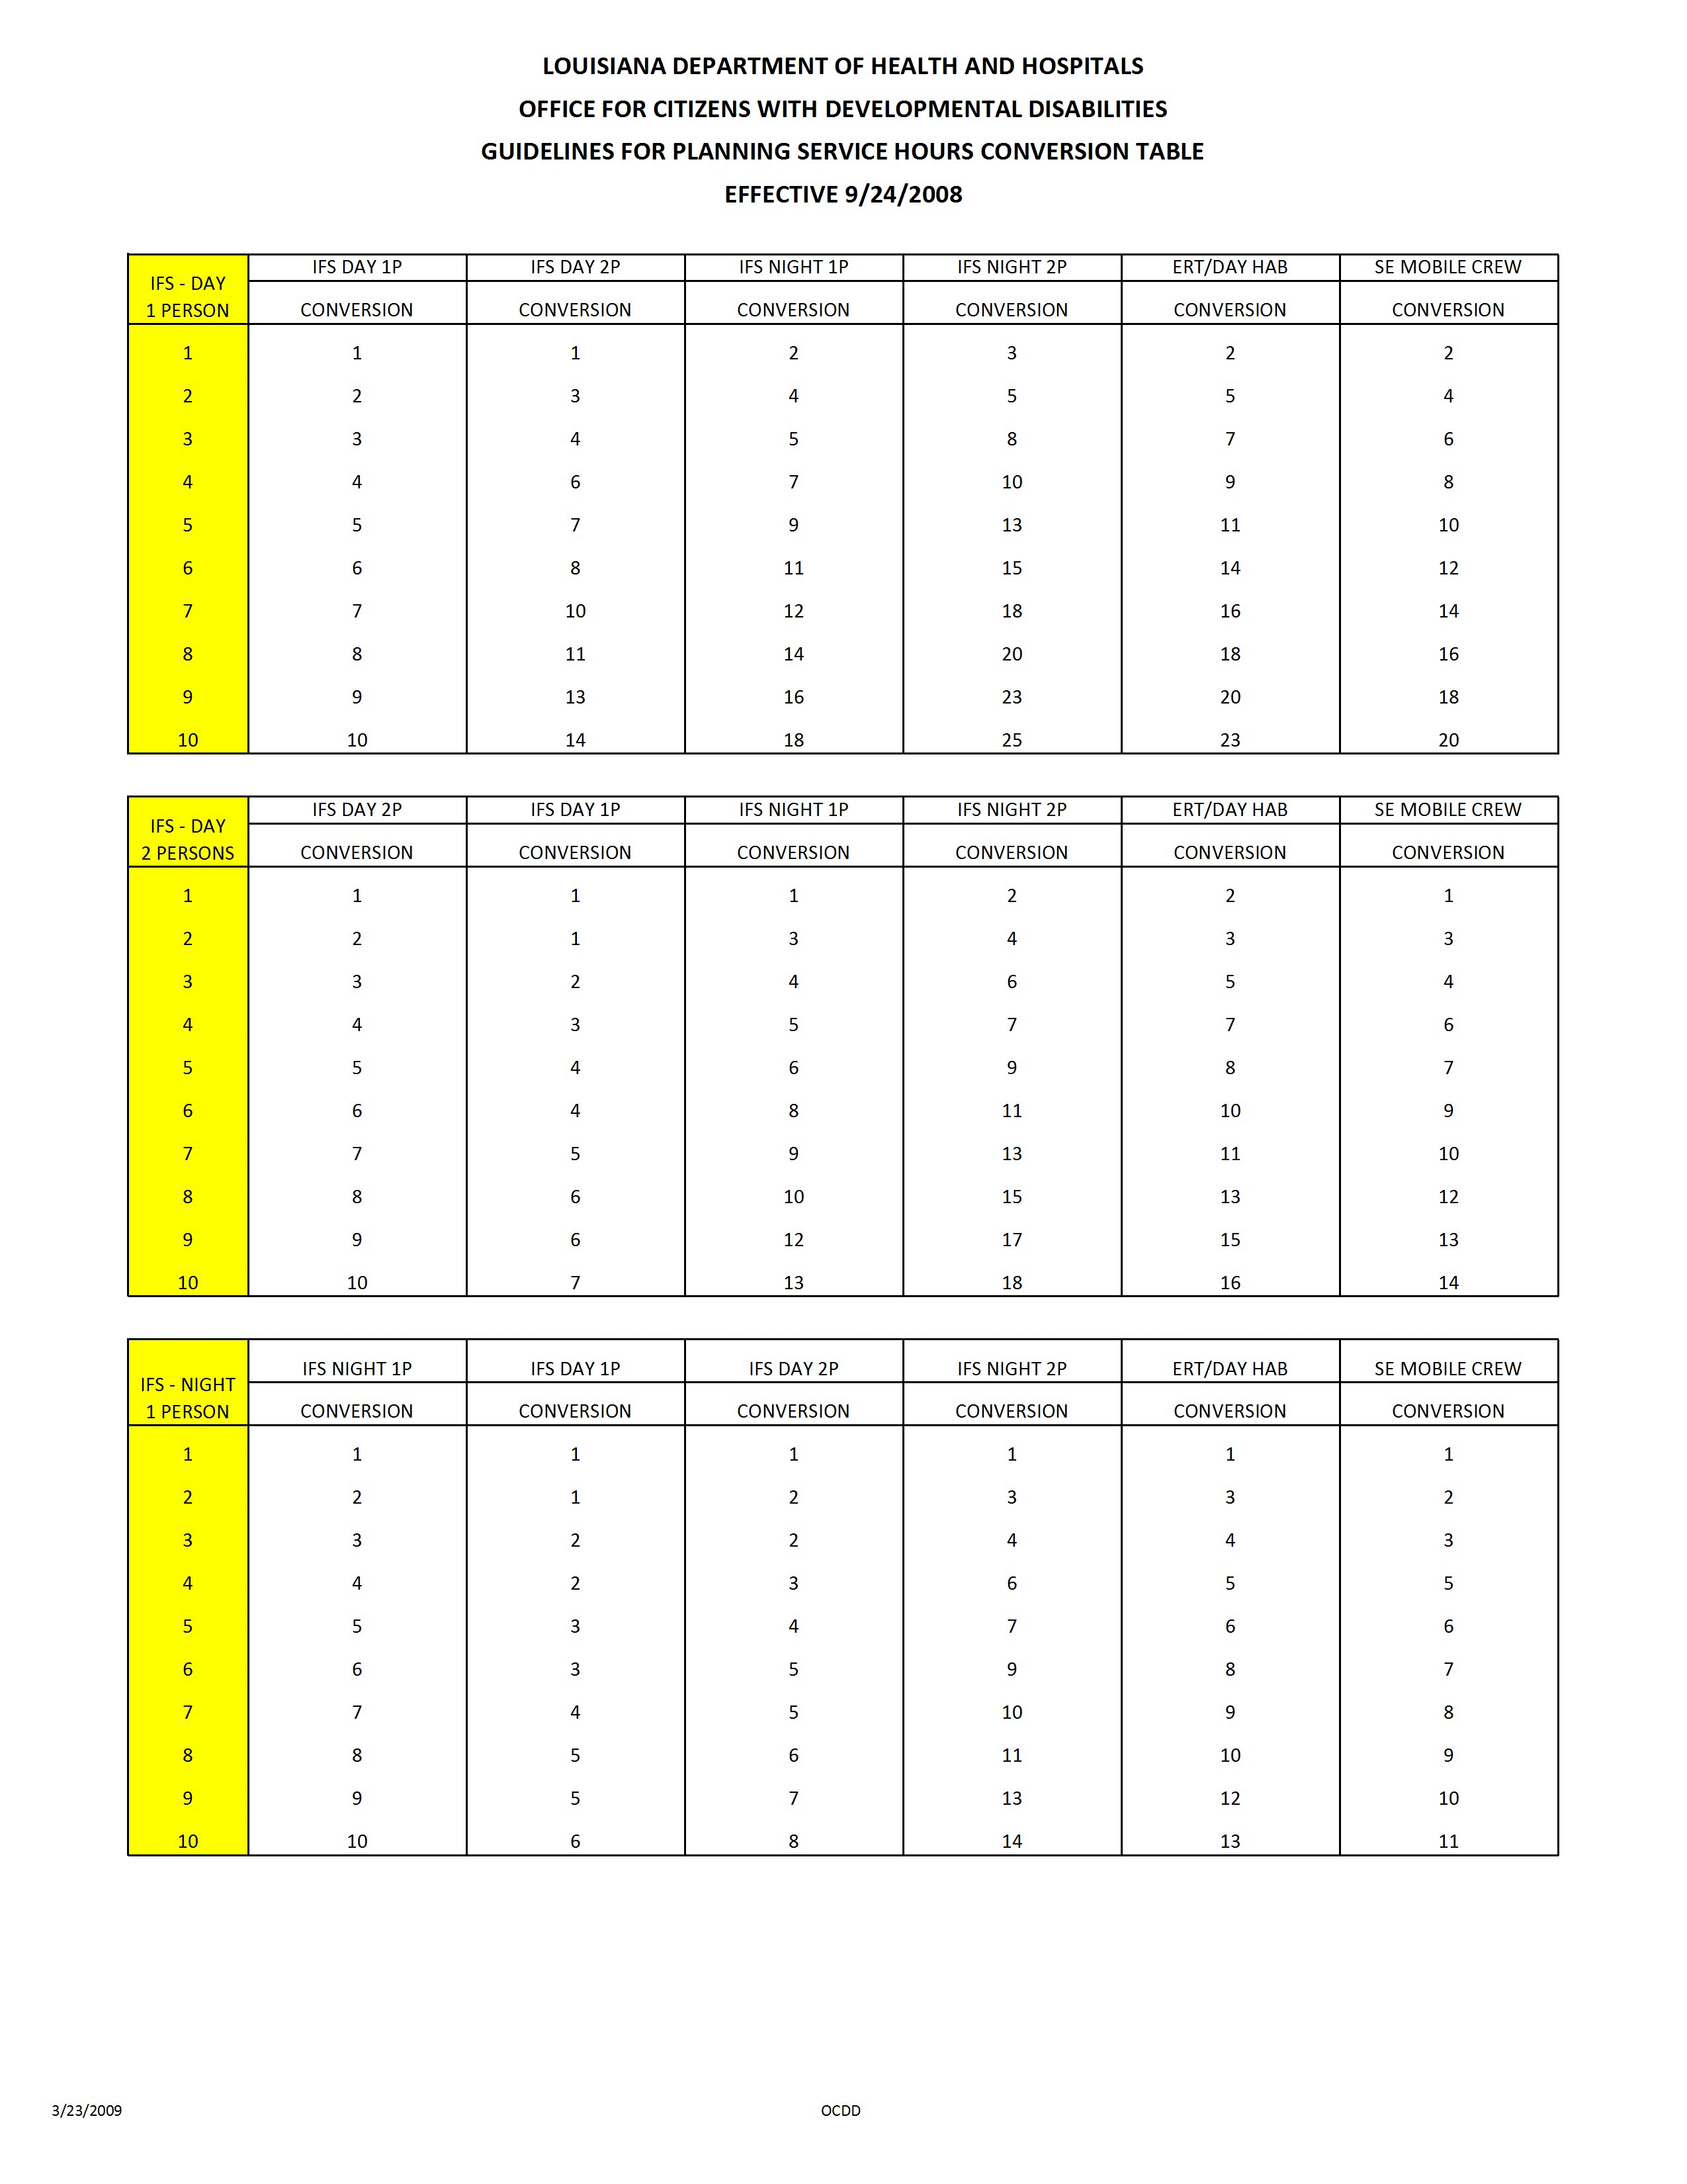

Attachment 5.10.3 Conversion Table
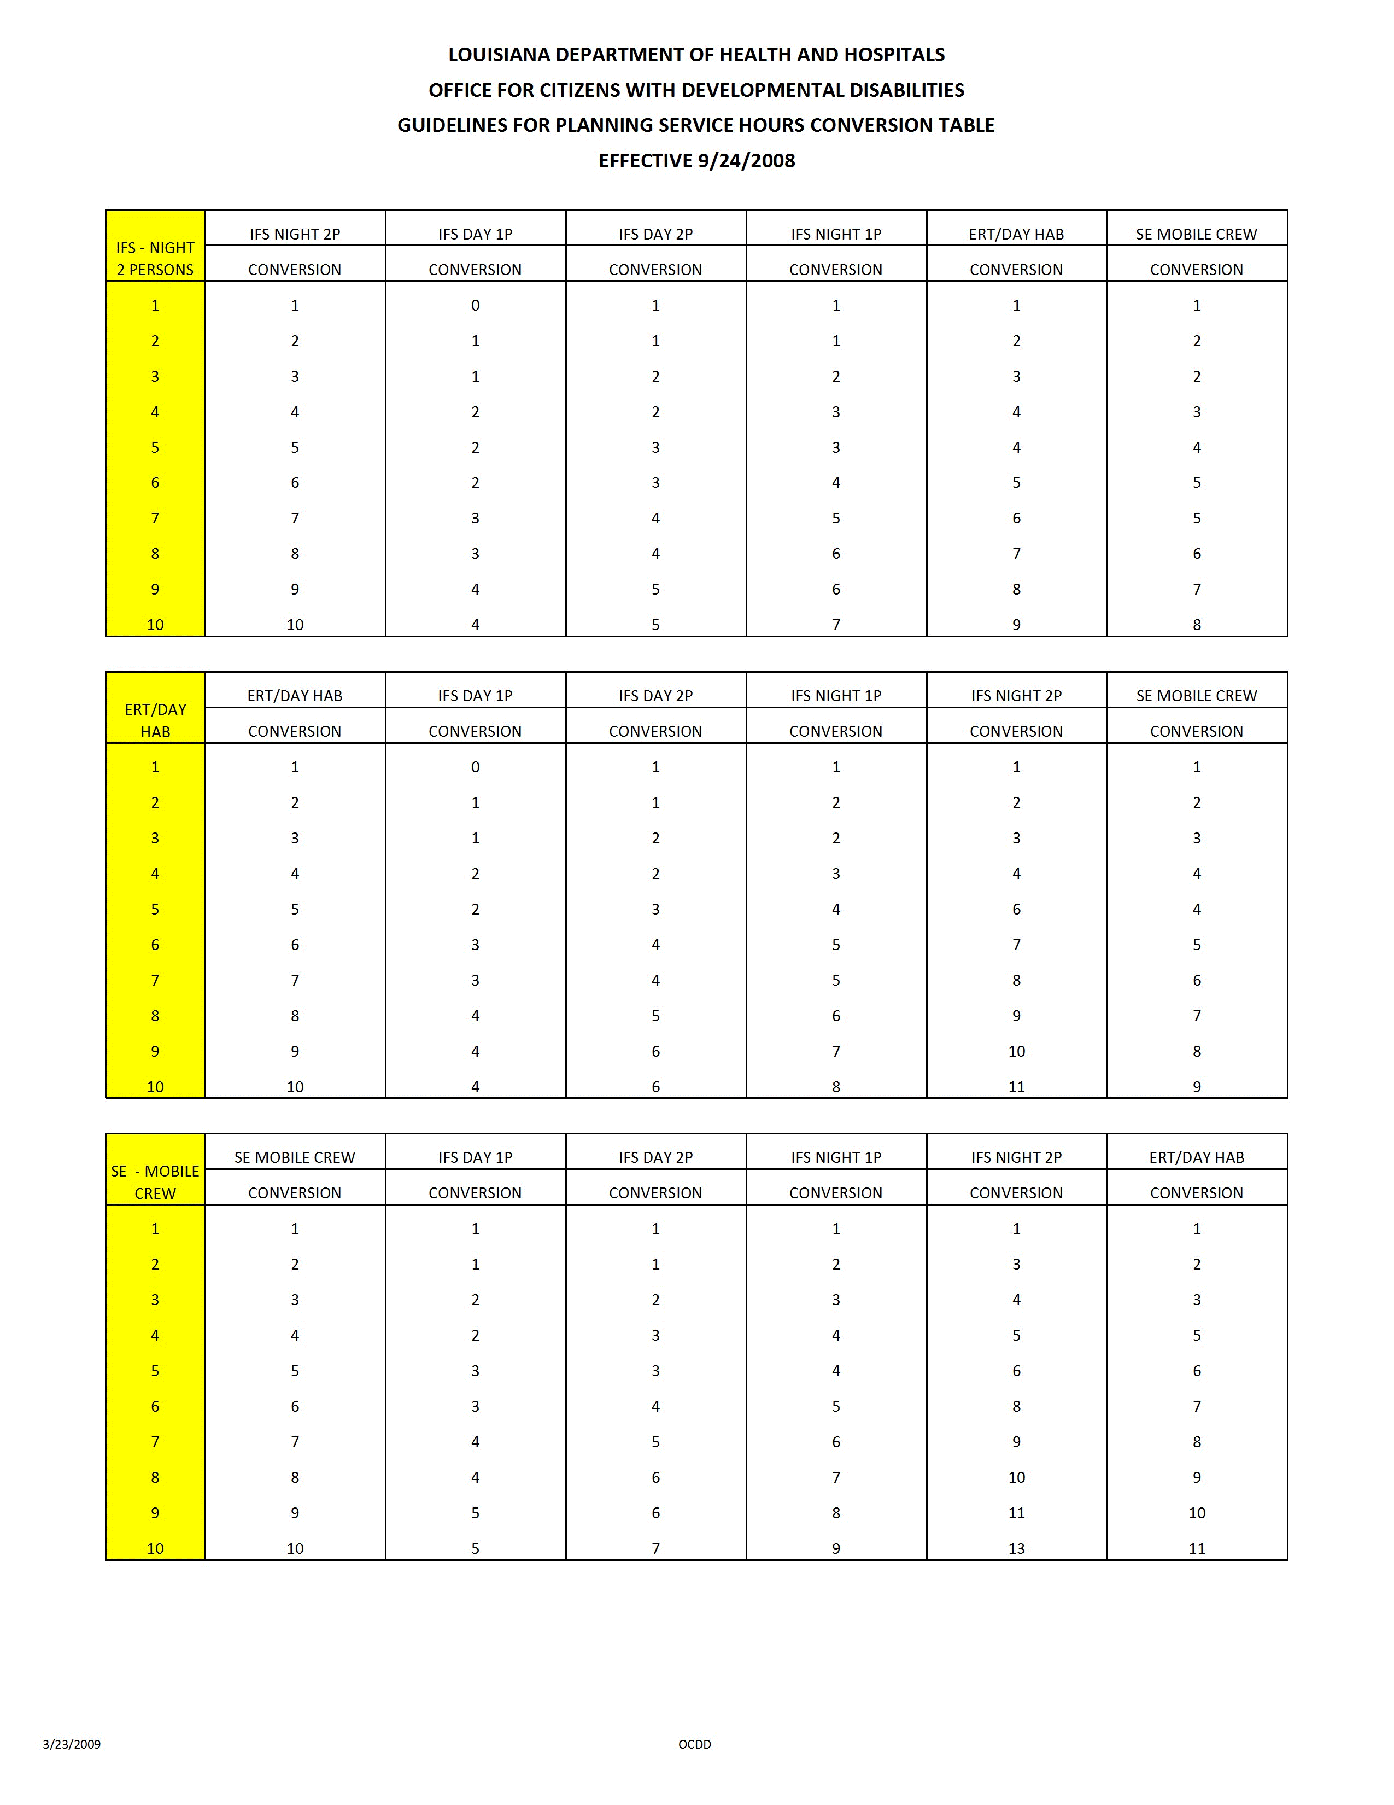

Attachment 5.10.4 Weekly Schedule and Budget Pages with Instructions
Attachment 5.10.4 Weekly Schedule and Budget Pages with Instructions
Attachment 5.10.4 Weekly Schedule and Budget Pages with Instructions
Attachment 5.10.4 Weekly Schedule and Budget Pages with Instructions
Attachment 5.10.4 Weekly Schedule and Budget Pages with Instructions
NOW POC Instructions

SECTION VII - TYPICAL WEEKLY SCHEDULE

Purpose

The intent of this schedule is to assist participants and their families in assessing and planning for services and supports that will help them move closer to their desired personal outcomes. Utilization of this section and subsequent planning will help assure continuity of care and reduce redundant and/or unnecessary service delivery. Services should be provided in accordance with what is requested and needed by the participant, no more, no less. Simply list the source of service provision when applicable. In addition, for waiver support simply mark the time the participant typically receives supports by using the “Pw” coding. The service delivery schedule is not to be used for daily monitoring of service delivery or monitoring of the participant’s daily activities.

This section is for planning purposes only. It is understood that this schedule is flexible and a participant’s daily routine may change based on need or preference. The waiver supports that are initially requested will be based on this planning document.

Subsequent changes must to be requested by the participant, and/or their authorized representative, and processed through the support coordinator utilizing the appropriate Revision Request forms (see Revision Request Form in Appendix A of this instruction manual).

Typical Weekly Schedule

The top of this section lists the participant’s desired/needed supports. For each hour indicate how the participant will typically spend their time using the codes listed below.

CODES: Ns = Natural Supports

S = Self

Sc = School

C = Companion

Pw = Paid Waiver Support

P = Paid Support*

*Note: Paid Support is support provided by another funding source besides waiver funding (For example, Louisianan Rehab. Services (LRS), private pay funds, etc.).

When listing Paid Waiver Support (Pw), identify the waiver support (For example, PW – IFS, PW – Day Hab, etc.).

An example of a typical weekly schedule is:
TIME | MON | TUES | WED | THURS | FRI | SAT | SUN
12pm | Pw – Individual Family Support (IFS) | Pw –Supported Employment (SE) | Ns | Pw – SE | Self (S) | S | Ns

After completing the Typical Weekly Schedule, tally the hours by codes (For example Pw) and enter the number of hours next to the appropriate code in the box located on the bottom left-hand corner of the page. The total number of hours in a week is 168.

Attachment 5.10.4 Weekly Schedule and Budget Pages with Instructions
NOW POC Instructions

SECTION VIII - TYPICAL ALTERNATE SCHEDULE

(For Planning Purposes Only)
- Purpose

The purpose of the Typical Alternate Schedule is to provide families flexibility in the utilization of units based on possible projected needs, (for example holidays, school closures, work schedule changes, etc.). Proper planning for the participant will allow for flexibility for families and the reduction of the need for revisions. This section is to assist with planning for holiday/vacation schedules, and to assure continuity of supports and services during those times when additional supports are requested. It is understood that the schedule remains flexible. Planning for holiday/ vacation or other alternate schedule time will ensure the participant will have access to the needed supports in a timely, consistent manner. This page is simply designed to provide a visual overview of service delivery during holiday/vacation, or other alternate schedule time.

Subsequent changes must be requested and processed through the support coordinator utilizing the appropriate Revision Request forms (See Appendix A of this Instruction Manual).

- Typical Alternate Schedule Calendar

The Typical Alternate Schedule calendar contains the twelve (12) months of the year followed by the year: “20______” (the appropriate year will need to be filled in). This calendar should begin and end with the months for that particular POC year. The dates when alternate services have been requested by the participant, and/or his/her authorized representative/guardian should be marked (this can be done by marking an “X” for appropriate date(s), by shading dates, or other means of marking dates. Important Note: Prior planning and consideration of all possible dates a participant may need alternate services at the POC planning meeting will provide families flexibility in the utilization of service units based on possible projected needs, and will minimize the need for revisions during the POC year.

For Example:

January 2004 February 2004 March 2004
1 | 2 | 3 | 4 | 5 | 6 | 7 |  | 1 | 2 | 3 | 4 | 5 | 6 | 7 |  | 1 | 2 | 3 | 4 | 5 | 6 | 7
8 | 9 | 10 | 11 | 12 | 13 | 14 |  | 8 | 9 | 10 | 11 | 12 | 13 | 14 |  | 8 | 9 | 10 | 11 | 12 | 13 | 14
15 | 16 | 17 | 18 | 19 | 20 | 21 |  | 15 | 16 | 17 | 18 | 19 | 20 | 21 |  | 15 | 16 | 17 | 18 | 19 | 20 | 21
22 | 23 | 24 | 25 | 26 | 27 | 28 |  | 22 | 23 | 24 | 25 | 26 | 27 | 28 |  | 22 | 23 | 24 | 25 | 26 | 27 | 28
29 | 30 | 31 |  |  |  |  |  | 29 |  |  |  |  |  |  |  | 29 | 30 | 31

COMMENTS: Jan. 1 to 3, 2004 – School Winter Break, 1/19/04 – Martin Luther King, Jr. Holiday, 2/23 – 25, 2004 – Mardi Gras Holidays, 3/12/04 – Early dismissal – ½ day at school.
Attachment 5.10.4 Weekly Schedule and Budget Pages with Instructions
NOW POC Instructions
SECTION IX: - POC REQUESTED
WAIVER SERVICES (BUDGET SHEET)

Section IX (A) - Typical Weekly Schedule & Section IX (B) - Typical Alternate Schedule

Purpose
The purpose of this section is to document all services a participant and/or his authorized representative/guardian have requested in accordance with information gathered and documented during the POC planning process. In addition, this section identifies whom the participant and/or his authorized representative/guardian have chosen to provide the specified service(s), the frequency, amount (units of service) and duration of each requested service for that particular POC year.

The Budget Page is divided into two (2) Sections - IX (A) and (B).
Section IX (A): List the Typical (Routine) Weekly Schedule – Daily Service Totals of services a participant has requested for that POC year. This schedule is reflected on a weekly schedule.
Section IX (B): List the Typical Alternate (Holiday/Vacation/Other) Schedule – Total Additional Units of Service being requested per each quarter of the POC year. This schedule is reflected on a quarterly basis.

Signatures of the participant and/or his or her authorized representative, the chosen provider and support coordinator appear on this page documenting review and approval of services as reflected on Budget Sheets as written during the POC planning meeting.

OCDD is responsible for assuring that all information on the Budget Sheets is accurate before signing their approval of the POC as written.

The POC is a legal document and must be treated as such. The POC Budget Sheets must be completed in blue or black ink. ALL corrections must be made by marking through an error only once and initialing each correction as such.

Complete Section IX (A) & (B) of the POC (Budget Sheets) as follows:
SECTION IX (A) – BUDGET SHEET:
SSN#: Indicate the participant’s SSN#

Attachment 5.10.4 Weekly Schedule and Budget Pages with Instructions
NOW POC Instructions
TYPICAL WEEKLY SCHEDULE – DAILY SERVICE TOTALS

List the participant’s requested services as described in Section V of the participant’s POC: Identified Services, Needs, and Supports, Section VII: Typical Weekly Schedule, and Section VIII: Typical Alternate Schedule. It is very important that the Budget Sheet (Section IX (A) & (B) be accurately and thoroughly completed so that delivery of supports and services is not adversely affected or delayed. Failure to do so will affect data input into the Prior Authorization system, which will ultimately affect billing and delay reimbursement. Each section should be completed as follows:

PROVIDER NAME: List provider agency to provide NOW service (Full Name, no acronyms).

SERVICE PROCEDURE
CODE(S): List the NOW procedure code(s) for each requested service(s) (See attached NOW PROCEDURE CODES AND SERVICE RATES chart).

SERVICE TYPE: List the type of NOW service provided (For example, IFS, Day Hab, etc.)

MONDAY – SUNDAY: List the units of service for each NOW Procedure Code you have listed, under the day of the week they have been requested for. For services that are billed in 15 minute units, the units are computed by multiplying the number of hours per day by four. For example, if a participant receives Day Habilitation services five hours per day, Monday through Friday, then the Day Habilitation unit per day would equal 20 and the total Day Habilitation weekly units would equal 100.

TOTAL WEEKLY #
OF UNITS OF SERVICE: List the total weekly number of units of service for each NOW Procedure Code listed.

Attachment 5.10.4 Weekly Schedule and Budget Pages with Instructions
TYPICAL ALTERNATE SCHEDULE – TOTAL ADDITIONAL
UNITS OF SERVICE PER QUARTER

PROVIDER NAME: List the name of the provider agency that has been chosen by the participant/authorized rep. /guardian to provide the service (Full Name, no acronyms).

SERVICE
PROCEDURE CODES: List the NOW procedure code(s) for each service listed. (See attached NOW PROCEDURE CODES AND SERVICE RATES chart.)

SERVICE TYPE: List the type of NOW service being requested (For example, IFS, Day Hab, etc.).
TOTAL # OF UNITS
(+ or -): Add (+) or subtract (-) total # of units of service for each additional service requested. For example: A participant receives Day Hab 3 days a week, 5 hours a day (20 Units per day, 60 units per week). During your POC planning meeting you learned that Day will be closed during the Christmas holidays for the 3 days this participant would normally attend Day Hab. The participant is requesting an additional 5 hours a day (an additional 20 Units per day, 60 units per week) of Individual Family Support (IFS) services for the 3 days during the Christmas holidays the Day Hab will be closed. You would subtract (-) the 3, 5 hour days of Day Hab Service (20 Units per day, 60 units per week) of Day Hab services for the appropriate POC Quarter and add (+) an additional 5 hours a day (an additional 20 Units per day, 60 units per week) of IFS for the appropriate POC quarter.

DATE/PURPOSE: Provide the date(s) when a request for alternate services are being added or subtracted and make a brief note indicating the purpose for additional (+) or for units of services being subtracted (-) (For example, “Holidays”, “Early School Dismissals”, “Vacation”, “Illness” etc.)

QUARTERS: There are five sections listed. The first is a partial quarter, then the first full quarter, 2nd full quarter, 3rd full quarter and 4th partial quarter. The year that quarter is in should be noted at the top of each quarter by the “Yr. ___” Blank. Be especially sure to note what year you are referring to for those times when alternate services may be covered in two different years for the same month. For example, a POC with alternate services requested for all quarters with a begin date of July 15, 2009 would also cover alternate services through July 15, 2010.

Attachment 5.10.4 Weekly Schedule and Budget Pages with Instructions
TOTAL ALT.
COST FOR ALL
QUARTERS: List the total cost for each quarter in the POC year (This is the total sum of each POC Quarter)

TOTAL TYPICAL ANNUAL

ALTERNATE

SCHEDULE
COST: List the total cost for all Alternate units of service listed (Add or subtract each of the cost listed in this column to give you a Total Alternate Schedule Cost)

Attachment 5.10.5 IFS Flex Conversion Table
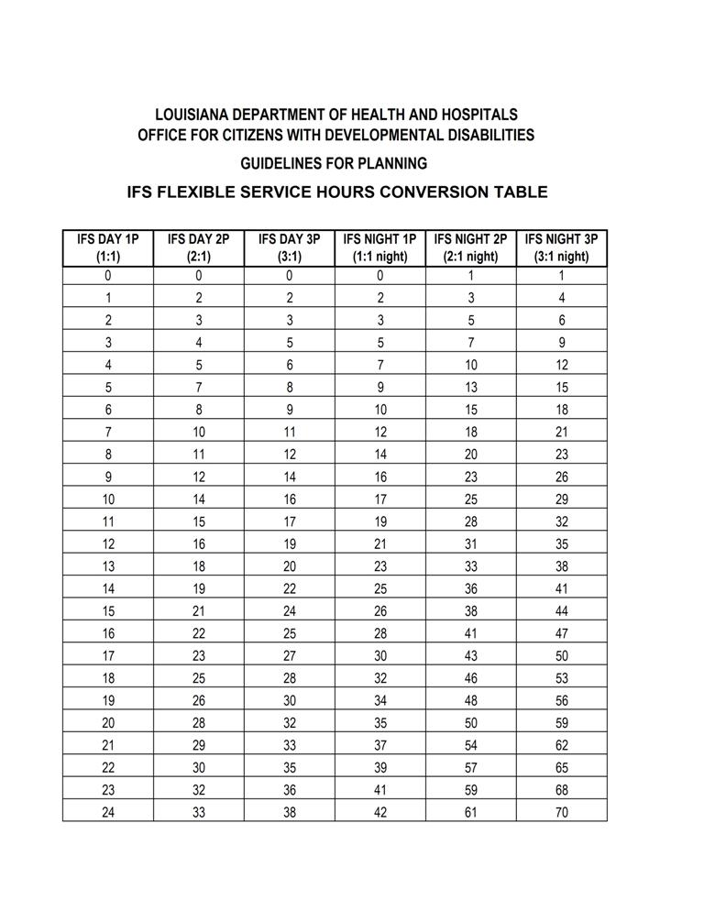

6

Using Shared Supports

6.1 Benefits of Sharing Supports
6.2 General Requirements for Sharing Supports
6.3 Requirements when Sharing Supports in Casual/Everyday Situations (Non-Roommate)
6.4 Requirements for Sharing Supports Among Roommates
6.5 NOW Protocol for Support Coordination and Sharing IFS Supports
6.6 Roles and Responsibilities of the IFS Provider with Service Delivery of Shared Supports
6.7 Roles and Responsibilities of the Participant when Sharing Supports
6.8 When Not to Share Supports
6.9 Using Intermittent Supports
6.10 Attachments
6.10.1 Shared Supports Brochure
6.10.2 HIPAA 404P
6.10.3 Documentation for Authorization of Shared Staff and Release of Information for New Opportunities Waiver (NOW)
USING SHARED SUPPORTS
Current NOW policy and procedures allow up to three participants who may or may not live together to share Individual and Family Supports.
Participants may share when the circumstances of the sharing are agreed to by each party and when the health and welfare can be assured for each participant.
Participants are required to share supports in the same setting, at the same time, while receiving supports from the same direct support person. A setting may include the home of one of the participants or a community setting.
A few examples of ways to share supports are listed below:
- weekend activities/hobbies/church/movies/sporting events
- morning/evenings (before/after work/day program)
- living with one or two persons (housemate)
Persons who do not live together may use intermittent supports, which involve a single direct support staff moving between residences to support each participant independently. Intermittent supports are not “shared,” but rather are an individual (one-to-one) service.

6.1 BENEFITS OF SHARING SUPPORTS
A. Sharing supports provides opportunities for a person to get to know others, expand one’s social support network, and become better integrated into one’s community.
      - Opportunities are available for a person to gain independence in day-to-day skills and increase self-confidence in his/her own abilities.
      - Sharing supports (and expenses) by having one or two housemates allows people to share their monthly living expenses, including rent, utilities, and food costs. This may result in improved housing options and having additional funds for recreation, leisure, and personal activities.
      - Sharing supports may lead to learning opportunities through exposure to other people, customs, and ways of life.
      - Even when sharing, people have opportunities for non-shared or one-to-one hours.
      - Sharing supports can lead to friendships and reduce isolation.
      - Relationships developed through sharing supports challenge individuals to try new things and grow.
B. Shared supports are included in all living independently guidelines (Attachment 5.10.2). Sharing supports for participants living with family can have similar benefits and extend the total hours of services available.
C. OCDD has a brochure available about sharing supports. (See Attachment 6.10.1.)

6.2 GENERAL REQUIREMENTS FOR SHARING SUPPORTS
A. Participants sharing supports are required to have the same IFS provider.
B. Both support plans must include authorized units for shared supports (two persons or three persons). The IFS provider bills for all participants simultaneously using the appropriate shared supports coding. The billing submission is required to match among participants served by the IFS provider.
Rate Example*:
1 person and 1 staff $4.00 per 15 minutes for one–to-one staffing
2 persons and 1 staff $2.88 per 15 minutes person 1
$2.88 per 15 minutes person 2
TOTAL $5.76 per 15 minutes for providing shared supports
*Rates are subject to change. Refer to the NOW Rate Code Sheet available on the OCDD web site for the most current rates.
C. Both support plans must include documentation that shared supports are appropriate service utilization.
D. The staff person who provides shared support services is required to be present with the participants at all times in order to bill for the service delivery.
- “Present” indicates proximity in a shared space, while allowing for independent movement and utilization of the environment.
- In the case of home delivery of shared supports, the IFS staff does not have to be in the same room with all participants, but may move freely between indoor and outdoor spaces related to the home to assist persons in choice activities. Staff must be available to respond readily to support needs.
- In the case of a community-based event, IFS staff may maintain proximity with visual and auditory contact, offering hands-on assistance when appropriate. By maintaining proximity, staff must be capable of providing prompt assistance and of quickly responding to support needs. For example, if two persons go to the park, staff may sit on a bench with one person, while maintaining visual/auditory contact with the other person who is playing fetch with his dog. Any break in contact, for example for toileting, must be brief.

  - Determining length/type of brief breaks in contact and the physical distance from the staff support is done on a case-by-case basis, taking into account the acuity level of each person, the particular community location, and the specific factors within the environment that may impact the health and safety of the persons supported.
E. Participants sharing supports are required to be present within the same residence, house, or apartment.
- Participants are not required to live together to share supports. However, in-home supports may not be shared between people who live in distinct residences when the persons are in their own respective homes. Participants are required to be in one residence together to share supports.
- Persons living next door to each other may not share supports when each is in his/her own home, including persons who live in separate apartments within one complex. (See Section 6.9 for discussion of Intermittent Supports.)
F. IFS Shared supports may be provided across settings so long as they are not billed during the same days and hours as the following other supports: Day Habilitation, Supported Employment, Employment Related Training, Transportation for Habilitative Services, Professional Consultation, Transitional Professional Support Services, Center-Based Respite, Skilled Nursing Services, Day-Night Individualized and Family Supports or Community Integration Development. (See Louisiana Medicaid Program Chapter 32 Section 32.10.3 and 32.10.3.1 for complete details.)
6.3 REQUIREMENTS WHEN SHARING SUPPORTS IN CASUAL/ EVERYDAY SITUATIONS (NON-ROOMMATE)
A. Support teams must discuss the appropriateness of shared supports for the participant. Teams must specifically address casual/everyday situations that may occur in the typical week, taking into account the following five items.
- Activities of Daily Living (ADL) support requirements during mealtimes and toileting. Does the person require hands-on, eyes-on at all times? If so, they will not be able to share a single staff with another person who also requires this level of care. Consider the length of time: Are there amounts of time where sharing is okay and then when sharing may not be okay? For example, a person with significant ADL support needs may be able to share supports for two hours, but sharing for six hours may put the person at risk.
- Medical support needs that may act as an exclusion to sharing with particular persons or during particular times, including medication administration, positioning and changing schedules, etc.
- Behavioral support needs that may act as an exclusion to sharing with particular persons or during particular times.
- Personal preferences and interests as identified in Discovery and throughout plan implementation. Participants should be supported to share when taking part in activities based on their own personal preferences and interests. These interests must be listed in the support plan. Any situations where shared supports should not occur should be clearly documented in the plan according to Section 6.3, B (below).
- Emergency situations and the type of intervention and assistance that may be required in such situations. Teams should assume a reasonable, prudent level of risk based upon a community standard.
B. Information relevant to sharing supports must be clearly documented in the support plan Section III.C, “Current Community Supports or Other Agency Involvement.” For example, the plan may include the following information to assist with shared supports service implementation:
- The person becomes frightened and agitated by crowds, so he/she should not attend events where this may be an issue.

- The participant requires constant hands-on support for mealtimes and is at high risk for choking, thus he/she should not share mealtime staff supports in the community with other persons who also need this level of support.
(Note: Sharing when eating out is probably best done with a person who is independent with dining and has no food-related behavioral support needs that may necessitate interruption.)
- Each participant must agree to inclusion of shared support hours in his/her support plan. This agreement is indicated by the participant’s signature on the final version of the support plan and any revisions.
- No signed agreement is required between service participants for casual/everyday sharing. The names of participants do not have to be listed in the support plan. Participants must utilize the same IFS provider. This means that a participant is free to share supports, within plan guidelines, with any individual also using the same IFS provider’s services.
- Participants are responsible for making their preferences related to specific persons and specific activities known to their IFS Provider.
F. IFS providers must implement support plan elements as specified in the plan. This includes making accommodations to offer shared supports based upon personal preferences and interests, including with whom the person shares and preferences for certain types of activities. A person’s preferences and interests, including who they wish to spend time with and how they wish to spend their time, may change during the plan year. Thus, if new preferences/interests are identified that are not listed in the support plan, the IFS provider may provide opportunities and activities that reflect these new preferences/interests. All service delivery must be consistent with goals and strategies in the support plan and with risk mitigation requirements. Changes in activities, preferences, and interests should be discussed with the support coordinator at the monthly call and quarterly meetings. The annual Personal Outcomes Assessment should also take any changes into account and incorporate the newly identified interests and preferences into the next annual plan or sooner if indicated.
G. Any significant change in information must be communicated to the support team immediately for discussion and revision of sharing criteria. Sharing criteria should be discussed at each quarterly meeting.

H. Both the participant and IFS provider should carefully evaluate any financial impact that sharing supports may have. Some activities such as dining out, going to the movies, or going shopping, if done every week, may put a strain on a fixed income. Thus, planning for free or low-cost activities that utilize community spaces and community events should occur. Going to church events, the park, free concerts, or the library may be good alternatives. Learning activities may also be low cost (learning to do own laundry, cook meals, etc.).
6.4 REQUIREMENTS FOR SHARING SUPPORTS AMONG ROOMMATES
    - Finding a person or persons to share supports within one’s home is based upon the choice and preferences of the participants involved. However, both support coordination agencies and IFS provider agencies are expected to assist participants with the process of selecting a roommate. Appropriately matching people who are compatible takes time and thought. If it is done well at the outset, it will reduce the likelihood that frequent, time-consuming revisions will have to be made later in plans.
    - A participant may already have an idea with whom he/she may like to live. If at all possible, persons completing the NOW offer activities (Section 2) are encouraged to choose the same support coordination agency as their prospective roommate. This will facilitate information sharing in the planning phase.
    - Participants must choose an IFS agency. Persons sharing supports must use the same IFS agency.
    - If the participant knows who he/she would like to live with, that preference should be indicated to the support coordinator during Discovery.
      - For those participants who have requested to be roommates, but currently use different IFS provider agencies, the participants involved must negotiate between themselves and come to an agreement on which IFS provider agency they will use. They may choose one of the agencies currently being used by one of the (potential) roommates, or they may choose a new agency. The support coordinator(s) involved will assist participants to exercise freedom of choice, but no support coordinator, OCDD affiliate, or provider staff may suggest or encourage participants to choose a particular IFS provider agency.
    - If the participant does not know who he/she would like to live with, the support coordinator notifies the chosen IFS provider and requests assistance.
      - The chosen IFS agency gets Discovery information from the support coordinator to evaluate the support needs and preferences of the person.
      - The chosen IFS agency suggests persons served/other incoming persons who may have similar interests.
      - The chosen IFS agency arranges formal and informal meetings, including meeting with families and/or in the person’s homes for possible roommates.

      - The participant completes the meetings and provides information on his/her preferences to an IFS agency representative participating in his/her planning.
      - The IFS agency representative gathers information relevant to sharing supports according to the indicated preferences.
    - If the person who is being considered as roommate does not utilize the same support coordination agency, the IFS provider agency explains the process and requests that both persons complete an information release (HIPAA 404P) (See Attachment 6.10.2.) for the opposite support coordinators representing the potential roommate situation. These releases are required so that support coordinators representing the two participants may openly discuss risks and benefits to sharing supports as roommates. When completing the HIPAA 404P form, the IFS provider should note the expiration date as one year from the “Request Date” (top section, first line of form). A new HIPAA 404P form is required each year for persons using different support coordination agencies. No information release is required if the participants share the same support coordination agency.
G. The IFS provider agency representative (able to make decisions about agency capability) and support coordinators assigned to the individuals must hold a discussion without the individuals present regarding the IFS provider agency offering services to the proposed pair. The discussion must include consideration of risks and benefits. In accordance with DHH HIPAA policies, this discussion occurs among the IFS provider and support coordinator(s) post-Discovery and is done in confidence to protect sensitive information about participants that may not be appropriate for release to the entire support team or to other participants. The Support Coordinator facilitates discussion of risks, benefits, and plan structure associated with a participant’s sharing supports with one or more specific individuals as roommates. The focus of the discussion is on whether the IFS provider can reasonably meet the support requirements and assure health and safety. The following are areas covered in this discussion.
- Activities of Daily Living:
- Source: SIS/LA PLUS, current team (if coming from ICF or community home), interview with person and family, previous or current staff.
- Discuss: Primary mode of mobility. Level of assistance needed (verbal prompting, modeling, hands-on) to complete everyday activities of daily living - transferring, toileting, eating, bathing, dressing, grooming. Can the person independently complete an ADL task and know the appropriate time in which to do so (e.g., washing hands after going to rest room)? How quickly does the person learn a new task?
- Medical:
- Source: SIS/LA PLUS, current team (if coming from ICF or community home), current physician, interview with person and family, previous or current staff.
- Discuss: Types and amount of physical assistance and/or equipment needed. Types of nutritional assistance needed. Known conditions or illnesses which result in departures from planned schedules or events. Known conditions or illnesses which require use of additional safety precautions. Medication administration including dosage time(s) and side effects. Incident reports related to medical issues.
- Behavioral/psychiatric:
- Source: SIS/LA PLUS, current team, current psychologist, psychiatrist or therapist records, police reports (history of arrests), interview with person and family, previous or current staff, incident reports related from current/previous provider.
- Discuss: Frequency, intensity, and duration of behavioral and/or psychiatric issues. Axis I and II diagnoses. Predictable and progressive behavioral patterns. Needed behavioral interventions.
- Personal preferences:
- Source: Interview with person and family, staff, current team, LA PLUS
- Discuss: Are there close friends or existing roommates who may wish to share supports? What type of people does he/she get along well with? Does he/she enjoy spending lots of time with others, or does he/she prefer to spend most time alone? What types of activities does he/she enjoy doing with others?
- Similar routines:
- Source: Interview with person and family, staff, current team.
- Discuss: Does this person have a consistent morning and/or evening routine? Is this routine similar to one or more persons being considered? Are there income considerations - sufficient funding for the planned living situation or activities? Are there transportation considerations, including availability of accessible transportation?
- Common interests:
- Source: Interview with person and family, staff, current team, results of Personal Outcomes Assessment, LA PLUS
- Discuss: Will the two or three participants most likely maintain shared supports for a consistent period of time? Do they have a relationship, or is there indication that one is likely to develop? Do they have clearly indicated common interests or a common goal? Have certain local activities, hobbies, or classes been identified which appeal to all participants sharing?
- Consistency in decisions:
- Source: Interview with person and family, staff.
- Discuss: Is the person unpredictable? Does he/she often change his/her mind about planned activities at the last minute? How will this impact participants sharing supports with him/her? What will the team do to encourage the participant to indicate changes in preferences in an appropriate and timely manner?
H. To move forward with planning, the discussion must result in a recommendation from the IFS provider and support coordinator(s) that the roommate match may be accommodated by the IFS provider and is appropriate within service requirements for health and safety assurance. If not appropriate, then the discussion should move to any alternate(s) proposed by the participant. If there are no alternate(s) proposed, the support coordinator and IFS provider must complete action at Section 6.4, I. (below) and assist the participant to resume facilitated meetings and continue the selection process.
I. The respective support coordinator(s) communicates the outcome of the discussion with the participants involved. All communication must respect minimum necessary information and federal HIPAA privacy standards. No protected health information or other privacy-protected information may be shared. The participants indicate their final preference regarding who is to be their roommate. The support coordinator and team must work to resolve outstanding barriers and issues related to the proposed living circumstance, removing barriers where possible while ultimately preserving health and safety of participants involved.
1. The participant will choose with whom he/she will live. Neither the support coordinator(s) nor the provider may mandate roommate choice.
2. The IFS provider may state that the agency is unable to accommodate the roommate request. In this circumstance, the support coordinator(s) provide assistance to the participant(s) to locate another IFS provider that is capable of accommodating the roommate request. The support coordinator is obligated to assist the participant to address barriers to service access/delivery and must exert effort to do so.
3. Competent individuals of age have the responsibility to choose with whom they live. In the waiver service, participants are subject to the judgment of the support team and OCDD Regional Waiver Office regarding health and safety assurances. If a participant makes choices in opposition to required waiver assurances, then that participant risks disenrollment and discharge from the waiver service.
4. The OCDD maintains administrative authority to approve or deny support plans based upon health and safety assurances. Corrective action requests are made, with timelines to complete interventions. OCDD Regional Waiver Offices, OCDD Regional Offices/ Human Services Districts & Authorities, and the OCDD Central Office are responsible for participating in interventions, including assisting the participant to find ways to address barriers and identify other persons with whom to share supports. If interventions fail, the OCDD Regional Waiver Office may take steps to disenroll the participant from the waiver service (See Section 10.1 Disenrollment, Decertification, and Discharge Procedures.)
J. If the team, inclusive of the participants’ consent, reaches consensus, and roommates are identified, then participants who will live together as roommates must be named in Section III.B of the CPOC, “Current Living Situation: Information.”
K.. The outcomes of the risk/benefit discussion must be documented in Section III.B of the support plan, “Current Living Situation: Information” and in Section III.C of the support plan, “Current Community Supports or Other Agency Involvement.”
      - Documentation must comply with minimum necessary information and HIPAA privacy standards for protection of sensitive health information. For example, a plan may specify “Universal precautions are required,” but may not state “Stacy’s roommate Mary has hepatitis, so staff must use universal precautions.”
L. Participants who live together as roommates and who agree to share supports must sign the Documentation for Authorization of Shared Staff and Release of Information for New Opportunities Waiver (NOW) (Attachment 6.10.3).
- The Documentation of Authorization of Shared Staff and Release of Information for New Opportunities Waiver (NOW) form provides release of information so that each participant’s name(s) may be used in the support plan, progress notes, provider service plan, etc. of other individuals with whom one shares.
        - The support coordinator must explain participant rights according to HIPAA and protected health information (PHI). Participants may choose to reveal PHI to their roommates, but PHI will not be discussed in the roommate’s team meetings or documented in the roommate’s support plan.
        - A participant’s roommate does not have access to his/her support plan unless the participant provides permission. A participant may provide permission for a roommate to receive a copy of the support plan by completing the HIPAA 404P form (Attachment 6.10.2). He/She must check the “OTHER” box and specify “support plan” in the space provided.
- The Documentation of Authorization (Attachment 6.10.3) explains that participants have a right to refuse or discontinue shared supports with their roommate(s). This right to refusal is conditional based on the following:
- Notification of the other participant(s) and support coordinator must be made 30 days prior to the requested effective date. This ensures adequate time to develop short and long-range planning for all participants impacted by the change.
- If a participant is at imminent risk, the shared situation may be discontinued immediately. All applicable reporting requirements must be followed.
- Not all requests for discontinuation may be granted in the timeframe requested, due to complications with legal agreements (marriage, lease agreements, judicial placements/orders), housing arrangements, or other health and safety concerns that would jeopardize waiver eligibility. The participant should be informed of any complications and assisted by his support coordinator and IFS provider to develop an appropriate and timely resolution. Persons who vacate the premises prior to resolving legal obligations may be subject to liability as a result of these obligations.
M. If family members of competent individuals of age voice objections regarding the roommate choice or plan elements for in-home supports, the support team should acknowledge appropriate concerns and ensure that any valid concerns are adequately addressed in the support plan.
  - Teams review the roommate risk/benefit discussion. If needed, the team should hold further team discussion to insure that all reasonable risks and valid concerns have been addressed appropriately. The support coordinator documents the required information in the support plan, making change updates (if plan not yet approved) or revisions as needed.
  - Plan elements and strategies must respect the competent individual’s rights and the rights of the roommate, while meeting the programmatic requirements and assurances of the waiver program.
  - Examples of family objections:
- Anne has a history of changing her mind frequently. She has never had a roommate before and may not fully understand the commitment she is making, instead thinking that she can leave when she feels like it.
    - Strategy to address: Involve Anne and her new roommate in choosing their apartment, selecting furnishings and decorations together, and moving in at the same time. (Responsible: IFS Provider and family) Provide ongoing education and reinforce points with Anne about the responsibilities of having a roommate. (Responsible: IFS Provider and family) Speak with Anne monthly about her roommate and what is working/not working. Ask her if she wants to continue living with her roommate. (Responsible: Support Coordinator)
- The family takes Frank on a one week vacation in the spring and home for the major holidays- Thanksgiving, Christmas, Easter, Fourth of July, Mother’s and Father’s day, and his birthday. We don’t see this noted in his support plan or schedule. We are assuming that taking Frank home for a few days might interfere with his roommate’s schedule for shared supports. Does this need to be addressed in Frank’s plan and also considered by his roommate’s team?
    - Strategy to address: Update or revise Frank’s support plan to include the planned natural support holidays. Firm up the exact dates and duration of the natural supports to finalize alternate schedule days for Frank. (Responsible: Support Coordinator) Speak with his roommate’s team about Frank’s anticipated holidays and the need for his roommate to utilize other sharing options, natural/community supports, or one-to-one hours, as appropriate. (Responsible: IFS Provider)
N. Plans for participants sharing supports among roommates are submitted at the same time (together) to the OCDD Regional Waiver Office. Each support coordinator (if different among roommates) is responsible for following the applicable timelines and process for submission of plans, whether the plan is an initial, annual, or revision. Support coordinators have a responsibility to maintain open communication with the other support coordinator involved to align their timelines and ensure that plans are submitted together.
O. Plans require review and prior approval by the same OCDD Regional Waiver Office staff.
P. In order to receive approval, plans must include:
- Signed Documentation for Authorization of Shared Staff and Release of Information for New Opportunities Waiver (NOW) (Attachment 6.10.3). This form must accompany all plans involving roommates, regardless of whether the plan is an initial, annual, or revision;
- Listing of all names of roommates in Section III.B of the CPOC, “Current Living Situation: Information” and documentation of discussion of risks and benefits in the same section (Plans must match up between participants.); and
- Copies of budget sheets of all participants with whom the person may share as a roommate (Budget sheets and typical weekly schedules must match up between participants in terms of overnight shared hours, early morning, and late evening.).
Q. Special instruction for those plans involving roommates during the 2009-2010 implementation year: If one roommate’s annual date is earlier than the other’s and a roommate’s plan is in the old CPOC format, the plan in the old format will require an addition/revision to Section III.B to comply with the plan review/approval requirements. Section III.B must be updated by documenting the outcome of the roommate risk/benefit discussion and the name of the participant’s roommate(s). The typical weekly schedule, alternate schedule(s), and budget sheet must be updated/revised as appropriate.
R Even if roommates have the same support coordinator, joint team meetings are not recommended due to confidentiality concerns. At all times, confidentiality protections must be observed by both the support coordinator(s) and IFS provider agency.
6.5 NOW PROTOCOL FOR SUPPORT COORDINATION AND SHARING
IFS SUPPORTS

A. It is recommended that participants sharing supports use the same support coordination agency if possible. This is not a requirement.
B. When the individuals have a common agency, OCDD encourages the agency administration to assess the appropriateness of a common support coordinator to maximize collaboration and coordination of supports.
C. When the individuals have different support coordination agencies or different support coordinators within the same agency, the expectation is that the support coordinators collaborate and coordinate services, including meetings, as appropriate and necessary.
D. The role of support coordinator includes completing assessments in the Discovery phase that assist in determining the appropriateness of shared supports and in planning for sharing opportunities. Assessments include:
- SIS/LA PLUS,
- Discovery Phase,
- Initial planning for support needs (frequency and intensity),
- Day activities planning,
- Risk assessment, and
- Setting the minimum adequate staff supports for each individual.
  - The support coordinator is the primary responsible party for identifying interests and preferred activities, routines, and preferences regarding shared supports (during Discovery) and documenting these in the support plan for implementation by the IFS provider.
  - The support coordinator is responsible for completing a risk assessment that takes into account shared supports. First, the determination must be made whether the participant may share supports at all, then the following:
- Identify circumstances in which the participant can share supports,
- Identify certain risk factors which may make the participant’s sharing supports difficult in given situations,
- Contextualize 1 and 2 above for team discussion according to instructions for team discussion of casual/everyday sharing (Section 6.3) and sharing with a roommate (Section 6.4), and
- Facilitate discussion of risk assessment results and other assessment/Discovery information with the participant’s team.
  - The support coordinator must focus the team on development of creative solutions and options that are consistent with preferences and support needs. This includes leading team discussion in creative ways of addressing preferences for use of IFS hours and mitigating risk (e.g., use of intermittent supports, assistive technology, equipment, or environmental modifications).
  - The support coordinator must assure the availability of ongoing opportunities (through the IFS provider) for making new friends and exploring new casual sharing partners or roommates, as desired.
  - The support coordinator works to maximize collaboration among support teams for persons considering/sharing supports.
J. The support coordinator must adhere to HIPAA and confidentiality requirements, and facilitate team members following established requirements.
K. Support coordinators are responsible for appropriate plan documentation and plan revision for shared supports prior authorization.
- All shared supports hours are included in the budget sheet and require prior approval.
- People who agree to share supports in casual settings have plan documentation as described in Section 6.3.
- People who agree to share supports as roommates complete all steps described in Section 6.4.

6.6 ROLES AND RESPONSIBILITIES OF THE IFS PROVIDER WITH
SERVICE DELIVERY OF SHARED SUPPORTS

- NOW protocol does not require persons sharing supports to have the same support coordinator or support coordination agency. The commonality is the IFS provider. Thus a fair amount of responsibility lies with the IFS provider to assist with the initial and ongoing matching of participants who wish to share supports.
- The IFS provider must offer opportunities for persons supported by the agency to meet each other. This facilitates matching participants to share supports in casual/everyday situations and as roommates. Formal and informal meetings hosted by IFS providers are for: (1) people coming into NOW and needing help locating persons to share supports with and/or (2) people already using NOW who want to explore sharing options.
- IFS providers assist participants to use shared supports with person(s) of choice as specified in the support plan.
- IFS providers should anticipate changes in casual/everyday sharing configurations, as participants’ needs and preferences change. People may develop new friendships and relationships. Thus, the IFS provider must equip staff to effectively support multiple persons and changing configurations of sharing partners in home and community settings.
- IFS providers must implement a process by which participants supported by their agency may make shared supports changes in a uniform manner.
- Items covered in the process may include: roommate change, apartment/home change, staff changes, staff preferences, alternatives to be attempted before resorting to changing shared supports and schedules, etc.
- The agency must be prepared to respond to questions and complaints about their process.
F. IFS providers must implement a continuing education program to keep participants informed of shared supports options.
1. The IFS provider must be able to provide answers to questions about changing roommates, changing schedules, emergencies, etc. within the scope of the IFS provider’s agency. Also, people should learn from other participants who have tried different configurations of shared supports (e.g., sharing daytime hours with one person and evening/night supports with a roommate).
2. IFS providers must share general information about shared supports provided by OCDD.
G. IFS providers discuss at the initial planning meeting and following planning meetings the outcomes of facilitated meetings, discussions with the participant regarding preferences, and formal requests made by the participant. The IFS provider agency completes steps in the process discussed in Section 6.4 for assistance in choosing a roommate and completing planning for roommates.
H. IFS providers assist participants to track utilization of flexible hours and alternate schedule hours as described in Section 5.

  - ROLES AND RESPONSIBILITIES OF THE PARTICIPANT WHEN SHARING SUPPORTS

A. NOW participants assume the following roles and responsibilities when sharing supports:
- Collaborate with one’s IFS provider to meet other waiver participants and establish compatible sharing partner(s).
- Provide ongoing feedback to his/her support coordinator and IFS provider about preferences with regard to participants with whom to share supports, as well as how he/she would prefer to share time with such person(s).
- Agree to adhere to his/her typical weekly schedule.
- Agree to terms of use of alternate schedule(s).
- Make preferences known regarding choice of flexible hours use.
- Agree to his/her responsibilities and timelines in regards to requesting changes to the typical weekly schedule (using flexible hours) as established in NOW policy, support coordination policy, and IFS agency policy.
- Complete HIPAA/confidentiality release (Form 404P) for discussion of personal information in the support coordinator/IFS team meeting on roommates.
- Sign Documentation for Authorization of Shared Staff and Release of Information for New Opportunities Waiver (NOW) (Attachment 6.10.3) with any roommate(s) listed in the approved support plan.
6.8 WHEN NOT TO SHARE SUPPORTS
A. There are some situations that are not conducive to sharing supports. The support coordinator must carefully assess the risks of sharing before proceeding.
B. The following list provides suggestions for situations in which sharing supports may exceed a reasonable level of risk. Individual cases that meet criteria below can be proposed as an exception through the Regional Waiver Office to the GPSORC for approval of shared supports.
- An individual who has been a sexual offender.
- An individual with high intensity aggressive episodes that have resulted in injury or were life-threatening (particularly if directed towards a roommate) in the past.
- An individual with a diagnosis of paranoid schizophrenia, anxiety disorder, or autism who exhibits a strong avoidance of social contact or has a history of significant altercations or injury to roommates.
- A person who has been a victim with a person who has a history of victimizing others.
- An individual with a significant wandering/elopement history that necessitate staff search and chase for extended periods of time (unless there is another mechanism for locating the missing roommate).
- An individual with a Borderline Personality Disorder diagnosis with significant history of false accusations or difficulty getting along with roommates.
- An individual with a highly infectious medical condition with someone else who requires extensive supports as well.
8. Other situations and/or conditions which may preclude sharing supports.
C. If a participant is unable to share supports when his/her recommended IFS hours include shared supports, the support team requests an exception with justification. The support coordinator prepares and submits a justification that is unique to the participant and directly tied to needs that distinguish the participant from others in their level membership.

- Status is reviewed at least quarterly or more frequently with a significant change in the participant’s circumstances.
- Sections 5.7 to 5.9 provide more information about justifying the need for additional IFS hours.
6.9 USING INTERMITTENT SUPPORTS
  - Participants sharing supports at home are required to be present within the same residence, house, or apartment. For people who do not have a roommate, sharing supports overnight and at early morning and late hours within the Resource Allocation System may be challenging. In these cases, intermittent supports may be programmatically appropriate.
  - Intermittent supports are non-continuous paid supports delivered in appropriate time increments, ranging from 15 minutes to an hour. The direct support worker is not physically present for a continuous period of time, but rather comes in and out of the home or community setting in prescribed time increments.
  - Support teams must discuss risks and benefits associated with using intermittent supports and record the discussion outcome in the support plan (CPOC Section III.B). Teams should focus on supporting participants to be as independent as possible, while also assuring health and safety. Reasonable risk is an expected part of utilizing intermittent supports. Technology, natural supports (such as neighbors), or creative alternatives to mitigating risk may be utilized.
  - Support plans (CPOC Sections VI and IX) and billing are required to reflect appropriate use of intermittent supports.
  - In the event of nearness of residences (apartments in the same complex), supports delivered in home may be intermittent coupled with shared instances when persons do things together, like watch TV or share a meal. The following example provides a scenario of intermittent supports coupled with shared supports:

Intermittent Supports Coupled with Shared Supports Example:
Sally and Ann live next door to each other. Sally and Ann use the same IFS provider and receive intermittent supports in the morning to get ready for work. The staff person visits Sally at 6:30 AM to wake her up and prompt her to brush her teeth and dress. The staff person prepares breakfast and leaves it on the table for Sally. At 7:00 AM, the staff person visits Ann to do the same. At 7:30 AM, the staff person checks back with Sally to ensure that she is ready to go to work. At 7:45 AM, the staff person checks with Ann to make sure she is ready to go to work. Sally and Ann leave together with their staff at 8:00 AM to go to the lobby of their apartment building and wait for the bus, which usually comes between 8:15 AM and 8:30 AM.
Scheduling Intermittent and Shared Supports
 | Sally | Ann
6:30 AM | S5125 U1 | --
6:45 AM | S5125 U1 | --
7:00 AM | -- | S5125 U1
7:15 AM | -- | S5125 U1
7:30 AM | S5125 U1 | --
7:45 AM | -- | S5125 U1
8:00 AM | S5125 U1, UN | S5125 U1, UN
8:15 AM | S5125 U1, UN | S5125 U1, UN

6.10 ATTACHMENTS

6.10.1 Shared Supports Brochure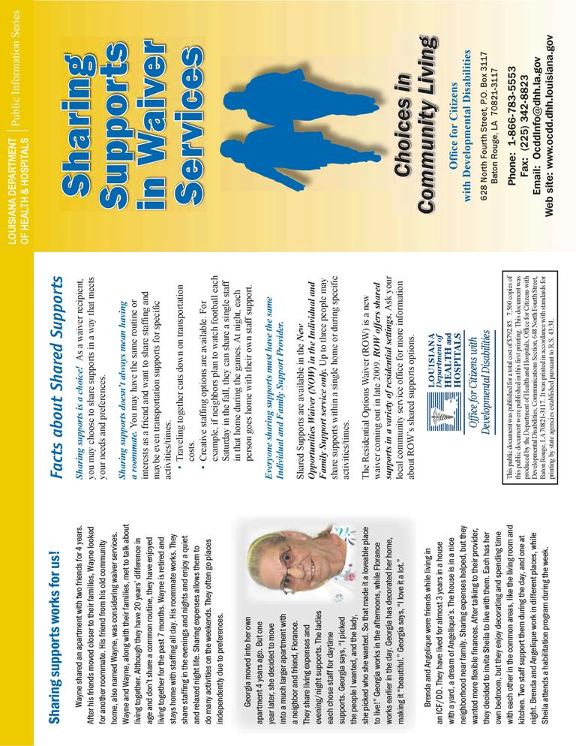
6.10.1 Shared Supports Brochure
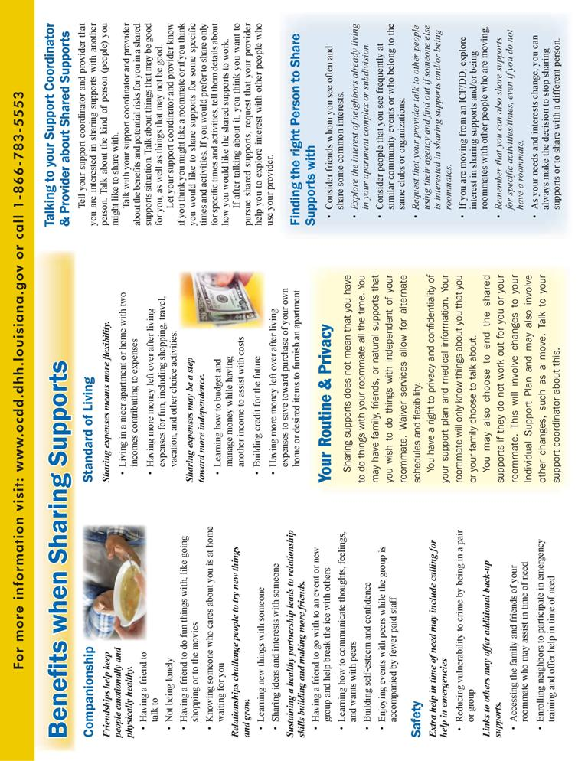

    - HIPAA 404P
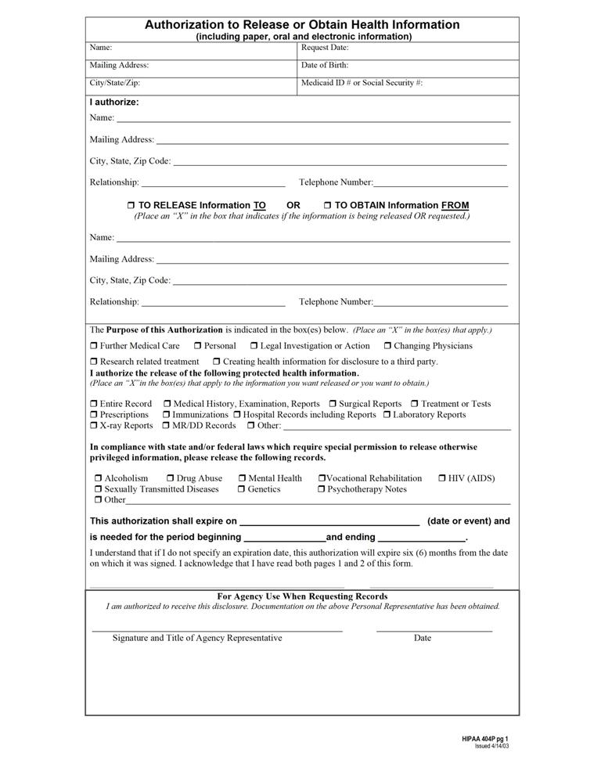
6.10.2 HIPAA 404P
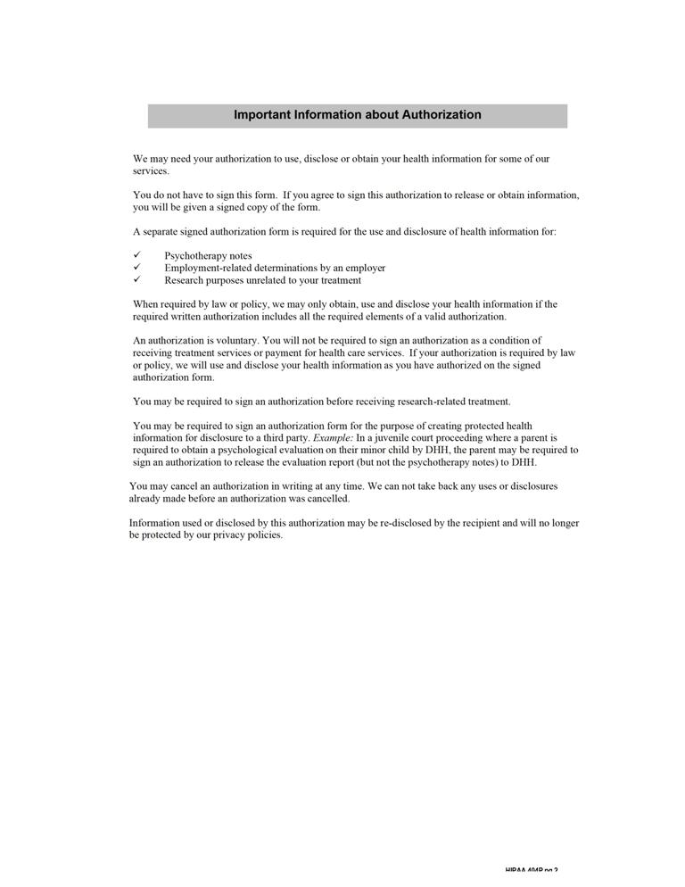
6.10.3 Documentation for Authorization of Shared Staff and Release of Information for New Opportunities Waiver (NOW)
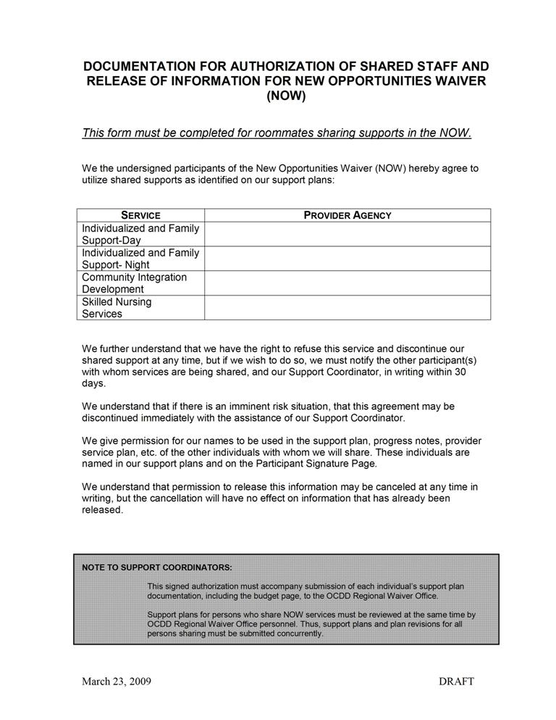
6.10.3 Documentation for Authorization of Shared Staff and Release of Information for New Opportunities Waiver (NOW)
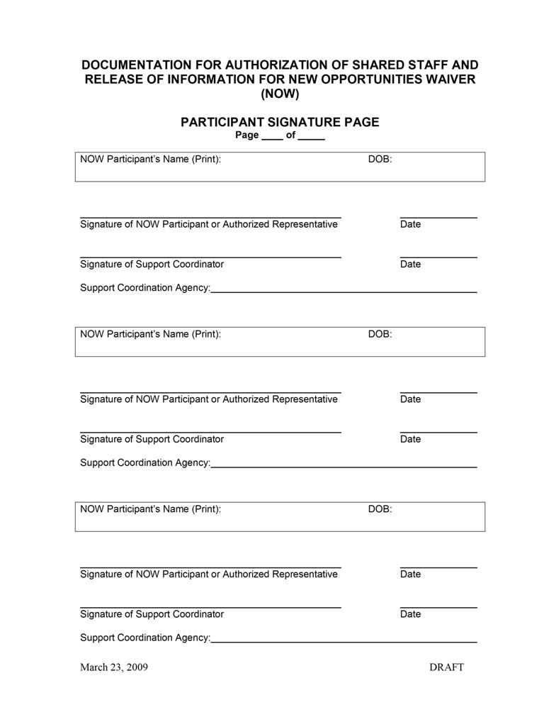

7

Support Plan Approval Process

7.1 Supervisory Review
7.2 OCDD Regional Waiver Office Review
7.3 OCDD Guidelines for Planning Regional Office Review Committee
7.4 OCDD Guidelines for Planning State Office Review Committee
7.5 Attachments
7.5.1 Individual Supports Review (ISR)
7.5.2 Individual Support Plan Approval Guidelines form

SUPPORT PLAN APPROVAL PROCESS
In order to assure that the “Guidelines for Support Planning” are implemented consistently for all individuals receiving NOW services, OCDD has restructured the support plan approval process.

The approval process is built on a three-tiered review and approval system. The review is based upon criteria detailed in the Individual Support Review (ISR) Protocol (Attachment 7.5.1).
- Review and approval by the support coordinator supervisor to assure plan compliance with established criteria and provide ongoing supervision, feedback, and training to all Support Coordinators.
- Review by the OCDD Regional Waiver Office to assure that all CMS and OCDD requirements are met and that health and safety can be assured.
- Review by the OCDD Guidelines for Planning Regional Office Review Committee (GPRORC) and/or Guidelines for Planning State Office Review Committee (GPSORC) when exceptions to recommended IFS hours are requested, when any element of a proposed plan is appealed, when the participant’s plan indicates significant risk issues as determined by the committee, when the participant’s SIS/LA PLUS indicates an outlier or atypical score profile, and upon request.
- Review by the OCDD Regional Waiver Office and the OCDD Guidelines for Planning State Office Review Committee (GPSORC) to certify support coordinators and supervisors in use of the “Guidelines for Support Planning.”
Attachment 4.4.1 contains details of timelines for initial support planning, including timeframes related to the support plan submission and approval process.

7.1 SUPERVISORY REVIEW
- A. Upon completion of the support plan, the support coordinator submits the plan to his/her supervisor for review and approval. Support coordination agencies must work internally to complete this review within the timeframes required for plan development (See Section 4 and Attachment 4.4.1).

- The support coordinator supervisor reviews the plan using the Individual Supports Review (ISR) Protocol (Attachment 7.5.1). For each item, the supervisor uses the guidelines within the ISR to determine the rating for each item and places a mark in the appropriate column for the rating.

- Basic required items (as determined by OCDD) must achieve a particular rating for the plan to be recommended by the supervisor to the OCDD Regional Waiver Office for approval. The necessary compliance rating is determined by OCDD. Plans are submitted for approval to the OCDD Regional Waiver Office only after the supervisor verifies the plan meets the compliance criteria.

- ISR protocol required areas requiring correction must be addressed by the support coordinator prior to submission to the waiver regional staff. Once corrected the supervisor notes the correction and changed rating on the Individual Supports Review.

- The remaining items can be shaped and corrected over time with actions in the support plan where appropriate. For these remaining items, the supervisor provides notes about the corrections and plans on the Individual Supports Review.

- If during ISR review, the support coordinator supervisor discovers a significant oversight or error in the SIS/LA PLUS ratings or significant changes in support needs have occurred since the assessment, the supervisor will require that the support coordinator send a written request with the plan submission requesting permission to alter the relevant ratings.

- The written request should include specific and compelling justification for the request to alter assessment ratings based on available information about the person.

- The request should reference exactly which items/ratings the support coordinator is requesting be altered.

- The request should reference the source of the information suggesting the rating(s) should be altered.

- Examples of when alterations might be requested include:

- Failure to note in SIS section 3A a medical support issue, and there is clear evidence that this support need exists and should have resulted in different ratings.

- Example 1: During SIS assessment, it was not reported that the person has diabetes. The medical diagnosis was discovered in reviewing medical records, and it was noted that in addition to being on medication, the person is on a special diabetic diet and that support is required for such.

- Example 2: During SIS assessment, the assessor was not made aware that the person has occasional asthma attacks. It is later reported during Discovery that the person requires inhaler treatments from time to time, and staff must closely observe for asthma symptoms during the winter months, particularly when he goes outdoors into the cold or when he exercises in the cold. The parent recalls an incident last year when failure to do this led to an attack.
- Failure to note in SIS section 3B a behavioral support issue and there is clear evidence that this support need exists and should have resulted in different ratings.
- Example 1: During SIS assessment, it was not reported that the person has mental health treatment support needs. During Discovery, the support coordinator discovers that the person has had two previous psychiatric hospitalizations and currently receives ongoing preventative environmental or therapeutic supports to minimize recurrence of psychiatric symptoms.

- Example 2: During SIS assessment, it was not reported that a person has, in the past, engaged in episodes of stealing from various stores. It is later reported by the family that, while there have been no episodes of stealing in the past year, it is because they never take their son to stores; thus, he has not had the opportunity to steal.
- After the written request has been submitted, the Regional Waiver Office staff will review the assessment and will:
- Request the Support Coordinator submit a revised assessment,
- Require an updated SIS/LA PLUS assessment if significant changes in status have occurred,
- Request additional justification for the alteration of ratings, or
- Instruct the Support Coordinator that the new information does not warrant revising the assessment.
- If the Regional Waiver Office staff request the assessment be revised, revision should be submitted to the ROS within 3 working days of the request.

7.2 OCDD REGIONAL WAIVER OFFICE REVIEW
- Following completion of the plan by the support coordinator, the SIS/LA PLUS, support plan and the supervisory review consistent with Section 7.1, along with all required documentation and assessments, are sent to the regional waiver staff for review and approval prior to implementation of the plan. Required documents and assessments include:

- Supports Intensity Scale and Louisiana Plus (SIS/LA PLUS),

- 90-L,

- Behavioral assessment for individuals with behavior plan,

- Psychiatric evaluation for individuals receiving psychotropic medication,

- Most recent support plan and last year’s worth of quarterly reviews from the Supports and Services Center if moving from a Supports and Services Center,

- Any other assessments/documents used in the planning process, and

- If the request is for an exception, permanent or temporary, to the Louisiana Resource Allocation System hours, a written justification using a format prior-approved by OCDD Central Office must be completed. This format should include the exception as well as other options explored and the expected period of time the exception will be required.

- Upon receipt of the assessment and support plan, the Assistant Community Services Regional Administrator assigns a waiver regional staff member to complete the approval process.

- The assigned regional waiver staff reviews the plan using the SIS/LA PLUS protocol and Individual Supports Review (ISR) for all initial plans and annual plans with a new SIS/LAPLUS. For annual plans with no new SIS/LAPLUS, the regional waiver staff reviews the support coordinator supervisor’s ISR and completes the Individual Support Plan Approval Guidelines form (Attachment 7.5.2). Assessments and plans are reviewed within ten (10) working days of submission of the plan and required documentation. For each item, the staff member uses the guidelines within the SIS/LA PLUS protocol and the ISR to determine the rating for each item and places a mark in the appropriate column for the rating according to protocol established for both instruments.

- The table on the last page of the ISR is completed after all items are scored. In order for a plan to be approved, the required ratings must be present per the instructions on the last page of the ISR.

- The assigned regional waiver staff compares his/her ratings to the submitted support coordination supervisor ratings when an ISR is completed. Reliability of the ratings between the support coordinator supervisor and the OCDD Regional Waiver Office staff are calculated by dividing the number of items in agreement by the total number of items.

- The OCDD Regional Waiver Office staff maintains documentation of the following components of the review and approval process:

- name of the support coordinator,

- name of the support coordinator supervisor,

- name of the OCDD Regional Waiver Office staff completing the review,

- name of the participant,

- date of support plan,

- date of linkage,

- date of submission,

- date of review,

- approval status,
- approved,
- approved with recommendations,
- approved for 90 days,
- returned for corrections,
- date returned with corrections (if applicable),
- date approved,
- initial ISR scores, and
- ISR scores at time of approval.
- If the plan indicates support needs which require additional review (i.e., plans which request IFS hours beyond the recommended level, plans associated with atypical score profiles and indicate a potential outlier to the Resource Allocation model, etc.), the plan and supporting documentation is forwarded to the OCDD Guidelines for Planning Regional Office Review Committee (GPRORC) as described in Section 7.3 or the Guidelines for Planning State Office Review Committee (GPSORC) as described in Section 7.4.

- There are particular plans which request additional IFS hours beyond the recommended level, but are exempt from the need for a committee review. The following plans can be approved by Regional Waiver Office staff and do not require review by the regional or state committees:

- A one-year approval for hours over the allocation (inclusive of 24-hour 1:1 supports if recommended by the support team) for individuals transitioning from an SSC/ICF institutional setting. This approval period applies only to the first year in waiver services; following the initial first year, the approval guidelines are the same as with any other waiver recipient (i.e., will require review and approval by regional/state committee).

- Temporary requests for additional hours due to caregiver illness/absence or individual illness necessitating short-term additional supports which are limited to less than 30 days (per each request). The Regional Waiver Office may approve a first time request (up to 30 days) and one renewal of this original request (up to an additional 30 days). If the request is needed beyond 60 days (length of original request plus one renewal), or if more than two separate requests for additional hours (for 30 days or less) are made, GPRORC approval is needed.

- Plans whose typical weekly schedule is within the recommended hours, but additional hours (in an alternate schedule) are needed only for school/day program closures. This exception pertains only to those persons assigned to Levels 2-5 and meet the following criteria:

- Natural supports are unavailable to provide care (i.e., both parents are at work), and there is no appropriate alternative care available (i.e., individual is too old to attend day care).

- When possible, efforts must be made to have natural supports available to provide care for some of the school/day program closure days.

- If a plan falls within the BASIC level membership and the support team determines that a small number of IFS hours would more appropriately meet the individual’s needs instead of use of the typical SIL service, these plans may utilize IFS hours if the cost of the hours is less than or equal to the cost of the SIL per diem rate.

- If during review, it is determined by the OCDD Regional Waiver Office that a significant oversight or error in SIS/LA PLUS ratings of medical or behavior support needs has occurred or that significant changes in status of support needs have occurred since the most recent assessment, the assigned Regional Waiver staff should instruct the support coordinator to 1) make revisions to the assessment or complete a reassessment, and 2) submit revisions or an updated assessment to the ROS.

- The support coordinator should make revisions only at the instruction of the assigned OCDD Regional Waiver Office staff.

- Revisions or reassessments and justification should be submitted to the ROS within 10 working days of the request by the OCDD Regional Waiver Office.

- After the written request has been submitted by the support coordinator, the ROS will:

- Submit the revised assessment to the database and if necessary provide the support coordinator with a new Level. The revised assessment will replace the previous assessment.

7.3 OCDD GUIDELINES FOR PLANNING REGIONAL OFFICE REVIEW COMMITTEE
- OCDD developed the Guidelines for Planning Regional Office Review Committee (GPRORC) and process to perform oversight functions required for implementation of the “Guidelines for Support Planning.” The committee’s duties include:
  - Review of support plans for each support coordinator and supervisor following the “Guidelines for Support Planning” training in accordance with OCDD quality review protocols;
  - Review of plans that request hours above the IFS hours recommended for the individual’s acuity level, including requests for temporary changes and permanent changes;
  - Review of plans and SIS assessments that show atypical score profiles and potentially signify outliers to the Resource Allocation Model; and
- Committee Membership
- The OCDD Guidelines for Planning Regional Office Review Committee is chaired by the OCDD Regional Office Specialist (ROS), or designee. Committee members include:
- Assistant Community Services Regional Administrator (CSRA),
- Regional Waiver Office staff assigned to the case,
- Support coordination staff (optional).
- Process and Procedure
- An initial person-centered plan is completed for all individuals using the support plan and process discussed in Sections 3 through 6.
- The plan is forwarded to the OCDD Regional Waiver Office for review and approval according to current approval process. The plan is reviewed consistent with Sections 7.1 and 7.2.
- The assigned Regional Waiver Office staff forwards plans needing GPRORC discussion to the GPRORC chair within one working day of review. The following additional information must accompany each plan and budget:
- Approved Supports Intensity Scale and Louisiana PLUS (SIS/LA PLUS) that resulted in level assignment,
- 90-L,
- Behavioral assessment for individuals with behavior plan,
- Psychiatric evaluation for individuals receiving psychotropic medication,
- Most recent support plan and last year’s worth of quarterly reviews from the Supports and Services Center if moving from a Supports and Services Center,
- Any other assessments/documents used in the planning process, and
- If the request is for an exception, permanent or temporary, to the Louisiana Resource Allocation System hours, a written justification for the exception including other options explored and the expected period of time the exception is required. A format prior-approved by OCDD Central Office must be used.
- The GPRORC Chair forwards the plan and/or assessment (and accompanying documentation) to the committee members with notice of review scheduled for the next GPRORC meeting.
- The committee is scheduled to meet every week at a designated day and time. All reviews must be completed within five working days of receiving the plan.
- The committee completes a review and makes one of the following recommendations relative to the assessment:
- The assessment is adequate considering newly presented information (It adequately captures the support needs of the individual in areas of general, medical, and behavioral supports.);
- The assessment contains minor inaccuracies but does not result in inaccurate level membership, does not substantially alter the support plan, and does not negatively impact allocated resources (Some information on the SIS/LA PLUS needs to be adjusted in collaboration with the support coordinator after considering newly presented information.);
- The assessment results do not adequately reflect the needs of the person.
- If is it determined from the review process that the assessment inadequately captured the individual’s support needs (e.g., the assessment over predicts or under predicts the support needs of the individual and/or fails to capture important general, medical, or behavior support needs), then a new SIS/LA PLUS needs to be completed.
- The support coordinator is informed of the areas of suspected deficiency in the assessment and asked to schedule another assessment of the individual within three days of announcement of the decision in the matter.
- Once completed, this new assessment is submitted to the GPRORC Chair for review and level assignment. After the support coordinator is informed of the results and level assignment, he/she is to begin revising the support plan based on the revised assessment data and other recommendations from the committee.); or
- More information is needed before a determination can be made (The support coordinator is responsible for gathering and forwarding the information to the GPRORC for determination.).
Note: Because the SIS requires specialized training and certification to administer and score, it will not be subject to appeal after the reviews noted above.
- The committee makes one of the following recommendations relative to the plan:
- The plan meets the individual’s identified needs and outcomes, and no alternate strategies exist to meet the identified needs and outcomes (If additional hours have been requested, then the hours are approved. Approved hours are time limited, and the Committee specifies the timeframe for the approval.);
- The plan meets the individual’s identified needs and outcomes, but strategies exist that should be considered by the support team (If additional hours have been requested, then they are not approved, and recommendations for modifications are forwarded to the support team.); or
- The plan does not meet the individual’s identified needs and outcomes (Specific recommendations regarding plan supports in excess of need, unaddressed needs and unaddressed outcomes are forwarded to the support team.).
- The recommendation is forwarded by the committee chair (or designee) to the OCDD Regional Waiver Office and support coordinator within five working days of the decision.
- The recommendations are addressed and implemented by the individual’s support team with assistance from the OCDD Regional Waiver Office as needed. When there are questions, concerns or alternate proposals to the recommendations, the support team, led by the support coordinator, discusses options with the OCDD Regional Waiver Office waiver staff.
- A response addressing the recommendations is forwarded through the OCDD Regional Waiver Office to the committee chair within specified timelines determined in the review.
- Each month the GPRORC submits a report to the OCDD Quality Improvement Committee and OCDD Executive Management Team regarding the following:
- Number of plans reviewed,
- Percentage of plans meeting Individual Supports Review requirements,
- Percentage of plans meeting support needs within the IFS hours allocated,
- Percentage of plans meeting supports needs but requiring additional IFS hours,
- Total number of approved hours above the IFS hours allocated (Monthly and Year to Date) by Level and living arrangement,
- Summary of the factors justifying the approval,
- Percentage of plans for which alternate programmatic options could be explored,
- Types of alternate options proposed, and
- Reasons for eliminating possible alternate options
- Notification to Initiate Services
- The GPRORC Chair electronically sends notice, including information about IFS hours approved above the maximum recommendation for the participant’s level, to SRI and the OCDD Regional Waiver Office within one working day of plan approval.
- All plans requesting additional IFS hours beyond the recommended amount will be reviewed by the GPRORC. Those plans which request additional hours on a more permanent basis (multi-year approvals) or those plans which may require exceptional resources such as 2 on 1 staff support are the only plans that require additional review and approval by GPSORC. Exceptions to GPRORC and/or GPSORC review are discussed in Section 7.2

7.4 OCDD GUIDELINES FOR PLANNING STATE OFFICE REVIEW COMMITTEE
- OCDD developed the Guidelines for Planning State Office Review Committee (GPSORC) and process to perform oversight functions required for implementation of the “Guidelines for Support Planning.” The committee’s duties include:
- Review of plans that request hours above the IFS hours recommended for the individual’s acuity level, including requests for temporary changes and permanent changes;

- Review of plans and SIS assessments that show atypical score profiles and potentially signify outliers to the Resource Allocation Model;

- Review of SIS assessments (previously reviewed and approved by Regional Waiver Office staff) in which the SIS level is disputed by a family member or caregiver; and

- Review and recommendation of changes to the “Guidelines for Support Planning”.

- Committee Membership
- The OCDD Guidelines for Planning State Office Review Committee is chaired by the OCDD Clinical Director, or designee. Committee members include:
- NOW Program Manager,

- OCDD Central Office Staff as determined by the Assistant Secretary,

- Assigned OCDD Regional Waiver Office staff in the region submitting the plan or requesting an exception (Assistant Community Services Regional Administrator, Regional Office Specialist, and assigned regional office waiver staff), and

- A self-advocate

- Process and Procedure
- An initial person-centered plan is completed for all individuals using the support plan and process discussed in Sections 3 through 6.
- The plan is forwarded to the OCDD Regional Waiver Office for review and approval according to current approval process. The plan is reviewed consistent with Sections 7.1 and 7.2.
- The GPRORC Chair or designee forwards plans needing GPSORC discussion to the GPSORC Chair within one working day of review and determination of need for GPSORC review by the regional office staff member assigned the plan for review. The following additional information must accompany each plan and budget:
- Approved Supports Intensity Scale and Louisiana PLUS (SIS/LA PLUS) that resulted in level assignment,
- 90-L,
- Behavioral assessment for individuals with behavior plan,
- Psychiatric evaluation for individuals receiving psychotropic medication,
- Most recent support plan and last year’s worth of quarterly reviews from the Supports and Services Center if moving from a Supports and Services Center,
- Any other assessments/documents used in the planning process, and
- If the request is for an exception, permanent or temporary, to the Louisiana Resource Allocation System hours, a written justification for the exception including other options explored and the expected period of time the exception is required. A format prior-approved by OCDD Central Office must be used.
- The GPSORC Chair forwards the plan and/or assessment (and accompanying documentation) to the committee members with notice of review scheduled for the next GPSORC meeting.
- The committee is scheduled to meet every week. All reviews must be completed within five working days of receiving the plan.
- The committee completes a review and makes one of the following recommendations relative to the assessment:
- The assessment is adequate considering newly presented information (It adequately captures the support needs of the individual in areas of general, medical, and behavioral supports.);

- The assessment contains minor inaccuracies but does not result in inaccurate level membership, does not substantially alter the support plan, and does not negatively impact allocated resources (Some information on the SIS/LA PLUS needs to be adjusted in collaboration with the support coordinator after considering newly presented information.);

- The assessment results do not adequately reflect the needs of the person.
- If is it determined from the review process that the assessment inadequately captured the individual’s support needs (e.g., the assessment over predicts or under predicts the support needs of the individual and/or fails to capture important general, medical, or behavior support needs), then a new SIS/LA PLUS needs to be completed.
- The support coordinator is informed of the areas of suspected deficiency in the assessment and asked to schedule another assessment of the individual within three days of announcement of the decision in the matter.
- Once completed, this new assessment is submitted to the ROS and GPSORC chair for review and level assignment. After the support coordinator is informed of the results and level assignment, he/she is to begin revising the support plan based on the revised assessment data and other recommendations from the committee.); or
- More information is needed before a determination can be made (The support coordinator is responsible for gathering and forwarding the information to the GPSORC for determination.).
Note: Because the SIS requires specialized training and certification to administer and score, it will not be subject to appeal after the reviews noted above.
- The committee makes one of the following recommendations relative to the plan:
- The plan meets the individual’s identified needs and outcomes, and no alternate strategies exist to meet the identified needs and outcomes (If additional hours have been requested, then the hours are approved. Approved hours are time limited, and the Committee specifies the timeframe for the approval.);
- The plan meets the individual’s identified needs and outcomes, but strategies exist that should be considered by the support team (If additional hours have been requested, then they are not approved, and recommendations for modifications are forwarded to the support team.); or
- The plan does not meet the individual’s identified needs and outcomes (Specific recommendations regarding plan supports in excess of need, unaddressed needs and unaddressed outcomes are forwarded to the support team.).
- The recommendation is forwarded by the committee chair (or designee) to the OCDD Regional Waiver Office and support coordinator within ten working days of the decision.
- The recommendations are addressed and implemented by the individual’s support team with assistance from the OCDD Regional Waiver Office as needed. When there are questions, concerns or alternate proposals to the recommendations, the support team, led by the support coordinator, discusses options with the OCDD Regional Waiver Office waiver staff.
- A response addressing the recommendations is forwarded through the OCDD Regional Waiver Office to the committee chair within specified timelines determined in the review.
- Each month the GPSORC submits a report to the OCDD Quality Improvement Committee and OCDD Executive Management Team regarding the following:
- Number of plans reviewed,

- Percentage of plans meeting Individual Supports Review requirements,

- Percentage of plans meeting support needs within the IFS hours allocated,

- Percentage of plans meeting supports needs but requiring additional IFS hours,

- Total number of approved hours above the IFS hours allocated (Monthly and Year to Date) by Level and living arrangement,

- Summary of the factors justifying the approval,

- Percentage of plans for which alternate programmatic options could be explored,

- Types of alternate options proposed, and

- Reasons for eliminating possible alternate options

- Notification to Initiate Services
- The GPSORC Chair electronically sends notice, including information about IFS hours approved above the maximum recommendation for the participant’s level, to SRI and the OCDD Regional Waiver Office within one working day of plan approval.

7.5 ATTACHMENTS
Attachment 7.5.1 Individual Supports Review (ISR)
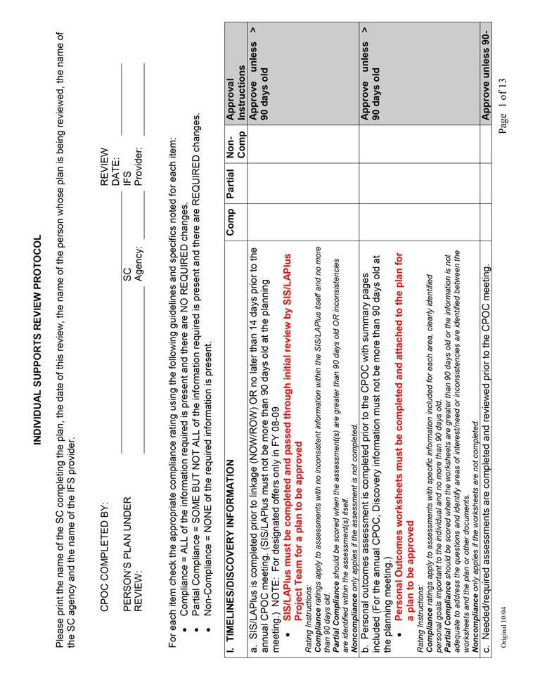
Attachment 7.5.1 Individual Supports Review (ISR)
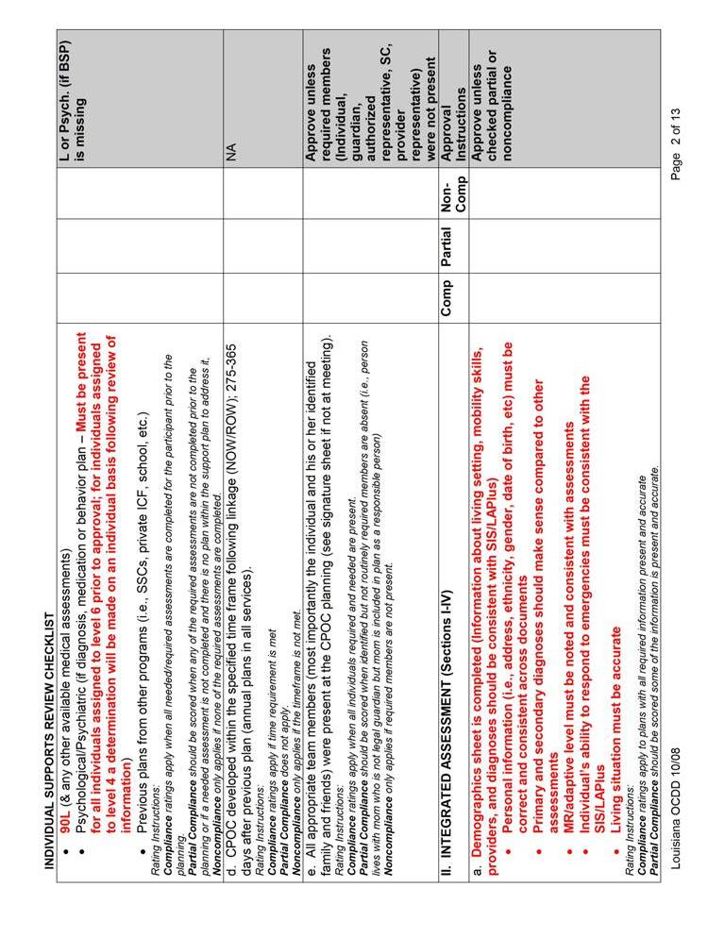
Attachment 7.5.1 Individual Supports Review (ISR)
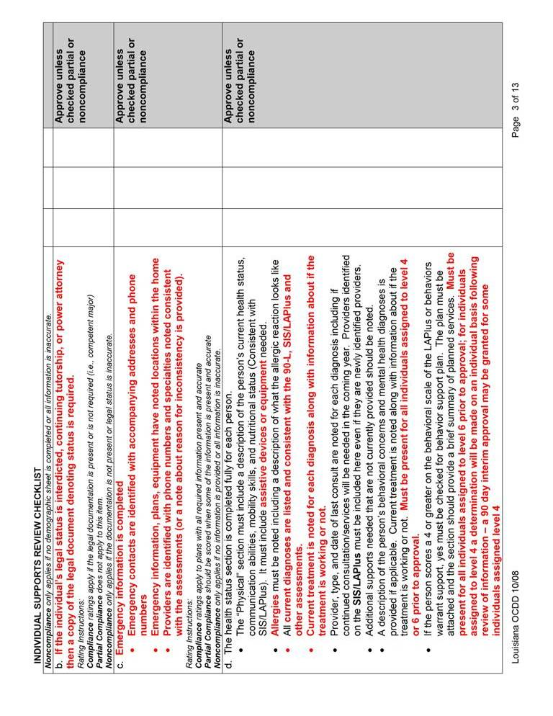
Attachment 7.5.1 Individual Supports Review (ISR)
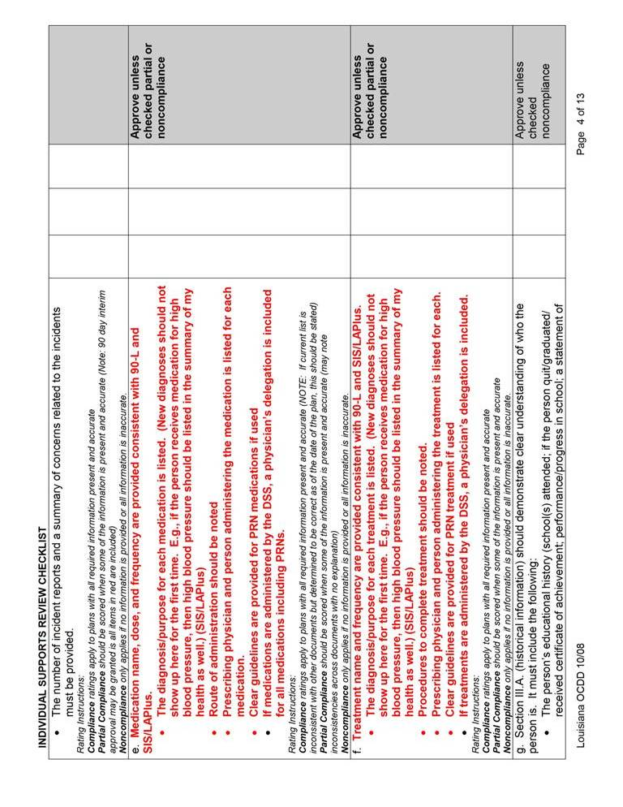
Attachment 7.5.1 Individual Supports Review (ISR)
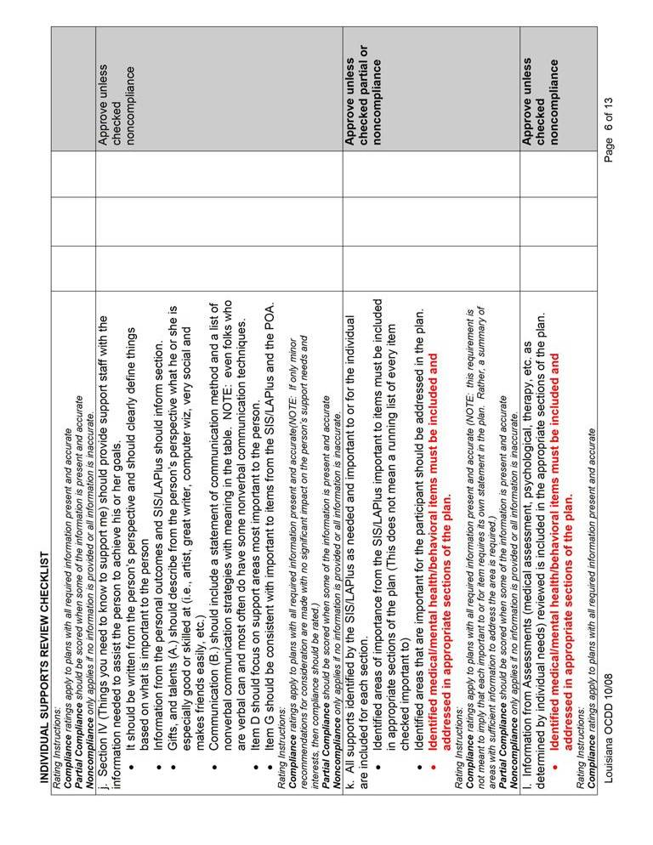
Attachment 7.5.1 Individual Supports Review (ISR)
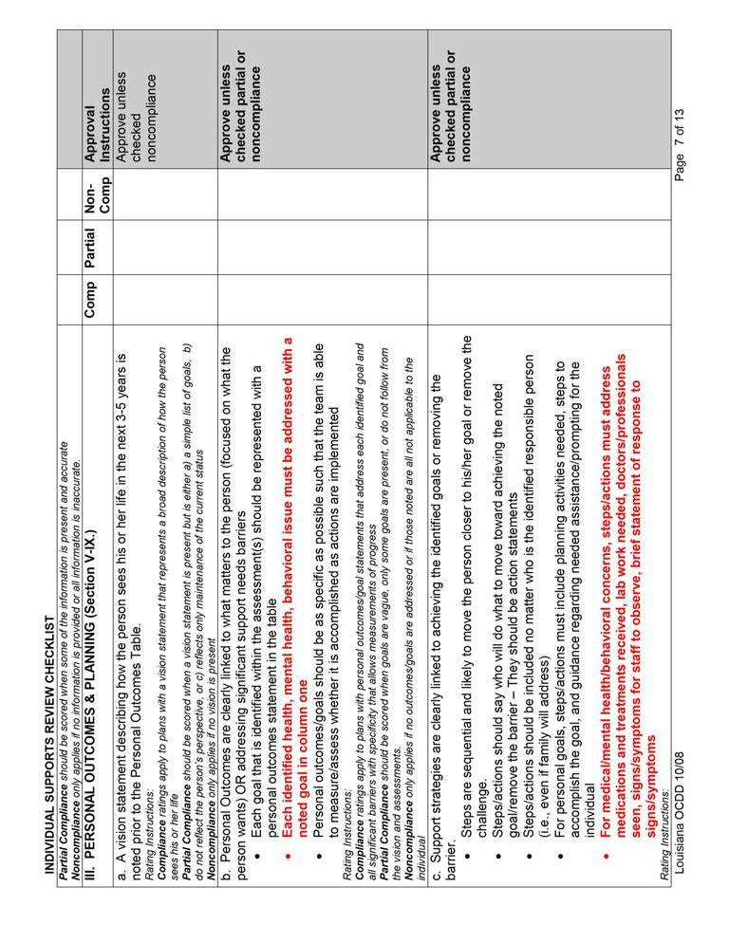
Attachment 7.5.1 Individual Supports Review (ISR)
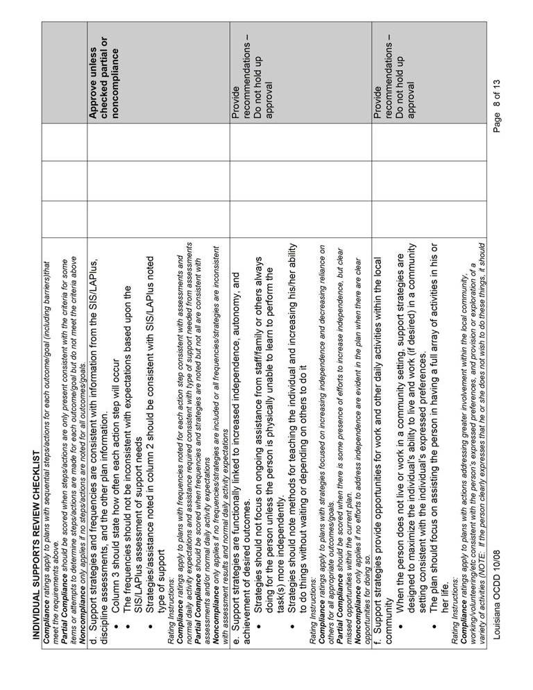
Attachment 7.5.1 Individual Supports Review (ISR)
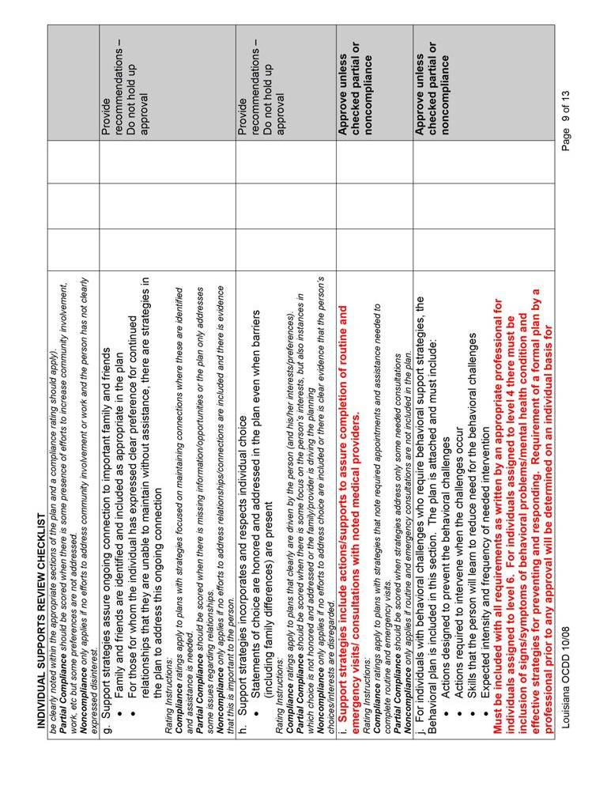
Attachment 7.5.1 Individual Supports Review (ISR)
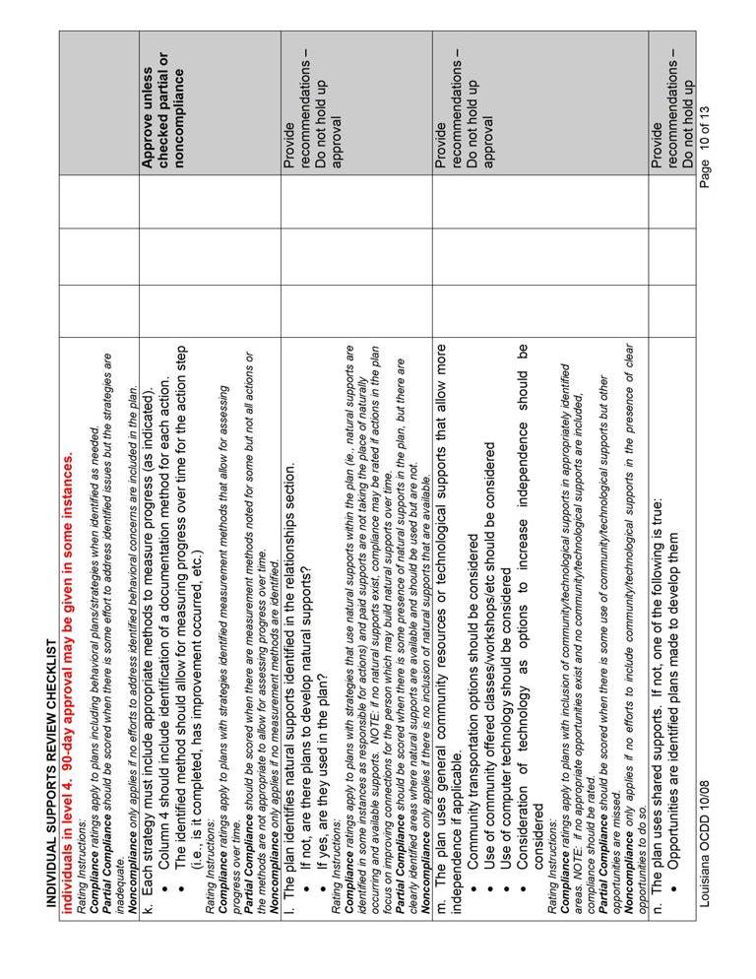
Attachment 7.5.1 Individual Supports Review (ISR)
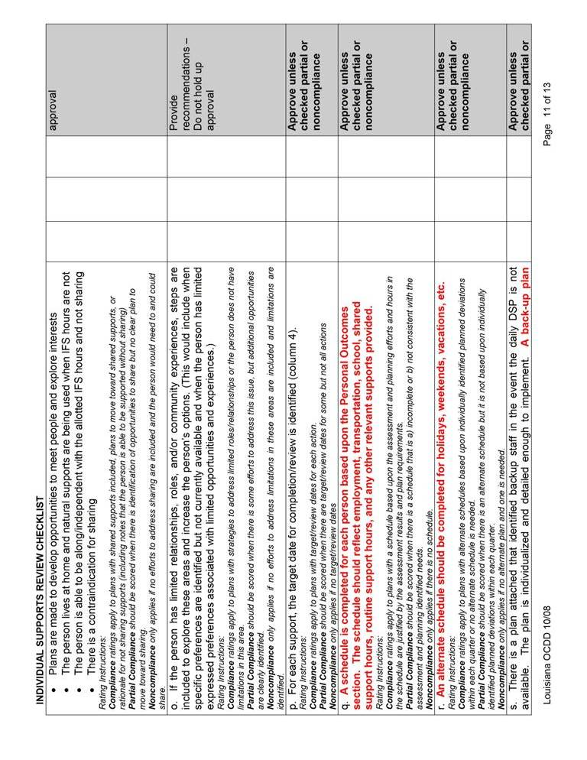
Attachment 7.5.1 Individual Supports Review (ISR)
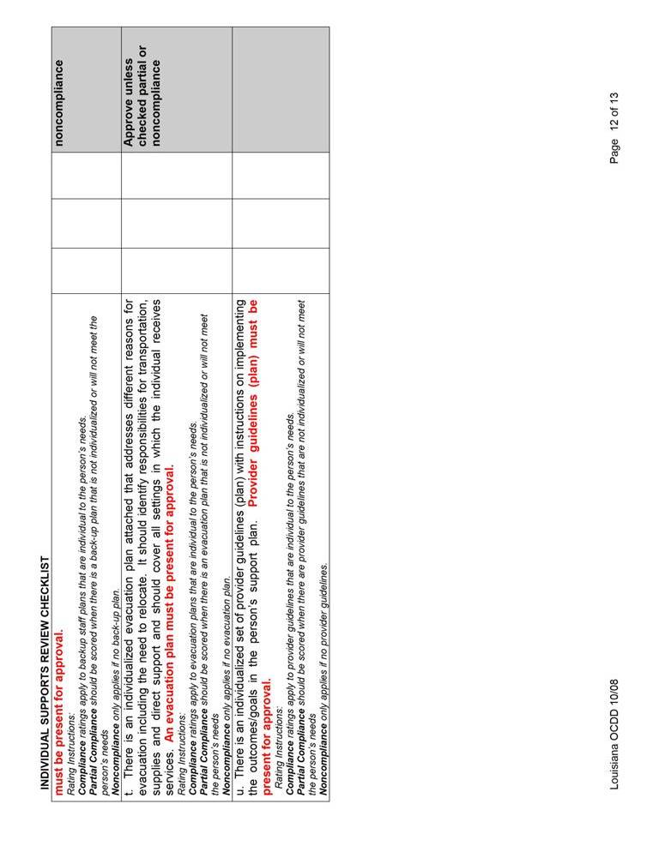
Attachment 7.5.1 Individual Supports Review (ISR)
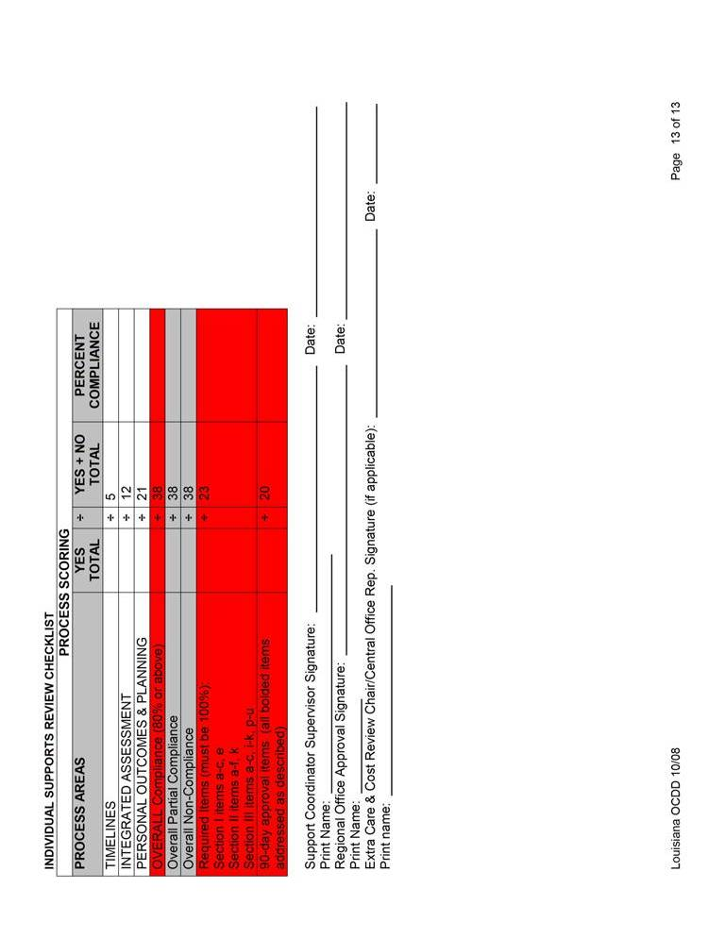

Attachment 7.5.2 Individual Support Plan Approval Guidelines Form
Individual Support Plan Approval Guidelines for Approval Requiring Local Entity Review Prior to Approval
Activity | Initial/Annual with new SIS & change in level  (Regional) | Level 4/5/6 w/ >1 CI in last 12 months;  GPSORC  (Regional)
- ISR is completed with scoring indicating the plan meets approval criteria | □ No  □ Yes | □ No  □ Yes
- Demographic information is accurate and legal status is noted with accompanying documents if applicable | □ No  □ Yes | □ No  □ Yes
- Budget calculations match the requested schedule and are correct mathematically along with correct procedure codes | □ No  □ Yes | □ No  □ Yes
- Most recent SIS assessment is included | □ No  □ Yes | □ No  □ Yes
- Provider documents (backup plan, emergency plan, and provider plan of care) are present and address health and safety issues. | □ No  □ Yes | □ No  □ Yes
- Other assessments and plans are included as appropriate for the individual’s needs (i.e., psychological and behavioral plan; home health plan) | □ No  □ Yes | □ No  □ Yes
- Form 148 attached and completed (initials only) | □ No  □ Yes
- All applicable sections of the 90L completed (i.e. level of care, physician signature…) | □ No  □ Yes | □ No  □ Yes
- Has up to date SOA (for annuals, referral to the entry unit) | □ No  □ Yes | □ No  □ Yes
- SC initialed statement that they informed participant of all state plan services and how to access the services | □ No  □ Yes | □ No  □ Yes
- Participant signature page completed with all participants’ signatures along with SC and SC Supervisor. | □ No  □ Yes | □ No  □ Yes
- Physician delegation forms completed, signed and consistent with plan | □ No  □ Yes | □ No  □ Yes
- FOC for SC stamped with linkage date from SRI (agency selected matches agency submitting plan) (initials only) | □ No  □ Yes
- FOC for service provider selected, initialed and dated by participant/guardian/authorized representative and signed and dated by SC | □ No  □ Yes | □ No  □ Yes
- Other forms completed as appropriate (authorized representative; shared support authorization – roommate’s budget sheets attached, etc) | □ No  □ Yes | □ No  □ Yes
- The person and those identified as support team members were present for the planning meeting (must include the SC, provider representative and legal guardian if applicable) | □ No  □ Yes | □ No  □ Yes
NOTES:

Signature of waiver staff completing review and approval: __________________ Date: ________________
Individual Support Plan Approval Guidelines for Approval With SC Supervisor Review and Local Entity Verification and Final Approval (All plans not specifics on page 1)
Activity | All annual plans not meeting criteria for local entity review
- ISR is completed by the SC supervisor with scoring indicating the plan meets approval criteria (Plan and ISR do not have to be rechecked/reviewed by the local entity only verification of a submitted ISR with scoring meeting approval criteria) | □ No  □ Yes
- SC supervisor submits checklist noting that the following information is present and accurate (these do not have to be rechecked by the local entity only verification that SC supervisor signed off on checklist):  - Demographic information is accurate and legal status is noted with accompanying documents if applicable  - Provider documents (backup plan, emergency plan, and provider plan of care) are present and address health and safety issues.  - Other assessments and plans are included as appropriate for the individual’s needs (i.e., psychological and behavioral plan; home health plan)  - SC initialed statement that they informed participant of all state plan services and how to access the services  - Participant signature page completed with all participants’ signatures along with SC and SC Supervisor.  - Physician delegation forms completed, signed and consistent with plan  - The person and those identified as support team members were present for the planning meeting (must include the SC, provider representative and legal guardian if applicable)  - Other forms completed as appropriate (authorized representative; shared support authorization – roommate’s budget sheets attached, etc) | □ No  □ Yes
- Budget calculations match the requested schedule and are correct mathematically along with correct procedure codes (must be verified by local entity; must check sharing partners budget sheet if applicable)) | □ No  □ Yes
- Most recent SIS assessment is included (presence must be verified by the local entity) | □ No  □ Yes
- All applicable sections of the 90L completed (i.e. level of care, physician signature…) (presence and accuracy must be verified by local entity as it relates to level of care determination) | □ No  □ Yes
- Has up to date SOA (for annuals, referral to the entry unit) (must be verified by local entity as it relates to level of care) | □ No  □ Yes
- FOC for service provider selected, initialed and dated by participant/guardian/authorized representative and signed and dated by SC (must be verified by local entity) | □ No  □ Yes
NOTES:

Signature of waiver staff completing verification and approval: ________________ Date: ______________
Individual Support Plan Review Guidelines for SC Supervisor for Submission to Local Entity
Activity | All annual plans not requiring local entity review
- ISR is completed with scoring indicating the plan meets approval criteria | □ No  □ Yes
- Demographic information is accurate and legal status is noted with accompanying documents if applicable | □ No  □ Yes
- Budget calculations match the requested schedule and are correct mathematically along with correct procedure codes | □ No  □ Yes
- Most recent SIS assessment is included | □ No  □ Yes
- Provider documents (backup plan, emergency plan, and provider plan of care) are present and address health and safety issues. | □ No  □ Yes
- Other assessments and plans are included as appropriate for the individual’s needs (i.e., psychological and behavioral plan; home health plan) | □ No  □ Yes
- Form 148 attached and completed (initials only)
- All applicable sections of the 90L completed (i.e. level of care, physician signature…) | □ No  □ Yes
- Has up to date SOA (for annuals, referral to the entry unit) | □ No  □ Yes
- SC initialed statement that they informed participant of all state plan services and how to access the services | □ No  □ Yes
- Participant signature page completed with all participants’ signatures along with SC and SC Supervisor. | □ No  □ Yes
- Physician delegation forms completed, signed and consistent with plan | □ No  □ Yes
- FOC for SC stamped with linkage date from SRI (agency selected matches agency submitting plan) (initials only)
- FOC for service provider selected, initialed and dated by participant/guardian/authorized representative and signed and dated by SC | □ No  □ Yes
- Other forms completed as appropriate (authorized representative; shared support authorization – roommate’s budget sheets attached, etc) | □ No  □ Yes
- The person and those identified as support team members were present for the planning meeting (must include the SC, provider representative and legal guardian if applicable) | □ No  □ Yes
NOTES:

Signature of SC Supervisor completing review: _______________ Date of review: ___________

8

Implementing the Participant’s Support Plan

8.1 Support Plan Approval: Activities for Implementation
8.2 Providing Training to Family and Staff
8.3 Identifying and Securing Needed Resources
8.4 Documentation of Implementation and Collecting Data/Information
8.5 Family Members as Staff
8.6 Attachments
8.6.1 Support Plan Revision Request Form
8.6.2 Provider Guidelines
8.6.3 Instruction Sheets
8.6.4 Skills Training Data Sheet
8.6.5 Seizure Report
8.6.6 Weight Log
8.6.7 Meal/Fluid Log
8.6.8 Bowel Log
8.6.9 Medication Side Effects Assessment
8.6.10 Psychiatric Symptoms Assessment
8.6.11 Menstrual Chart
8.6.12 Sleep Log
8.6.13 Challenging Behavior Chart
8.6.14 Behavioral Incident Report (ABC)
8.6.15 Graphic Schedule

IMPLEMENTING THE PARTICIPANT’S SUPPORT PLAN
The support team should leave the planning meeting with a clear agreement of who is responsible for completing which actions (or providing which supports) at what frequency (or within what timeframe).
The responsible people and frequencies for each action step and support should be noted in the support plan document as appropriate.

This document then becomes the basis for implementation of the plan.

8.1 SUPPORT PLAN APPROVAL: ACTIVITES FOR IMPLEMENTATION
- After the initial support plan is approved, the OCDD Regional Waiver Office submits the cover page, budget pages, approval signature page, Form 18-W, and Form 51-NH to the DHH data contractor for prior authorization. The OCDD Regional Waiver Office submits the complete support plan to the support coordinator.

- After the annual support plan is approved, the OCDD Regional Waiver Office submits the cover page, budget pages, and approval signature page to the DHH data contractor for prior authorization and the complete support plan to the support coordinator.
- After a revision is approved, the OCDD Regional Waiver Office submits the budget sheets to the DHH data contractor and the complete revision form to the support coordinator. The revision form is located in Attachment 8.6.1.

- After the support plan\revision is approved by the OCDD Regional Waiver Office, the support coordinator has two (2) calendar days or the next business day to forward the support plan\revision to the provider and the participant.

- The support coordinator contacts the participant and/or his/her authorized representative within ten (10) days following the approval of an initial support plan to assure the adequateness and appropriateness of services.
8.2 PROVIDING TRAINING TO FAMILY AND STAFF
A. Each participant’s support plan includes multiple strategies and actions to achieve his/her life vision and goals while addressing key support needs.
B. The support team identifies training the participant’s family or staff may need in order to implement actions and strategies described in the plan.
C. The support team determines who will provide any needed training. The training may be specialized in nature and require an outside source. If specialized training is needed, an assigned team member is charged with securing a training source and monitoring that the training is completed.
1. Support teams should encourage people with disabilities to develop self-advocacy skills. Self-advocacy skills are an important component of participating actively in the community, achieving personal goals, establishing meaningful relationships, and recognizing and confronting discrimination. Developing self advocacy skills may require specialized training. There are several state organizations available to assist with empowering people with disabilities to advocate for themselves and their peers: People First has several local chapters located throughout the state. The Arc of Louisiana, 606 Colonial Drive, Baton Rouge, LA 70806, (225) 383-1033, can assist people with locating local chapters of People First. Other organizations that can also provide support in self-advocacy skills include Families Helping Families (see www.fhfla.org to find a local chapter) and the Advocacy Center of Louisiana (see www.advocacyla.org.)
D. Training is competency-based. Competency-based training provides needed information, knowledge or skills to the trainee and then “assesses” if the information, knowledge or skills can be demonstrated by the trainee.
- Training focused on providing assistance is followed by observing the trainee complete the assistance for the participant.
- Training focused on learning specific signs/symptoms/triggers of a specific problems or condition is followed by asking the trainee to repeat the information provided.
- Training focused on steps to teach a particular skill/activity is followed by demonstration of the particular skill or activity.

E. Staff must receive any necessary training within 10 calendar days following plan approval
- Staff acting as direct service workers must meet requirements established by Louisiana Medicaid in rule published as LAC 48:I.Chapter 92 and authorized by R.S. 40:2179-2179.1.
- Residential services providers must provide an in-service consistent with item 8.2.D above to direct service workers for each participant the direct service worker will support. This includes shared supports pairings. The in-service focal areas should include, at a minimum, the participant’s plan goals requiring implementation during the shift, supports requirements, preferences, and interests.

8.3 IDENTIFYING AND SECURING NEEDED RESOURCES
A. The support team identifies resources needed by the participant’s family or staff to implement actions and strategies.
B. The support team determines who will provide or acquire anything needed for implementation.
C. The support team and the IFS provider agency provide tools to support caregivers and staff. Tools are focused on successful plan implementation. These include, at a minimum, Provider Guidelines (Attachment 8.6.2) and Instruction Sheets (Attachment 8.6.3) for complex need areas, a schedule, and agreed upon documentation sheets. A visual or graphic schedule may be helpful in assisting participants and families to manage a routine (see Attachment 8.6.15).

8.4 DOCUMENTATION OF IMPLEMENTATION AND COLLECTING DATA/INFORMATION
    - For each strategy and action, the support team has identified a method for measuring progress. This method specifies the means of documenting provision of the support or completion of the action.
    - Support coordination agencies and direct service providers are responsible for documenting activities during the delivery of services. There are recommended documentation formats provided in this document; however, providers may substitute their own format as long as it includes essential elements of the required documentation. All documentation content and schedule requirements must be met by both support coordination agencies and direct service providers.
    - A Service Log is a document which contains a chronological listing of contacts and services provided to a participant, as authorized in the approved plan of care, which serves as justification for service authorization.
- Federal requirements for documenting service claims require the following information be included on the service log:
- Name of participant,
- Name of service provider and employee providing the service,
- Service provider agency contact telephone number,
- Date of service contact,
- Start and end time of service contact,
- Place of service contact,
- Purpose of service contact,
- Other issues addressed, and
- Content and outcome of service contact.

- Support coordinators must record the chronology of events and contacts, which support justification of critical support coordination elements, in the Case Management Information System (CMIS). Each service contact is to be defined (i.e., telephone call, face-to-face visit) with a narrative in the form of a progress note.

- Direct service providers must complete a narrative which reflects each entry into the payroll sheet and elaborates on the activity of the contact.

- Service logs must be reviewed by the supervisor to ensure that all activities are appropriate in terms of the nature and time, and that documentation is sufficient.

    - Progress Notes are notes completed by a provider at the time of each activity or service which summarize the participant’s day-to-day activities and progress toward achieving his/her personal outcomes as identified in the approved plan of care.

- Progress notes must be completed by both support coordinators and direct service providers for each contact and service provided and documented in the service log or as a separate document.

- Progress notes must be of sufficient content:
- To reflect descriptions of activities, procedures, and incidents,
- To give a picture of the service provided to the participant,
- To show progress towards the participant’s personal outcomes,
- To record any changes in the participant’s medical condition, behavior, or home situation which may indicate a need for reassessment and plan of care change,
- To record any changes or deviations from the typical weekly schedule in the participant’s approved plan of care, and
- To reflect each entry in the service log and/or timesheet.

- All progress note entries must be legible, written in ink, and must include:
- The name of the person making the entry,
- The title of the person making the entry,
- A legible signature of the person making the entry, and
- The full date of documentation.

- The following are examples of general terms, which when used alone, are not sufficient and do not reflect adequate content for progress notes:
- “Supported _____”
- “Assisted _____”
- “____ is doing fine”
- “____ had a good day”
- “Prepared meals”

- Checklists alone are not adequate documentation for progress notes.

- For those who are receiving formal training to learn a specific skill, progress notes must be paired with a skills training data sheet (Attachment 8.6.4). Progress notes are written daily to document that skills training occurred. The progress note should serve as a pointer to data collection mechanisms used. In the example provided in Attachment 8.6.4, one time weekly, a formal data point is placed on the skills training data sheet and paired with the daily progress note. The team uses the trend of the documented data points to determine level of advancement in the goal area over time. A “completed independently” rating of 5 consecutive data points may be used as an indicator of independence for a particular skill and necessitate the development of a new skills training area.
- Progress notes must be reviewed by the supervisor to ensure that all activities are appropriate in terms of the nature and time, and that documentation is sufficient.
    - A Progress Summary is a summary that includes a synthesis of all activities for a specified period which address significant activities, progress toward the participant’s desired personal outcomes, and changes in the participant’s social history. This summary must be of sufficient detail and analysis to allow for evaluation of the appropriateness of the participant’s current plan of care, sufficient information for use by other support coordinators, direct service workers, or their supervisors, and evaluation of activities by program monitors.
- Support coordinators and direct service providers may include the progress summary in the service log for this documentation requirement.
- A progress summary must be completed at least every quarter.
    - A Discharge Summary for Transfers and Closures is a summary of the participant’s progress prior to a transfer or closure.
- Support coordinators and direct service providers may include the discharge summary in the service log for this documentation requirement.
- The discharge summary must be completed within fourteen (14) days of discharge.
    - Direct service providers, who provide both waiver and state plan services, must provide separate documentation for these services.

Required Documentation and Schedule
SUPPORT COORDINATORS & SERVICE PROVIDERS
WAIVER | SERVICE LOG/PAYROLL SHEET | PROGRESS NOTES | PROGRESS SUMMARY | CASE CLOSURE/  TRANSFER
NOW | At time of every activity | At time of every activity | At least every quarter | Within 14 days of discharge

H. The support team assures that other documentation and data collection methods other than progress notes, progress summary, and discharge summary are considered so that appropriate measures are used to track progress on plan goals and objectives.
I. For persons with behavioral, psychiatric, or medical risk factors, individualized documentation must be utilized as a means of tracking each key area of risk. This documentation is not required for those whom do not have identified risk factors. Risk factors requiring individualized documentation include, but are not limited to:
1. Having a seizure disorder and/or receiving seizure medication - Data forms used to track this information must include seizure reports (Attachment 8.6.5). The team may also need to consider assessing for the presence of side-effects of seizure medication on a monthly or quarterly basis.
2. Having a medical issue which is significantly affected by or has a significant effect upon one’s weight - Such issues may include diabetes, cardiovascular issues, medication side-effects, or receiving nutrition through g-tube, peg-tube, etc. Data forms used to track this information must include weight logs (Attachment 8.6.6). The team may also need to consider tracking meal/fluid intake with a daily meal/fluid log (Attachment 8.6.7), tracking frequency/consistency of bowel movements with a daily bowel log (Attachment 8.6.8), and assessing for the presence of medication side-effects (Attachment 8.6.9).
- Receiving certain medications which can have severe side effects or potentially cause death if medication management protocols are not strictly adhered to - Data forms used to track this information must include an assessment for the presence of medication side-effects on a monthly or quarterly basis (Attachment 8.6.9). The team may also need to consider tracking meal/fluid intake with a daily meal/fluid log (Attachment 8.6.7), and tracking frequency/consistency of bowel movements with a daily bowel log (Attachment 8.6.8).
- Having a psychiatric diagnosis and/or receiving psychotropic medication - Data forms used to track this information must include a psychiatric symptoms assessment (Attachment 8.6.10). Based on the person’s presenting symptoms, antecedents, and psychotropic medication guidelines, the team may also need to consider tracking meal/fluid intake with a daily meal/fluid log (Attachment 8.6.7), tracking frequency/consistency of bowel movements with a daily bowel log (Attachment 8.6.8), tracking frequency of menstrual cycles with a menstrual chart (Attachment 8.6.11), tracking sleep patterns with a sleep log (Attachment 8.6.12), tracking frequency/intensity of challenging behaviors with a challenging behavior chart (Attachment 8.6.13), and assessing for the presence of medication side-effects (Attachment 8.6.9).
- Having challenging behaviors which are severe or disruptive enough to warrant a behavioral treatment plan - Data forms used to track this information must include behavioral incident reports (Attachment 8.6.14). The team may also need to consider tracking frequency/intensity of psychiatric symptoms with a psychiatric symptoms assessment (Attachment 8.6.10), tracking frequency/consistency of bowel movements with a daily bowel log (Attachment 8.6.8), tracking frequency of menstrual cycles with a menstrual chart (Attachment 8.6.11), tracking sleep patterns with a sleep log (Attachment 8.6.12), and assessing for the presence of medication side-effects (Attachment 8.6.9).
Examples can be seen in Section 8.6. These are not mandated forms, but are intended as models of appropriate tools for data collection.
J. Documentation collected by IFS providers related to items in Section 8.4, I. must be organized and made available to professionals, nursing, and medical personnel providing services to the participant in order to facilitate quality of care.
K. For all documentation and data collection specified in the support plan related to items noted in Sections 8.4.D.6 and I. (above), the data collection mechanism (e.g., the form or other collection method) must be submitted with the support plan and, if altered, with any succeeding revisions.
1. The OCDD may request a revision of the data collection mechanism or may suggest an alternative mechanism that may better assist in the required monitoring.
2. Technical assistance is available through the OCDD Regional Waiver Office for implementation of the data collection mechanism.
L. Documentation and data collection as specified in the plan must be accurate. This serves as a basis for assessing progress toward the individual’s goals and making necessary changes to the plan.

8.5 FAMILY MEMBERS AS STAFF
A. New Opportunities Waiver Rules Regarding Use of Family Members as Paid Direct Support (Louisiana Register, Vol. 30, No. 6, June 20, 2004 §13901 Individualized and Family Support and §13907 Residential Habilitation – Supported Independent Living)
- For Individual & Family Support (IFS) services - Reimbursement will not be paid for direct support services furnished by a legally responsible relative. A legally responsible relative is defined as the parent of a minor child, foster parent, curator, tutor, legal guardian, or the recipient's spouse.
- For Supported Living (SL) services - Family members who are not legally responsible relatives as defined in §13901.D.1, can be SL workers provided they meet the same qualifications as any other SL worker. Legally responsible relatives may not be SL providers. Payment for SL does not include payments made directly or indirectly to members of the individual’s immediate family. Minors living in their guardian’s home are presumed not to need SL services. If SL services are needed, they must be requested with justification.
- For Substitute Family Care (SFC) services - Immediate family members (mother, father, brother and/or sister) cannot be substitute family care parents.
B. Act No. 333 (2008) and Limitations on Family Members as Paid Direct Support
- In the Regular Session, 2008, of the Louisiana Legislature, Act No. 333 was passed. This act requires the state Department of Health & Hospitals (DHH) to develop criteria regarding any parent, stepparent, grandparent, son, daughter, brother, sister, aunt, or uncle of a participant serving as a direct support worker. Act No. 333 (2008) Online document link:
http://legis.state.la.us/billdata/streamdocument.asp?did=499966
- The Act asserts that general state policy is to not allow family to serve as a paid direct service worker unless the relative meets the criteria established by the rule and has received a waiver issued by the secretary of DHH or his designee. The waiver must state that the relative is the best available appropriate direct service worker for the person using services. Family members who have acted as paid direct service workers prior to July 1, 2008 are grandfathered in and allowed to continue working as paid direct service workers.

- As of June 2009, Act No. 333 is not yet in effect. DHH is still working on developing the criteria for family members as direct support and the process to apply for and get a waiver. Before these changes can be enacted, they must be posted in rule format, according to state regulations, and also receive approval at the federal level from the Centers for Medicare & Medicaid Services.
C. Support Team Discussion of Using Family Members as Paid Direct Support
- Support teams should anticipate implementation of Act No. 333 by regularly discussing any use of family as paid direct service workers and by actively considering alternatives. In accordance with the act requirements, DHH will establish regulations for requests of waivers to enable family members to act as paid direct service workers. The following provides guidance for team discussion and consideration in preparation for a waiver request:
  - Is the use of a family member age and developmentally appropriate?
- The team needs to consider the day from the person’s perspective. Sometime having family around may be fine. Other times may not be. Does a 30 year-old generally have his mom accompany him to evenings out with friends? Not usually. Support teams must look at ways of using family as paid direct service workers in situationally appropriate times that are consistent with meeting the person’s support needs.
- If using family as a paid direct service worker for some times makes sense, then consider including non-family members for shifts involving planned socializing and peer interaction.
  - Will using family members as paid direct service workers enable the person to learn and to adapt to different people and also to form new relationships?
- The support team must build in opportunities to meet different people and form relationships, including making choices about selection of different direct support workers.
- The support team must discuss any barriers to increased community integration or friendship development presented by use of family as paid direct service workers and how to address these barriers.
  - Is the person learning flexibility and skills for increased independence?

- The support team and IFS provider must reinforce with the family member that he/she is not in a “caretaking” role, but rather in a supportive role that is intended to encourage autonomy and skills building for independence in community living. The support team must ensure that the family member providing direct support approaches the job as such and does not present barriers to individual goals and treatment objectives.
  - Support teams should approach with considerable caution use of family as paid direct support for persons with significant behavioral challenges due to requirements of treatment plans and treatment objectives.
  - What happens when the family caregiver is gone? Who else is prepared to step in and provide support?
e. Is this in the best interest of the person in the long-term?
- Is this something that is sustainable for the long-term? Continuity of care in provision of direct services is an important aspect of achieving personal outcomes, including goals, wellness, and progression of skills.
f. Is this about the person’s wishes, desires, needs, or about supplementing a family member’s income?
- Support teams must consider the motive and level of commitment of a family member requesting to act as a paid direct service worker. Protecting against exploitation is key. In the end, if a family member is only focused on money, the quality of care will be low, and the person will be put at risk.
2. Support teams should consider paying a family member in the following situations:
- Staff supports are required at difficult times of the day to get or schedule employees;
- The participant lives in a rural or isolated area;
- The family member may work on a temporary basis while other staffing options are explored;

- When having a family member as staff:
i. Truly reflects the person’s wishes and desires,
- Increases the person’s quality of life in measurable ways,
- Increases the person’s level of independence,
- Increases the person’s choices, and
- Increases access to the amount of service hours for needed supports;
3. Holding regular team discussions and considering all of the above factors will assist in the preparation of waiver requests once Act No. 333 goes into effect.
8.6 ATTACHMENTS
Attachment 8.6.1 Support Plan Revision Request Form 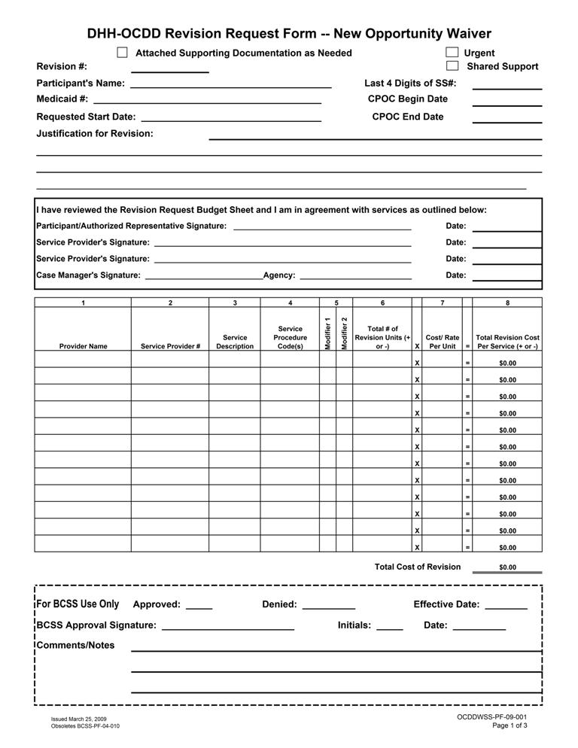
Attachment 8.6.1 Support Plan Revision Request Form
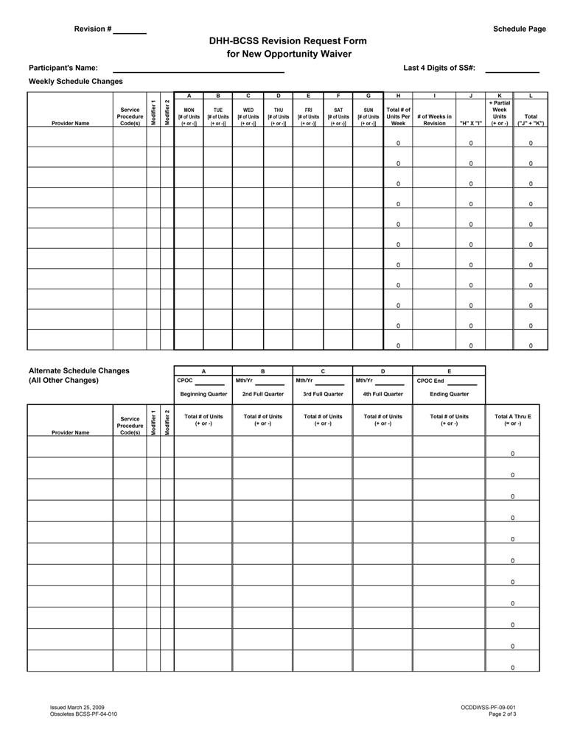

Attachment 8.6.1 Support Plan Revision Request Form
NOW CPOC Revision Request Form
Instructions
Purpose
The purpose of this form is to document revisions to the budgeted waiver services as the needs of the individual participant change during the CPOC year. Support Coordinators shall submit revision requests in accordance with the policies and procedures as outlined in the NOW manual, the Case Management manual, the Guidelines for Planning Manual and as updated by written notification from the OCDD Program Offices.
Revision Request Form - Page 1 (Budget Page)
Page 1 of the Revision Request form indicates: (1) waiver participant identifying information, (2) requested time line for the revision changes, (3) justification for the revision request, (4) signatures of all parties affected by the revision, including the transferring provider if any (5) identification of the waiver service provider’s Medicaid vendor number (provider #), (6) a summation of all CPOC cost changes effected by the revision, (7)OCDD’ designation of the effective start date, and (8)OCDD’ approval signature of the revision request.
Revision #
From the CPOC start date, each revision submitted to OCDD must be numbered consecutively for each CPOC year. Enter on this line the number of this revision request.
Attached Supporting Documentation as Needed
If the waiver participant/authorized representative is requesting changes for the remainder of the CPOC year, the change(s) SHALL be documented in the body of the CPOC and attached to the revision form. These changes shall be reflected in accordance with how the participant defines or prioritizes his/her personal outcomes/goals and/or service needs, and be submitted with the revision form. This request form does not change the annual CPOC dates.
Examples of attachments may include:
- Documented changes in the body of the CPOC
- Environmental modification and/or assistive device forms, including bids and diagrams
- Physician approved delegation of medication administration forms
- Service provider Freedom of Choice (FOC) Forms
- Home Health Plan of Care (POC)
- Hospice POC

Recipient Name
The participant’s full legal name must be on the CPOC revision form. Please enter last name - comma - first name. If the individual prefers to use a nick name, this may be entered in brackets after the first name.
Medicaid I.D. Number
Enter the Participant’s 13-digit Medicaid Identification (ID) Number. Please do not enter a Control Card Number (e.g. 7770000......).
Last 4 Digits of Social Security No.
The number entered on this line is the last four digits of the individual’s Social Security Number.
Requested Start Date
Enter the requested start date for service changes to begin. (NOTE: The requested start date may be different from the approved effective date as in cases of emergency submission.)
Justification for Revision
Enter a detailed explanation for the needed change in authorized waiver services. If this is an urgent revision the justification should also address why this is an urgent situation.

Attachment 8.6.1 Support Plan Revision Request Form
Routine Revisions
Whenever possible, additional service needs should be anticipated and planned for in the original CPOC. When an unanticipated need is identified 10 or more business days prior to the change, a CPOC Revision Request should be submitted and will be processed within 10 business days. If an unanticipated need is identified after the 10th business day the CPOC Revision Request must be identified as “Urgent”, and the additional responsibilities for Provider and Support Coordinator must be assumed (see below).

Urgent
This box should be checked if the revision is an urgent request. An urgent need exists when there is an unplanned/unpredictable event which requires urgent changes(s) to waiver services and/or changes in the service provider. Urgent changes are changes that must begin less than 10 business days from receipt by the OCDD Regional Waiver Office.
If a revision meets the above criteria for urgent:
- It is the responsibility of the waiver service provider to contact the Support Coordinator about the situation.
- It is the responsibility of the Support Coordinator to telephone the OCDD Regional Waiver Office and inform OCDD that there is an urgent request for Prior Authorization (P.A.). The Support Coordinator then must submit to the OCDD Regional Waiver Office a revision request as soon as possible on the date of notice.
- When the Support Coordinator telephones the OCDD office about the urgent request, the incoming call from the Support Coordinator will be directed to the staff person who will handle the revision. All urgent calls for emergency revisions will be rotated to an OCDD staff member according to the Region’s policy.
- The Support Coordinator must be available to the OCDD staff member who will be handling the emergency request. This is necessary in the event additional information is needed to justify approval of the revision, or in the event there are corrections needed. If the Support Coordinator will not be available arrangements should be made for a Support Coordination Supervisor to be available to handle immediate requests for information or corrections.
- If an urgent service need occurs during non-business hours, Emergency changes must be submitted within 24 hours or by the close of the next working day. It is also the responsibility of the Support Coordinator to call, to ensure that the request has been received and is being processed.
- Whenever possible the urgent revision request should have the participant/authorized representative and the service providers’ signatures on the completed revision form. When it is not possible to obtain all signatures, the incomplete revision request form should be sent to OCDD according to the instructions above, and a fully signed copy must be sent to OCDD by the fifth working day. If a fully signed copy is not received by the fifth working day, the revision request will be forwarded to the Support Coordination Program Manager with the recommendations by the OCDD Regional Waiver Office (services can not continue without a CPOC verified by the participant/authorized representative and service provider).
- When an urgent CPOC revision request is approved, the OCDD Regional Waiver Office staff will call Statistical Resources, Incorporated (SRI) to notify them that an urgent request for PA is being faxed. OCDD will request that the PA be issued promptly. OCDD will also provide a copy of the approvals to SRI and the Support Coordinator.
- It is the responsibility of the provider to have prior authorization for all services. In the case of an urgent need after hours, the prior authorization must be obtained by the close of the following business day. If the Support Coordinator cannot be contacted, the Support Coordination Supervisor should be contacted. If results are still not obtained, the Health Standards complaint line should be called.
Attachment 8.6.1 Support Plan Revision Request Form
Shared Support
Check this box if the individual is receiving shared supports and submit with the CPOC revision for the other person/person sharing supports.
CPOC: BEGIN DATE
Enter the approved begin date of the current full CPOC.
CPOC: END DATE
Enter the traditional annual ending date of the CPOC year. This date does not change.
Signature Box
AFTER the form is completed, it shall be signed to indicate agreement with the requested changes entered on pages 1 and 2 of this revision request form.

- Recipient/Authorized Representative signs and enters the date they signed.
- Waiver Service Provider signs and enters the date they signed.
- Support Coordinator signs and enters the date they signed.

The Support Coordinator is to also enter the full name of their Support Coordination Agency.
CPOC Revision Budget Table (page 1)
This table will contain a summation of all costs and PA changes entered on the Weekly Schedule Changes Table and the Alternate Schedule Changes Table on Page 2.
Column 1 -Service Provider Name
Enter the name of the Waiver Service Provider which will provide the listed service and to which SRI will issue the change(s) in PAs. (Note: All service providers affected by the change must be listed – this includes a service provider who will stop providing services).
Column 2 - Service Provider No.
Enter the Service Provider’s Medicaid Vendor Number for the listed service. Be sure to enter the correct number for the correct service.
Column 3 - Service Description
Enter an abbreviated description of the type of waiver service (e.g. ACS, CC, PER).
Column 4 - Service Procedure Code
This is the billing code assigned to the specific service. (Refer to the most recently issued service/procedure code/rate document).
Column 5 - Modifier
Enter the billing code modifier assigned to the service. (Refer to the most recently issued service/procedure code/rate document).
Column 6 - Total # of Revision Units (+ or -)
Enter the cumulative total of changes (+ and/or -) entered in the Weekly Schedule Changes Table and the Alternate Schedule Changes Table (Page 2), for the same service provider and the same service type.
Column 7 - Cost/Rate Per Unit
Enter the assigned cost per service unit. (Refer to the most recently issued service/procedure code/rate document).
Column 8 - Total Revision Cost Per Service (+ or -)
Enter the number arrived at (+ and/or -) when the number in Column 6 is multiplied by the number in column 7. (Column 8 = Column 6 x Column 7).

Attachment 8.6.1 Support Plan Revision Request Form
TOTAL COST OF REVISION
Enter the sum of all figures in Column 8. (This figure (+ and/or -) reflects the change in the CPOC year costs as a result of this revision request).

OCDD USE ONLY
Upon review and approval of the CPOC revision request, an OCDD Certification Specialist shall assign an effective date for the revision to begin. The OCDD Certification Specialist will also sign, initial, and enter the date of signature.

Attachment 8.6.1 Support Plan Revision Request Form
Instructions for Schedule Page – Page 2

Revision #
Enter the same revision number (#) that was entered on page 1 of this Revision Request Form. It is very important that this number be entered correctly as it is the entry that identifies this page as part of the current revision request.

Recipient’s Name
The participant’s full legal name must be on this page 2 of the CPOC Revision Form. Please enter last name - comma - first name. If the individual prefers to use a nick name, this may be entered in brackets after the first name.

Last 4 Digits of the Social Security Number
The number entered on this line is the last four digits of the individual’s Social Security Number.

Weekly Schedule Changes
Enter on this table changes (+ or -) that are consistent from week to week and extend through the end of the CPOC year. Intermittent changes to service units are not entered in this schedule. A separate line entry is to be completed for each provider and for each service type.

Column 1 -Service Provider Name
Enter the name of the Waiver Service Provider which will provide the listed service and to which SRI will issue the change(s) in PAs. (Note: All service providers affected by the change must be listed – this includes a service provider who will stop providing services).

Column 2 - Service Procedure Code
This is the billing code assigned to the specific service. (Refer to the most recently issued service/procedure code/rate document).

Column 3 - Modifier
Enter the billing code modifier assigned to service. (Refer to the most recently issued service/procedure code/rate document).

Columns A through G
Enter the number of units to be changed (+ or -), for each day of the week.

Column H
Enter the sum (+ or -) of Columns A through G.

Column I
Enter the total number of full weeks (Monday through Sunday), that are included in the time range from the requested date of the revision through the end date of the CPOC year.

Column J
Enter the total of the number in column H multiplied by the number in column I. (J= H x I)

Column K
Enter the partial week units (+ or -) in this column. Determine the number of units in partial week(s) (less than Monday through Sunday), included in the requested time range at the beginning and/or end of this CPOC revision time range. (This time range is from the requested start date through the end of the CPOC year.

Column L
Enter the sum of columns J and K. (L = J + K)

Alternate Schedule Changes
Enter changes in service units or providers that are not consistent from week to week and/or do not extend through the remainder of the CPOC year.
Attachment 8.6.1 Support Plan Revision Request Form

Column 1 -Service Provider Name
Enter the name of the Waiver Service Provider which will provide the listed service and to which SRI will issue the change(s) in PA’s.

Column 2 - Service Procedure Code
This is the billing code assigned to the specific service. (Refer to the most recently issued service/procedure code/rate document).

Column 3 - Modifier
Enter the billing code modifier assigned to service. (Refer to the most recently issued service/procedure code/rate document).

Column A
At the top of the column enter the current CPOC begin date. If the CPOC begin date is not the first date of a fiscal year quarter, Column A will identify a partial quarter at the beginning of the CPOC year. This column will contain changes that occur from the Begin date of the CPOC to (not through) the start date of the next consecutive fiscal year quarter. (April 1st, July 1st, October 1st, or January 1st).

If alternate changes occur during this partial quarter enter the following information:
If there are any service unit or provider changes that occur during this partial quarter, enter the number of service unit changes (+ or).

Columns B, C and D
At the top of each of these columns enter the month and year of each of the next three consecutive fiscal year quarters. Dates at the top of this column should be 01/YR, 04/YR, 07/YR, or 10/YR (not necessarily starting in that order as the CPOC start date may have been later in the fiscal year.)

If alternate changes occur during these full fiscal year quarters enter the following information: If there are any service unit or provider changes that occur during these full fiscal year quarters, enter the number of service unit changes ( + or -).

Column E
Enter the current CPOC end date. If the CPOC end date is not the last date of a fiscal year quarter, Column E will identify a partial quarter at the end of the CPOC year.
This column will contain changes that occur from the beginning of this consecutive ( to Column D ) fiscal year quarter ( January 1st, April 1st, July 1st, or October 1st ) through the CPOC end date.

If alternate changes occur during this partial quarter enter the following information:
If there are any service unit or provider changes that occur during this partial quarter, enter the number of service unit changes (+ or).

Column F
Enter the sum of service unit changes (+ or -) that were entered in columns A through E.
(F = A + B + C + D + E)
The summation of changes entered in the Weekly Schedule Change Table and the Alternate Schedule Change Table must also be included on page 1 in the BUDGET Change Table.

Attachment 8.6.2 Provider Guidelines
DIRECT SUPPORT PROVIDER GUIDELINES
There are several phases associated with the ISP process and the following are the expectations and guidelines that Providers are required to follow throughout the process.
- Discovery-The SIS/ LA PLUS and Personal Outcomes Assessment are included in this phase. Provider is required to attend and actively participate in all meeting(s) and interviews during this phase of the process.
  - Appropriate Staff (Direct Support Professionals/Residential Support Staff and QMRP) and other people that know the person well should be present for these meetings and available to interview. If staff is unavailable for meeting, then QMRP is responsible for interviewing them to gather pertinent information prior to planning meeting.
  - Relevant documentation pertaining to the person’s wants and needs (assessments, records, etc) should be provided to Support Coordinator to prepare for planning meeting.
  - Prior to the planning meeting, provider will be given information by Support Coordinator that has been gathered during the discovery process. Provider is responsible for reviewing this information and adequately preparing for the planning meeting.
  - When shared supports are indicated, provider will use information gathered during the discovery process to begin locating compatible sharing partners that the participant may share supports consistent with the participant’s preferences and interests, support needs, and risk mitigation requirements.
  - SIL providers are to assist recipients that they serve in obtaining an annual 90-L prior to the planning meeting.
- Planning
  - Provider will be notified by the Support Coordinator 30 days in advance of an annual/initial planning meeting in writing, followed by a 2 weeks in advance notice by fax, email, or telephone.
  - Appropriate Staff (Direct Support Professional/Residential Support Staff and QMRP) need to attend this meeting. A decision-making authority from the Provider must be present to negotiate service provision requirements.
  - Provider is required to attend and actively participate in the planning meeting. This includes assisting the individual with developing their vision and establishing goals that will achieve their vision.
  - Following the planning meeting, the provider will begin to develop the service plan, back-up plan, and emergency evacuation plan based upon the consensus reached at the planning meeting. The provider will receive the finalized support plan from the Support Coordinator within 7 calendar days of the planning meeting
  - Upon receipt of the finalized support plan, the provider representative will have 5 calendar days to review the plan with budget sheets, sign the documents, and return the plan and budget sheets along with the finalized provider service plan, back-up plan, and emergency evacuation plan to the Support Coordinator.
- Implementation of Plan
  - Provider must ensure that staff are adequately trained to implement the plan. Staff training must be completed within 10 days of plan approval.
  - Provider will complete instructional sheets (Attachment 8.6.3 provides an example template for instructional sheets) which will be kept in the in-home binder that can be quickly and easily accessed by staff.
  - Provider will develop appropriate documentation (Templates) as per agreement in the plan (action steps and sustained supports; critical incident reporting; major life changes).
  - Provider will track utilization of IFS hours, including flexible hours, per approved plan. Provider will work with person to manage approved hours effectively. Provider will notify Support Coordinator of anticipated need of additional hours request/plan revision in advance and in a timely fashion for the Support Coordinator to complete and submit the revision request.
- Evaluation/Review
  - During planning meeting, specific persons and timelines have been established to complete action steps. Provider’s supervisory staff is required to monitor/follow up to insure that tasks are being completed by assigned persons when they are scheduled to be completed.
  - Supervisory Staff/QMRP are responsible for reviewing plan and implementation at least quarterly, but may review more frequently. This review includes monitoring of plan implementation to determine if outcomes are being met and to modify objectives as needed as well as reviewing direct support staff documentation. Individual’s satisfaction with life situation should be assessed.
  - Provider Quarterly Review must be completed and submitted to Support Coordinator at the quarterly review meeting.

Attachment 8.6.3 Instruction Sheets
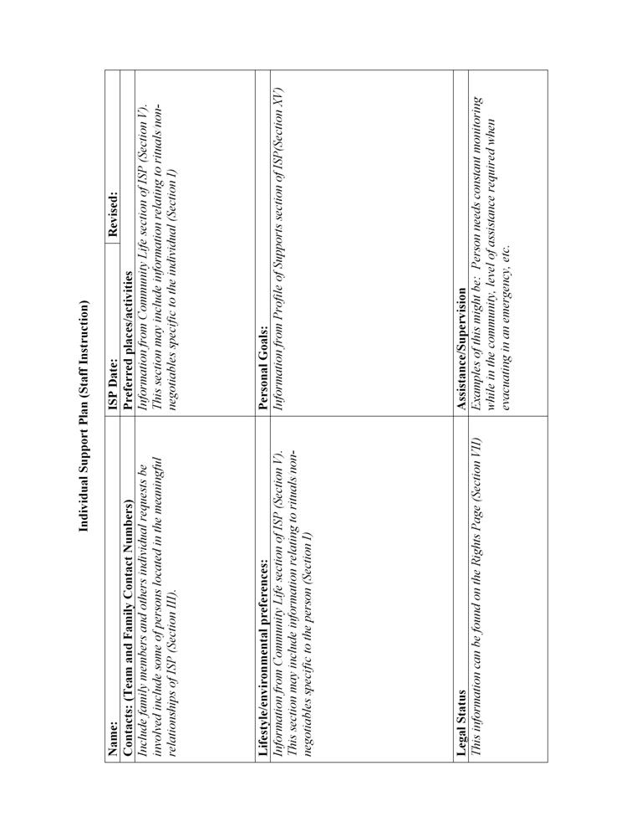
Attachment 8.6.3 Instruction Sheets
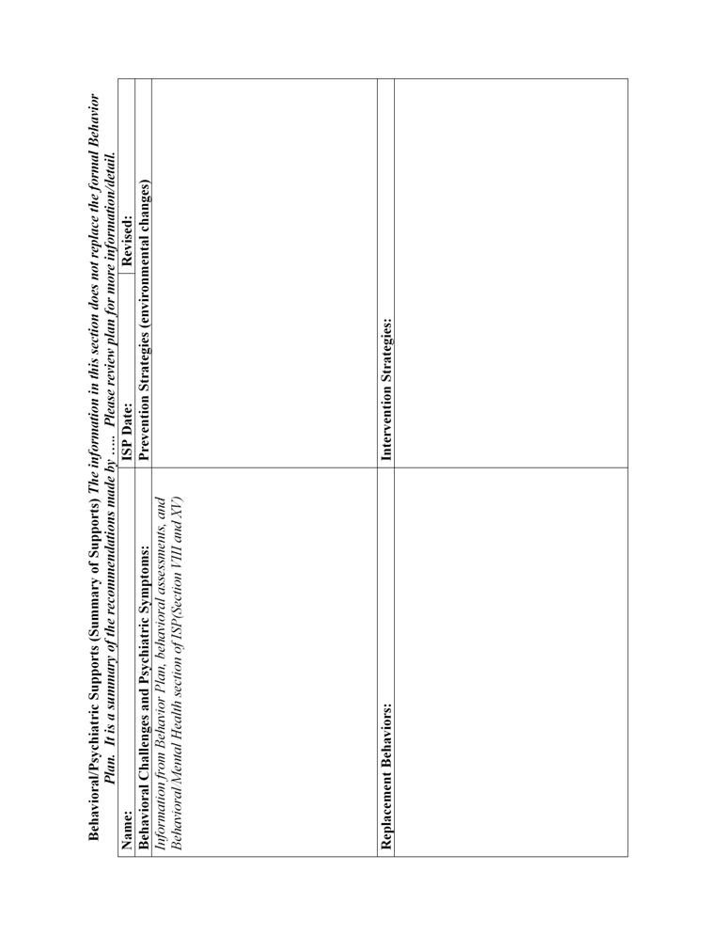
Attachment 8.6.3 Instruction Sheets
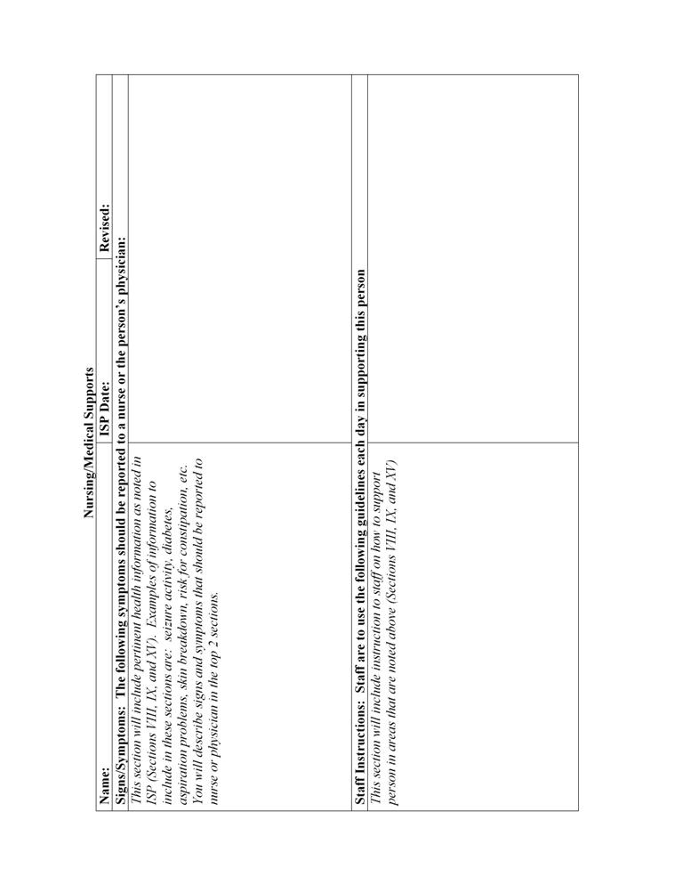
Attachment 8.6.3 Instruction Sheets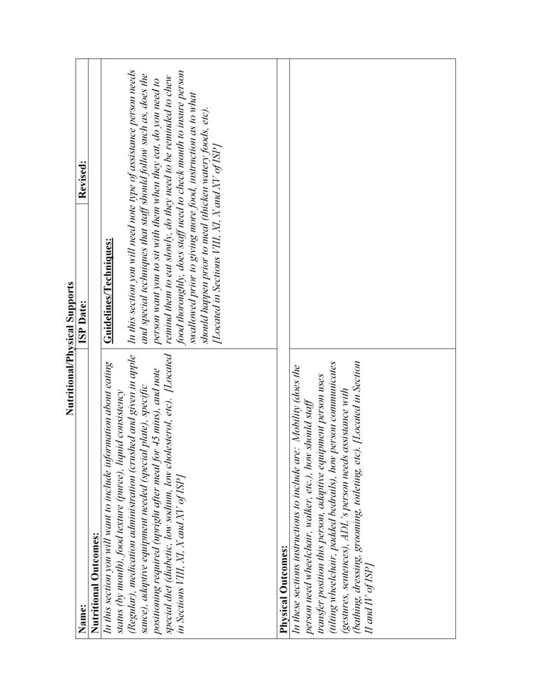
Attachment 8.6.4 Skills Training Data Sheet
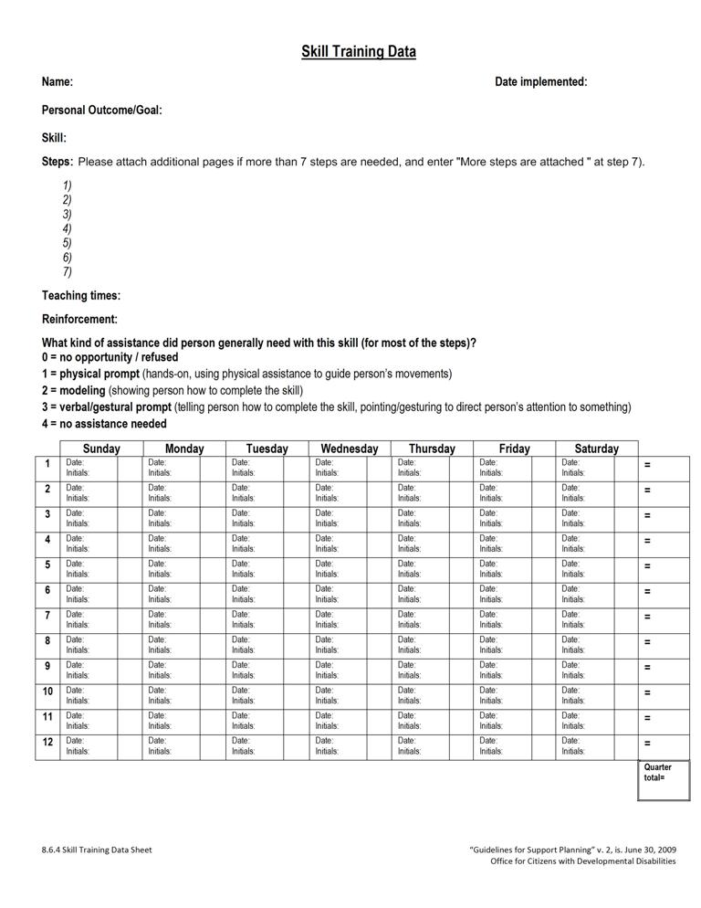
Attachment 8.6.4 Skills Training Data Sheet
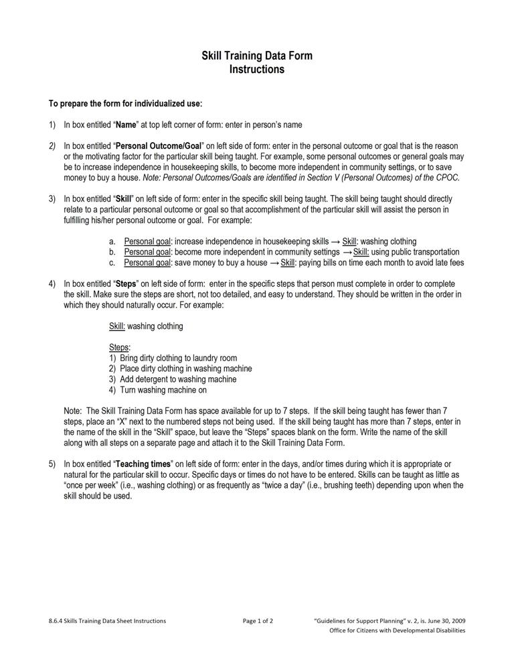
Attachment 8.6.4 Skills Training Data Sheet
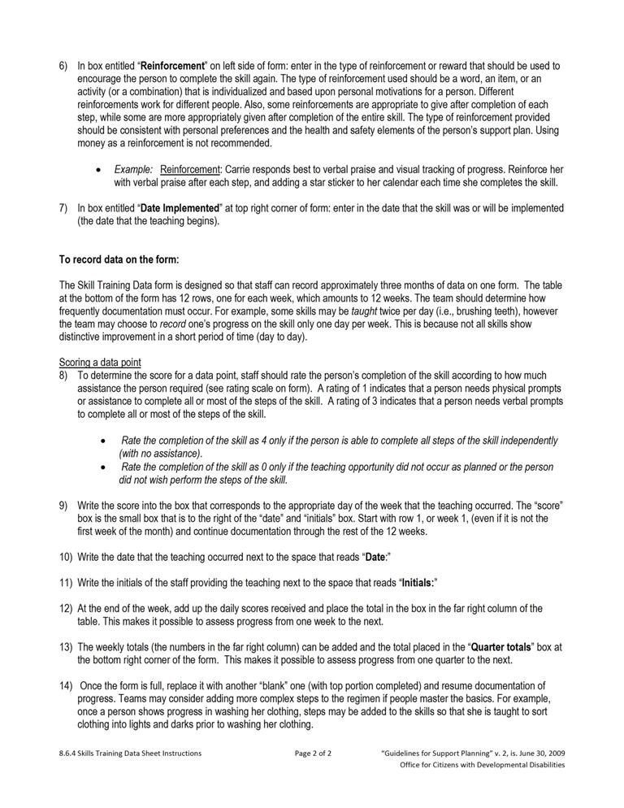
Attachment 8.6.5 Seizure Report
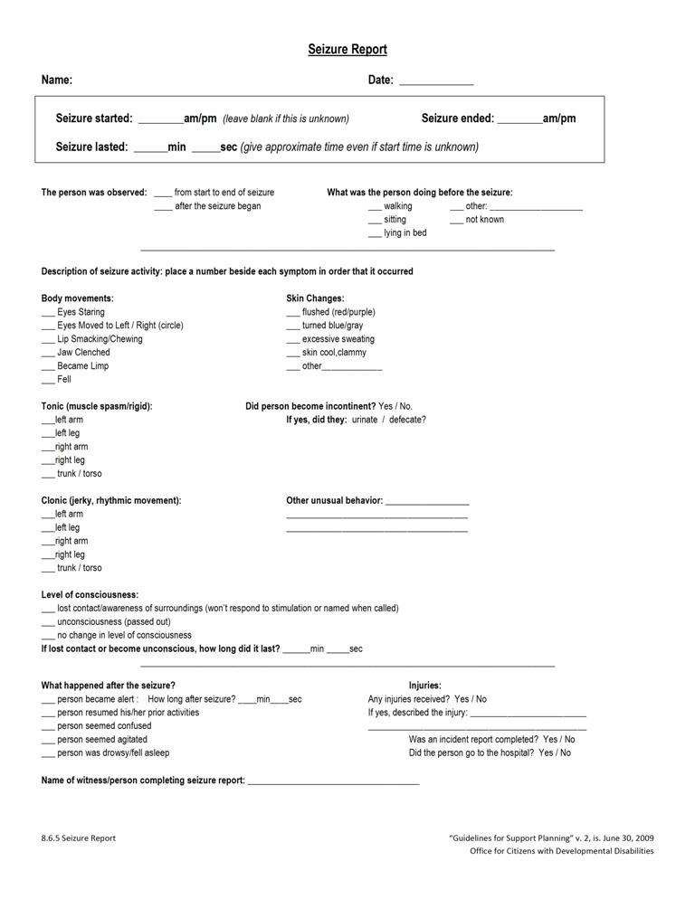
Attachment 8.6.6 Weight Log
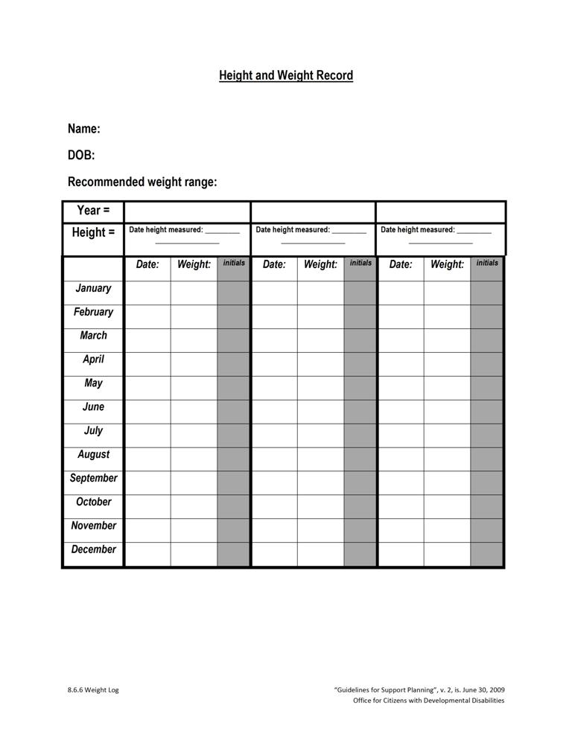
Attachment 8.6.7 Meal/Fluid Log
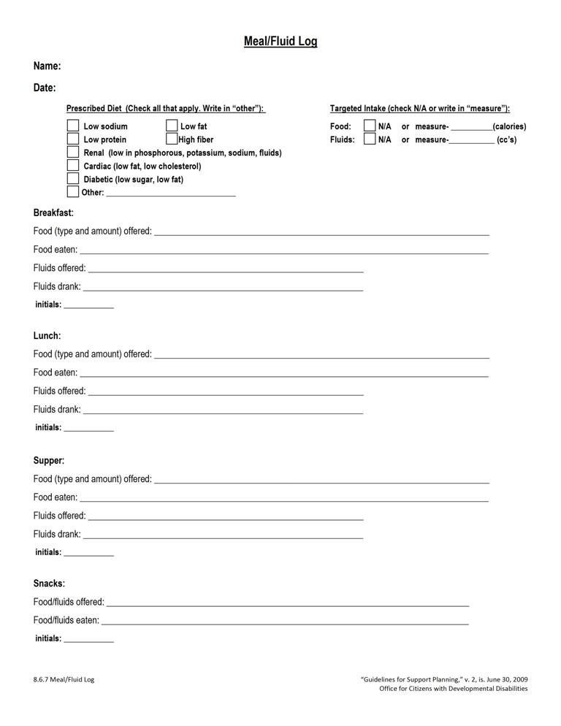
Attachment 8.6.8 Bowel Log
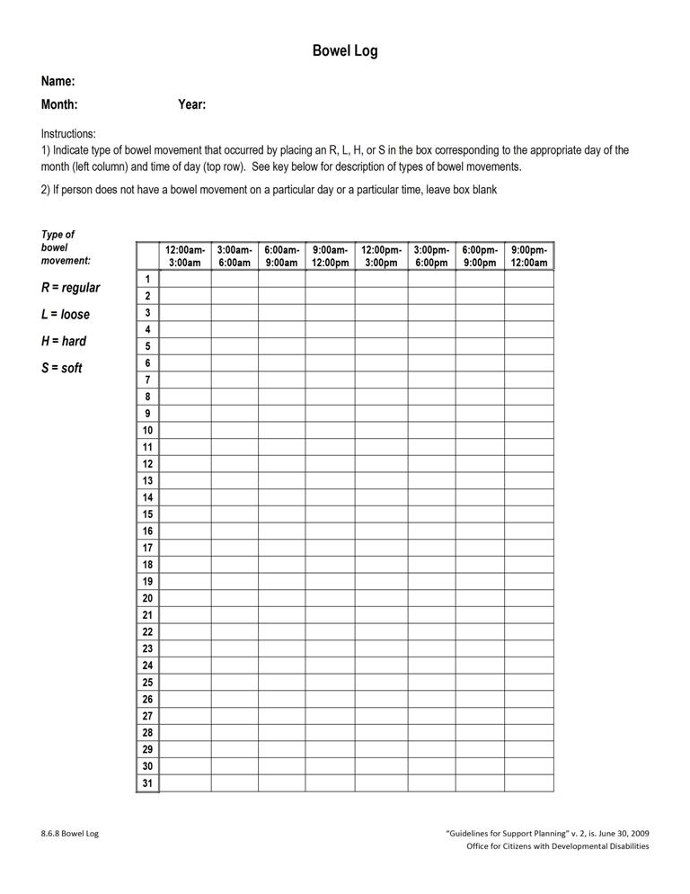
Attachment 8.6.9 Medication Side Effects Assessment
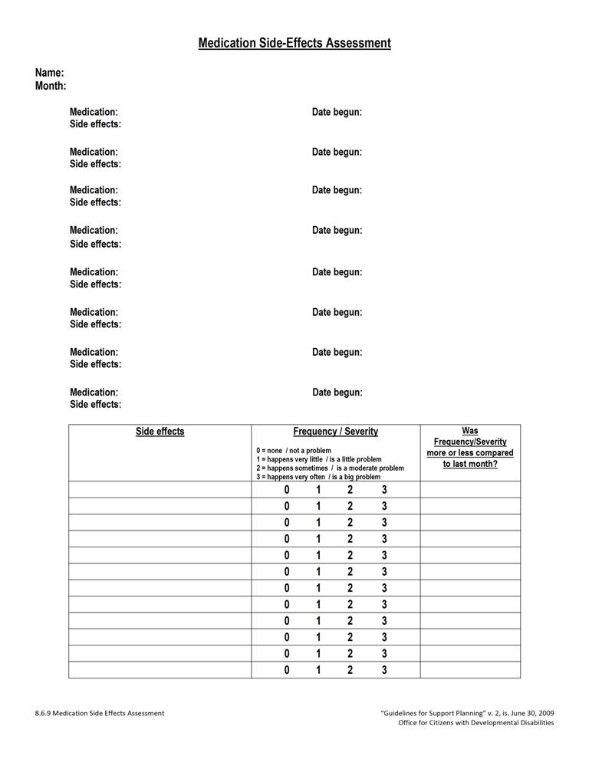
Attachment 8.6.9 Medication Side Effects Assessment
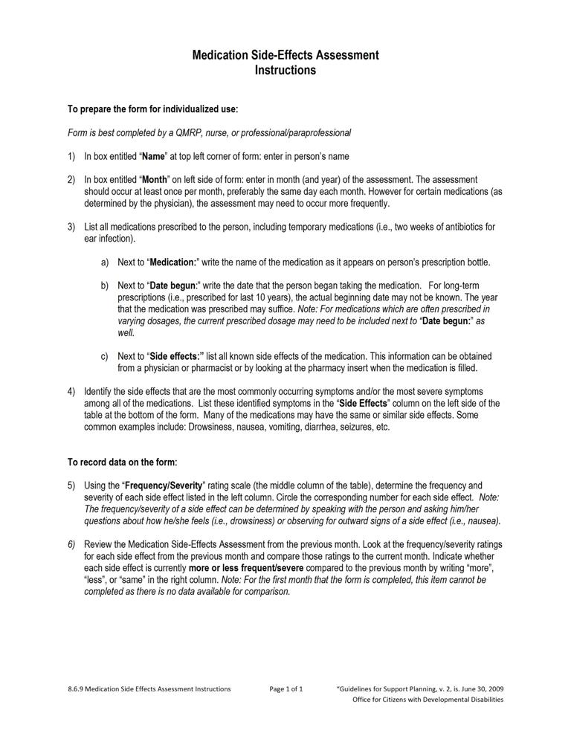
Attachment 8.6.10 Psychiatric Symptoms Assessment 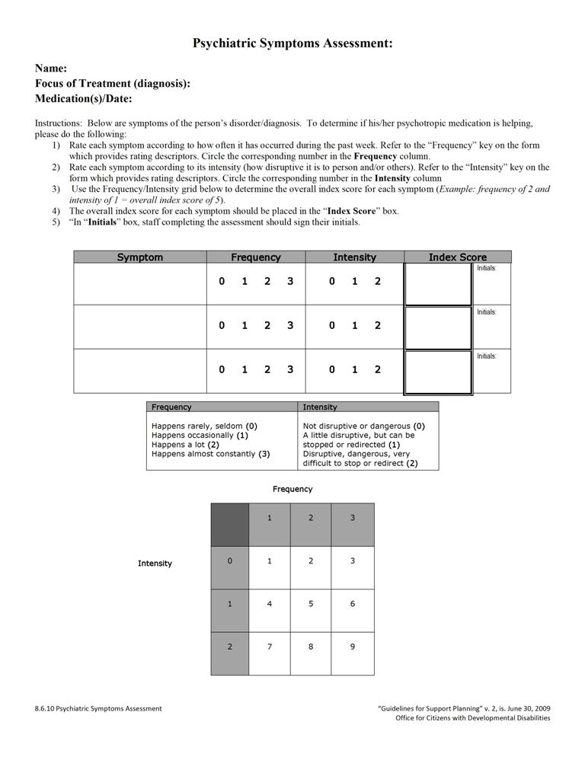
Attachment 8.6.10 Psychiatric Symptoms Assessment
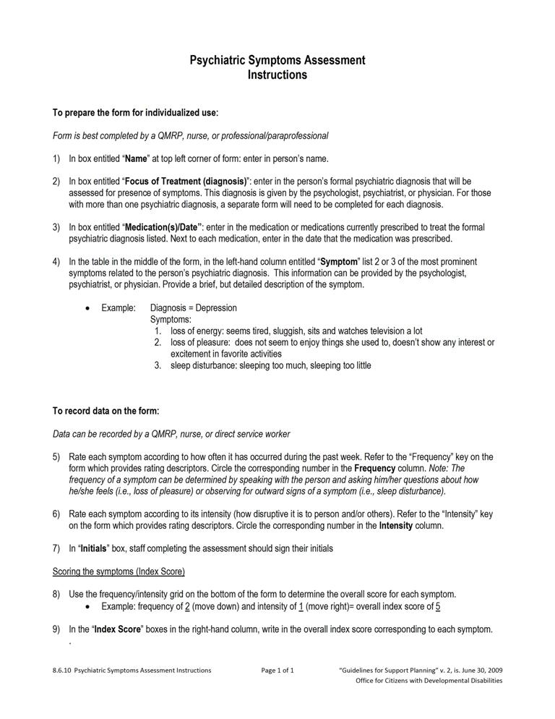
Attachment 8.6.11 Menstrual Chart
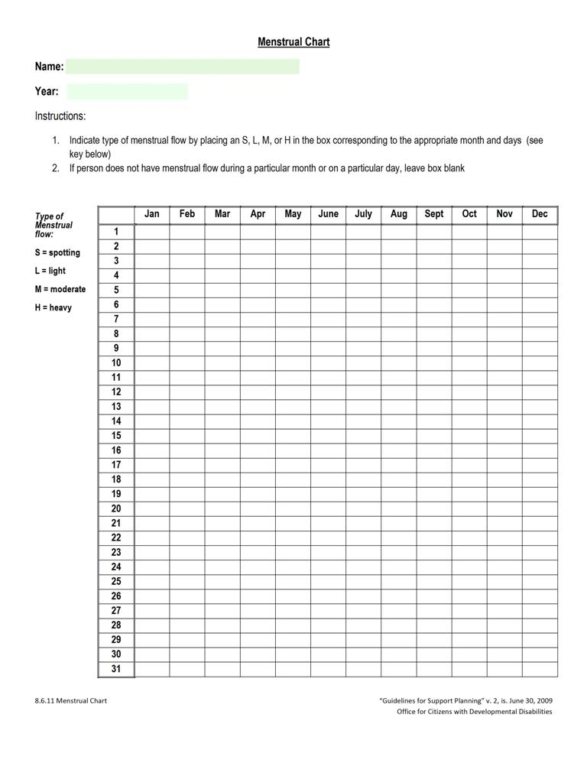
Attachment 8.6.12 Sleep Log
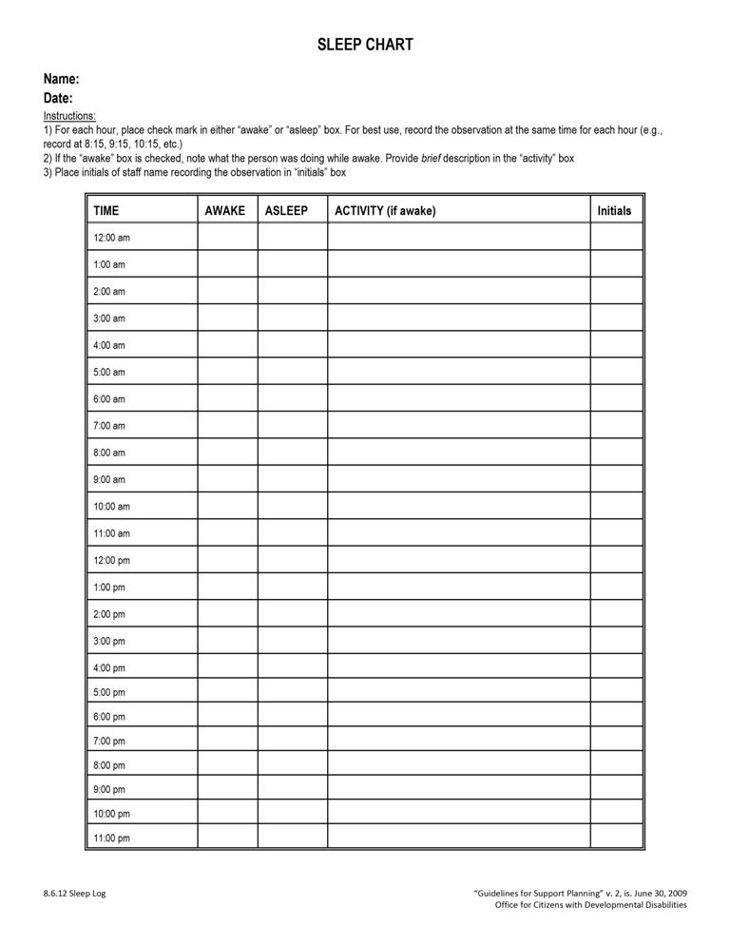
Attachment 8.6.13 Challenging Behavior Chart
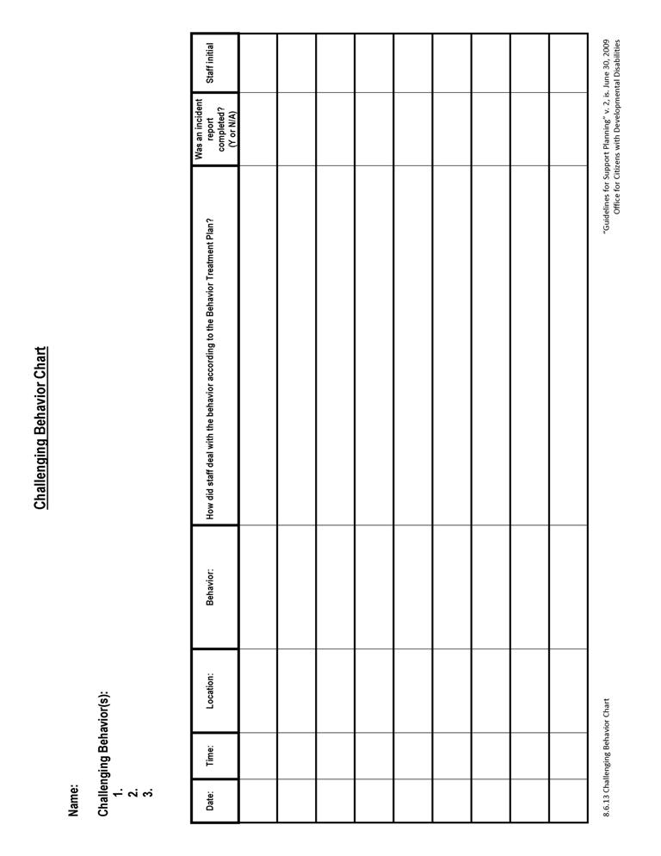
Attachment 8.6.13 Challenging Behavior Chart
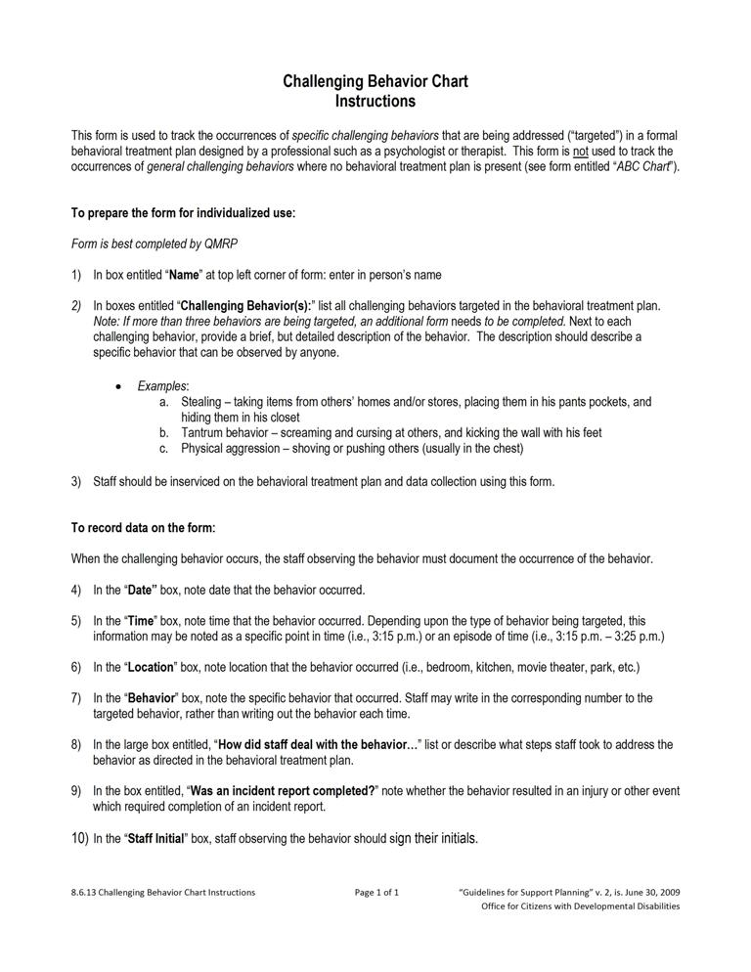
Attachment 8.6.14 Behavioral Incident Report (ABC)
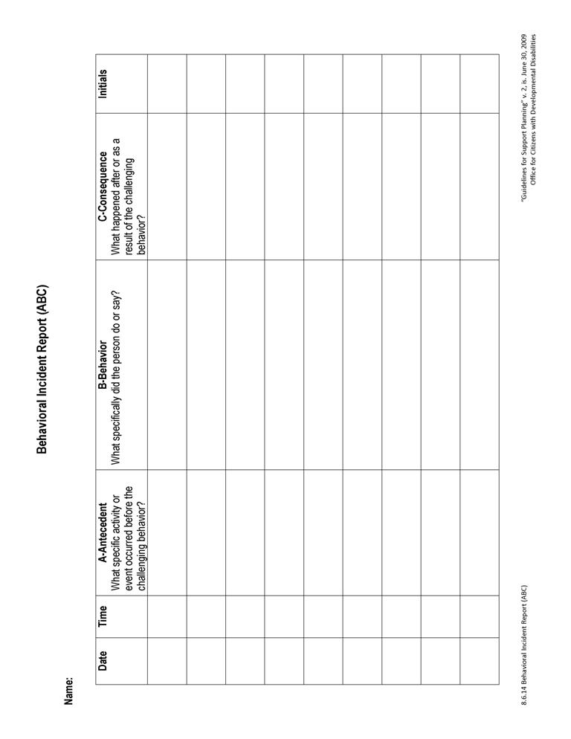
Attachment 8.6.15 Graphic Schedule
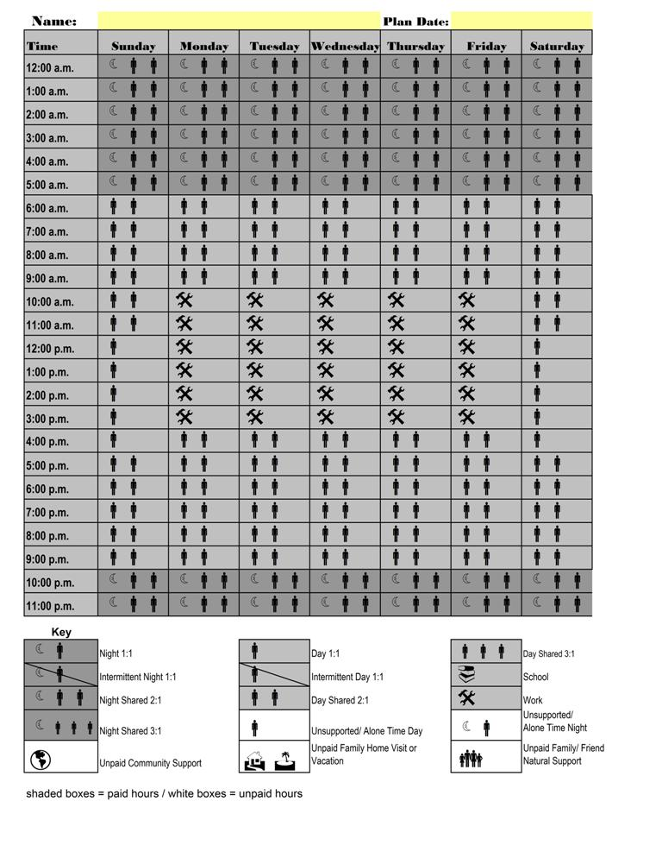
Attachment 8.6.15 Graphic Schedule
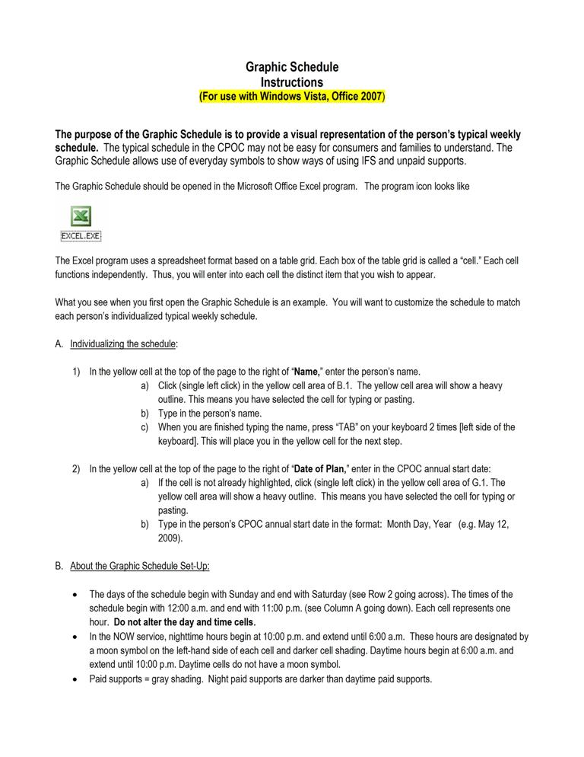
Attachment 8.6.15 Graphic Schedule

Attachment 8.6.15 Graphic Schedule 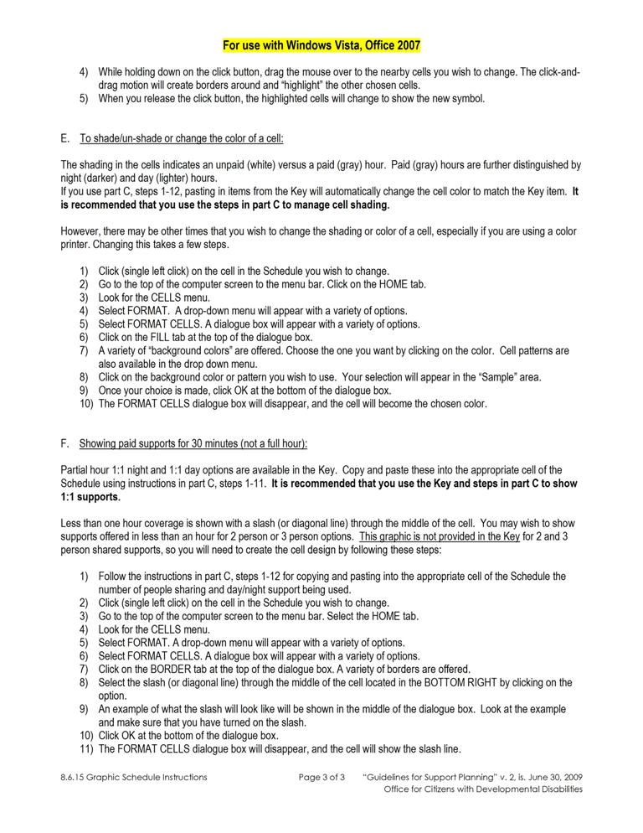
Attachment 8.6.15 Graphic Schedule

Attachment 8.6.15 Graphic Schedule 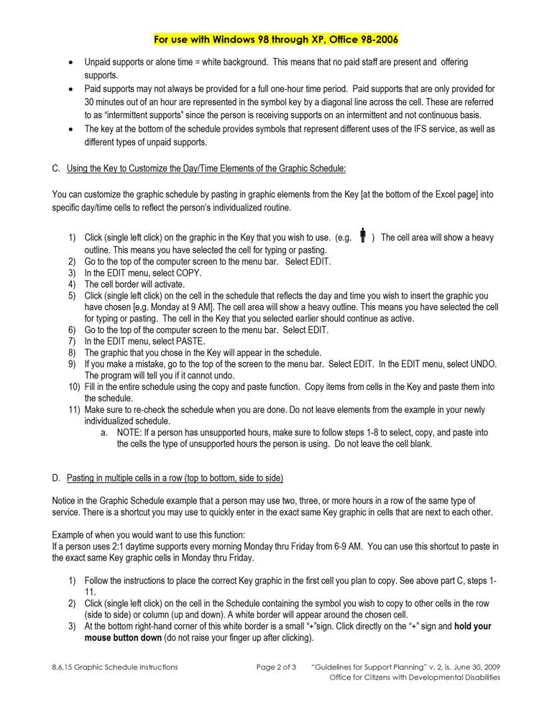Attachment 8.6.15 Graphic Schedule 

9

Review and Modification of the
Participant’s Support Plan

9.1 Purpose of Monthly Calls in the Plan Review Process
9.2 Preparing for the Quarterly Review
9.3 Completing the Quarterly Review
9.4 Using the Quarterly Quality Review to Document Progress
9.5 Using the Quarterly Review for Annual Planning
9.6 Urgent Meetings to Address Crisis Issues
9.7 Attachments
9.7.1 Quarterly Quality Review
REVIEW AND MODIFICATION OF THE PARTICIPANT’S SUPPORT PLAN
Support plan review is completed by the support team for each individual quarterly. Support plan review may occur more frequently based on the person’s request or presence of need(s).
The support plan review provides a structured setting for the team to discuss monitoring of the implementation of planned services within the home and other applicable settings, such as work or school.
The team should:
- Discuss action steps in the support plan document,
- Discuss supports delivery according to the support plan document,
- Evaluate the individual’s progress/status in meeting set outcomes,
- Determine when and if changes need to be made to the support plan, and
- Designate who is responsible for making the needed modifications to the plan.
9.1 PURPOSE OF MONTHLY CALLS IN THE PLAN REVIEW PROCESS
A. Each support coordinator is required to complete at least a monthly phone call to each participant and discuss the items in Section 9.4.B (below).
B. The monthly phone call is part of the required monitoring of each participant’s support plan. During the call the support coordinator reviews the following information. Follow-up probes may be needed for each item to acquire meaningful information.
- Satisfaction with supports,
- Implementation of plan actions and supports,
- Identification of any barriers existing, and
- Identification of any new interests/goals/needs.
- Documentation of the monthly phone call must indicate responses to the items outlined in Section 9.4.B.1-4. Documentation must show:
- Participant spoken with (or about),
- Family member spoken with,
- Date and time of contact, and
- Responses to each item.
D. With the participant’s agreement, the support coordinator speaks to provider staff and family members, if the participant lives with family, to determine if the plan is being implemented and is working for the participant.
1. In exercising his/her mutual responsibility with providers, the support coordinator is responsible for verifying, via communication with the provider, that the participant’s IFS hours authorized for the quarter are sufficient to meet the participant’s needs.
E. New barriers, concerns or needs that cannot wait for the quarterly review are addressed as needed, including revision to the plan as needed.
      - In exercising his/her mutual responsibility with providers, the support coordinator must work with the participant and provider to determine the need for a revision request for additional hours or an alteration of the typical schedule. Requests for additional hours in a quarter should be made proactively (anticipating the need), rather than as a last-minute emergency request. Regular communication between the support coordinator and provider as described in item 9.1.D above will facilitate identification of needed changes to a participant’s plan.
- As described in Section 6.6.H, the IFS provider has an ongoing responsibility to monitor the use of and assist persons with the management of their allocation of IFS hours, including IFS flexible hours and alternate schedule hours.
F. The provider must receive written notification of any changes within three (3) working days of approval.

9.2 PREPARING FOR THE QUARTERLY REVIEW
A. The review meeting is facilitated by the support coordinator in conjunction with the individual. At a minimum, the support coordinator, provider staff, individual, and his/her family and friends (as invited by the individual) should be present. Participation of the vocational provider is required if the participant receives vocational/day services.
B. If a support team member is unavailable to attend the meeting and has crucial information for the review process, the support coordinator contacts that person prior to the meeting to assure that the recommendations from that member are clear and can be conveyed during the meeting.
- Following the meeting, the support coordinator completes further follow-up to assure agreement of the absent team member with the resulting plan.
- Team members anticipating an absence should be offered the opportunity to participate by phone. The support coordinator should inquire about the team member’s availability by phone for incidental questions that may come up during the meeting time and secure contact information.
- The support coordinator works with the individual (as with the initial/annual meeting) to determine a time, date and location. The support coordinator provides written notification to all members of the time, date, and location of the quarterly review at least two weeks prior to the meeting. OCDD recommends that the quarterly schedule be developed during the annual planning meeting. This helps to assure attendance and assist in maintaining the two week’s notice requirement. A phone call reminder will occur 1 week prior to the scheduled meeting.
- If the fourth quarterly is being used as the annual planning meeting, a 30 day written notice must be provided (time, date, and location). A two week prior follow-up notice is sent as required in Section 9.2.C (above).
- In preparation for each quarterly meeting, the support coordinator must observe services within the home setting (and other applicable settings) and must also review the provider’s documentation. This activity may occur on the same day as the scheduled meeting, but the meeting may not substitute for the observation and review.

9.3 COMPLETING THE QUARTERLY REVIEW
A. During the meeting, the support coordinator facilitates a discussion about the status of supports, the prospect for sustained supports, and progress on action steps.
B. The support team discusses and reaches consensus about any recommended/ requested changes in the plan. Discussions should consider whether the plan is working in assisting the individual to meet his/her set outcomes (and work toward his/her vision).
C. The individual (or those who know him/her best) is given an opportunity to modify his/her vision or outcomes.
D. The support team makes and plans for any needed changes.
E. The support coordinator ensures that prior to leaving the meeting, all changes have an assigned responsible person, date, and data sources (full plan) for the actions required.

9.4 USING THE QUARTERLY QUALITY REVIEW TO DOCUMENT PROGRESS
A. At the end of the quarterly meeting, the support coordinator facilitates discussion to answer the questions posed on the Quarterly Quality Review (Attachment 9.7.1).
B. For quarters 1, 2, and 3, the review is focused on the quarter as it compares to the previous quarter in determining progress.
C. For the last quarter, the review focuses on the entire year to determine progress since implementation of that annual plan. The third quarter meeting includes all Discovery activities necessary for annual planning meeting.
D. The support coordinator keeps documentation of the Quarterly Quality Review and submits the final Quarterly Quality Review with the newly proposed plan for the participant as part of the annual process.

9.5 USING THE QUARTERLY REVIEW FOR ANNUAL PLANNING
- The appropriate quarterly review is to be used as the annual planning meeting. The support coordinator must provide a 30 day written notice (time, date, and location) to members of the support team prior to the annual planning meeting date. Two week prior follow-up phone notice must be sent according to Section 9.1.C.

- The support coordinator must send the participant the 90-L with accompanying instructions at least 90 days prior to the support plan expiration date.

- The SIS/LA PLUS assessment must not be completed more than 90 days prior to the expiration of the participant’s support plan if it is scheduled to be updated. If reassessment is not scheduled, then the most recent assessment is reviewed consistent with Sections 2.7 and 3.1

- Other Discovery activities must also be completed with the participant. This includes updating the participant’s Personal Outcomes Assessment. Each quarterly may be used to update the Personal Outcomes information with formal updating of the worksheets and verification of accuracy of information occurring at the third quarterly.

- The support coordinator shares information with support team members one week prior to the planning meeting by email or fax by circulating to the support team a rough draft of the support plan document that includes key information from Discovery, the Personal Outcomes Assessment, and results of the SIS/ LA PLUS. The SIS in its entirety is not sent to team members. It is important that support team members have all of the information that has been gathered, along with the vision and outcomes which have been identified by the person, available to them in the plan format for review before the meeting. This allows time for the team to prepare for the meeting, including bringing any concerns and proposed strategies to address these concerns to the planning meeting for optimal team discussion.
1. The support plan rough draft does not need to be written to the quality and volume of content required in the final planning document; it is a draft. However, the support coordinator must include information in all plan sections that can be filled in with Discovery information.
a. This includes information pertaining to criteria for shared supports.

b. Support coordinators are not to complete the Personal Outcomes Table (Section 5 of the CPOC) other than the person’s Vision.
2. In order to include shared supports information for roommates, the support coordinator and IFS provider must have held the roommate risk/benefit discussion prior to sending out the draft document (see Section 6.4).
3. The support coordinator is responsible for assuring that the person understands that this information will be shared.

- The planning meeting must be held no less than 55 days prior to the expiration of the support plan.

- Following the planning meeting, the support coordinator must develop the support plan. The IFS provider must concurrently develop the participant’s individualized service plan, back-up plan, and emergency evacuation plan.

- The support coordinator monitors the completion of the 90-L.

- Within (7) calendar days following the planning meeting, the support coordinator sends the support plan to the participant and the support team for review and agreement.

- The provider and other support team members have five (5) calendar days to review the support plan and return the signed support plan to the support coordinator. The provider must also include the individualized service plan, back-up plan, and emergency evacuation plan to the support coordinator.

- The support coordinator then submits the signed support plan to the support coordinator supervisor. The support coordinator supervisor has seven (7) calendar days to review, require any necessary revisions, and complete submission to the OCDD Regional Waiver Office.

1. Within 35 days prior to the expiration of the support plan, support coordination supervisors must complete submission of the support plan, provider’s individualized service plan, emergency evacuation plan, back-up plan, and 90-L to the OCDD Regional Waiver Office.

- The OCDD Regional Waiver Office is responsible for reviewing and approving the support plan within ten (10) business days following receipt of the plan.

- Once the support plan is approved, the support coordinator forwards the approved plan to the provider and the participant within two (2) calendar days or by the next business day.

9.6 URGENT MEETINGS TO ADDRESS CRISIS ISSUES
A. Team members aware of urgent and critical issues or concerns are responsible for notifying the support coordinator of the need for a meeting.
B. The support coordinator should not delay discussion until the next scheduled review, but should assure that items are addressed. Intervention may include development of a plan or course of action that may require revising the participant’s support plan.
C. Issues that may require an urgent meeting and/or plan revision include, but are not limited to, the following:
- A risky or life-threatening critical incident,
- A trend of repeated critical incidents, or
- Risk of losing current living situation.
D. An urgent meeting may need to be held with little notice. Use of phone conferencing is appropriate to assure attendance by all support team members.
E. Written changes to the support plan must be sent to team members and submitted within three (3) working days.
9.7 ATTACHMENTS
Attachment 9.7.1 Quarterly Quality Review
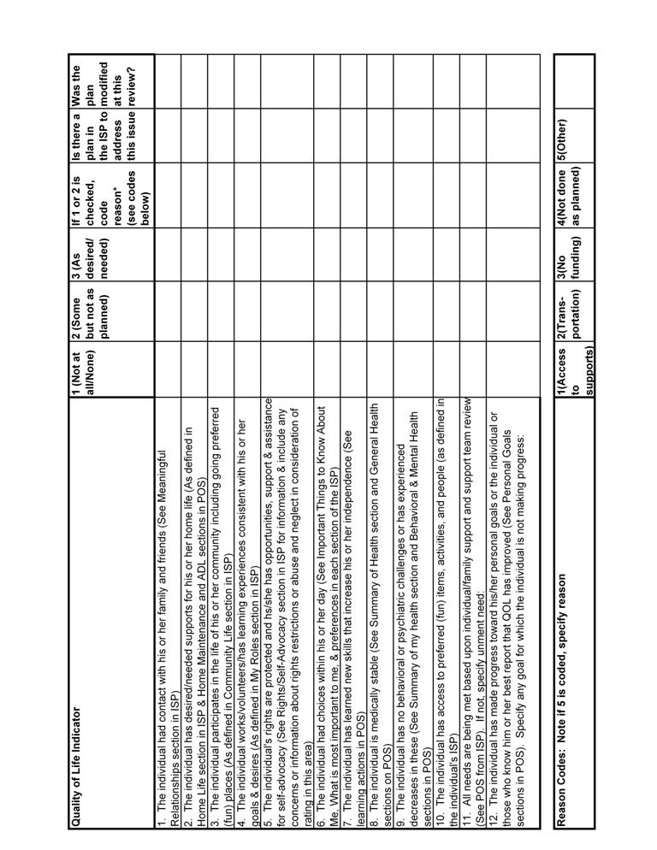
10

Appealing Denials of Services

10.1 Disenrollment, Decertification, and Discharge Procedures
10.2 Denial of IFS Hours
10.3 Attachments
10.3.1 Medicaid Fair Hearings Brochure
10.3.2 BHSF Form 142 Notice of Medical Certification

APPEALING DENIALS OF SERVICE
A fair hearing is an administrative procedure that affords participants the statutory right and opportunity to appeal adverse decisions regarding Medicaid eligibility or benefits to an independent arbiter.
Participants have the opportunity to request a fair hearing/appeal when denied eligibility, when eligibility is terminated, or when denied a covered benefit or service by the Department of Health and Hospitals (DHH). For further information on fair hearing and appeals, refer to the Medicaid Vendor Administration, Administrative Manual, Appeals. (Medicaid Vendor Administration, Administrative Manual, Appeals
http://10.12.8.169/administrativemanual/applicant-enrollee%20appeals.pdf.)

A brochure on Medicaid fair hearings is included as Attachment 10.3.1.
Fair hearing and appeals only as they apply to the New Opportunities Waiver (NOW) and recommended IFS hours are addressed in this Section.
The OCDD Regional Waiver Office issues a notice of adverse action in five circumstances:
- The individual no longer meets the level of care requirements for NOW participation (90 L).
- The individual can no longer be safely served under the NOW.
- The individual violates waiver policies and responsibilities.
- The individual requested and was denied additional IFS hours.
- The individual does not receive a waiver services for more than 30 days.
The first three circumstances require that the individual be disenrolled from the NOW. The decertification and waiver discharge procedures in Section 10.1 apply in these cases. The procedures for denial of IFS hours are presented separately in Section 10.2 of the Guidelines.
10.1 DISENROLLMENT, DECERTIFICATION, AND DISCHARGE PROCEDURES
A. The following procedures are established if a participant meets any of the three criteria requiring disenrollment from the NOW.
- The OCDD Regional Waiver Office issues a notice of adverse action. In the case where any individual no longer meets the level of care criteria or requires a higher level of care than available under the waiver a “Notice of Medical Certification” BHSF Form 142 (Attachment 10.3.2) with a cover letter to the participant, support coordinator, the Department of Health and Hospitals (DHH) data contractor, and Bureau of Health Services Financing (BHSF) is issued to discharge the participant from the waiver.
- Services continue until the appeal is resolved, provided that the participant requests an appeal within thirty (30) calendar days of the adverse action notice and requests the continuation of services. Participants must submit their appeal request in writing or verbally to the DHH Bureau of Appeals. The appeal request should specifically state the reason of disagreement with the decision. The OCDD Regional Waiver Office notifies the support coordinator, provider, DHH data contractor, and BHSF immediately by telephone or fax if an appeal is made within this timeframe.
- If an appeal request is not received within thirty (30) calendar days of the adverse action notice, then all services are stopped on the 31st calendar day (All prior authorizations are voided through the DHH data contractor on the 31st calendar day.).
- If the participant appeals within 30 calendar days of the adverse action notice, the OCDD Regional Waiver Office completes a Summary of Evidence and prepares for the appeal.
- If the appeal decision is in favor of the participant, the OCDD Regional Waiver Office takes steps to reinstate the participant’s waiver certification and services.
B. Decertification or any other disenrollment of a waiver participant is subject to review by the State Office Review (SOR) panel prior to notification of appeal rights and subsequent termination of waiver services.
10.2 DENIAL OF IFS HOURS
A. The following processes apply to denials of requested IFS hours:
- The Developmental Disabilities Regional Waiver Office issues a Notice of Adverse Action for IFS requests that are denied. This notice is sent to the participant and to the support coordinator. The notice includes a cover letter and formal notice of appeal and fair hearing rights.
  - The Developmental Disabilities Regional Waiver Office notifies the OCDD data contractor (SRI) of any change in current authorizations.
- If the individual is not receiving IFS services, he/she may appeal within 30 days of the notice of the adverse action. If the appeal decision is in favor of the individual, the OCDD initiates hours as appropriate.
- If the individual is currently receiving IFS hours in excess of the recommended IFS hours and wishes to continue current IFS hours service delivery during the appeals process, he/she must file a request for appeal within thirty (30) calendar days of the notice of adverse action. This request for appeal must also request continuation of services during the appeal period.
  - The participant must submit his/her appeal request in writing or verbally to the DHH Bureau of Appeals. The appeal request should specifically state the reason for disagreement with the denial decision.
  - The Developmental Disabilities Regional Waiver Office notifies the support coordinator, provider, OCDD data contractor, and BHSF immediately by telephone or fax if an appeal is made within the thirty (30) day timeframe and also requests continuation of services. IFS hours will be continued at the higher level.
- If the individual is currently receiving IFS hours in excess of the recommended IFS hours, he/she may appeal within 30 days of the notice of adverse action. Appeals not requesting continuation of services (described in #3 above) and appeals not occurring within thirty (30) calendar days of the notice of adverse action (also described in Section 10.2.A.3 above) will result in IFS hours being delivered according to the approved support plan. This delivery may be a reduced number of IFS hours than what the participant is requesting in the appeal.
  - The participants must submit his/her appeal request in writing or verbally to the DHH Bureau of Appeals. The appeal request should specifically state the reason for disagreement with the denial decision.
10.3 ATTACHMENTS
______________________________________________________________________
Attachment 10.3.1 Form 142 Notice of Medical Certification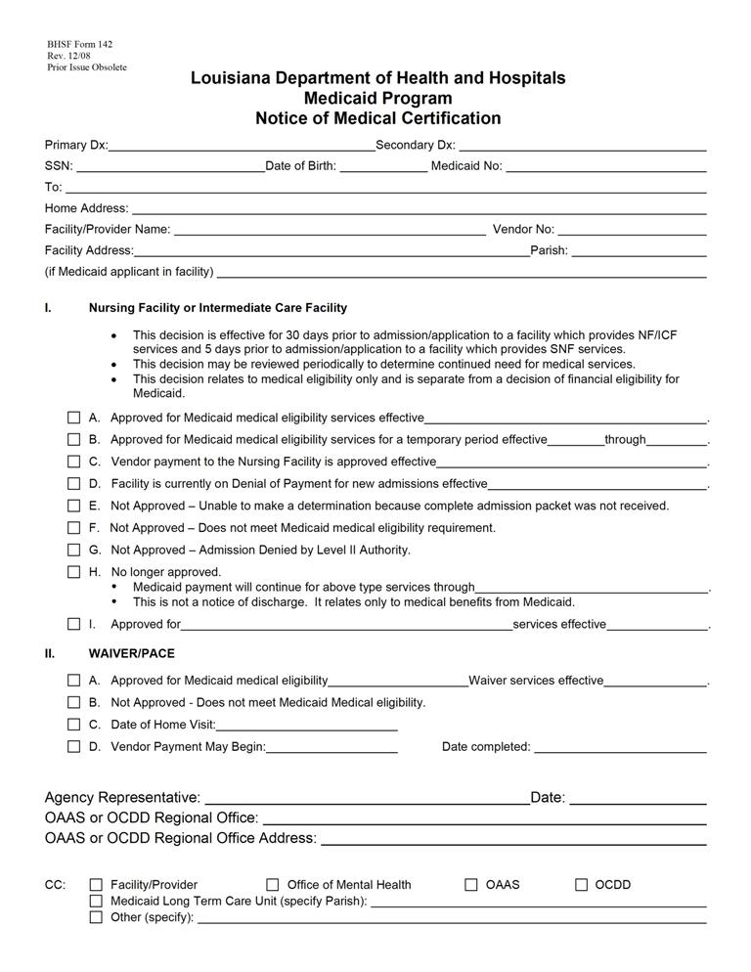
11

Training and Certification Processes

11.1 Training for the SIS/LA PLUS Assessors
11.2 Certification in the use of the SIS/LA PLUS
11.3 Certification Step 1: Classroom Training for the “Guidelines for Support Planning”
11.4 Certification Step 2: Support Plan Completion Consistent with the
“Guidelines for Support Planning”
11.5 Designation and Requirements of Master Trainers
11.6 Attachments

TRAINING AND CERTIFICATION PROCESSES
Realizing that good assessments and planning start with good assessors/facilitators, OCDD places a high priority on the training and certification of assessors and those developing and reviewing plans.
OCDD's objective is to ensure that assessments are accurate reflections of individuals and their needs and that they are used to develop quality plans to meet identified desires and needs.

  - TRAINING FOR THE SIS/LA PLUS ASSESSORS
A. The training and certification process for assessors involves a multiphase process.
B. The first phase includes classroom training (2.5 days - involving 2 days of classroom training and typically a ½ day videoconference). The classroom training is used to introduce both assessment tools. It covers the following information:
- Background in tool development,
- Uses of the tool, and
- Administration of the tools.
C. At the end of each day, trainees are expected to practice administration of the tools (SIS on day one and LA PLUS on day two). At the end of the second day, trainees are expected to pass a written competency test of material presented.
D. On the third day, a videoconference is used to present the electronic versions of both instruments and have trainees become familiar with the features found in the electronic versions of the SIS and LA PLUS.
- Particular emphasis is given to demonstrating the features of the electronic versions so that trainees can become knowledgeable of such.
- Trainees are then given electronic versions of both instruments and encouraged to familiarize themselves with them by engaging in practice manipulations.
- It is noted that the videoconference is the format utilized by SIS/LA PLUS Project Team. Regional Office Specialist staff and support coordinator agency master trainers (defined in Section 11.5) may utilize an agency on-site training variation (i.e., may conduct training on-site at the particular agency where staff are being trained).
11.2 CERTIFICATION IN THE USE OF THE SIS/LA PLUS
A. The second phase of certification continues the practice involved in training and begins the competency process. The assessor trainees are required to schedule three assessments that are to be shadowed by a previously certified assessor (“rater”) as the second level in the process.
B. The rater completes the SIS and LA PLUS for the same individual with the same information while the assessor trainee is conducting the assessment.
- If the trainee is a state Regional Office Specialist (ROS) or ROS back-up, the assessments are shadowed by a rater from the SIS/LA PLUS Project Team.
- If the trainee is a support coordinator agency master trainer, the assessment is shadowed by either the ROS or ROS back-up rater.
- If the trainee is a support coordinator, the assessment is shadowed by the support coordinator master trainer.
C. The rater compares the results of the assessment he/she completes with that of the assessor trainee. A formula (an inter-rater reliability formula established by a statistical consultant for OCDD) is used which allows the rater to help determine if an assessment was conducted reliably.
D. If after the first shadowed assessment (and any other subsequent assessments until certification is achieved) the rater determines that a reliable assessment was not performed, the rater offers pointers, training tips, etc. to better prepare the assessor trainee for the next scheduled assessment(s).
- Pointers, training tips, etc. are offered only after and between assessments.
- A rater does not offer pointers, tips, etc while the assessment itself is conducted. This goes against protocol in the inter-rater reliability process.
E. When a minimum of three assessments are completed, both the trainee’s assessments and the rater’s shadowed assessments are forwarded to the SIS/LA PLUS Project Team for review.
- It is important that the rater note the sequence of assessments as the SIS/LA PLUS Project Team looks for progressive improvement in trainee skill.
- It is important that trainees be reminded that the shadowed assessments are used for training purposes only.
- No assessments occurring during shadowing exercises can be used for planning purposes. (This applies to both the rater’s and the trainee’s.)
F. A review of all trainee assessments by the SIS/LA PLUS Project Team is the third level in the process. (This also would likely include consultation with ROS staff.) The SIS/LA PLUS Project Team reviews all submitted assessments by a trainee and the matching shadowed assessment by the rater.
G. The State SIS/LA PLUS Project Team uses the inter-rater reliability formula to determine if the trainee’s assessments are within acceptable reliability guidelines. In addition, the trainee’s assessments are reviewed to determine if there appears to be comprehension of assessment principles relevant to both tools (i.e., Did the assessor appear to grasp the concept of the “Important To” and “Important For”? Was documentation supplied which justifies the response and demonstrates comprehension of this assessment concept? In addition, did the assessor complete the assessment in entirety? Did the assessor make assessment errors that demonstrate a failure to grasp pertinent assessment rules?).
H. If the State SIS/LA PLUS Team determines that a trainee has mastered the assessment concepts and that the third assessment was within acceptable reliability guidelines, then certification is granted for one year.
I. If the trainee failed to demonstrate mastery of assessment principles and/or fell outside acceptable reliability guidelines, then a plan of remediation as determined by the SIS/LA PLUS Project Team is applied.
- It is typical that a plan of remediation begins with a request that an additional assessment and shadowing experience occur.
- Before an additional assessment occurs, the trainee and rater are notified of the deficiencies by e-mail.
- SIS/LA PLUS Project Team members may also counsel the trainee by phone in an attempt to clarify any misunderstanding a trainee may have following the e-mail noting deficiency.
- It is important that this counseling be individualized to the particular needs of the trainee and discusses areas of weakness.
- Counseling is also used to increase skill proficiency.
- After the additional assessment is completed, it is forwarded to the State SIS/LA PLUS Team for review.

- If the additional assessment contains deficiencies, the trainee may be asked to submit revisions or may be asked to complete additional shadowed assessments.
- Other remediation strategies include: having the trainee participate in additional classroom training, conducting additional phone or in-person counseling by a member of the SIS/LA PLUS Project Team, having the trainee observe a member of the SIS/LA PLUS Project Team or ROS staff conduct an assessment and then conduct another shadowed assessment along with a rater, etc.).
J. After various attempts at remediation and the submission of five deficient assessments, a trainee is determined ineligible for certification for six months following the date of the last assessment submitted for review.
K. The SIS/LA PLUS Project Team issues the final determination of whether certification is granted or denied.
L. At any time after certification, the assessor trainee can begin conducting assessments independently.
M. If certification is denied, the trainee shall not conduct any additional assessments. Following a six month period subsequent to denial of certification, an individual may restart the assessor trainee process. The individual must complete the classroom training and complete a minimum of three (3) shadowed assessments that are submitted to the SIS/LA PLUS project team for review.
N. Certification is valid for up to one year. Before issuance of re-certification, a minimum of one shadowing experience must occur with the assessor demonstrating mastery standards.
O. To maintain integrity in the assessment process and for data collection purposes, all certified assessors are monitored. All certified assessors are defined as Region Office Specialists and back-ups, support coordination master trainers and back-ups, and support coordinators. Monitoring procedures include:
- A minimum of one shadowing experience for all ROS and back-ups every quarter - The shadowing is to be conducted by a member of the SIS/LA PLUS Project Team. If the shadowed individual fails to meet reliability criteria, then a remedial plan of action is initiated (either additional classroom training, observation of SIS staff conducting assessments, or additional shadowings of the ROS and back ups);

- A minimum of one shadowing experience for all support coordination master trainers and back-ups every quarter - The shadowing is to be conducted by the ROS or ROS back-ups. If the shadowed individual fails to meet reliability criteria, then a remedial plan of action is initiated (either additional classroom training, observation of ROS staff conducting assessments, or additional shadowings of the support coordination master trainer and back ups); and
- A minimum of one shadowing experience for all support coordination agency support coordinators semi-annually - The shadowing is to be conducted by a support coordination master trainer or back-up. If the shadowed individual fails to meet reliability criteria, then a remedial plan of action is initiated (either additional classroom training, observation of support coordination agency master trainers and/or back-ups conducting assessments, or additional shadowings of the support coordinator).
P. Should a certified assessor be unable to demonstrate reliability, the assessor is de-certified. The assessor and immediate supervisor, as well as the OCDD Executive Director of Community Services are notified of the decertification. The assessor is no longer permitted to conduct SIS and LA PLUS assessments independently. If the ROS staff are de-certified, they are no longer be able to train, shadow and perform other assessment and training duties relevant to the role of ROS.
Q. All certified assessors must attend and successfully complete a yearly classroom training that is offered by the SIS/LA PLUS Project Team. The purpose of the annual classroom training is to:
- Present and train on any new assessment procedures (e.g., if additional data categories are added to the existing assessments),
- Reinforce current skills,
- Clarify questions, concerns or issues that may have emerged since last contact, and
- Extend certification of the participant.
R. Manual checking of all assessments conducted occurs by SIS/LA PLUS Project Team before submission to the OCDD SIS/LA PLUS database. The purpose is to assure that assessments are complete and error free and to identify potential problem assessments.
(Note: This additional data monitoring step is proposed and is necessary until Information Technology is able to create the technological framework necessary that will render such manual checks obsolete.)
S. A SIS/LA PLUS users group meets with Regional Office Specialists and back-ups in quarterly phone conferences. The SIS/LA PLUS Project Team ask all ROS and back-ups to answer questions and/or clarify concerns which may present. This concept is repeated by ROS and back-ups in their own respective regions with support coordination master trainers and back-ups.
T. Finally, all data pertaining to training, shadowings, certification status and assessments are tracked by the SIS/LA PLUS Project Team. This data is monitored to determine compliance with OCDD policy and procedures.

11.3 CERTIFICATION STEP 1: CLASSROOM TRAINING FOR THE “GUIDELINES FOR SUPPORT PLANNING”
A. The training and certification process for support coordinators in the “Guidelines for Support Planning” is separate and distinct from SIS/LA PLUS training required for assessors.
  - The first step in certification for the “Guidelines for Support Planning” is completion of a multi-day classroom training that covers all key areas of the “Guidelines for Support Planning.” During each day of training, trainees are expected to practice the various components of the planning process.
  - The number of days of required training is based upon the role of the support coordination agency personnel.
- Supervisors are required to attend two and one-half (2 ½) days of classroom training.
- Support coordinators are required to attend at least two (2) days of classroom training.
D. Following successful completion of classroom training, support coordinators and supervisors progress to the second step in certification, which is completion of support plans consistent with the principles in the “Guidelines for Support Planning.”

11.4 CERTIFICATION STEP 2: SUPPORT PLAN COMPLETION CONSISTENT WITH THE “GUIDELINES FOR SUPPORT PLANNING”
- In addition to classroom training, all support coordination supervisors and support coordinators must complete three (3) support plans that meet the requirements of the “Guidelines for Support Planning.” This determination is made through application of the Individual Supports Review (ISR) by the support coordination agency supervisor (for support coordinators only), designated OCDD Regional Waiver Office staff, and Guidelines for Planning State Office Review Committee. (The detailed process is discussed in Sections 7.1, 7.2, and 7.3)
- Trainees must complete Discovery activities, conduct a planning meeting, and develop a complete plan following the process described in “Guidelines for Support Planning” Sections 3 through 6. Trainees may be shadowed during planning meetings until two plans are approved.
- When the plans are completed, the support coordination agency supervisor must complete the ISR according to protocol in Section 7.
    - Both the trainee’s plan and the support coordination agency supervisor’s ISR are forwarded to the GPSORC Chair for review. (See Section 7.)
D. The GPSORC (or designees of the committee) reviews the three completed plans and ISRs. The review includes consultation with Region Office Specialist (ROS) staff. Plans are reviewed using the criteria in the ISR consistent with the review process in Section 7.
E. If after review it is determined that three of the trainee’s initial submissions were within acceptable approval guidelines, then certification is granted for one year.
F. If the trainee fails to meet criteria and/or falls outside acceptable guidelines, then a plan of remediation as determined by the GPSORC (or designees of the committee) is applied.
- The plan of remediation is developed by GPSORC (or designees of the committee).
  - Typical remediation strategies begin with a request that additional planning meetings with shadowing experience occur.
  - The ROS may also provide additional training in an attempt to clear any misunderstanding a trainee may have following the e-mail noting deficiency.

  - It is important that any additional training be individualized to the particular needs of the trainee in order to address areas of weakness.
- The trainee and supervisor are notified of the deficiencies and the remediation requirements by e-mail.
- One or more additional plan(s) may be requested to demonstrate competency. After the additional plan(s) is completed, it is forwarded to the GPSORC Chair (or designee) for review.
- Should the plan still contain deficiencies, the trainee may be asked to submit revisions or to complete additional shadowed plans.
- Other remediation strategies include: having the trainee participate in additional classroom training, having the trainee observe a ROS staff conduct a planning meeting and complete a plan, having the trainee complete an additional shadowed plan post additional training or observation of ROS, etc.
G. After various attempts at remediation and submission of five deficient plans, a trainee is determined ineligible for certification for six months.
H. The GPSORC Chair issues the final determination of whether certification is granted or denied.
I. Should the trainee not be eligible for certification status, he/she must cease conducting any additional planning meetings or completing any additional plans.
J. Trainees who master the required skill level are issued a certificate that is valid for up to one year from the time of issuance.
K. In an effort to maintain integrity in the planning process, on-going reliability measures and monitoring of support coordinators is required. In addition to support coordinators, once certified, all ROS and back-ups and support coordinator master trainers and back-ups are also monitored on an on-going basis. Monitoring requirements of ROS, support coordinator master trainers, and support coordinators are described in the following paragraphs.
- A minimum of one reliability review for all ROS and back-ups every quarter. The shadowing is to be conducted by a member of the GPSORC. If the shadowed individual fails to meet reliability criteria, then a remedial plan of action is initiated.

- A minimum of one reliability review for all support coordinator master trainers and back-ups every quarter. The shadowing is to be conducted by ROS or back-ups. If the shadowed individual fails to meet reliability criteria, then a remedial plan of action is initiated.
- A minimum of one shadowing experience for all support coordinators semi-annually in addition to regularly required supervisory review of plans. The shadowing is to be conducted by support coordination master trainers or back-ups and includes review of Discovery activities, observation of planning meeting and review of the support plan. If the shadowed individual fails to meet reliability criteria, then a remedial plan of action is initiated.
L. Should a certified support coordinator be unable to demonstrate an ability to maintain standards, the support coordinator is de-certified. The support coordinator and immediate supervisor, as well as the OCDD Executive Director of Community Services, are notified. The support coordinator is no longer able to conduct planning independently.
M. If an OCDD Regional Waiver Office staff person is unable to demonstrate an ability to maintain standards, that individual is no longer able to train, shadow, and perform other duties relevant to the role of ROS in support planning.
N. All individuals conducting support planning and/or those who train persons to conduct support planning are required to attend and successfully complete a yearly classroom training that is offered by the OCDD. The purposes of training attendance are to complete the following:
- Reinforce current skills,
- Clarify questions, concerns, or issues that may have emerged since last contact, and
- Extend certification of the participant.
O. Finally, all data pertaining to training completion, certification status, and support plan ratings (according to the ISR) are tracked by the GPSORC. This data is monitored to determine compliance with OCDD policy and procedures.

11.5 DESIGNATION AND REQUIREMENTS OF MASTER TRAINERS
A. The support coordinator master trainer is appointed by the support coordination agency.
B. The support coordinator master trainer serves as the lead agency trainer in assessment and the “Guidelines for Support Planning” training matters for the agency.
C. A back up is appointed for each agency.
D. The support coordinator master trainer (and back up) undergo additional OCDD sponsored trainings, certification, and monitoring as compared to other agency staff.
- The support coordinator master trainer (and back up) attends an additional training session that focuses on preparing him/her to train other staff.
- Information is disseminated to the support coordinator master trainer on how to properly conduct shadowing with trainees.
- The Region Office Specialist (ROS) conducts routine reliability checks on the support coordinator master trainer. The reliability checks are used to determine maintenance of skill level and need for remediation.
- The ROS attends the initial training offered by the support coordinator master trainer in order to assure that the training offered by the master trainer is in compliance with quality standards.
- The support coordinator master trainer must circulate an evaluation form to all those that he/she trains to get participant feedback on his/her effectiveness in training on the material.
E. Support coordinator master trainers and back-ups are required to be certified in both the assessment of support needs (SIS and LA PLUS) and in the creation of support plans for individuals (“Guidelines for Support Planning”).
- If an agency designated master trainer or back-up does not initially meet full certification requirements, then the agency must designate another individual as the master trainer or back-up.
- If an individual is not certified in SIS/LA PLUS, but does gain certification in the “Guidelines for Support Planning,” he/she may develop support plans based on assessments conducted by certified assessors. But he/she may not independently conduct SIS/ LA PLUS assessments.
- The individual is able to attempt certification again after the passing of six (6) months since last attempting certification.
- Attempting certification again involves starting the training process over and includes going through classroom training (including SIS/LA PLUS, “Guidelines for Support Planning,” and Train the Trainer) and a minimum of three (3) shadowed assessments and submission of three (3) plans that meet requirements of the “Guidelines for Support Planning.”
- If at that time the individual passes both certifications, the agency may designate that individual as a master trainer or back-up.

G. The above also applies to individuals who have been originally certified and failed at re-certification.

11.6 ATTACHMENTS
No attachments for Section 11.6

12

OCDD Quality Monitoring Process

12.1 Relevant Policies and Requirements
12.2 Support Planning Quality Monitoring Process
12.3 Establishing and Monitoring Performance Indicators
12.4 Responsibilities for Assuring the Quality of Support Plans and Delivery of Services
12.5 Attachments

OCDD QUALITY MONITORING PROCESS

The Office for Citizens with Developmental Disabilities (OCDD) Quality Monitoring Process involves a coordinated effort among providers, support coordination agencies, Regional Developmental Disability Offices, and OCDD Central Office in obtaining and reviewing information and data in order to assure that:
- Office programs are achieving outcomes important to people with developmental disabilities by meeting established performance criteria;
- Individual situations that require remediation are addressed;
- Data collected on specific performance indicators identifies trends, patterns, and opportunities for improvement and appropriate action for remediation; and
- Data provides information on how well the service system is meeting the needs of individuals served, Department/Office goals and priorities, and the Centers for Medicare and Medicaid Services (CMS) assurance requirements.
12.1 Relevant Policies and Requirements
A. In accordance with the OCDD Quality Enhancement Process Policy #603, it is the policy of OCDD that quality assurance is the responsibility of every person at every level within the developmental disabilities services system and that quality assurance activities occur at provider, support coordination, regional, and statewide levels in order to provide quality services and to identify and respond to opportunities for improvement in the provision of supports and services to people with developmental activities.
B. Home and Community-Based Services Waiver Requirements
1. OCDD must demonstrate adherence to waiver assurances and other federal requirements as documented in each waiver application. OCDD’s quality assurance program systematically collects and reviews data in order to assure the requirements are being met and engages in remediation actions when non-adherence is identified.
2. OCDD must adhere to six (6) major waiver assurances with one or more requirements (also known as subassurances) for each assurance. The six major assurances are:
a. Level of care,
b. Service plan,
c. Qualified providers,
d. Health and welfare,
e. Financial accountability, and
f. Administrative authority.
3. The OCDD “Guidelines for Support Planning” process must adhere to service plan assurance by implementing processes that address the five (5) required subassurances.
a. Service plans address all participants’ assessed needs (including health and safety risk factors) and personal goals, either by provision of waiver services or through other means.
b. The state monitors service plan development in accordance with its policies and procedures.

c. Service plans are updated and or revised at least annually or when warranted by changes in the waiver participant’s needs.
d. Services are delivered in accordance with the service plan, including the type, scope, amount, duration and frequency specified in the service plan.
e. Participants are afforded choice between waiver services and institutional care and between/among waiver services and providers.
4. For each of the service plan subassurances, OCDD must specify within each waiver application:
a. Performance indicators including methods used to obtain information about compliance and the frequency of and process for data review,
b. Remediation activities followed to correct individual problems including data collection for remediation activities, and
c. The quality enhancement process including how data is aggregated, reviewed, and used to develop and implement quality improvement initiatives.

  - Support Planning Quality MONITORING Processes
- OCDD has developed several methods for obtaining information about the quality of support plans and the delivery of supports and services; thereby assuring that waiver participants’ needs and preferences are identified, plans address assessed needs and preferences, and services are delivered as according to participants’ plans.
- People’s needs and preferences are assessed through administration of the SIS/LA PLUS to individuals and through pre-planning Discovery activities to identify needs and personal goals. Quality management strategies to assure that needs and personal goals are comprehensively assessed include:
- A certification process for the SIS/LA PLUS to assure that SIS/LA PLUS assessments are only conducted by support coordinators who have been determined to reliably administer the SIS/LA PLUS assessment and document assessment results. A description of the certification processes is described in Section 11, Training and Certification Process.
- A certification process for “Guidelines for Support Planning” to assure that support coordinators identify participant’s needs and personal goals during the pre-planning Discovery process. A Personal Outcomes Assessment is completed by the support coordinator each year as part of the planning process to identify the preferences and priorities of the individual as part of the planning process. [See Section 3.2, Completing Discovery (Using Personal Outcomes Interview/Mapping Strategies/Discovery Meeting) and Section 3.3, Developing a Personal Vision and Goals.]
- Certification in the “Guidelines for Support Planning” that requires that support coordinators successfully complete a classroom training in which support coordinators learn Discovery activities to identify a participant’s needs and preferences. Support Coordinators also received training in the use of the Discovery information during planning process to develop an individualized support plan for each participant. A description of the certification process is described in Section 11, Training and Certification Process. Spreadsheets for tracking Certification for the SIS/LA PLUS and “Guidelines for Support Planning” are maintained in both the OCDD Central Office and the Regional Developmental Disability Offices database to assure that only certified people are performing the functions of SIS/LA PLUS administration and Support Coordination Supervisor reviews with the Individual.

- Support Plans meet people’s assessed needs and preferences. OCDD provides ongoing training and certification to support coordination agency supervisors and trainers and Regional Office Specialists and other staff on the use of the Individual Supports Review Protocol as a mechanism for determining that support plans meet participants’ assessed needs, personal goals, and OCDD and CMS requirements. In order to assure that support plans address participants’ needs and include strategies to help participants attain their personal goals, several quality management processes have been implemented, including:
- Support coordinator supervisors and their subordinates are required to be certified in the “Guidelines for Support Planning.” The certification includes classroom instruction and shadowing. Training competencies include:
  - Understanding of OCDD planning values and assumptions,
  - Purpose of person-centered planning and service delivery,
  - Discovery process,
  - Planning format,
  - Planning meeting preparation,
  - Planning meeting facilitation,
  - Development of planning strategies,
  - Plan implementation, and
  - Plan review and revision.
- The Support Coordination Supervisor is required to review 100% of the initial and annual support plans using the Individual Supports Review Protocol. (See Section 7, Support Plan Approval Process.) If the support coordination supervisor determines that a support plan does not meet criteria for approval, the supervisor must assure that the support plan is corrected. The Individual Supports Review Protocol must be submitted along with the participant’s support plan to the Regional Developmental Disability Office Waiver Unit for approval once the support coordinator supervisor certifies the plan meets OCDD Protocol requirements.
- Regional Developmental Disability Office staff is required to review 100% of the service plans using the Individual Supports Review Protocol. Regional Developmental Disability Office staff shall require revisions when criteria as established in the Individual Supports Review Protocol are not met. In addition, Regional Developmental Disability Office waiver staff is required to complete a reliability verification of the support coordination supervisor’s Individual Supports Review Protocol and complete certification of the support coordination supervisor. Certification is verified by Central Office staff through a review of three qualifying Individual Supports Review Protocols from the support coordination supervisor and Regional Developmental Disability Office staff. Regional Developmental Disability Office staff also tracks plan approval in terms of timelines, approval status, and compliance with the “Guidelines for Support Planning” requirements by support coordination agency, support coordination supervisor, and support coordinator.
- The OCDD Central Office receives data by agency from the Regional Developmental Disability Offices and reviews the data reports to identify agency, regional, and statewide trends with regard to this subassurance. This data is then used to determine Office initiatives inclusive of training efforts, remediation strategies, and other corrective measures. Central Office staff also review a random sample of all plans completed to assure quality and accuracy of the process.
D. Support coordinators are required to monitor participants’ support plans to assure that the support plans continue to adequately meet participants’ needs and help them accomplish their personal goals and that services are delivered as specified in the participants’ support plans.
- Support coordinator monitoring activities include:
  - Monthly phone contacts,
  - Quarterly in-person visits,
  - Quarterly support team meetings to review the participant’s support plan to assure that services are delivered according to the plan and that the plan continues to meet the needs and preferences of participants,
  - Quarterly observation of services, and
  - Annual update of the support plan.
- Support coordinator documentation of support coordination monitoring results is maintained in the support coordinator’s contact and progress notes/service logs and the data is entered into the Case Management Information System (CMIS).
- In conducting required monitoring, support coordinators monitor and observe any type of IFS used, including flexible hours. It is not necessary to conduct an additional observation to assure monitoring of a planned service.
- Tracking of support coordination monitoring is maintained in CMIS and includes when the monitoring was done and what was observed.
- The Quarterly Quality Review Tool is completed at each quarterly review for each participant by the support team led by the support coordinator. This information is used to assure that services are being provided and goals and needs are being met. This data is submitted with the annual plan review for the next planning cycle and is reviewed by the Regional Developmental Disability Office staff for compliance with monitoring practices and to assess outcomes for each participant. The information is entered into an OCDD database and reviewed for trends and patterns by agency, support coordination supervisor, and support coordinator.
- OCDD Central Office receives data per agency from the Regional Developmental Disability Office and reviews it to track agency, regional, and statewide trends with regard to this subassurance. This data is then used to determine Office initiatives inclusive of training efforts, remediation strategies, and other appropriate corrective measures.
12.3 Establishing and Monitoring Performance Indicators
A. Establishing Performance Indicators
1. OCDD determines performance indicators related to the “Guidelines for Support Planning” through its annual strategic planning process.
2. Data for these indicators are reviewed at least quarterly to determine progress and identify any challenges or barriers. Trends and patterns are analyzed by support coordination agency, region, and statewide.
3. Indicators may be modified or added to based upon this quality review process.
B. Monitoring Performance Indicators
1. Reports with performance indicator data are generated as specified by frequency of review and presented to the OCDD Performance Review Committee. The committee determines if strategies need to be developed and implemented to improve performance.
2. The OCDD Performance Review Committee monitors implementation and effectiveness of strategies to improve performance.
12.4 Responsibilities for Assuring the Quality of Support Plans and Delivery of Services
- Responsibilities of the Direct Service Provider Agency include:
- Completing the provider responsibilities as a member of the support team as described in Section 3.4 (Establishing the Support Team),
- Notifying the support coordinator if the participant’s plan is not meeting the participant’s needs or if the participant’s needs and preferences change.
- Tracking agency performance for plan implementation,
- Reviewing data and implementing remediation and quality improvement strategies, as warranted [(See http://www.dhh.louisiana.gov/offices/publications.asp?ID=77&Detail=2312 for a copy of the Quality Enhancement Provider Handbook that was jointly developed by OCDD and the Office for Aging and Adult Services (OAAS).], and
- Requesting technical assistance from the OCDD Regional Developmental Disability Offices, when needed.
- Responsibilities of the support coordination agency include:
- Maintaining sufficient numbers of support coordinators that are certified in administration of the SIS/LA PLUS and the “Guidelines for Support Planning,”

- Maintaining a master trainer certified to train agency staff in the SIS/LA PLUS and Guideline for Planning,
- Reviewing 100% of support coordinator’s service plans with the Individual Supports Review Protocol by the support coordination supervisor and remediating any plan deficiencies prior to submission to the OCDD Regional Developmental Disability Offices.
- Monitoring service plan implementation during monthly contacts and quarterly reviews and revising service plans, as needed,
- Tracking compliance with time lines for service plan submission, percentage of plans that meet criteria identified in the Individual Support Review Protocol, and compliance with quarterly monitoring of plans to assure that services are delivered according to the plan and that the plan continues to meet participant’s needs and preferences,
- Reviewing data and implementing remediation and quality improvement strategies, as warranted, and
- Requesting technical assistance from the Regional Developmental Disability Offices, when needed.
- Responsibilities of the Regional Developmental Disability Offices include:
- Maintaining a Regional Office Specialist and a back-up who are certified in the “Guidelines for Support Planning” and the SIS/LA PLUS,
- Maintaining waiver staff who are certified in the “Guidelines for Support Planning,”
- Providing training and technical assistance on the “Guidelines for Support Planning” to Regional Developmental Disability Office, support coordination agency, and direct service provider staff,
- Following Office policy on reviewing and approving service plans, including conducting in-depth reviews on a representative sample of plans from each support coordination supervisor and on plans for participants at risk because of behavioral, medical, or environmental risk factors,
- Tracking performance for timeliness of service plan submission, adequacy of plan to meet criteria identified in the Individual Support Review Protocol, and adequacy of monitoring of the plan to assure that services are delivered according to the plan and that the plan continues to meet participant’s needs and preferences,
- Reviewing data and implementing remediation and quality improvement strategies, as warranted, and
- Requesting technical assistance from the OCDD Central Office, when needed.
- Responsibilities of the OCDD Central Office include:
- Assuring that policies and procedures are issued and updated, as needed,
- Requiring and tracking any needed remediation,
- Reviewing reports with aggregate data on performance indicators and remediation to identify trends and patterns,
- Developing and implementing quality improvement strategies,

- Tracking implementation of quality improvement strategies,
- Evaluating effectiveness of quality improvement strategies, adjusting strategies as needed to improve quality of plans and services, and
- Providing training and technical assistance, as needed.
12.5 ATTACHMENTS
For more details on OCDD’s quality enhancement process, see the agency policy: Policy #603, OCDD Quality Enhancement Process, Adopted 11/20/07. This policy is available by request from the OCDD Central Office (telephone: 225-342-0095).

13

Frequently Asked Questions

13.1 Assessments
13.2 Planning
13.3 Shared Supports
13.4 Resource Allocation
13.5 General Questions

FREQUENTLY ASKED QUESTIONS
  - ASSESSMENTS
A Where will the SIS/LA PLUS document be kept?
The SIS/LA PLUS is kept electronically by the support coordinator and in a centralized database at OCDD. A hard copy will be kept in the regional waiver office.
B. Will the level be re-evaluated every year?
The SIS/LA PLUS will be completed at least every 2 years and the Resource Allocation System level reviewed/modified as needed based upon the updated results. It may also be completed following a significant change in status that may change the person’s support needs.
C. Who will be sitting in for the assessments SIS/LA PLUS?
The following criteria are used to determine respondents for the SIS/LA PLUS:
- Respondents should know the individual well across a variety of settings and activities;
- Minimal criteria for length of time respondent has known the individual is three months;
- Individual agrees for the person to participate as a respondent; and
- More than one respondent may be used if appropriate and agreeable to the participant.
D, What is the timeframe for when levels are assigned by the SIS/LA PLUS Project team?
SIS/LA PLUS assessments are submitted to the ROS within three business days of the assessment. The ROS uploads all assessments and assigns preliminary acuity levels within two business days of receipt of the assessment. Level confirmation occurs following planning when the support plan is approved so that all Discovery information can be used to ensure assessment accuracy.

  - PLANNING
A. Is the provider required to be at the support plan meeting or can the individual refuse to let the provider attend? Are providers required to participate in the Discovery process?
The direct service provider must be present at the support plan meeting. If an individual is requesting that the provider not attend, then the support coordinator should assess why he/she does not wish for the provider to attend and either work with the individual to resolve any real issues or to obtain another provider with whom he/she is comfortable. The direct service provider is also expected to participate in the Discovery process as requested by the support coordinator. If the individual receives vocational or day services, then the vocational/day service provider is expected to attend meeting as well. This will not be possible when an individual is newly receiving the NOW.
B. Will the support coordinator meet with the family initially and come up with goals and write the plan? At what point does the provider become involved in the process? Who writes the support plan? Will provider plans be turned in with support plan?
The support coordinator will meet with the individual/family/etc. based upon individual request to complete the SIS/LA PLUS and personal outcomes interview. A provider will be chosen prior to completion of the support plan. The provider should be present with other team members including the individual/guardian at the support plan meeting. The support coordinator will complete the support plan document based upon the planning meeting. The provider plan must be turned in with the support plan.
C. Once a goal in the support plan is attained, should it be taken off the support plan?
If a goal is attained and no longer requires maintenance actions or supports, then it can be removed as a personal outcome item in the table. If it represents a personal goal, then it should be noted as an accomplishment in the appropriate section of the support plan. If it is related to a medical or behavioral issue/barrier, then it should be discussed in terms of positive improvements in the appropriate section of the support plan. If the goal is attained and continues to require maintenance actions or supports, then it should continue to be noted in the personal outcomes table with the needed supports listed.
  - SHARED SUPPORTS
A. Can the participants attend each others meetings?

If they invite one another and wish to attend, then they may do so. Each participant’s support coordinator must explain the person’s rights in relation to protected health information and explain that such information may be discussed in the team meeting. The participant does not have to share protected health information with his/her roommate.
B. Do persons that share have to be of the same sex? If male and females do share supports, can a male staff member bathe a female participant? If a male staff cannot bathe a female, how can you make sure the female wants to bathe when there is a female staff available?

Persons do not have to be the same sex to share supports. It is common practice (and OCDD recommended practice) that male staff should not provide personal supports (bathing, dressing, completion of gender-specific ADLs related to hygiene) for a female participant. Each circumstance should be evaluated on case by case basis (Does the person require physical assistance to take a bath, or does he/she just need someone to verbally tell him/her to go and bathe?). OCDD recommends that male staff be used to provide personal supports for male individuals only. Female staff may provide personal supports to males or females.

  - Must participants be married in order to live with someone of the opposite gender?

OCDD does not have any requirements relative to persons being married. This is a personal choice. Support teams must hold a risk/benefit discussion, identify necessary and appropriate support areas, and address through each person’s support plan goals and strategies to meet personal goals, provide needed supports, and assure health and safety. Support teams are responsible for assuring people are not exploited, abused, or neglected. Appropriate consent must be obtained, and the Documentation for Authorization of Shared Staff and Release of Information in New Opportunities Waiver must be signed by responsible parties.

  - What if two persons are sharing and shared monthly bills are put in one participant’s name, such as the electric bill; what happens if sharing does not work or if one individual does not want to pay their share?

An IFS provider agency should have policies developed for these situations. It is the expectation that the two persons sharing would enter a contractual agreement and that both of their names would be listed on the lease and all bills.

E. Would there need to be a consent signed to introduce people when developing shared supports?
No, introductions should occur as they do in any instance in which someone meets someone new. No private information needs to be shared to introduce people. They should agree to meet and, if interdicted, their guardians should be informed about the process being used to explore the possibilities of sharing. Once the individuals decide to share supports as roommates, consent is required. Individuals’ protected health information remains confidential, even with the consent present. This means that even if a person is interdicted, his/her family cannot learn private things about the roommate. If sharing in casual/everyday situations only (not as roommates), then no consent is required because names of persons will not be included in support plans.

  - RESOURCE ALLOCATION
A. How is allocating hours according to Resource Allocation Level System person-centered?
Each level sets a range with an upper limit of expected needed IFS hours. Members of the level will have different numbers of IFS hours used based upon individual support team determination of need. The level membership reflects general level of support needed across a variety of life areas. Members of the same group should generally require the same amount and type of support; thus, the level is used to determine range of needed IFS hours. The level does not determine where, with whom, or how the person spends his/her time. A personal outcomes assessment is completed prior to the planning meeting and used to develop a life vision and goals. The plan is then developed to assist the individual in achieving these goals and addressing other support needs required for maintenance of health and well-being. Each person’s life vision, goals, support needs, and plan will be tailored based upon his/her interests, likes/dislikes/etc. and no two plans should look the same. However, individuals in the same level will generally have similar needs in terms of the amount of IFS hours and support needed. A process is also in place to request (based upon assessed need) additional hours above the level guidelines. A committee will review these need requests and where there is a justified need additional hours may be incorporated into the plan.
B. Why do the day program hours change from level to level in the chart?

With regard to Day Program/Activities hours, numbers in the Guidelines for Planning reflect anticipated use based on review of persons in each level. It reflects the assumed number of day program hours for individuals who are in that level.
In "Lives with Family" table, members of Level 1A are allocated fewer than 30 hours of Day Program hours. In our review of persons who are currently members of Level 1A, many people were competitively employed and were not using Day Program hours. The less than 30 hours reflects those observations, demonstrated diminished need of people who are actually in Level 1A.
Members of Level 5 and Level 6 are also allocated less than 30 hours in the Guidelines. While one of the underlying principles of the model is that persons should have meaningful day activities, in looking at persons who are actual members of Level 5, many had medical support needs and medical conditions that prohibited full time day activity participation.
When looking at actual current members of Level 6, many had behavior support needs and/or mental health conditions that limited ability to participate in day activities for 30 hours a week. The reduced hours allocated reflects what was observed in looking at these people, their needs, and capabilities.
Persons may freely access additional Day Activities hours (i.e., If member of Level 5 wants greater than 12 hours, he/she may access this. If member of Level 3 requires greater than 30 hours, he/she can access this).

Additional Day Activities hours can be freely accessed within the NOW service limits (Whereas additional IFS hours beyond the "Guidelines for Planning" must be requested through the Guidelines for Planning State Office Review Committee.).

C. Do conversions apply to all hours for initial planning? Can flexible hours be converted as well?

Conversion options apply to all hours for initial planning. See Section 5 of the Guidelines for specific information on conversion of hours to establish the typical weekly schedule (initial planning) and the different process of conversion of IFS hours for flexible hours (after a person has a prior approved plan).

D. Is this move comparable to what other states are doing with waivers?

Yes. Most others states are moving toward developing resource allocation models, and the most commonly used assessment in these efforts is the SIS. Most states are emphasizing natural supports, meaningful day activities, and shared supports. No other state to our knowledge has an uncapped waiver built on 24 hour 1-on-1 supports. Most other states have either capped waiver services or rely on shared supports (with the smallest setting typically being four individuals). The NOW allows up to three individuals to share supports.

13.5 GENERAL QUESTIONS
A. Can people retire and at what age?
People receiving NOW services can retire just as anyone can retire. The guideline for retirement age should be the typical social security retirement age, taking into account individual differences/choice/needs as appropriate. It is important to remember that retirement does not mean that the individual does not engage in meaningful activities during the day. For any individual who retires, the team will need to explore individual preferences in terms of retirement/senior activities, volunteer opportunities, hobbies, and other interests.
B. What is the timeframe for all these expectations to occur for a new participant; that is, once he/she receives the letter offering the waiver, how soon can services actually begin?
Each individual/family will receive a NOW offer letter explaining waiver services and the process for accessing the offer. The participant/family must return the Support Coordination Freedom of Choice form and Waiver Acceptance/Inactive/Declination form to SRI. At that time, SRI will link the participant to a support coordination agency. The participant must obtain a completed 90-L from his/her physician. The assigned support coordination agency will contact the participant within 3 days following linkage to begin the discovery assessment and planning process. The discovery assessment and planning process is expected to take approximately 60 days. Plans are generally approved within 10 days following submission to the OCDD Regional Waiver Office. Services may begin as early as the day following plan approval.
C. How will this process be monitored by the regions (quality enhancement)?

The quality monitoring process has several components:
- The first one hundred plans and every plan a newly trained support coordinator completes will be reviewed by a joint committee from OCDD Central Office and OCDD Regional Waiver Office to determine certification of the support coordinator in the planning process. Re-certification will be completed on an annual basis.
- For every plan completed, the support coordinator supervisor will complete a plan review using the Individual Supports Review document.
- The plan of care and the Individual Supports Review will be submitted to the OCDD Regional Waiver Office for review and approval.
- Once a plan is approved and implemented, regular required quarterly reviews will be completed with the support coordinator completing a Quarterly Quality Review to determine individual status and progress in targeted areas.
- Data will be reviewed by Central Office and OCDD Regional Waiver Office regarding plan certification (by region, by agency, by support coordinator) and each quality area (by region, by support coordination agency, by support coordinator, and by provider).
- This data will be used to determine areas in need of further training and technical assistance.
D. Is there an age limit for individuals that are support workers?

Support workers must be at least 18 years old (Title 50 Chapter 1 Section 101.E.2.a of Standards of Payment).

E. Right now I have a lot of family support with my son; however, I am concerned about his care as I get older. What if I want to get the waiver later; can I do this?

If a person is on the Registry and is not interested in using NOW services immediately but would like to access the waiver later, he/she can request inactive status. Inactive status will hold the original protected request date. When the person is ready to request their NOW services, a written request should be submitted to the OCDD Regional Office/ Human Services District/ Authority asking for their waiver opportunity. The written request must include the person’s original protected request date and state that he/she would like his/her name removed from Inactive status.

F. How will emergency situations be handled when a regularly scheduled natural support outing cannot occur?

If the person is receiving SIL services (SIL per diem), the SIL provider is responsible to provide back up support and emergency coverage.

Appendix
14

Development of Louisiana’s
Resource Allocation System

14.1 Selection and Testing of the Needs Assessment
14.2 Linking the Needs Assessment to Resource Use
14.3 Validation of the Model
14.4 Framework for Louisiana’s Allocation of IFS Hours
14.5 Programmatic Assumptions for each of Seven Levels
14.6 IFS Hours Allocated to Each Level
14.7 Resource Allocation for Participants Under 16 Years of Age
14.8 Attachments
14.8.1 Recommended IFS and Day Program Hours by Level - Lives with Family
14.8.2 Recommended IFS and Day Program Hours by Level - Lives Independently
14.8.3 Conversion Table

DEVELOPMENT OF LOUISIANA’S RESOURCE ALLOCATION SYSTEM
The Louisiana Resource Allocation System has seven levels. The levels start at Level 1A, representing the lowest level of need, and extend to Level 6, representing the highest level of need.
The development of the Louisiana Resource Allocation System occurred over several years. There were two key components in the development of the process:
- Selection and testing of the needs assessment
- Linking the needs assessment to resource use.

Section 14.4 provides the framework underlying the system.
Section 14.5 provides the programmatic assumptions for each of the seven levels that guide planning.

Section 14.6 provides the IFS hours allocated to each level.
For participants sharing services, available IFS hours are greater than hours for one person alone.
The last subsection provides a conversion table for support coordinators that translate the IFS and Day Activity hours allocated to each level.

14.1 Selection and Testing of the Needs Assessment
A. The selection of the Supports Intensity Scale (SIS) and the LA PLUS as the needs assessment for the NOW resulted from several years of development during which OCDD:
- Formed a Stakeholder Group with broad representation,
- Conducted an extensive review of other states’ instruments and processes,
- Evaluated available instruments,
- Selected the Supports Intensity Scale,
- Developed a complementary tool – LA PLUS,
- Over a two year period field-tested, modified, and refined the needs assessment process,
- Completed SIS assessments on more than 2,000 people served under the NOW, private ICF/DD providers, and Public Supports and Service Centers (SSCs),
- Conducted reliability testing,
- Developed better descriptions for the tool, and
- Developed training and certification requirements for support coordinators conducting the SIS/LA PLUS assessments.
B. The SIS assesses Advocacy, Medical Support, and Behavioral Support needs; and
the SIS assesses six life activities based on 49 items:

- Home Living,
- Community Living,
- Lifelong Learning,
- Employment,
- Health and Safety, and
- Social Activities.

C. LA PLUS includes supplemental items in a number of areas:
- Material supports (e.g., powered wheelchair, walker, vehicle modification, etc.),
- Vision related supports,
- Hearing related supports,
- Supports for communicating needs,
- Positive behavior supports,
- Physician supports,
- Professional supports (e.g., registered nurse, psychologists, occupational therapists, physical therapists, speech therapists, etc.),
- Stress and risk factors,
- Protective supervision,
- Summoning help, and
- Sharing supports.
D. The information on the SIS/LA PLUS is used both in determining the level membership in the Resource Allocation System and in developing support plans for each participant based upon their unique support needs.
E. Additional information on the SIS is available at the official web site http://www.siswebsite.org/.

14.2 Linking the needs assessment to Resource Use
A. Once the SIS/LA PLUS was selected as the needs assessment tool, the next step in development of the Louisiana Resource Allocation System was linking supports to those needs. During this process, OCDD:
- Evaluated resource allocation processes in other states, including regression based models,
- Conducted regression analyses on a statewide sample of assessments in Louisiana and examined the supports used by participants with different needs,
- Established the need levels (originally six and expanded to seven) and SIS scoring that defines membership in each level,
- Subjected data to different potential model configurations involving different covariations of general, medical, and behavioral supports to determine best fit with Louisiana citizens’ needs profiles,
- Analyzed the use and cost of all services for all participants in the NOW for Fiscal Year 2006 and Fiscal Year 2007,
- Analyzed the use and cost of services for participants at each of the seven levels of supports (using two data samples – a statewide representative sample of approximately 400 and a capitol area sample of approximately 800),
- Conducted a clinical validation of the model, and
- Examined outlier cases.
B. The original proposal was for six levels of need. However, Level 1 was too large and contained people with a broad range of needs. Approximately half of the waiver population fell into Level 1. As a result, Level 1 was split into 1A and 1B to ensure the Levels contained people with comparable needs.
C. These steps resulted in a recommended maximum number of IFS hours for participants living with family and those living independently at each Level of need referred to as the Louisiana Resource Allocation System. The hours are a key component of the “Guidelines for Support Planning;” however, they are not a fixed cap. The hours for each participant is determined based upon individual circumstances and identified need. Additional hours may be requested with justification.

14.3 VALIDATION OF THE MODEL
A. The statistical analyses and model fitting of assessment data gathered during a sampling of NOW waiver participants in 2006 and 2007, and review of services and associated costs for FY 2006 and 2007 for these same participants produced a proposed model of resource allocation.
B. To guide the development of IFS hours allocated to each level and to evaluate the validity of the levels themselves, OCDD conducted a clinical validation study. The clinical validation of the system was designed to determine whether the levels meaningfully differentiated persons with lower and higher needs and resulted in within-level memberships of persons with generally comparable support needs.
C. The validation process began by selecting participants with both typical and atypical profiles that populated each of the proposed levels. Atypical profiles included persons within a level who had medical or behavioral support needs greater or less than the majority of other persons within that level or had scores that placed them near the boundary between two levels. The process resulted in the selection of nearly 100 (or approximately 25% of the total NOW statewide representative sample) participants for the validation study.
D. OCDD staff collected the plan of care, psychological evaluations, 90-L, medical notes and provider progress notes for each of the participants selected for the study. A team of experts from various backgrounds and experiences was assembled. Comprising the team were experts in needs-based assessment (the Supports Intensity Scale -SIS and LA PLUS), experts in support coordination, national experts in resource allocation methodology and those with a background in community-based direct service provision to those with intellectual and developmental disabilities.
E. The team conducted a detailed inspection and study of participants' completed SIS assessments, plans of care, psychological and medical reports, and progress notes. For each participant in the sample, waiver support needs were defined by the clinical expert based on all of the available assessment information independent of the supports historically used. Waiver support needs were defined using the structure below.
- IFS Day Support Hours
- IFS Night Support Hours
- Unsupported Hours

- Day Program Hours
- Supported Employment Hours
- One-Time Supports
- Other Services
- Shared Services
F. The clinical validation study found that persons with similar SIS scores have similar support needs and, in most comparisons, persons with the same Level membership have generally comparable support needs. Further, the IFS hours in the Louisiana Resource Allocation System are consistent with the clinical determination of support needs.
G. The clinical validation study underscored the need for mechanisms to allow additional hours for outlier cases. OCDD developed the process for approvals of additional IFS hours (Section 7.3).
H. In conducting the clinical validation, team members also examined the accuracy of the assessor in reflecting the participant’s needs. Most SIS assessments had few problems. The most frequent problem was underrating of the participant’s medical support needs. To further guard against these errors, OCDD developed:
- A formal training and certification protocol, and
- A self-check protocol for assessors.

14.4. FRAMEWORK FOR LOUISIANA’S ALLOCATION OF IFS HOURS
A. In allocating IFS hours, OCDD adopted a framework consistent with the planning assumptions introduced in Section 1. The framework has the following principals:
- People who live with family have different IFS needs than those who live independently and, therefore, IFS hours allocated differ by living situation.
- Natural supports are to be used as appropriate and applicable in each person’s living circumstances.
- Age appropriate school/day programs/work activities are to be assumed in planning as a natural part of a weekly schedule. These hours may be converted to a proportionate number of IFS hours depending on individual need and choice.
- IFS hours and IFS shared support hours may be converted one to another proportionately within allocated hours.
- Participants who score less than 15 on the General Support factor of the SIS and have minimal or no behavioral or medical challenges are presumed not to need IFS hours. These participants may freely access all other services in the NOW through the planning process. Any proposed need for IFS hours by these participants has to be requested and is considered as an exception by the Guidelines for Planning State Office Review Committee.
- Supportive Living services are available only by exception to participants living with their families. Participants who need this service may request it in the planning process. These requests are considered on an individual basis in the OCDD Regional Waiver Office. This service is not available for participants in self-directed services.

14.5 PROGRAMMATIC ASSUMPTIONS FOR EACH OF SEVEN LEVELS
A. The resource needs of participants falling into each of the seven levels differ both for participants living at home and participants living independently.
B. As a result, the programmatic assumptions for participants living at home and participants living independently at each level also differ. These differences in programmatic assumptions are a key component in planning for supports.

LEVEL 1A
Description:
Members of Level 1A, with regard to our citizens with developmental disabilities, require the least amount of supports. These participants have SIS scores below the 25th percentile indicating fewer General Support needs (Home Life, Community, Health and Safety Support Needs) than 75% of the population with developmental disabilities. Support needs tend to be minimal. Most members have mild intellectual disabilities. They are capable of managing many aspects of their lives independently. Teaching supports and monitoring, as well as supports of a more intermittent nature, are frequently what are requested by 1A members.

LIVING AT HOME | LIVING INDEPENDENTLY
Programmatic Assumptions for Members of Level 1A living at home include that these participants:  - Normally, do not require nighttime supports  - Should participate in school, work, or other day activities that are personally meaningful and meet their needs  - Generally benefit from participation in age-appropriate competitive employment activities  - Can independently meet some or even many of their own needs and can have some or perhaps even a substantial number of unsupported hours | Programmatic Assumptions for Members of Level 1A living independently include that these participants:  - Can share supports  - Normally, do not require nighttime supports  - Should participate in school, work, or other day activities that are personally meaningful and meet their goals  - Generally benefit from participation in age-appropriate competitive employment activities  - Can independently meet some or even many of their own needs and can have some or perhaps even a substantial number of unsupported hours

LEVEL 1B
Description:
Members of 1B have General Support Needs that fall from the 25th to 50th percentile, relative to our citizens with developmental disabilities. Many participants in 1B have mild intellectual disabilities, although broader ranges of intellectual disabilities do occur in this level. Level 1B is the largest level. While these participants require more support than members of Level 1A and may manage fewer personal needs independently, support needs still generally are minimal to limited in a number of life areas.

LIVING AT HOME | LIVING INDEPENDENTLY
Programmatic Assumptions for Members of Level 1B living at home include that these participants:  - Generally benefit from participation in school, work, or day activities  - Normally do not require paid night time supports  - In some instances could have unsupported hours | Programmatic Assumptions for Members of Level 1B living independently include that these participants:  - Can share supports  - Generally benefit from participation in school, work, or day activities  - In many instances will not require night time supports. Some members with more significant intellectual disabilities may.  - In some instances could have unsupported hours

Level 2
Description:
Members of Level 2 have General Support Needs that place them between the 50th and 75th percentile relative to other persons with developmental disabilities. These participants have significant support needs relative to tasks of daily living. Most participants in Level 2 have severe or profound intellectual disabilities. For most, behavior and medical support needs are minimal or nonexistent.

LIVING AT HOME | LIVING INDEPENDENTLY
Programmatic Assumptions for Members of Level 2 living at home include that these participants:  - Normally do not require paid nighttime supports given acuity level. Natural supports are appropriate options at night.  - Generally benefit from participating in day activities  - In most instances could not have unsupported hours  - In the context of acuity of their needs, a balance of natural and paid supports, with some natural supports occurring during the day and natural supports occurring at night, will meet the needs of most participants and families | Programmatic Assumptions for Members of Level 2 living independently include that these participants:  - Can share supports  - Do require nighttime supports  - Generally benefit from participating in day activities  - In most instances could not have unsupported hours

Level 3
Description:
Members of Level 3 include citizens with the most significant General Support Needs in the absence of very extensive medical or behavioral support needs. These participants have greater General Support needs than 75% of the population with developmental disabilities. Most have some medical support needs, although these needs do not reach the significance of the needs of members of Level 5. Many participants in Level 3 have significant physical support needs. For example, many have Cerebral Palsy. Many require full physical supports. Most members have severe or profound intellectual disabilities, although some members may have mild intellectual disabilities with significant physical support needs.

LIVING AT HOME | LIVING INDEPENDENTLY
Programmatic Assumptions for Members of Level 3 living at home include that these persons:  - Normally do not require paid nighttime supports. Natural supports are appropriate options at night.  - Generally benefit from participating in day activities that can accommodate physical support needs  - Could not have unsupported hours  - Intensity of support needs are such that during awake hours enough paid support hours should be available to exceed the number of natural support hours if participants and families need this. | Programmatic Assumptions for Members of Level 3 living independently include that these persons:  - Can share supports.  - Do require paid nighttime supports  - Generally benefit from participating in day activities that can accommodate physical support needs  - Could not have unsupported hours

Level 4
Description:
Members of Level 4 include persons who have significant behavior support needs but who do not meet the extensive behavior support requirements of participants in Level 6. Most have some level of aggressive behavior. Support profiles of members differ with intellectual disabilities ranging from mild to profound, although the majority of members have General Support Needs that fall below the 50th percentile. Some members have mental health challenges or concerns. Some members have autism with significant challenging behaviors. Most members of Level 4 do not have substantial medical support needs.

LIVING AT HOME | LIVING INDEPENDENTLY
Programmatic Assumptions for Members of Level 4 living at home include that these participants:  - Normally do not require paid nighttime supports. Natural supports are appropriate options at night.  - Are generally good candidates for benefiting from day activities that can accommodate behavior and/or mental health support needs including school and vocational options  - In some instances could have unsupported hours  - Intensity of behavior support needs are such that during awake hours paid support hours may outnumber natural support hours for participants and families who need this. | Programmatic Assumptions for Members of Level 4 living independently include that these participants:  - In most but not all cases can share supports  - Do require paid nighttime supports  - Are generally good candidates for benefiting from day activities that can accommodate behavior and/or mental health support needs including school and vocational options  - In some instances could have unsupported hours

Level 5

Description:
Members of Level 5 include persons with the most extensive Medical support needs. Extensive physical support needs, including lifting and positioning support needs, often associated with Cerebral Palsy, are typical. G-tube and other feeding support needs, oxygen therapy or breathing treatment, and/or suctioning are common as well. The need for full physical supports with regard to activities of daily living is common.

LIVING AT HOME | LIVING INDEPENDENTLY
Programmatic Assumptions for Members of Level 5 living at home include that these persons:  - In most instances, do not require paid nighttime supports, although some participants may. For most persons in Level 5, natural supports are appropriate options at night.  - Should have access to personally meaningful day activities although medical issues may limit day activity attendance. Day activities will need to accommodate their significant medical support needs.  - Could not have unsupported hours  - Intensity of physical and medical support needs are such that during awake hours paid support hours should be available to provide significant assistance to persons and families and minimize the need for natural support hours for participants and families who require this. | Programmatic Assumptions for Members of Level 5 living independently include that these persons:  - In most cases can share supports. For some participants, sharing supports might be difficult. For some participants, sharing supports with a ratio of two paid supports per three participants might be a more suitable option that a 1:2 ratio.  - Require nighttime supports  - Should have access to personally meaningful day activities although medical issues may limit day activity attendance. Day activities will need to accommodate their significant medical support needs.  - Could not have unsupported hours

Level 6
Description:
Members of Level 6 include persons with the most significant Behavior Support Needs. Many of these participants require one-to-one supervision. All members of Level 6 have multiple significant behaviors support needs. Mental health conditions with accompanying aggressive or self-injurious behavior are common. Some members may have high rates of challenging behavior in the absence of a mental health condition although this is less common. Some members would pose safety risks to the community or themselves without continuous supervision and support. Most Level 6 members do not have Medical Support Needs and General Support Needs typically fall below the 50th percentile.
LIVING AT HOME | LIVING INDEPENDENTLY
Programmatic Assumptions for Members of Level 6 living at home include that these persons:  - In most instances, do not require paid nighttime supports. Natural supports are typically suitable options.  - Behavior and mental health support needs pose challenges to identifying day activities. Personally meaningful day activities, particularly activities with mental health treatment components or that can at least support mental health needs, should be explored. These activities need to take into consideration the participant’s ability to tolerate others, danger to others, and possible psychological fragility.  - Could not have unsupported hours  - Intensity of behavior support needs are such that during awake hours paid support hours should be available to provide significant assistance to persons and families, minimizing the need for natural support hours if participants and families require this. | Programmatic Assumptions for Members of Level 6 living independently include that these persons:  - In most instances could not share supports although this should be explored on an individual basis.  - Require paid nighttime supports.  - Behavior and mental health support needs pose challenges to identifying day activities. Personally meaningful day activities, particularly activities with mental health treatment components or that can at least support mental health needs, should be explored. These activities need to take into consideration the participant’s ability to tolerate others, danger to others, and possible psychological fragility.  - Could not have unsupported hours
14.6 IFS HOURS ALLOCATED TO EACH LEVEL
A. Attachment 14.8.1 and Attachment 14.8.2 provide the weekly maximum IFS hours that may be accessed without additional approvals for each of the seven levels for participants living with family and participants living independently respectively as well as the expected day activity hours and natural support hours. The IFS hours for a participant at a given level should be included in the support plan unless an exception is approved consistent under Sections 5.7-9 and 7.3.
B. The seven levels appear across the columns of each table. The rows show day, night and shared IFS hours, total IFS hours highlighted and the assumptions for day programming and natural supports. The final row totals 168, the number of hours in a week (24 hours x 7 days). Consistent with OCDD’s assumptions for planning, meaningful day activities and natural supports are a component of the weekly schedule and the allocated IFS hours. Natural supports may include hours when the participant is able to support themselves without assistance. For participants living independently, shared hours for both day and night are included reflecting OCDD’s encouragement of shared services.
C. There are two adjustments to the hours appearing on Attachment 14.8.1 (Lives with Family). If the participant is less than 18 years of age, maximum IFS hours are reduced by 7 hours for all seven levels. For example, for Level 1A, IFS hours are reduced from 25 to 18 to reflect age appropriate parental support. If the participant is older than 55 years of age, 7 hours are added to maximum IFS hours for each level to reflect additional needs of older participants. In Level 1A, for example, rather than 25 hours of IFS, hours would increase to 32.
D. For participants living independently, there is also an adjustment to Level 1A and 1B to add 7 hours for those older than 55 years of age. These additional hours reflect the added effort for older participants from natural supports. There is no adjustment to the other five levels for participants living independently because there are no natural support hours included in the weekly schedule.
E. To use the conversion table (Attachment 14.8.3), select the type of hours that must be converted to another type of hour. For example, use the first section to convert from an IFS Day 1 person hour to another type of hour. Using the row for Five IFS Day 1 Person hours and moving across the columns convert to 7 IFS Day 2 person hours. Similarly, ten IFS Day 1 Person hours convert to 20 SE Mobile Crew hours shown in the last column.
F. If Employment Related Training/Day Habilitation hours need to be converted to IFS or SE Mobile Crew Hours, use the 5th section of the conversion table. Five ERT/Day Hab hours convert to 2 IFS Day 1 person hours.
14.7 Resource Allocation for Participants Under 16 Years of AGE
- The Louisiana Level System, which includes seven levels of Individual and Family Support hours associated with different volumes and types of support needs described in the “Guidelines for Support Planning,” has undergone additional study since its initial development in 2008. Additional examination of the Levels relative to the support needs of participants provided further indications of the overall validity of the system and indicated applicability for participants under 16 years of age.
- For youths under 16 years of age, the recommended number of IFS hours for planning is proposed based on a two step process.
  - First, the Supports Intensity Scale or SIS (minus items not relevant for youths) will be used as the needs-based assessment instrument with the agreement of AAIDD, the developers of the SIS. This adapted version of the SIS, which maintains items relevant to determining general, medical, and behavioral support needs and which does not assess items not relevant for youths (e.g., supports needed for Employment), is currently being used in some other states and has been used for some time pending development of a new youth version of the SIS which OCDD intends to adopt pending the completion of psychometric studies and final development of the new youth instrument. This adapted version of the SIS was also been used by OCDD to assess youths under 16. OCDD further validated the use of the SIS for assessing the need of children for IFS hours by comparing the actual use of IFS hours with the acuity level recommended by their SIS assessment. Both the SIS and LA PLUS will be used for support planning purposes.
  - Secondly, OCDD staff currently certified in both SIS and the OCDD Planning process and who currently serve as the quality monitoring entities for NOW CPOC’s will review the SIS, intellectual, and adaptive assessment information and apply professional judgment and experience to assure that the assessment information meets the programmatic assumptions for the recommended level for the participant.

- The participant’s team in the planning process may request IFS hours beyond those recommended by the SIS assessment using the process outlined in Section 5.8 of the “Guidelines for Planning.”
- In addition, a participant retains the right to appeal any denial of requested IFS hours by following procedures outlined in Section 10.2 of the “Guidelines for Planning.”

14.8 ATTACHMENTS
Attachment 14.8.1 Recommended IFS and Day Program Hours by Level –
Lives with Family

Louisiana Department of Health and Hospitals

office for citizens with developmental disabilities

Guidelines for Planning:

Recommended IFS and Day Program Hours by Level
Lives with Family
 | 1A | 1B | 2 | 3 | 4 | 5 | 6
IFS Day | 25 | 32 | 46 | 56 | 62 | 62 | 82
IFS Day Shared | 0 | 0 | 0 | 0 | 0 | 0 | 0
IFS Night | 0 | 0 | 0 | 0 | 0 | 0 | 0
IFS Night Shared | 0 | 0 | 0 | 0 | 0 | 0 | 0
Day Program Hours | 20 | 30 | 30 | 30 | 30 | 30 | 12
Total Paid Hours | 45 | 62 | 76 | 86 | 92 | 92 | 94
Natural Sup Hours | 123 | 106 | 92 | 82 | 76 | 76 | 74
Total Hours | 168 | 168 | 168 | 168 | 168 | 168 | 168
<18 years = -7 hrs IFS Day | -7 | -7 | -7 | -7 | -7 | -7 | -7
>55 years add = +7 hrs IFS Day | +7 | +7 | +7 | +7 | +7 | +7 | +7

Attachment 14.8.2 Recommended IFS and Day Program Hours by Level -
Lives Independently

Louisiana Department of Health and Hospitals

office for citizens with developmental disabilities

Guidelines for Planning:

recommended IFS and Day Program Hours by Level

Lives Independently
 | 1A | 1B | 2 | 3 | 4 | 5 | 6
IFS Day | 10 | 10 | 10 | 10 | 14 | 14 | 112
IFS Day Shared | 35 | 40 | 72 | 72 | 68 | 86 | 0
IFS Night | 0 | 0 | 0 | 0 | 0 | 0 | 56
IFS Night Shared | 0 | 40 | 56 | 56 | 56 | 56 | 0
Day Program Hours | 30 | 30 | 30 | 30 | 30 | 12 | 0
Total Paid Hours | 75 | 120 | 168 | 168 | 168 | 168 | 168
Natural Sup Hours | 93 | 48 | 0 | 0 | 0 | 0 | 0
Total Hours | 168 | 168 | 168 | 168 | 168 | 168 | 168
>55 years add = +7 hrs IFS Day | +7 | +7
Attachment 14.8.3 Conversion Table
Attachment 14.8.3 Conversion Table

Appendix
15

Emergency Protocol for Tracking Location Before, During, and After Hurricanes

Emergency Protocol for Tracking Location
Before, During, and After Hurricanes

When a hurricane threatens Louisiana, every effort will be made to assure to track the location of participants, and Direct Service Provider and Support Coordination Agencies will provide OCDD with contact information for the agency if phones are temporarily out-of-order or the agency needs to temporarily relocate the agency’s office.

Location of Participants and Provision of Emergency Assistance will be tracked as follows:
- As soon as it is likely that mandatory or voluntary evacuation may be required, the Support Coordinator will contract the participant, participant’s family, and/or the provider to determine for each participant in their caseload: 1) the location to which the person will be evacuating and 2) contact information (phone number) to reach the participant. The support coordinator should also assure that the participant has whatever assistance he or she needs to prepare for the hurricane and evacuate, if necessary, including that the person’s Take and Go Emergency Book is readily available. (A copy of The Take and Go Emergency Book is available athttp://www.dhh.louisiana.gov/offices/publications.asp?ID=77&Detail=1193).

- The Support Coordination Agency must contract the Regional Developmental Disabilities Office prior to the hurricane to provide the office with evacuation information for the participants for which they provide services.

- The Regional Developmental Disabilities Office will submit to the OCDD Central Office a list with the evacuation information for participants in the region in the format requested by the OCDD Central Office.

- As soon as feasible after the hurricane, Support Coordinators will contact participants to assure that they are safe and that any emergency needs are being met. If the participant has evacuated, the Support Coordinator will work with the participant, family, Direct Service Provider, and Regional Developmental Disabilities Office to assure that any assistance needed by the participant is provided to come back home, repair their home, find a new home, and obtain needed services or emergency assistance.

Location and Contact Information for Direct Service Provider and Support Coordination Agencies:
- Prior to a hurricane, Direct Service Provider and Support Coordination Agencies must notify the Regional Developmental Disabilities Office of a phone number that the agency can be reached at if their power goes off.

- If the agency temporarily moves their office due to lack of power or damage to the office, the agency must immediately notify the Regional Developmental Disabilities Office.

Additional Resources:
- Additional Resources are available at http://www.dhh.louisiana.gov/offices/publications.asp?ID=77&Detail=1193 including the Providers EP Best Practice Guidelines and Support Coordination EP Best Practice Guidelines.
- Providers EP Best Practice Guidelines and Support Coordination EP Best Practice Guidelines.

Appendix
16

NOW Resource Allocation Phase-In Plan:

Beginning July 1, 2009

As of December 9, 2010, OCDD has removed Appendix 16 of the Guidelines for Support Planning which discusses the New Opportunities Waiver Resource Allocation Phase-In plan. The Resource Allocation will be implemented in its entirety beginning January 1, 2011.

