Section 1: Licensing Action (Must Be Completed)
Initial License | Legal Name Change | Relocation | Service Action:
License Renewal | DBA Name Change | Mailing Address Change | Other:
Voluntary Closure | Ownership Change | Corporate Address Change
License: State ID: BC |  | Expiration Date:

Section 2: Free Standing Birthing Center Information (Must Be Completed)
Facility Legal Entity Name as it is registered with the IRS: (Must submit IRS documentation showing legal name & EIN):

IRS #
Facility DBA Name (if applicable):
Facility Geographical Street Address:
Facility City: |  | Parish: |  |  | Facility Zip:
Is this FSBC located on the campus or in the building of another healthcare facility?
No Yes If yes, list the name (s) of other healthcare facility:
Main Phone # (not voice mail) that can be reached during business hours: |  |  |  | Main Fax #:
Facility Email Address:
Mailing Address | Corporate Mailing Address |  | Fiscal Information |  |  | Accrediting Information  (submit copy of Accreditation)
Street or P.O. Box: | Street or P.O. Box: |  | MAC (Medicare Administrative Contractor): |  |  | Accrediting Body:
City/State/Zip: | City/State/Zip: |  | Cost Report Year End:  month day |  |  | Accreditation Exp:

Section 4: Contact Information (Must Be Completed)
Administrator | Director of Clinical Midwifery Services | Designated Contact Person
Name: | Name: | Name:
Phone: | Phone: | Phone:
Email: | Email: | Email:

Section 5: Clinical Staff (Must Be Completed For Initials, Conversions & Changes in Ownership)
For all others, has this information changed since the initial/renewal application: No (skip to next section) Yes (complete this section)
Licensed Healthcare Practitioner Staff | Licensed Healthcare Practitioner Staff | Licensed Healthcare Practitioner Staff | Licensed Healthcare Practitioner Staff
Name: | Name: | Name: | Name:
Phone: | Phone: | Phone: | Phone:
Email: | Email: | Email: | Email:

Section 6: Payment Information (Must Be Completed If There Is a Fee Associated with This Action)
Check or Money Order Number:
Mail Payment & Payment Transmittal Form To | Email License Application To
LDH Licensing Fee  PO Box 734350  Dallas, TX 75373-4350 | Libby.Gonzales@LA.Gov

Section 7: Type of Ownership (Must Be Completed For Initials, Conversions & Changes in Ownership)
For others: Has this information changed since the initial/renewal application: No (skip to next section) Yes (complete this section)
Non-Profit  (Must submit evidence of non-profit status) | For Profit | Government  (Must submit evidence of government status)
Individual / Sole Proprietor | Individual / Sole Proprietor | Federal Facility
Corporation | Corporation | Hospital Service District
Limited Liability Corporation | Limited Liability Company | State Facility
Partnership | Partnership | Combination Gov-N-Profit
Religious Affiliation | Group Practice | Parish (specify)
Unincorporated Association | Other: | Other
Other:

Section 8: Ownership Structure (Must Be Completed For Initials & Changes in Ownership)
For other: Has this information changed since the initial/renewal application: No (skip to next section) Yes (complete this section)
If yes, when did this change occur:
Please include all persons or entities with 5% or greater direct and/or indirect ownership or membership
This information must match the CMS 855A
All Owners’ Names With 5% or greater direct or indirect ownership | Percentage | Tax ID Number/Social Security # | Address, phone #, fax #, Email Address
Please use the example below to submit an ownership diagram attached to this license application for all Initial Licensure applications. Please include the legal names, tax ID numbers and ownership percentages and relationships. If this application is associated with a Change of Ownership, a diagram of the “Before” and “After” ownership must be submitted.
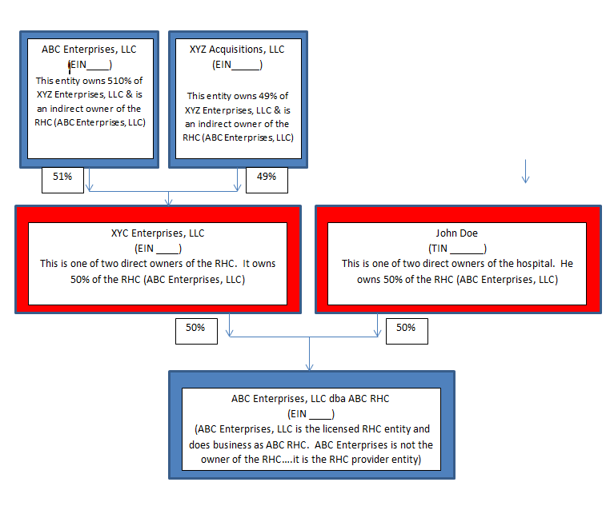

Section 9: Expansion/Renovation/Relocation
- Were any changes to the Center made other than cosmetics, painting the walls, installing new floors and/or new light fixtures? | Yes | No
- Were any walls moved, doors relocated or did the footprint/floorplan of the Center change? | Yes | No
- Is your Center relocating?  - If so, what is the new address? | Yes | No

- If this is an initial licensure application or you answered yes to either question #2 or #3, please provide the Health Facility Plan Review project number. For information on this plan review, please visit our website at: http://dhh.louisiana.gov/index.cfm/directory/detail/740.  In order for your packet to be reviewed, your plan review must be released for our review on the Office of State Fire Marshal (OSFM) IMS website. To release the plan review for our review, you will need our first name, last name and login. HSSHospitals should be entered in each of these fields. Ensure your plan review includes a site map showing all buildings demarcated, a floor map with the area boundaries demarcated, floor plan with all rooms identified by purpose or patient room number and floor plans showing what the area looked like before the change.  *Please note if plan review was required, submit the plan review attestation with this packet*. | DH- -  DH- -  DH- -  Not applicable.
- Please provide the OSFM Plan Review for the Life Safety/Occupancy Approval. The OSFM can exempt you from this review. If exempt, please provide the documentation showing the exemption. For information on this plan review, please visit our website at: http://dhh.louisiana.gov/index.cfm/directory/detail/740.  In order for your packet to be reviewed, your plan review must be released for our review on the Office of State Fire Marshal (OSFM) IMS website. To release the plan review for our review, you will need our first name, last name and login. HSSHospitals should be entered in each of these fields. | AR- -  AR- -  AR- -  Exempt.
- Describe the Delivery, Pre/Post Natal, Educational, and wraparound services provided by the Center:

What arrangements will be made for patients requiring emergency services? (Please do NOT provide an answer such as “call 911” or “transport to nearest emergency room”. You must briefly explain how your policies/procedures will be followed to provide initial care and treatment to persons experiencing emergencies).
- Submit a copy of the Center’s written transfer agreement with a hospital in the community providing Labor and Delivery Services 24 hours/day, 7 days/week with this application, if applicable.
- Provide a map showing the distance from the Center to the above contracted facility, if applicable

Section 11: Building Information (Must Be Completed For Initials, Conversions & Changes in Ownership)
For others: Has this information changed since the initial/renewal application: No (skip to next section) Yes (complete this section)
Is this Center located on the campus or in the building of another healthcare facility? No, Yes
If yes, list the name (s) of other healthcare facility:
Does this Center share space with any other business: No Yes (explain):
Is this a single story building or multi-story building? If multi-story, how many stories does the Center occupy?

Section 12: Hours of Operation: Must be completed for Initials
Has this information changed since the initial/renewal application: No (skip to next section) Yes (complete this section)
Monday | Tuesday | Wednesday |  | Thursday | Friday
am to pm | am to pm | am to pm |  | am to pm | am to pm
am to pm | am to pm | am to pm |  | am to pm | am to pm
Saturday |  |  | Sunday
am to pm |  |  | am to pm

Section 13: Accrediting Organization Information
Initial Application: No (skip to next section) Yes (complete this section)
Once licensed, which Accrediting Organization will you be pursuing certification through:

CABC or AABC Other

Section 14: Attestation & Signature

I understand that if the agency license is granted with this application action, it is granted for one year and shall become void upon change of ownership or change in geographical address. It is my responsibility to notify the Louisiana Department of Health, Health Standards Section, in writing of any changes in the information provided in this application in a separate packet. I attest that the Free Standing Birthing Center currently complies with the requirements of the Free Standing Birthing Center licensing standards, Office of State Fire Marshal, Office of Public Health and building codes. I certify that the information herein is true, correct and supportable by documentation to the best of my knowledge. Documentation of the information above is available upon request by the Louisiana Department of Health. I certify that I am aware that an onsite licensing survey must be conducted prior to the Free Standing Birthing Center receiving a license.

Emergency Preparedness Attestation:
I certify that I am in compliance with all appropriate federal, state, departmental or local statutes, laws, ordinances, rules, and regulations concerning emergency preparedness.

Authorized Representative’s Printed Name & Title:

Authorized Representative’s Signature | Date:

Section 14: Required Licensing Information to Attach to this Application
Please attach all items denoted by “X” below for the type of application you are submitting. Please do not attach extraneous information or information not requested for your licensing action.
 | INITIAL | RENEWAL | LEGAL NAME CHANGE | DBA NAME CHANGE | SERVICE ACTION | RELOCATION | MAILING ADDRESS CHANGE | CORPORATE ADDRESS CHANGE | VOLUNTARY CLOSURE
HSS-FSBC-01 Application | X | X | X | X | X | X | X | X | X
Proof of Insurance: | X | X
- General liability-$3000,000 per occurrence | X | X
- Workers compensation as required by law | X | X
- Professional Liability or proof of self-insurance (if not enrolled in PCF, HSS identified as certificate holder) | X | X
- Proof of a line of credit (Federal; $50,000) | X | X
CLIA Certificate or CLIA Certificate of Waiver, if applicable | X | X
Copy of Transfer Agreement with Labor/Delivery Hospital, if applicable | X | X
Secretary of State’s Articles of Incorporation | X
Organizational Chart including names, position titles of key administrative personnel and governing body | X
AR Plan Review Number: | X |  |  |  | X | X
Please release the plan review in the OSM website for our review; log-in, first name, last name will be HSSHospitals | X |  |  |  | X | X
DH Plan Review Number: | X |  |  |  | X | X
Please release the plan review in the OSM website for our review; log-in, first name, last name will be HSSHospitals | X |  |  |  | X | X
DH Plan Review Attestation | X |  |  |  | X | X
8.5 X 11 inch mapped floor plan | X |  |  |  |  | X
Please ensure that IMS has a site map, floor map & floor plan with all rooms identified by purpose. | X |  |  |  | X | X
OSFM Walk Through Inspection showing the dba name of the Center and geographical address: | X | X |  |  | X | X
OPH Walk Through Inspection showing the dba name of the Center and geographical address: | X | X |  |  | X | X
Map showing distance from Center to L&D Hospital | X |  |  |  |  | X
Copy of the Payment Transmittal and check | X | X | X | X |  | X
Initial: $600 | X |  |  |  |  | X
Renewal: $600 |  | X
Reprint of License: $25 |  |  | X | X
Diagram of the Ownership Structure showing all entities/persons with 5% or greater direct and/or indirect ownership/membership of the Center (see example in section 8 of this application). | X |  | X | X
IRS Information Showing Legal Name & EIN | X |  | X
Legal Documents for the change |  |  | X | X
Documentation from the US Postal Service Showing Change in Mailing Address |  |  |  |  |  |  | X
Administrator-Qualifications | X
Director of Clinical Midwifery Services-Qualifications | X
A Letter of Intent to include the following: |  |  |  |  |  |  |  |  | X
Effective Date of the closure |  |  |  |  |  |  |  |  | X
Name, address, and phone number where the Center’s Medical Records will be stored |  |  |  |  |  |  |  |  | X
Name, address and phone number for the designated custodian of Medical Records for the clinic |  |  |  |  |  |  |  |  | X
Plans for discharge or transfer of patients from this location. |  |  |  |  |  |  |  |  | X
Public notice regarding access to records in the newspaper with largest circulation near closing provider, at least 15 days prior to the effective date |  |  |  |  |  |  |  |  | X

