CLAIMS RELATED INFORMATION

Hard copy billing of total parenteral nutrition (TPN) services is billed on the paper CMS-1500 (02/12) claim form or electronically on the 837P Professional transaction. Instructions in this appendix are for completing the CMS-1500; however, the same information is required when billing claims electronically. Items to be completed are listed as required, situational or optional.

Required information must be entered in order for the claim to process. Claims submitted with missing or invalid information in these fields will be returned unprocessed to the provider with a rejection letter listing the reason(s) the claims are being returned or will be denied through the system. These claims cannot be processed until corrected and resubmitted by the provider.

Situational information may be required (but only in certain circumstances as detailed in the instructions that follow).

Paper claims should be submitted to:

DXC Technology
P.O. Box 91020
Baton Rouge, LA 70821

NOTE: Electronic claims submission is the preferred method for billing. Claims are submitted on the 837P with the DME file extension. (See the EDI Specifications located on the Louisiana Medicaid web site at www.lamedicaid.com, directory link “HIPAA Information Center, sub-link “5010v of the Electronic Transactions” – 837P Professional Guide.

This appendix includes the following:

- Instructions for completing the CMS 1500 claim form and a sample of a completed CMS-1500 claim form; and

- Instructions for adjusting/voiding a claim and a sample of an adjusted CMS 1500 claim form.

CMS 1500 (02/12) INSTRUCTIONS FOR PHARMACY TPN SERVICES

You must write “DME” at the top center of the claim form!

Locator # | Description | Instructions | Alerts
1 | Medicare / Medicaid / Tricare / Champva /  Group Health Plan /  Feca Blk Lung | Required -- Enter an “X” in the box marked Medicaid (Medicaid #). | You must write “DME” at the top center of the Louisiana Medicaid claim form in LARGE letters.
1a | Insured’s ID Number | Required – Enter the recipient’s 13 digit Medicaid ID number exactly as it appears when checking recipient eligibility through MEVS, eMEVS, or REVS.  NOTE: The recipients’ 13-digit Medicaid ID number must be used to bill claims. The CCN number from the plastic ID card is NOT acceptable. The ID number must match the recipient’s name in Block 2.
2 | Patient’s Name | Required – Enter the recipient’s last name, first name, middle initial.
3 | Patient’s Birth Date  Sex | Situational – Enter the recipient’s date of birth using six (6) digits (MM DD YY). If there is only one digit in this field, precede that digit with a zero (for example, 01 02 07).  Enter an “X” in the appropriate box to show the sex of the recipient.
4 | Insured’s Name | Situational – Complete correctly if the recipient has other insurance; otherwise, leave blank.
5 | Patient’s Address | Optional – Print the recipient’s permanent address.
6 | Patient Relationship to Insured | Situational – Complete if appropriate or leave blank.
7 | Insured’s Address | Situational – Complete if appropriate or leave blank.
8 | Reserved For NUCC Use | Leave Blank.
9 | Other Insured’s Name | Situational – Complete if appropriate or leave blank.
9a | Other Insured’s Policy or Group Number | Situational – If recipient has no other coverage, leave blank.  If there is other commercial insurance coverage, the state assigned 6-digit TPL carrier code is required in this block. The carrier code is indicated on the Medicaid Eligibility Verification (MEVS) response as the Network Provider Identification Number.  Make sure the EOB or EOBs from other insurance(s) are attached to the claim. | ONLY the 6-digit code should be entered for commercial and Medicare HMO’s in this field.  DO NOT enter dashes, hyphens, or the word TPL in the field.  NOTE: DO NOT ENTER A 6 DIGIT CODE FOR TRADITIONAL MEDICARE
9b | Reserved For NUCC Use | Leave Blank.
9c | Reserved For NUCC Use | Leave Blank.
9d | Insurance Plan Name or Program Name | Situational – Complete if appropriate or leave blank.
10 | Is Patient’s Condition Related To: | Situational – Complete if appropriate or leave blank.
11 | Insured’s Policy Group or FECA Number | Situational – Complete if appropriate or leave blank.
11a | Insured’s Date of Birth  Sex | Situational – Complete if appropriate or leave blank.
11b | Other Claim ID (Designated by NUCC) | Leave Blank.
11c | Insurance Plan Name or Program Name | Situational – Complete if appropriate or leave blank.
11d | Is There Another Health Benefit Plan? | Situational – Complete if appropriate or leave blank.
12 | Patient’s or Authorized Person’s Signature (Release of Records) | Situational – Complete if appropriate or leave blank.
13 | Patient’s or Authorized Person’s Signature (Payment) | Situational – Obtain signature if appropriate or leave blank.
14 | Date of Current Illness / Injury / Pregnancy | Optional.
15 | Other Date | Leave Blank.
16 | Dates Patient Unable to Work in Current Occupation | Optional.
17 | Name of Referring  Provider or Other Source | Required- Enter the applicable qualifier to the left of the vertical, dotted line to identify which provider is being reported.  DN Referring Provider  DK Ordering Provider  Enter the name (First Name, Middle Initial, Last Name) followed by the credentials of the professional who referred or ordered the service(s) or supply(ies) on the claim. | If multiple providers are involved, enter one provider using the following priority order:  1. Referring Provider  2. Ordering Provider
17a | Other ID# | Required – Enter the 7 digit Medicaid ID number of the referring or ordering provider.
17b | NPI # | Required - Enter the NPI number of the referring or ordering provider | The 10-digit NPI Number is required.
18 | Hospitalization Dates Related to Current Services | Optional.
19 | Additional Claim Information (Designated by NUCC) | Leave Blank.
20 | Outside Lab? | Optional.
21 | ICD Ind.  Diagnosis or Nature of Illness or Injury | Required – Enter the applicable ICD indicator to identify which version of ICD coding is being reported between the vertical, dotted lines in the upper right-hand portion of the field.  - ICD-10-CM  Required – Enter the most current ICD diagnosis code.  NOTE:  ICD-10-CM “V”, “W”, “X”, & “Y” series diagnosis codes are not part of the current diagnosis file and should not be used when completing claims to be submitted to Medicaid. | The most specific diagnosis codes must be used. General codes are not acceptable.  ICD-10 diagnosis codes must be used on claims for dates of service 10/1/15 forward.  Refer to the provider notice concerning the federally required implementation of ICD-10 coding which is posted on the ICD-10 Tab at the top of the Home page (www.lamedicaid.com).
22 | Resubmission and/or Original Reference Number | Situational. If filing an adjustment or void, enter an “A” for an adjustment or a “V” for a void as appropriate AND one of the appropriate reason codes for the adjustment or void in the “Code” portion of this field.  Enter the internal control number from the paid claim line as it appears on the remittance advice in the “Original Ref. No.” portion of this field.  Appropriate reason codes follow:  Adjustments  01 = Third Party Liability Recovery  02 = Provider Correction  03 = Fiscal Agent Error  90 = State Office Use Only – Recovery  99 = Other  Voids  10 = Claim Paid for Wrong Recipient  11 = Claim Paid for Wrong Provider  00 = Other | To adjust or void more than one claim line on a claim, a separate form is required for each claim line since each line has a different internal control number.
23 | Prior Authorization Number | Required – Enter the correct 9-Digit PA number in this field.
24 | Supplemental Information | Situational – DME Providers are required to enter 11-digit NDC codes on claim detail lines for enteral feeding products only.  In addition to the procedure code, the National Drug Code (NDC) is required by the Deficit Reduction Act of 2005 and shall be entered in the shaded section of 24A through 24G.  Claims for enteral feeding products must include the NDC from the label of the product administered.  A list of the procedure codes and NDCs for products that currently require NDC information can be found on www.lamedicaid.com under the Fee Schedules directory link. | DME providers must enter NDC information in the SHADED section of 24A – 24G of appropriate detail lines only.  This information must be entered in addition to the procedure code(s).  The NDC indicated on the claim must match the NDC on the Prior Authorization.
24A | Date(s) of Service | Required -- Enter the date of service for each procedure.  Either 6-digit (MM DD YY) or eight digit (MM DD YYYY) format is acceptable.
24B | Place of Service | Required -- Enter the appropriate place of service code for the services rendered.
24C | EMG | Situational – Complete is appropriate or leave blank.
24D | Procedures, Services, or Supplies | Required -- Enter the procedure code(s) for services rendered in the un-shaded area(s).  When a modifier(s) is required, enter the applicable modifier in the appropriate field. | Where modifiers are required, the modifier(s) on the claim must match the modifier(s) on the Prior Authorization
24E | Diagnosis Pointer | Required – Indicate the most appropriate diagnosis for each procedure by entering the appropriate reference letter (“A”, “B”, etc.) in this block.  More than one diagnosis/reference number may be related to a single procedure code.
24F | $Charges | Required -- Enter usual and customary charges for the service rendered.
24G | Days or Units | Required -- Enter the number of units billed for the procedure code entered on the same line in 24D
24H | EPSDT / Family Plan | Situational – Leave blank or enter a “Y” if services were performed as a result of an EPSDT referral.
24I | ID Qualifier | Optional. If possible, leave blank for Louisiana Medicaid billing.
24J | Rendering Provider ID# | Leave Blank.
25 | Federal Tax ID Number | Optional.
26 | Patient’s Account No. | Situational – Enter the provider specific identifier assigned to the recipient. This number will appear on the Remittance Advice (RA). It may consist of letters and/or numbers and may be a maximum of 20 characters.
27 | Accept Assignment? | Optional. Claim filing acknowledges acceptance of Medicaid assignment.
28 | Total Charge | Required – Enter the total of all charges listed on the claim.
29 | Amount Paid | Situational – If TPL applies and block 9A is completed, enter the amount paid by the primary payor. Enter ‘0’ if the third party did not pay.  If TPL does not apply to the claim, leave blank.  Do not report Medicare payments in this field.
30 | Reserved For NUCC Use | Leave Blank.
31 | Signature of Physician or Supplier Including Degrees or Credentials  Date | Optional. The practitioner or the practitioner’s authorized representative’s original signature is no longer required.  Enter the date of the signature.
32 | Service Facility Location Information | Situational – Complete as appropriate or leave blank.
32a | NPI # | Optional.
32b | Other ID# | Situational – Complete if appropriate or leave blank.
33 | Billing Provider Info &  Ph # | Required -- Enter the provider name, address including zip code and telephone number.
33a | NPI# | Required – Enter the billing provider’s 10-digit NPI number. | The 10-digit NPI Number must appear on paper claims.
33b | Other ID# | Required – Enter the billing provider’s 7-digit Medicaid ID number.  ID Qualifier – Optional – If possible, leave blank for Louisiana Medicaid claims. | The 7-digit Medicaid Provider Number must appear on paper claims.

A sample form is on the following page

SAMPLE CLAIM FORM
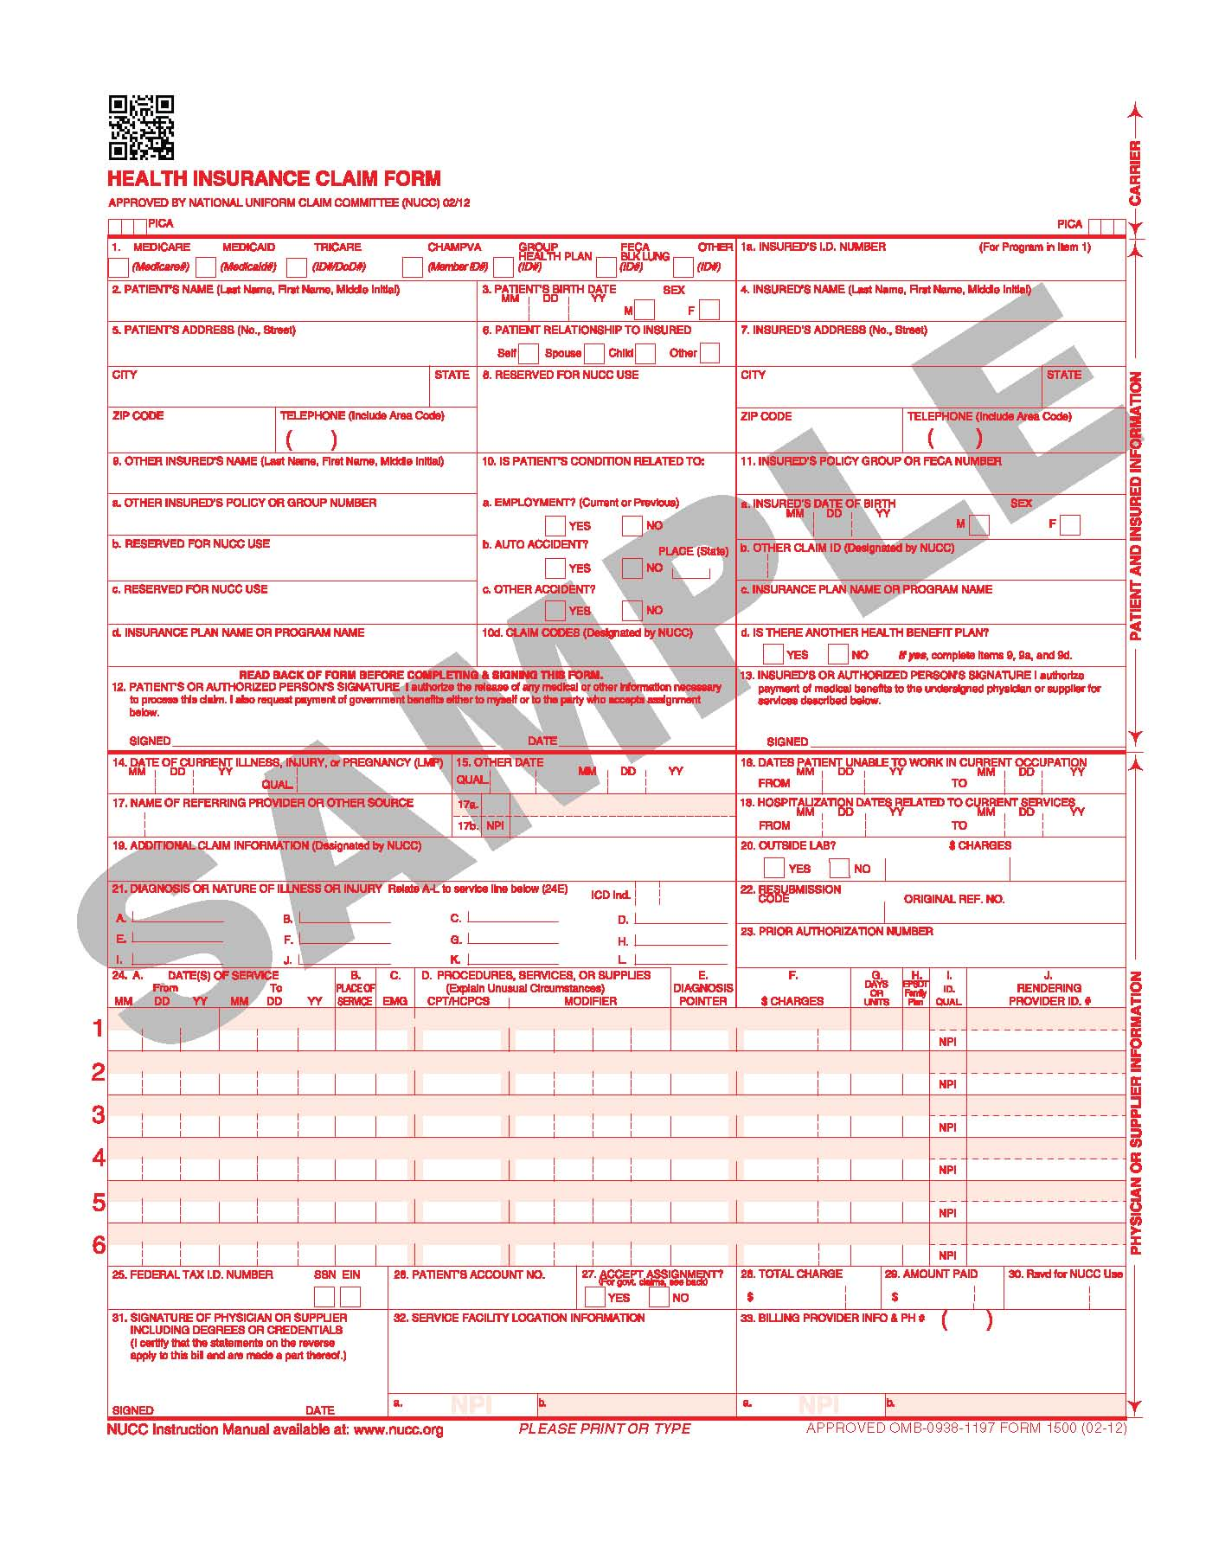

ADJUSTING/VOIDING CLAIMS

An adjustment or void may be submitted electronically or by using the CMS-1500 (02/12) form.

Only a paid claim can be adjusted or voided. Denied claims must be corrected and resubmitted – not adjusted or voided.

Only one claim line can be adjusted or voided on each adjustment/void form.

For those claims where multiple services are billed and paid by service line, a separate adjustment/void form is required for each claim line if more than one claim line on a multiple line claim form must be adjusted or voided.

The provider should complete the information on the adjustment exactly as it appeared on the original claim, changing only the item(s) that was in error and noting the reason for the change in the space provided on the claim.

If a paid claim is being voided, the provider must enter all the information on the void from the original claim exactly as it appeared on the original claim. After a voided claim has appeared on the Remittance Advice, a corrected claim may be resubmitted (if applicable).

Only the paid claim's most recently approved control number (ICN) can be adjusted or voided; thus:

- If the claim has been successfully adjusted previously, the most current ICN (the ICN of the adjustment) must be used to further adjust the claim or to void the claim.

- If the claim has been successfully voided previously, the claim must be resubmitted as an original claim. The ICN of the voided claim is no longer active in claims history.

If a paid claim must be adjusted, almost all data can be corrected through an adjustment with the exception of the Provider Identification Number and the Recipient/Patient Identification Number. Claims paid to an incorrect provider number or for the wrong Medicaid recipient cannot be adjusted. They must be voided and corrected claims submitted.

Adjustments/Voids Appearing on the Remittance Advice

When an Adjustment/Void Form has been processed, it will appear on the Remittance Advice under Adjustment or Voided Claim. The adjustment or void will appear first. The original claim line will appear in the section directly beneath the Adjustment/Void section.
The approved adjustment will replace the approved original and will be listed under the "Adjustment" section on the RA. The original payment will be taken back on the same RA and appear in the "Previously Paid" column.
When the void claim is approved, it will be listed under the "Void" column of the RA.

An Adjustment/Void will generate Credit and Debit Entries which appear in the Remittance Summary on the last page of the Remittance Advice.

NOTE: DME must be written in large letters in the blank area at the top of the claim form.

A sample form is on the following page

