These samples are being collected to determine the lead and copper levels in your tap water. This sampling effort is required by the Environmental Protection Agency and the Louisiana Department of Health and Hospitals. It is being accomplished through the cooperation of the public water system and their consumers (e.g. residents).

Collect samples from a kitchen tap that has not been used for at least 6 hours. To ensure the water has not been used for at least 6 hours, the best time to collect samples is either early in the morning or in the evening upon returning from work. Be sure to use a regularly used kitchen cold water tap. The collection procedure is described below.

1. Prior arrangements will be made with you, the customer, to coordinate the sample collection. Dates will be set for sample kit delivery and pick-up by water system staff.

2. There must be a minimum of 6 hours during which there is no water used from the tap where the sample will be collected and any taps adjacent or close to that tap. Either early mornings or evenings upon returning home are the best sampling times to ensure that the necessary stagnant water conditions exist. Do not intentionally flush the water line before the start of the 6 hour period.

3. Use a kitchen cold-water faucet for sampling. If you have water softeners on your kitchen taps, collect your sample from a cold water bathroom lavatory tap that is not attached to a water softener, or a point of use filter, if possible. Do not remove the aerator prior to sampling. Place the opened sample bottle below the faucet and open the cold water tap as you would do to fill a glass of water. Fill the sample bottle up to the neck of the bottle.

4. Tightly screw the bottle cap and place in the sample kit provided. Please review the sample kit label at this time to ensure that all information contained on the label is correct.

5. If any plumbing repairs or replacement has been done in the home since the previous sampling event, note this information on the following line provided below. Also if your sample was collected from tap with a water softener, note this as well.
________________________________________________________
6. Place the sample in the predetermined location so that water system staff may pick up the sample.

7. Results from this monitoring effort and information about lead will be provided to you as soon as practical but no later than 30 days after the system learns of the tap monitoring results. However, if excessive lead and/or copper levels are found, immediate notification will be provided as soon as possible.
TO BE COMPLETED BY RESIDENT:
Address of Residence: _______________________________________________________
Water was last used: Time: ______ Date: _________

Sample was collected: Time: ______ Date: _________

Sample was taken from (Circle only one): KT (kitchen tap) LT (bathroom tap)

I have read the above directions and have taken a tap sample in accordance with these directions

Name (print): ________________________ Signature: ______________________ Date: __________

Call the water system at ____________________ if you have any questions regarding these instructions.

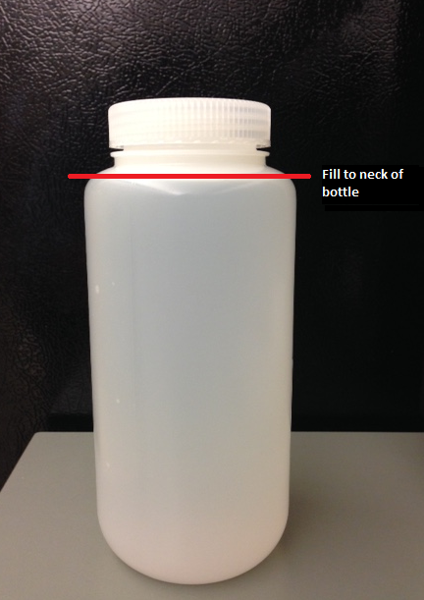
Tightly screw the lid back onto the bottle after collecting the sample.

- Each sample must be collected from a frequently used Kitchen (KT) tap in the interior of the residence or building. Try to avoid collecting samples from restroom lavatories. Samples shall NOT be collected from outside hose bibs or from vacant houses, mobile homes, or businesses.

- Collect samples from a tap that has not been used for at least 6 hours. Best time to collect samples is either early in the morning or in the evening upon returning from work

