I. GENERAL INFORMATION

A. PWS Information: B. Date Submitted:
PWSID:
PWS Name:
PWS Address:
City: State: Zip:
Population Served: System Type: CWS
Number of Surface Water Intake Sources:

B. Contact Person:
Name:
Title:
Phone #: Fax #:
E-mail:

C. Sample Location:
Provide sample location worksheet and schematic showing raw water intake(s), sample location(s), pre-treatment, point of chemical addition(s), filter backwash water recycle, the water treatment plant.

D. Sample Schedule (list the 24 dates by month/day/year):
10/14/15 | 11/12/15* | 12/16/15 | 1/13/16 | 2/10/16* | 3/16/16
4/13/16 | 5/11/16 | 6/15/16 | 7/13/16 | 8/10/16 | 9/14/16
10/12/16 | 11/16/16 | 12/14/16 | 1/11/17 | 2/15/17 | 3/15/17
4/12/17 | 5/10/17 | 6/14/15 | 7/12/15 | 8/16/15 | 9/13/15
Samples must be taken + or – two days of the above dates. Samples must be delivered to the lab same day as collected. *Note: 11/11/15 and 2/9/16 are a state holidays.

E. Approved Laboratory:
The LDHH lab will analyze all required Cryptosporidium samples in accordance with the Long Term 2 Surface Water Treatment Rule.
The LDHH lab will analyze all required E. coli samples in accordance with the Long Term 2 Surface Water Treatment Rule.

II. SAMPLING LOCATION WORKSHEET

Public Water System (PWS) Name: PWS ID:

Intake Name/ID

1. Source Name

2. Source Type
Flowing stream, or Lake/Reservoir

3. Source Water Sampling
Location Provide State assigned number

4. Usage
All year, Part-year, or Emergency (Describe conditions, constraints, months in operation)

5. Proportion of typical average daily flow | % | %
6. Pretreatment Practices
Pre-sedimentation, Bank filtration, or Off-stream storage

7. Recycling Practices (if
applicable) Description and return flow location

8. Chemical Pretreatment
(Indicate location on plant
schematic)

9. Sample Compositing Procedure (if applicable) Blended sample tap,
Composite sample, or Weighted

Use additional sheets or reverse side to provide more information

III. SAMPLING LOCATION SCHEMATIC

Public Water System (PWS) name: PWS ID:

Water treatment plant name: (provide one sheet per plant).

Indicate the following on the diagram that best represents your facility type (if applicable):

1. LT2 sampling location
2. Points of chemical treatment prior to the treatment plant
3. Filter backwash water addition
4. Pretreatment processes (e.g., pre-sedimentation basins, bank filtration)
5. Multiple source waters (show by adding additional sources)
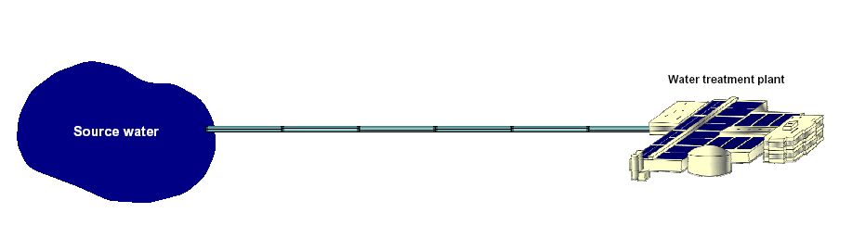 I certify that the information in this entire report, including any attachments, is true and accurate to the best of my knowledge. I acknowledge that any knowingly false or misleading information may be punishable under Louisiana Revised Statue 14:133 and other applicable laws.
Signature: _____________________________________________ Date: _____________________

