Louisiana Audiological Guidelines For
Hearing Rescreening of Infants

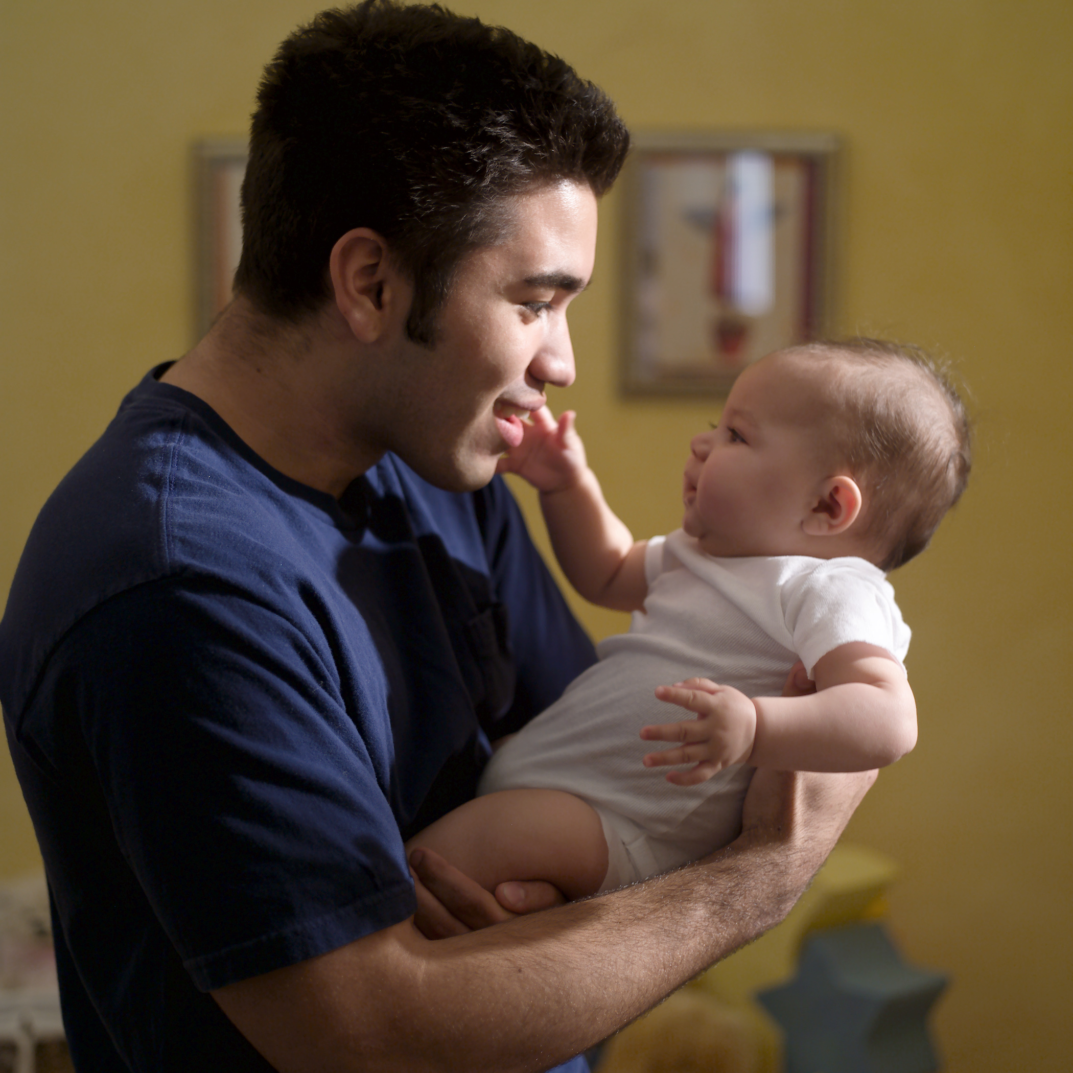

Protocols and Standards for Follow-up Screening after Failing Newborn Infant Hearing Screening

These protocols are intended as a guide for physicians who are performing follow-up hearing rescreening of newborns in their office.

Louisiana Department of Health and Hospitals
Office of Public Health
Hearing, Speech and Vision Services
Early Hearing Detection and Intervention Program

Funding was provided in part by grants from the Maternal and Child Health Bureau/Health Resources and Services Administration and the Centers for Disease Control and Prevention.
Quick Reference Guide

When should I complete the rescreening hearing test?

If an infant has failed the newborn hearing screening test in the hospital, test the infant as soon as possible, before one month of age or within one month after discharge of NICU infant. Both ears must be tested even if the child only failed one ear in the hospital.

Which hearing screening test to choose?

The only technologies approved for this population are:
OAE- (Otoacoustic Emission) or
AABR- Automated Auditory Brainstem Evoked Response

Both technologies are appropriate but infants who did not pass an AABR in the hospital must be rescreened with AABR to identify auditory neuropathy.

What is considered a “pass” for the OAE test?

A child must pass at least three frequencies in each ear. These frequencies must include:

one low frequency (between 1000 to 2000 Hz )
one high frequency (between 3000 or 4000 Hz )
one other frequency (between 1000-6000 Hz range)

What is considered a “Pass” for the AABR test?

The automated ABR units are usually preset to automatically screen for a response at 35 dB. Screening at 25 dB is recommended if possible.

What do I do if the infant passes the rescreening test?

Report hearing screening results on babies that are rescreened in physician’s offices to DHH within 7 days even if the results are normal.
Use the Physician Follow-up Services Report for Children Birth-3 years form found in this document

Monitor all children for speech/ language developmental milestones, auditory skills, parental concerns, and middle ear status at 9, 18 and 24-30 months of age using a validated assessment tool as recommended by the AAP.

What do I do if the infant does NOT pass the rescreening?

- Refer the child to an audiologist as soon as possible for further diagnostic testing. Do not attempt to perform diagnostic testing in your office. Make the appointment while the parents are in your office.

Report hearing screening results on babies that are rescreened in physician’s offices to DHH on the Physician Follow-up Services Report Form within 7 days after the screening was completed.

Also report hearing screening results to DHH within 7 days on babies given an initial hearing screening if born out of the hospital or if an infant was not screened prior to discharge from the hospital. (See appendix)

Give the parents information to help them understand the importance of further testing and need for early identification of hearing loss. Brochures are available free of charge by calling the Early Hearing Detection and Intervention Program at (504) 568-5028. Information for parents and practitioners can also be downloaded from the internet at www.hearspeech.dhh.louisiana.gov

What do I do when a child has a hearing loss confirmed by the audiologist?

- Make an appointment for the child to see:
an otolaryngologist who has knowledge of pediatric hearing loss
an ophthalmologist experienced in infant evaluation for Usher Syndrome
a geneticist if the family is interested

- Refer the child to Early Steps for early intervention services within 48 hours. ( See appendix for contact information)

- Refer the child to the Parent-Pupil Education Program to meet with a LA Deaf and Hard of Hearing Resource [LA-Hear] Coordinator in their home. (See appendix for contact information)

Table of Contents

Equipment Recommendations………………………………… 5

Technician Training Recommendations ……………………… 6

Rescreening Procedures ………………………………………. 7

Follow-up Procedures ………………………………………….. 8

Reporting Procedures ………………………………………….. 9

Medical Follow-up for Infants with Confirmed Hearing Loss... 10

Medical Follow-up for Children with Cochlear Implants …….. 11

Early Intervention Services …………………………………….. 12

Risk Indicators ………………………………………………….... 13

Additional Useful Documents:

DHH Rule and Regulations on Newborn Hearing Screening

Louisiana Early Hearing Detection and Intervention Staff Contacts

Sample Copy of Competency Check Sheet for Technicians

DHH Physician Follow-up Report Form

EQUIPMENT RECOMMENDATIONS

The follow-up newborn hearing rescreening or initial hearing screening for infants born out of the hospital should be performed using only FDA approved equipment which is recommended for infants. This equipment may be either:

- Distortion Product (DPOAE) or Transient Otoacoustic Emissions (TEOAE) which is capable of screening at several frequencies from 1000 Hz to 6000 Hz

- Automated Auditory Brainstem Evoked Response (AABR) equipment that detects mild to profound hearing loss in infants and newborns capable of screening as low as 25 dB if possible.

The equipment should be calibrated in accordance with the manufacturer’s recommendations annually. There are no national standards for the calibration of OAE or ABR instrumentation. Compounding this, there is a lack of uniform performance standards. Manufacturers of hearing-screening devices do not always provide sufficient supporting evidence to validate the specific pass/fail criteria and/or automated algorithms utilized in their instruments.

In the absence of national standards, it is recommended to obtain biological normative data for the instruments and protocols being used. Louisiana Department of Health and Hospitals have developed rules and regulations which set pass criteria for both OAE and AABR tests.

It is recommended that a log should be kept documenting the dates of calibration and repair or replacement of parts.

TECHNICIAN TRAINING RECOMMENDATIONS

All technicians and physicians performing hearing rescreening should have:

- Documentation that proper training in the use of the equipment has taken place for each screening technician/nurse, including familiarity with trouble-shooting and possible reasons for abnormal test responses.

- Documentation that technicians were trained in auditory development and behaviors in infants and young children

- Documentation that technicians were instructed in choosing proper test environments.

- Documentation that annual in-services or updates in training have taken place.

Testing technicians should not interpret the test results nor counsel the parents; only the supervising physician or audiologist should perform these duties.

The supervising physician or audiologist should continuously monitor the screening techniques and the test results of each technician. Annual updates and in-services are recommended to maintain competency.

Professionals should work in concert with experienced audiologists to assure that accurate results are obtained and appropriate referrals are made.

The DHH state Early Hearing Detection and Intervention (EHDI) staff is available for in-service training and consultation. The Department of Health and Hospital’s website has current contact information for EHDI staff at: http://www.hearspeech.dhh.louisiana.gov
peech.dhh.louisiana.gov
RESCREENING PROCEDURES
.

Waiting interval: Rescreening should not be delayed for longer than one month after hospital discharge even if transient middle ear pathology is suspected or is being treated.

Choice of test: Follow-up should begin with rescreening consisting of either OAE or ABR testing. The choice of test should be determined by the type of test used for the initial hospital screening.

If a child fails OAE screening in the hospital, then OAE or AABR rescreening is appropriate. If the child failed AABR, then only AABR should be used for rescreening or cases of auditory neuropathy/dys-synchrony may be missed.

(Although rare, auditory neuropathy/dys-synchrony has been diagnosed more frequently in the NICU population, and may have implications for the infant’s speech and language development and appropriateness of the use of amplification. These children have normal outer hair cell function and will usually pass an OAE but will continue to fail the ABR).

OTOACOUSTIC EMISSION TESTING: Use of either Transient (TEOAE) or Distortion Product (DPOAE) testing devices is acceptable. Both ears should be screened even if the child only failed one ear.

Pass Criterion: AT LEAST THREE FREQUENCIES IN EACH EAR MUST PASS THE RESCREENING

  - One passing frequency should be located between 1000 and 2000 Hz (low frequency range)
  - One other passing frequency should be located between 3000 and 4000 Hz (high frequency).
  - The third passing frequency can be at any other frequency in either range between 1000 or 6000 Hz.

AUDITORY BRAINSTEM EVOKED RESPONSE (ABR): Air-conducted clicks should be presented through insert earphones. Both ears should be screened even if the child only failed one ear.

Pass Criterion: NORMAL RESULTS CONSIST OF THE PRESENCE OF WAVE V RESPONSES FOR CLICKS AT 35 dB**IN EACH EAR.

**Warning: this screening level may still miss some mild hearing losses.
If the screening instrument settings can be changed, it is recommended to screen at 25 dB if possible.

FOLLOW-UP PROCEDURES WHEN AN INFANT PASSES THE RECREENING TEST

The physician should review every infant’s medical and family history for the presence of risk factors that require monitoring of delayed-onset or progressive hearing loss.

Evaluation by an audiologist who is experienced in testing children should be completed for all children at risk for hearing loss at least once by 24 months of age regardless of their newborn hearing screening results.

Infants with specific risk factors, such as those that received ECMO therapy and those with CMV infection, are at increased risk of delayed-onset or progressive hearing loss and should be monitored more frequently. (See updated list of risk factors for congenital and acquired hearing loss in this document.)

The primary care physician is responsible for developmental surveillance at every well child check-up. Monitoring for speech/ language developmental milestones, auditory skills, parental concerns, and middle ear status should occur at least at 9, 18 and 24-30 months of age, or whenever there is a concern, using a validated assessment tool as recommended by AAP.

FOLLOW-UP PROCEDURES WHEN AN INFANT FAILS THE RECREENING TEST

The infant should be referred to a licensed audiologist for a diagnostic audiological assessment as soon as possible. A delay in diagnostic testing will only increase the likelihood that sedation will be required for the testing procedure and will delay appropriate intervention. Infants older than 6 months usually need to be sedated for the diagnostic testing.

If a middle ear problem is suspected, diagnostic audiological studies can be completed while medical management is taking place. Repeated attempts at rescreening will only delay the determination of hearing status.

Each professional should have written information in the parent’s native language when a child fails the rescreen. Brochures on hearing loss, a state resource list of audiologists, and other useful information is available from the DHH upon request or is available on the DHH website: http://www.hearspeech.dhh.louisiana.gov

REPORTING RESULTS

Report all initial hearing screening results or re-screening results (both pass and refer) to the DHH/Office of Public Health.
Report test results for any infant receiving follow-up hearing re-screening due to a failed hospital test or for any infant receiving an initial hearing screening test due to home birth or missed screening in the hospital.

All results both pass and refer should be reported to the Office of Public Health by fax or mail within 7 days of testing using the approved Physician Follow-up Report Form (see attachments in this document). Also document any referral you have made if a child referred for further testing. It is within the Health Insurance Portability and Accountability Act of 1996 (HIPAA) Guidelines to share this information with the Office of Public Health, as a part of our public health surveillance system.

Notify the audiologist if the child had an appointment for outpatient rescreening but the testing was performed instead by the PCP.
Some infants leave the hospital with an appointment to see an audiologist for follow-up hearing rescreening. If the testing is completed instead at the primary care provider site, then notify the audiologist that the testing has already been completed and cancel the appointment. This will avoid duplication of efforts and confusion when the child fails to keep the scheduled audiology appointment.

MEDICAL FOLLOW-UP FOR INFANTS WITH CONFIRMED HEARING LOSS

Every infant with confirmed hearing loss and/or middle ear dysfunction should be referred for otologic and other medical evaluations. The purpose of these evaluations is to determine the etiology of the hearing loss, to identify related physical conditions, and to provide recommendations for medical/surgical treatment as well as referral for other services. Essential components of the medical evaluation include clinical history, family history of childhood-onset permanent hearing loss, identification of syndromes associated with early or late-onset permanent hearing loss, a physical examination, and indicated radiologic and laboratory studies (including genetic testing). Portions of the medical evaluations, such as urine culture for CMV, a leading cause of hearing loss, might even begin at the birth hospital particularly for infants spending time in the NICU.

The infant’s pediatrician or other primary health care professional is responsible for monitoring the general health, development, and well-being of the infant. In addition, the primary care physician must assume responsibility to ensure that the audiologic assessment is conducted on infants that do not pass screening and must initiate referrals for medical specialty evaluations necessary to determine the etiology of the hearing loss. Middle ear status should be monitored, because the presence of middle ear effusion can further compromise hearing. The primary care physician must partner with other specialists, including otolaryngologists, to facilitate coordinated care for the infant and family. Because 30%-40% of children with hearing loss will demonstrate developmental delays or other disabilities, the primary care physician should closely monitor developmental milestones and initiate referrals related to suspected disabilities.

For infants with a confirmed hearing loss, a genetics consultation should be offered to their families. Every infant with confirmed hearing loss should be evaluated by an otolaryngologist with knowledge of pediatric hearing loss and have at least one examination to assess visual acuity by an ophthalmologist experienced in evaluating infants for Usher’s syndrome.

Joint Committee on Infant Hearing 2007 Position Paper
Pediatrics, Volume 120, Number 4, October 2007
MEDICAL FOLLOW-UP FOR INFANTS WITH COCHLEAR IMPLANTS AND HEARING AIDS

Children with cochlear implants may be at increased risk of acquiring bacterial meningitis compared with children in the general US population. The CDC recommends that all children with, and all potential recipients of, cochlear implants follow specific recommendations for pneumococcal immunizations that apply to cochlear implant users and that they receive age-appropriate Haemophilus Influenza Type B vaccines.

(CDC, 2003)

EARLY INTERVENTION

According to federal guidelines, once any degree of hearing loss is diagnosed in a child, a referral should be initiated to an early intervention program within 2 days of confirmation of hearing loss. The initiation of early intervention services should begin as soon as possible but no later than 6 months of age. Even when the hearing status is not determined to be the primary disability, the family and child should have access to intervention with a provider knowledgeable about hearing loss.

The term “intervention services” is used to describe any type of habilitative, rehabilitative, or educational program provided to individuals with hearing loss. In some cases with mild hearing loss, amplification technology may be the only service provided. Some parents choose only developmental assessment or occasional consultation, such as parents with infants who have unilateral hearing losses. Children with high-frequency losses and normal hearing in the low frequencies may only be seen by a speech-language pathologist and those with significant bilateral hearing losses might be seen by an educator of the deaf and receive additional services by the speech-language pathologist, audiologist, and family service coordinator.

To ensure informed decision making, parents of newly diagnosed hearing loss should be offered opportunities to interact with other families who have infants or children with hearing loss as well as adults and children who are deaf and hard of hearing. Parents should be offered access to professional, educational, and consumer organizations and provided with general information on child development, speech and language development, and hearing loss.

Foundational characteristics of high quality early intervention programs include a family-centered approach, culturally responsive practices, collaborative professional-family relationships and strong family involvement, developmentally appropriate practice, interdisciplinary assessment, and community-based provision of services.

In Louisiana, home and community based services are provided to families of any child with any degree of unilateral or bilateral hearing loss by regional Louisiana Deaf & Hard of Hearing Resource [LA-Hear] Coordinators. LA-Hear Coordinators from the Parent-Pupil Education Program [PPEP] are certified teachers specializing in the education of children with hearing loss. LA School for the Deaf provides PPEP as a free state-wide outreach program. These services are provided in collaboration with Louisiana’s Early Steps Federal Part C Program.

Physicians can refer any family of a child with a hearing loss for free services provided by a regional LA-Hear Coordinator. For further information contact the PPEP Office at
1-888-769-8111 ext. 331.

RISK INDICATORS ASSOCIATED WITH PERMANENT CONGENITAL, DELAYED-ONSET OR PROGRESSIVE HEARING LOSS IN CHILDHOOD
(Joint Committee on Infant Hearing Position Statement, 2007)

The timing and number of hearing reevaluations for children with risk factors should be customized and individualized depending on the relative likelihood of a subsequent delayed-onset hearing loss.

Risk indicators that are in bold print are of greater concern for delayed-onset hearing loss and will need close audiologic monitoring. The previous 2000 JCIH position statement recommended every 6 months for the first three years.

Infants who pass the neonatal screening but have any of the other risk factor should have at least 1 diagnostic audiology assessment by 24 to 30 months of age.

Risk Indicators:

1. Caregiver concern regarding hearing, speech, language, or developmental delay.

2. Family history of permanent childhood hearing loss. If a blood relative of the infant had a permanent hearing loss from birth or which began in early childhood and needed a hearing aid or special schooling for the hearing-impaired. This DOES NOT include hearing loss due to illness, ear infections, or aging.

3. Neonatal intensive care of more than 5 days or any of the following regardless of length of stay: ECMO, assisted ventilation, exposure to ototoxic medications
(gentamicin and tobramicin) or loop diuretics (Furosemide/Lasix), and hyperbilirubinemia that requires exchange transfusion.

4. In utero infections, such as CMV, herpes, rubella, syphilis, and toxoplasmosis.

5. Craniofacial anomalies, including those that involve the pinna, ear canal, ear tags, ear pits, and temporal bone anomalies.

6. Physical findings, such as white forelock, that are associated with a
syndrome known to include a sensorineural or permanent conductive hearing loss.

7. Syndromes associated with hearing loss or progressive or late-onset hearing loss, such as neurofibromatosis, osteopetrosis, and Usher Syndrome; other frequently identified syndromes include Waardenburg, Alport, Pendred, and Jervell and Lange-Nielson.

8. Neurodegenerative disorders, such as Hunter Syndrome, or sensory motor neuropathies, such as Friedreich Ataxia and Charcot-Marie-Tooth syndrome.

9. Culture-positive postnatal infections associated with sensorineural hearing loss, including confirmed bacterial and viral (especially herpes viruses and varicella) meningitis.

10. Head trauma, especially basal skull/temporal bone fracture that requires hospitalization.

11. Chemotherapy.

APPENDIX 1 Algorithm for Hearing Screening. Available at: http://www.medicalhomeinfo.org/screening/Screen%20Materials/Algorithm.pdf
- PEDIATRICS Volume 120, Number 4, October 2007

Remember the goal for follow up is “1-3-6”

- Before 1 month old:
Identify those newborns needing further
assessment

- Before 3 months old:
Complete an appropriate diagnostic audiological
assessment

- Before 6 months old:
Fit amplification and begin early intervention
services

Children who follow these timelines have been shown to have significantly higher speech and language skills than those later identified children.

These guidelines were revised with assistance from the following Louisiana State professionals. Thanks to all who participated in the process.

Members of the Louisiana State Advisory Council on Infant Hearing:

Mimi Brooks Susan Sonnier
Vicki Crochet Evelyn Kluka, MD
Donna Embree Dorothy Rodriguez
Juan Gershanik, MD Naomi Dedual
Kathy Hughes
June Street

DHH Sound Start Early Hearing Detection and Intervention Staff:
Susan Berry Meshawn Tarver
Lorraine Farr Claudette DeGraauw
Christy Fontenot Dwana Green
Terri Mohren Melinda Peat
Mary Jo Smith Maegan Guilbeau
Regina Winbush

