

**Automated External Defibrillator (AED)**

**Procedure Manual**

**Jump Start Your Heart ACT 234**

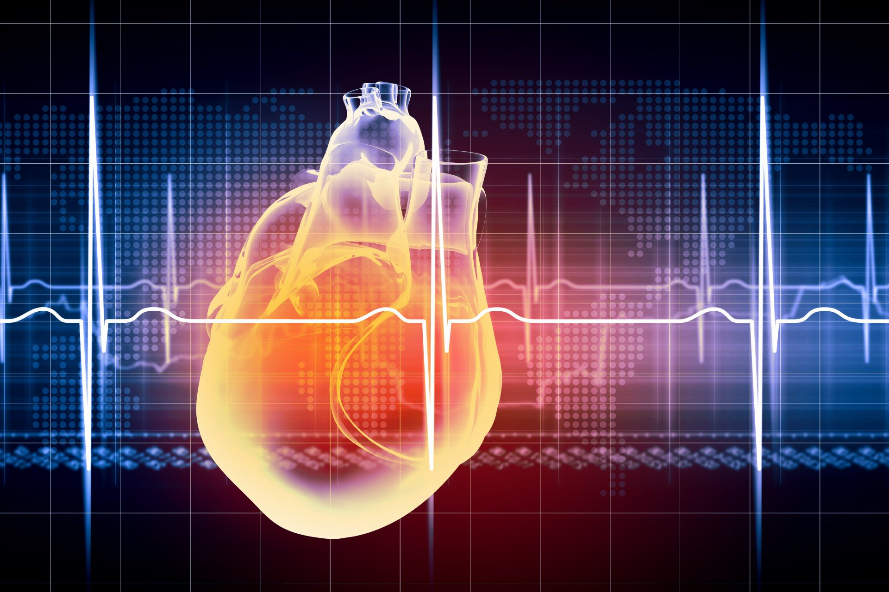

**Table of contents**

Page

1. Purpose and Definitions …………………………………………………………………………………………………….. 3
2. AED Maintenance & Use…………………………………………………………………………………………………….. 3
3. Educational Institutions Requirements……………………………………………………………………………….. 4
4. Additional requirements for post-secondary schools………………………………………………………….. 4
5. Cardiac Response Plan minimum requirements………………………………………………………………….. 4
6. Cardiac Response Team-**APPENDIX A**………………………………………………………………………………….5
7. All AED(s) and their locations- **APPENDIX B**…………………………………………………………………………5
8. Important staffing members information **APPENDIX C**………………………………………………………..5
9. Sudden Cardiac Arrest (SCA) while school is in session……………………………………………………….. 5
10. Additional information for Cardiac Response Plans during school hours or athletic events... 7
11. Communicating with 911 telecommunications­­­­…………………………………………………………………… 8
12. Post event Procedures………………………………………………………………………………………………………… 8
13. APPENDIX Location…………………………………………………………………………………………………………….. 9
14. **APPENDIX D**- Cardiac response drill checklist…………………………………………………………………… 10
15. **APPENDIX E**- AED Monthly Inspection Log………………………………………………………………………… 11
16. **APPENDIX F-** Hospitals and Air Med information………………………………………………………………. 12
17. **APPENDIX G**- Post event form…………………………………………………………………………………………… 13

**Jump Start Your Heart ACT 234**

The Louisiana Department of Health, Office of Public Health, and Bureau of EMS has the authority to promulgate all necessary rules and regulations to implement and assure compliance to R.S. 40:1137.3 S.B.12 ACT 234 relative to (AED) automated external defibrillators. (AEDs) are required on the premises of each post-secondary institution and each elementary, middle, and high school and at certain sponsored/host athletic events. Registration shall occur within 60 days of the effective date of this subsection, and any change in or addition to required information shall be uploaded to the Bureau of EMS Information Management System within 30 days from the date of occurrence.

## **Automated External Defibrillator (AED) -** a medical device heart monitor and defibrillator that:

1. Has received approval of its pre-market notification filed pursuant to 21 U.S.C. 360(k) from the United States Food and Drug Administration.
2. Is capable of recognizing the presence or absence of ventricular fibrillation or rapid ventricular tachycardia and is capable of determining whether defibrillation should be performed.
3. Upon determining that defibrillation should be performed, the AED automatically charges and requests delivery of an electrical impulse to an individual's heart.
4. Is capable of delivering the electrical impulse to an individual's heart.
5. Pediatric AED capabilities are required.

## AED Maintenance & Use

* The AED must be maintained and tested within the institution, according to the manufacturers’ guidelines, in accordance with state and federal rules and policies, including review of product warranty expirations and AED machine, pads and batteries.
* Expected AED users must receive appropriate training in CPR and in the use of and AED by American Heart Association, American Red Cross, the Health and Safety Institute, or the equivalent cardiopulmonary resuscitation credential that has been approved by LDH.
* The local provider of Emergency Medical Services (EMS) (such as 911 service, local ambulance service, or fire department) must be activated by the possessor as soon as possible when an individual renders emergency care to an individual in cardiac arrest by using CPR or an AED. It is the responsibility of the individual rendering the emergency care to activate the local EMS provider.
* Any manufacturer, wholesale supplier, or retailer of an AED must notify purchaser of AED's intended for use in the state of Louisiana of the requirements of R.S. 40:1137.3.
* After every event, in which an AED is used, it is the responsibility of the educational facility to immediately replenish the AED supplies that were used and prepare the device to be ready for the next event.
* Contact the AED manufacturer if you have any issues.

## All Educational Institutions are required to have the following:

* An AED on the premises of each postsecondary institution and each K-12 educational facilities.
* An AED is required a certain interscholastic and intercollegiate athletic events.
* An individual trained in the use of the AED and First-aid CPR at the events.
* A Cardiac Response Plan.
* A Cardiac Response Team.

Additional Requirements for Postsecondary Educational Institutions

Any institution of higher education that competes in intercollegiate athletics must have an AED on its premises in its athletic department, with posters approved by AHA/ARC on how to safely perform CPR and use the AED. The AED must be placed in open view within two feet of a telephone to readily enable a call to 911 from within the athletic department. It must also be placed in an area with easy access to coaches and athletic personnel where athletes are training and/or competing.

Cardiac Response Plan

The plan shall focus on preventing the loss of life. A plan must be written and identify the members of the Cardiac Emergency Response Team. At a minimum, the plan must include:

1. Establishing a cardiac emergency response team.
2. Activating the team in response to a sudden cardiac arrest.
3. Implementing AED placement and routine maintenance within the institution.
4. Maintaining ongoing staff training in CPR and AED use.

* Staff must complete a course recognized by a nationally recognized organization or association such as the American Heart Association (AHA), the American Red Cross (ARC), The National Safety Council and the Health and Safety Institute (HSI), or the equivalent cardiopulmonary resuscitation credential that has been approved by the Louisiana Department of Health.

1. Practicing using drills.
2. Integrating local EMS with the plan.
3. Annually reviewing and evaluating the plan.

|  |  |  |  |
| --- | --- | --- | --- |
| NAME | LOCATION ON CAMPUS | PHONE NUMBER | JOB |
| Team member #1 |  | XXX-XXX-XXXX | CALLS 911 (CELL)/AID IN CPR/ ALERTS OFFICE (SEND A STUDENT OR USE AN ADDITONAL PHONE) |
| Team member #2 |  | XXX-XXX-XXXX | RETRIEVES AED/ AID IN CPR |
| Team member #3 |  | XXX-XXX-XXXX | ACTIVATE TEAM / GATHERS PATIENT EMERGENCY INFORMATION FOR EMS/ CONTACT EMERGENCY CONTACT. |
| Team member #4 |  | XXX-XXX-XXXX | CLEAR THE AREA OF OTHER STUDENTS AND STAFF |
| Team member #5 |  | XXX-XXX-XXXX | AID IN CPR |
| Team member #6 |  | XXX-XXX-XXXX | AID IN CPR |
| Team member #7 |  | XXX-XXX-XXXX | MEETS EMS OUTSIDE/ GUIDES TO THE AREA OF THE PATIENT |
| Team member #8 |  | XXX-XXX-XXXX | DOCUMENTS EVENTS (TIMES) HELPS MOVES OTHER STUDENTS AND STAFF FROM AREA. |

Cardiac Response Team List:

|  |  |
| --- | --- |
| **ALL AED(s) and their locations** | |
| AED AND TYPE | LOCATION |
|  |  |
|  |  |
|  |  |
|  |  |
|  |  |

Other Important phones numbers:

|  |  |  |  |  |  |
| --- | --- | --- | --- | --- | --- |
|  | Athletic Director | Athletic Trainer | EMR/EMT | Principal | School Nurse |
|  |  |  |  |  |  |
|  |  |  |  |  |  |
|  |  |  |  |  |  |

In the event of Sudden Cardiac Arrest (SCA) on school premises, while school is in session, the following steps should be taken:

1. Using a cell phone or a landline near the patient, someone should call 911.
2. Confirm the location of the patient.
3. Send someone to retrieve the AED.
4. Use a second phone or send someone to the front office to notify the principal.
5. The front office will send overhead page for the “Cardiac Response Team” to respond to the location of the SCA.
6. The principal will confirm there is an AED enroute to the patient.
7. Someone should be placed outside to direct EMS/Fire Department to the patient.
8. Have someone keep time (timekeeper) of the events taking place.
9. Assess the patient Airway, breathing and circulation.
10. Bare the patient’s chest an Initiate CPR, if needed, until the AED arrives.
11. Once the AED is at the patient’s, side place the AED near the patient’s head, close to the AED operator.
12. Prepare to use the AED.
13. Make sure the AED is powered on and cables are attached.
14. Attach the AED to the patient.

* Make sure the chest is dry.
* For a children 8 years or younger, use pediatric pads.
* For adults, use adult pads.

1. Stop CPR. Allow the AED to analyze the cardiac rhythm to determine if a shock is necessary. (some models automatically deliver a shock, while others require the rescuer to push a button)

* Be sure all rescuers and bystanders are “CLEAR” before the shock is administered.

1. If no shock is indicated, follow prompts to reassess and continue CPR.
2. Upon arrival EMS, will take charge of the scene.

* Provide patient information to EMS professionals. (Name, age, known medical problems, emergency contact info).
* Provide EMS with the times tracked by the time keeper.

Additional information for Cardiac Response Plans during school hours or athletic events:

* Name and phone number of the EMS Company that will be responding in the area.
* Name and phone number of Fire Department that will be responding.
* Include an aerial map of each athletic venue, with arrows insinuating the route to enter and exit the area as quickly as possible.
* Include Air Med Landing Zone (LZ) with the correct coordinates for each event, including but not limiting to schools, football stadiums, baseball/softball fields etc. (Schools that host athletic events away from school premises will have more than one set of coordinates). Get with the areas local responders (EMS, Fire Departments) to assist with finding a LZ and the appropriate coordinates for each venue.
* Know where the AED or emergency equipment is located during athletic events.
* List the areas hospitals including phone numbers, addresses, and an estimated time of arrival drive time from the incident to the emergency room.

This picture indicates where the AED(s) are located in the area, how EMS should to access the patient, and the landing zone for Air Med if needed.

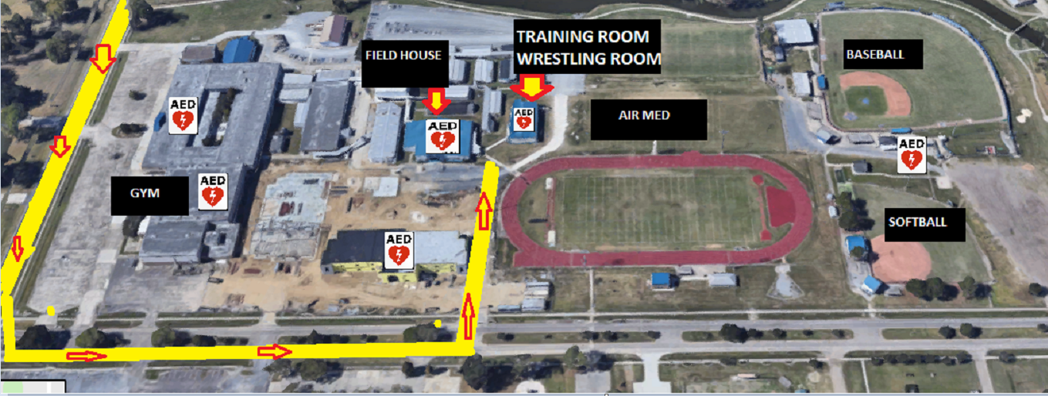

Communicating with 911 Operator:

* Remain calm and listen carefully.
* Don’t hang up, the 911 operator will stay on the line with you until EMS arrives.
* Let the 911 operator guide the conversation.
* Stay close to the patient and update the 911 operator about their status.
* Put your cell phone on speakerphone if needed so others can hear instructions as well.
* Be sure to ask the 911 operator for clarification if you don’t understand.
* Send someone to meet EMS and direct them to the patient (at school or at the venue of the

Athletic event).

Post Event Procedures:

* Check and replenish supplies as appropriate (AED pads, towels, gloves, etc.).
* Clean and disinfect the device.
* Check the battery and replace if needed.
* Check the device for any damages.
* Return the AED to its designated place.
* Assure the AED’s information such as replaced pads or batteries is updated in the Bureau of EMS IMS system. <http://labems.ldh.la.gov>.



Aimee Hall, NREMT

Jump Start Your Heart Coordinator

7273 Florida Blvd., Baton Rouge, La 70806

Office Phone: 225-925-4374

Email: [Aimee.Hall@la.gov](mailto:Aimee.Hall@la.gov)

APPENDIX A-F

Page

Appendix A Cardiac Response Team Members………………………………………………………………………………… 5

Appendix B All AEDs and their Locations………………………………………………………………………………………….. 5

Appendix C Important Contacts………………………………………………………………………………………………………… 5

Appendix D Cardiac response drill checklist…………………………………………………………………………………….. 10

Appendix E AED Monthly Inspection Log………………………………………………………………………………………… 11

Appendix F Hospitals and Air Med information……………………………………………………………………………….. 12

Appendix G Post event form……………………………………………………………………………………………………………. 13



|  |  |  |  |  |  |  |  |  |  |
| --- | --- | --- | --- | --- | --- | --- | --- | --- | --- |
| Cardiac Response Drill Checklist | | | | | | | | | |
| Date/Time: | | | School: | | | Drill Location: | | | |
| Response Action | | | | | | Yes | No | Unknown | Time |
| Was the sudden cardiac arrest witnessed? *If yes send for (AED) ASAP* | | | | | |  |  |  |  |
| 911 called? | | | | | |  |  |  |  |
| Victim unresponsive was determined | | | | | |  |  |  |  |
| Called 911. | | | | | |  |  |  |  |
| Send for and AED. | | | | | |  |  |  |  |
| Contact the front office (principal confirms AED is enroute to the patient) | | | | | |  |  |  |  |
| Cardiac Response Team was paged to the area. | | | | | |  |  |  |  |
| Initiated CPR? | | | | | |  |  |  |  |
| AED arrives to the patient side with in 3minutes. | | | | | |  |  |  |  |
| AED (Adult\Pedi) pads are placed on the patient’s bare chest. | | | | | |  |  |  |  |
| Allow AED to analyze (don’t touch the patient). | | | | | |  |  |  |  |
| Proper CPR mechanics? | | | | | |  |  |  |  |
| Proper AED pad selection? | | | | | |  |  |  |  |
| Proper AED pad placement? | | | | | |  |  |  |  |
| Office obtained Emergency Contact information for EMS? | | | | | |  |  |  |  |
| Timekeeper gave event times to EMS? | | | | | |  |  |  |  |
| Did someone go direct EMS? | | | | | |  |  |  |  |
| Crowd Control (students, family, bystanders etc...) | | | | | |  |  |  |  |
|  | | | | | |  |  |  |  |
|  |  |  |  |  |  |  |  |  |  |
| Post Drill Review: | |  |  |  |  |  |  |  |  |
|  |  |  |  |  |  |  |  |  |  |
| What did we do right? What was easy to remember to do? | | | | | | | | |  |
|  | | | | | | | | | |
|  | | | | | | | | | |
|  | | | | | | | | | |
| What could we do better? If needed, discuss with staff how the time from delivery of the AED to | | | | | | | | | |
| Delivery of first shock may be made quicker. What was hard to remember? | | | | | | | | | |
|  | | | | | | | | | |
|  | | | | | | | | | |
|  | | | | | | | | | |
|  |  |  |  |  |  |  |  |  |  |
| Cardiac Emergency Response Team Members who attended drill: | | | | | | | | | |
|  |  |  |  |  |  |  |  |  |  |
| 1) | | | |  | 5) | | | |  |
| 2) | | | |  | 6) | | | |  |
| 3) | | | |  | 7) | | | |  |
| 4) | | | |  | 8) | | | |  |
|  |  |  |  |  |  |  |  |  |  |
|  |  |  |  |  |  |  |  |  |  |

AED Monthly Inspection Log

|  |  |  |  |  |  |
| --- | --- | --- | --- | --- | --- |
| AED Type | AED Location | Serial Number | Battery Expiration | Adult Pads | Pediatric Pads |
|  |  |  |  |  |  |
|  |  |  |  |  |  |
|  |  |  |  |  |  |
|  |  |  |  |  |  |
|  |  |  |  |  |  |
|  |  |  |  |  |  |
|  |  |  |  |  |  |
|  |  |  |  |  |  |
|  |  |  |  |  |  |

AED Serial #:­­­­­­­­­__________________________ AED Location: _______________________________



Including the areas closes hospitals, phone numbers, the hospitals addresses and mileage from the incident to the hospital, and a landing zone and the coordinate to the landing zone.

|  |  |  |  |  |
| --- | --- | --- | --- | --- |
| Hospital Name  (which hospital has pediatrics) |  |  |  |  |
| Hospital Phone Number |  |  |  |  |
| Address |  |  |  |  |
| Millage |  |  |  |  |

|  |  |  |  |  |
| --- | --- | --- | --- | --- |
| EMS COMPANY RESPONDING | Air Med Landing Zone  Coordinates | Address of landing Zone | Phone number to Agency responding | Air Meds incident/call number |
|  |  |  |  |  |

|  |  |  |  |
| --- | --- | --- | --- |
| |  | | --- | |  | | | Post Event Form | |
| Aimee Hall JSYH ACT Coordinator for The Bureau of EMS | |
| Date of Event: Time: | |
| PATIENT IS A : Student/ Staff/Guest/Other (Circle one) | |
| Facility Name: | | |
| Facility Address: | | Contact # ( ) - - |
| AGE: SEX: M\F | Location of Incident: | |
| Was the incident witnesses? YES\NO | Time AED arrived to the patient side: | |
| If Witnessed, by whom? | | Contact #: |
| Were there signs of trauma? YES\NO If YES please explain below: | | |
|  | | |
|  | | |
|  | | |
|  | | |
| Was CPR Performed? YES\NO | By Whom? Credentials: | |
| Was and AED used? YES\NO | Was an AED shock delivered? YES\NO | How many? |
| Were there any AED issues? YES\NO If YES Please explain. | | Time AED was placed on the patient? |
|  | | |
|  | | |
| What time was 911 call? | What time was the facilities Cardiac Response Team notified? | |
| Who called 911? | Did the Fire Department respond? YES\NO Arrival Time: | |
| Name of the Fire Department that responded? | | |
| Fire Departments Incident # | EMS Incident # | |
| EMS arrival time: | Responding EMS company? | |
| Responding Police Department: | Arrival time: | Police Incident # |
| What was the patient doing before the event? | | |
| Where was the patient at the time of the event? | | |
| Did the patient have any complaints before the event? YES\NO If yes explain below: | | |
|  | | |
|  | | |
|  | | |
| Did EMS Transport? YES\NO Mode of transport: Ground/ Air Med | Hospital patient transported to : | |
| Please explain the event in detail on the lines below: | | |
|  | | |
|  | | |
|  | | |
|  | | |
|  | | |
|  | | |
|  | | |
|  | | |